CSU34031 Project 1

**A Web Proxy Server**

The objective of the exercise is to implement a Web Proxy Server. A Web proxy is a local server, which fetches items from the Web on behalf of a Web client instead of the client fetching them directly. This allows for caching of pages and access control.

The program should be able to:

1. Respond to **HTTP & HTTPS** requests and should **display each request** on a management console. It should forward the request to the Web server and relay the response to the browser.
2. Handle **Websocket** connections.
3. Dynamically **block selected URLs** via the management console.
4. Efficiently **cache** HTTP requests locally and thus save bandwidth. You must gather **timing and bandwidth** data to prove the efficiency of your proxy.
5. Handle multiple requests simultaneously by implementing a **threaded server**.

The program can be written in a programming language of your choice. However, you must ensure that you do not overuse any API or Library functionality that implements the majority of the work for you.

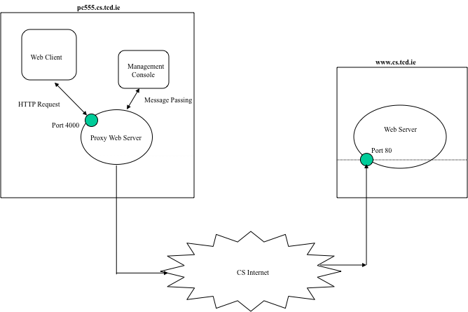

# Note

* You should provide a high-level description of the protocol design and implementation. A listing of the code should also be provided along with meaningful comments. You are required to submit a **single** PDF file containing the documentation and code though Blackboard.
* You must also provide a short **video demonstration** of your work. In the video you should demonstrate a working prototype, explain your design choices, talk through parts of your code which implement important aspects of your work.
* All submitted work **must** be original and your own. Please familiarize yourself with the College Plagiarism guidelines - <https://www.tcd.ie/undergraduate-studies/general-regulations/plagiarism.php>. Submissions that are similar to each other will result in zero marks being awarded to all parties that are identified.
* Late submissions will not be accepted unless accompanied by a medical certificate.
* This project is worth 10% of the marks and will be graded out of 100 marks

Deadline for submission is 23:59hrs on Sunday the 14th of March.