N-Body Physics

GalaxSee

One of the grand challenge problems in astronomy is the evolution and structure of the
universe and galaxies. The universe is seen to have a structure of sheets and voids on a
large scale. Galaxies are seen to often have a spiral structure that is difficult to explain.
Space is not occupied by a homogenous fluid, but by discrete particles that interact
through gravity over long ranges.

This is often modeled as discrete bodies interacting through gravity. The gravitational
force is given by Fg = G M1M2/D2, where M1 and M2 are two objects masses and D is the
distance between them. The acceleration of an object is given by the sum of the forces
acting on that object divided by its mass a = ΣF/M. If you know the acceleration of each
mass, you can calculate the change in velocity a = Δv/Δt. If you know the velocity, you
can calculate the change in position v = Δx/Δt..

The algorithm can be loosely described as

NEW = OLD + CHANGE

This is applied to each particle. To apply this to each particle, you need to know the
acceleration, but the acceleration is determined by the sum of all of the forces.

What this means is that the more objects you have, the more forces you need to calculate.
What’s worse, every object needs to know about every other object.
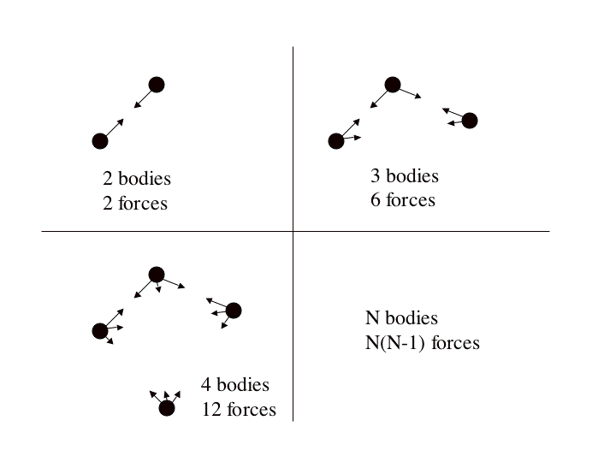

The GalaxSee code is a simple implementation of parallelism. Since most of the time in a
given N-Body model is spent calculating the forces, we only parallelize that part of the
code. “Client” programs that just calculate accelerations are fed every particle’s
information, and a list of which particles that client should compute. A “server” runs the
main program, and sends out requests and collects results during the force calculation.

You could think of the total running time in the following way

A. It takes some time to send out information on N particles to P-1 processors each
of S time steps

B. It takes some time for each processor to calculate N/P * N interactions each of
every S time steps

As long as you run the model for enough time steps that not much time is spent “setting up” the program, a reasonable model for how long the GalaxSee program will take to run on a given cluster is

time = A*N*(P-1) + B*N*N/P

For your cluster, what would be the coefficients of this equation?

To run the program on one node of your cluster, enter the following command

time mpirun –np 1 –machinefile machines GalaxSee 100 400 1000.0 1
#cpus #bodies #mass #final time do_display

(Run the following models without a display, and record the wall time for each model.)

A. Run the model with 1 processor, 500 bodies, and 1000 Myrs.
B. Run the model with 2 processors, 500 bodies, and 1000 Myrs.
C. Run the model with all processors, 500 bodies, and 1000 Myrs.
D. Run the model with 1 processor, 2000 bodies, and 1000 Myrs.
E. Run the model with 2 processors, 2000 bodies, and 1000 Myrs.
F. Run the model with all processors, 2000 bodies, and 1000 Myrs.

“Guestimate” the coefficients, and try it out for a few different
runs other than the ones above. Does this “model of the model” work?

What happens to your efficiency as you add processors? What would happen if you went
from 4 to 8 CPUs? 8 to 16? 16 to 32? 32 to 64?

What if the model were bigger? Real “production” N-Body codes use millions of
particles. How long would it take to run a million particle code for the lifetime of the
universe (14,000 Myrs with an 8 Myr timestep) on your cluster? What if you had 16
CPUs? 32? 256? 512? 2048?

How does adding CPUs affect cluster efficiency for a problem with a heavy
communication overhead? What does this say about the suitability of high
communication overhead models to parallel computing?

