v1.7 (2023/12/02)
Miyoo Mini (Plus)
1. Added 752x560 resolution support.
2. Added more background images with 752x560 pixels (images contributed from 河馬)
3. Added more background images with 640x480 pixels (images contributed from 路人乙)
4. Added more background images with 640x480 pixels (images contributed from Koriki)
5. Added more settings to the customized menu.
6. Added auto-save and auto-load support.
7. Added key rotation support. (0, 90, 270)
8. Added new book-style display mode.
9. Added new setting “half_vol” in settings.json file.
10. Added new setting “auto-slot” in settings.json file.
11. Added lower speed support for stylus.
12. Refined NEON instructions to improve performance.
13. Aligned keymap with Onion system.
14. Fixed repeating key issue after switch to stylus mode.

TRIMUI SMART
1. First released.

Q &Ａ
Q1: How to run the DraStic emulator on 752x560 resolution ?
A1: Change "USE_752x560_RES=1" in launch.sh file. By default, it is set as 0 (640x480 resolution)

v1.6 (2023/10/22)
1. Improved video performance up to 20%. (only works in Keypad mode)
2. Added multi-lingual support.
3. Added customized DraStic menu support. (replace original DraStic menu)
4. Added splash app for the first-run. (images contributed from 河馬)
5. Added DraStic menu’s background image. (images contributed from 河馬)
6. Added “menu_c0”, “menu_c1” and “menu_c2” settings in resources/settings.json.
7. Added “cust_menu”, “lang” and “dpad_90d” settings in resources/settings.json.
8. Put the stylus pen at central point when turns the stylus on.
9. Refined launch.sh file. (added splash app and adjusted sync commands)
10. Refined savestate settings. (disabled both “Compress savestate” and “Backup in savestate”)
https://github.com/steward-fu/archives/releases/download/miyoo-mini-plus/drastic-v1.6.7z

Q &Ａ
Q1: How to change the DraStic’s menu back to the original one ?
A1: Change the value of cust_menu in resources/settings.json file to 0.

Q2: How to change the language to another one ?
A2: As the following steps:
Step 1: add the new translation file in resources/translate folder, ex: jp
Step 2: change the value of lang in resources/settings.json file to match your language, ex: “lang”:”jp”
Step 3: update font.ttf in resources/font folder

Q3: How to rotate the DPAD to 0 or 90 degree ?
A3: Press SELECT+STRART to enter the customized menu and then go to the last item for changing.

Q4: How to customize the DraStic menu ?
A4: All images are put in resources/menu folder. The foreground, background and highlight color can be changed in resources/settings.json file as the following description:
"menu_c0":"0xffffff" Text color when select
"menu_c1":"0x000000", Text color when un-select
"menu_c2":"0x289a35" Highlight color

v1.5 (2023/10/11)
1. Fixed the pen cannot be shown properly on display mode 2 and 3.
2. Added swap_l1l2 and swap_r1r2 settings in resources/settings.json file.
3. Added filter support. (blur and pixel filters)
4. Refined hotkeys.
https://github.com/steward-fu/archives/releases/download/miyoo-mini-plus/drastic-v1.5.zip

Hotkeys
Hotkey | Functionality
R2 | Swap screen
L2 | Change Keypad mode / Stylus mode
SELECT + R1 | Fast forward
SELECT + R2 | Quick save state
SELECT + L2 | Quick load state
SELECT + L1 | Exit DraStic emulator
SELECT + START | Enter the customized menu
In the customized menu
Hotkey | Functionality
UP / DOWN | Select item
LEFT / RIGHT | Change setting
B | Apply changes and then exit
In Keypad mode
Hotkey | Functionality
MENU | Enter DraStic’s menu
SELECT + A | Alternate display mode
SELECT + B | Change filter (blur or pixel)
SELECT + Y | Change wallpaper
In Stylus mode
Hotkey | Functionality
DPAD | Move the stylus pen
A | Touch screen
SELECT + Y | Change stylus pen
SELECT + UP | Show the stylus pen on screen 1
SELECT + DOWN | Show the stylus pen on screen 0

Q & A
Q1. How to swap L1 and L2 keys ?
A1: Change the value of swap_l1l2 in resources/settings.json file.

Q2. How to swap R1 and R2 keys ?
A2: Change the value of swap_r1r2 in resources/settings.json file.

Q3. How to apply the overlay image ?
A3: Put overlay image in resources/overlay folder. Press SELECT+START to show the customized menu and then change the OVERLAY setting by pressing LEFT or RIGHT to apply the new setting. Please note that the wallpaper will be disabled when the OVERLAY setting is enabled.

v1.4 (2023/10/07)
1. Fixed the stylus pen cannot be moved in diagonal direction.
2. Fixed the pen cannot be shown properly on both normal and high resolution mode.
3. Fixed the crash issue when switch the display mode.
4. Added customized menu support.
5. Added Pikachu wallpaper images. (images contributed from 河馬)
6. Added font rendering support. (resources/font/font.ttf)
7. Added overlay support.
8. Added overlay images. (obtained from common-overlays GitHub)
9. Added mincpu setting in resources/settings.json file.
10. Changed the alpha setting from 0~9 level down to 0~7 level.
11. Changed the pen size on high resolution mode.
12. Removed digital images and digital display mode.
13. Refined hotkeys.
https://github.com/steward-fu/archives/releases/download/miyoo-mini-plus/drastic-v1.4.zip

User MUST set “Screen orientation” as vertical on DraStic menu to make sure the pen works properly. Here is the default settings for DraStic emulator:
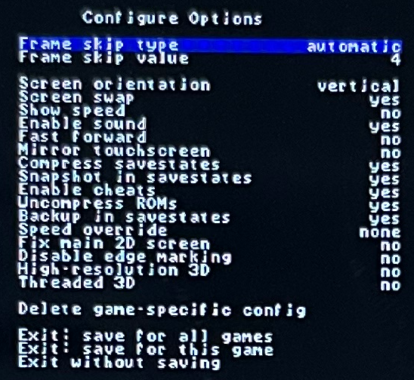
Hotkeys
Hotkey | Functionality
R2 | Swap screen
L2 | Change Keypad mode / Stylus mode
SELECT + R1 | Fast forward
SELECT + R2 | Quick save state
SELECT + L2 | Quick load state
SELECT + L1 | Exit DraStic emulator
SELECT + START | Enter the customized menu
In the customized menu
Hotkey | Functionality
UP / DOWN | Select item
LEFT / RIGHT | Change setting
B | Apply changes and then exit
In Keypad mode
Hotkey | Functionality
MENU | Enter DraStic’s menu
SELECT + Y | Change wallpaper
SELECT + A | Alternate display mode
In Stylus mode
Hotkey | Functionality
DPAD | Move the stylus pen
A | Touch screen
SELECT + Y | Change stylus pen
SELECT + UP | Show the stylus pen on screen 1
SELECT + DOWN | Show the stylus pen on screen 0

resources/settings.json
"pen":4, index of pen image
"theme":4, index of wallpaper image
"mode":5, display mode
"xv":10000, moving speed for x direction
"yv":12000, moving speed for y direction
"alpha":1, alpha level for small screen (only works on display mode 0 and 1)
"position":1, position for small screen (only works on display mode 0 and 1)
"border":1, border color for small screen (only works on display mode 0 and 1)
"maxcpu":1550, max cpu clock
"mincpu":500, min cpu clock
"touchpad":0, 0/1: show stylus pen on screen 0/1
"overlay":2, index of overlay image
"alt":2 alternative display mode

The Customized Menu
CPU: change the cpu clock
OVERLAY: change the overlay image (wallpaper will be disabled if overlay is enabled)
DISPLAY: change the display mode
ALPHA: change the alpha level for small screen (only works for display mode 0 and 1)
BORDER: change the border color for small screen (only works for display mode 0 and 1)
POSITION: change the position for small screen (only works for display mode 0 and 1)
ALT DISPLAY: change the alternative display mode
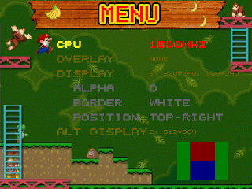
v1.3 (2023/09/30)
1. Improved audio performance.
2. Removed the audio feed and delay settings from resources/settings.json file.
3. Added ARM NEON instruction for nenon_memcpy() function for audio and video processing.
4. Added high resolution 3D support.
5. Added new background images for high resolution 3D mode. (images contributed from 河馬)
6. Added “book style” display mode.
7. Added new background images for “book style” mode. (images contributed from 河馬)
8. Added alpha settings for both 00 and 01 display modes.
9. Added the maximum CPU clock setting in resources/settings.json file.
10. Added adjustable position support for both 00 and 01 display modes.
11. Added adjustable position support for stylus pen (shows on screen 0 or screen 1).
https://github.com/steward-fu/archives/releases/download/miyoo-mini-plus/drastic-v1.3.zip

Hotkeys
Hotkey | Functionality
R2 | Swap screen
L2 | Change Keypad mode / Stylus mode
SELECT + X | CPU clock +50MHz
SELECT + B | CPU clock -50MHz
SELECT + START | Change display mode for normal resolution (13 modes)  00: 640x480, 170x128  01: 640x480, 256x192  02: 512x384 (bg_s0.png)  03: 640x480  04: 256x192, 256x192 (bg_v0.png)  05: 320x240, 320x240 (bg_v1.png)  06: 256x192, 256x192 (bg_h0.png)  07: 320x240, 320x240 (bg_h1.png)  08: 480x360, 160x120 (bg_vh_s0.png)  09: 384x288, 256x192 (bg_vh_s1.png)  10: 384x288, 256x192 (bg_vh_c0.png)  11: 384x288, 256x192 (bg_vh_c1.png)  12: 427x320, 427x320 (bg_hh0.png)  Change display mode for high resolution (2 modes)  13: 512x384 (bg_hres0.png)  14: 640x480
SELECT + R1 | Fast forward
SELECT + R2 | Quick save state
SELECT + L2 | Quick load state
SELECT + L1 | Exit DraStic emulator
Only work for small screen on 00 and 01 display mode
SELECT + UP | Alpha +1 (0 ~ 9 level)
SELECT + DOWN | Alpha -1 (0 ~ 9 level)
SELECT + LEFT | Change the position (top-left, top-right, bottom-left, bottom-right)
SELECT + RIGHT | Change the position (top-left, top-right, bottom-left, bottom-right)
SELECT + A | Change the border color  (none, white, red, green, blue, black, yellow, cyan)
Keypad Mode
Hotkey | Functionality
MENU | Enter DraStic’s menu
SELECT + Y | Change wallpaper
Stylus Mode
Hotkey | Functionality
DPAD | Move the stylus pen
A | Touch screen
SELECT + Y | Change image for stylus pen

Q & A
Q1. How to change the moving speed for stylus pen ?
A1: Change the xv and yv values in resources/settings.json file.
Speed for X position = time_cur – time_init / xv
Speed for Y position = time_cur – time_init / yv

Q2: How to change the initial CPU clock ?
A2: Change “./cpuclock 1500” to what you want. (1500 = 1500MHz = 1.5GHz)
For Miyoo Mini, the maximum CPU clock should be less than 1550MHz (experimental value)
For Miyoo Mini Plus, the maximum CPU clock should be <= 1850MHz (experimental value)

Q3: How to change the maximum CPU clock ?
A3: Change the maxcpu value in resources/settings.json file.

Q4: How to use the customized wallpaper (or background image) ?
Q4: All of wallpapers are put in resources/bg folder. User can replace the old ones or create the new folder for the new wallpapers.

Q5: How to use the customized stylus image.
A5: All of stylus images are put in resources/pen folder. The touch point is set by checking suffix file name. For example, the file name of 1_lt.png means the touch point is at left-top (_lt) and 2_lb.png means the touch point is at left-bottom (_lb) and so on. User can replace the old ones or create the new image for stylus pen. Here are all of supported positions:
xxx_lb.png: left-bottom
xxx_lt.png: left-top
xxx_rb.png: right-bottom
xxx_rt.png: right-top

Q6: How to use the customized logo shown on DraStic’s menu ?
A6: Replace the images in resources/logo folder. The resolution must be at 400x150 resolution.

Q7: How to use the customized digital images for digital display ?
A7: Replace the images in resources/digit folder. The image resolution will be checked automatically when loading it.

Q8: How to change the stylus pen to show on the another screen ?
A8: Change the value of touchpad in resources/settings.json file. 0: show the stylus pen on bottom screen, 1: show the stylus pen on top screen.

Q9: How to enable high resolution 3D mode ?
A9: Turn on “Hight-resolution 3D” and “Threaded 3D” settings on DraStic’s menu.

v1.2 (2023/09/25)
1. Added both audio feed and audio delay settings for user to fine-tune in resources/settings.json file.
2. Fine-tuned audio latency by setting feed=768 and delay=1000 in resources/settings.json file.
https://github.com/steward-fu/archives/releases/download/miyoo-mini-plus/drastic-v1.2.zip

While DraStic emulator is processing frameskip, no any audio data is feeded into our customized alsa library but we still need to provide dummy audio data to SSD202D’s audio driver (even though DraStic emulator doesn’t provide it to our alsa library) to avoid noising. Therefore, in gerneal, we delay an audio frame for such situation. In our customized alsa library, we set BUFFER as 8192 bytes and FREQUENCY as 44100, which is also the default settings in DraStic emulator. Honestly, these setting values are trade-off configuration because of frameskip and now it is time to customize by user.

BUFFER: 8192
FREQUENCY: 44100
audio frame delay = (((BUFFER * 1000) / FREQUENCY) - 10) * 1000 = 175759us

In resources/settings.json file, we set them as the following new values after try-and-error testing:
feed: 768 bytes
delay: 1000 us
It means we feed 768 bytes (dummy data) into SSD202D’s audio driver and then delay 1ms when DraStic is doing frameskip. In version v1.1, we set the feed as 8192 and the delay as 175759, which means feed 8192 bytes into SSD202D’s audio driver and then delay ~176ms.

For example, user can also reconfigure these values as:
feed: 0 bytes
delay: 0 us
It means we always wait for the next audio data coming from DraStic emulator without any delay.
P.S. if (feed < 0) or (delay < 0), we use the default settings (feed=768, delay=1000)

v1.1 (2023/09/24)
1. Fixed background pop noise. (happened every second)
2. Set frameskip value as 4 in order to improve latency issue. (DraStic’s default value)
https://github.com/steward-fu/archives/releases/download/miyoo-mini-plus/drastic-v1.1.zip

v1.0 (2023/09/23)
1. Improved sound performance.
2. Built-in 13 display modes. (images contributed from 河馬)
3. Built-in 4 customized wallpapers. (images contributed from 河馬)
4. Built-in 6 customized images for stylus pens.
5. Built-in overclock functionality.
6. Customized the direction for stylus pen.
7. Customized the movement speed for stylus pen.
8. Customized the DraStic logo. (images contributed from 河馬)
9. Fine-tuned swap ration in launch.sh file.
10. Removed swap file (ram.img) because the system has cachefile already.
https://github.com/steward-fu/archives/releases/download/miyoo-mini-plus/drastic-v1.0.zip

Display Mode (SELECT + START)
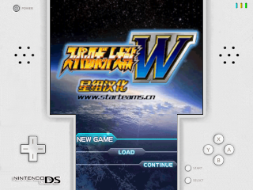
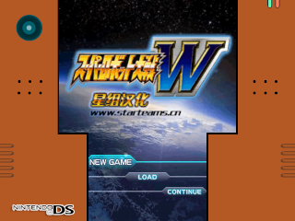
Wallpaper (SELECT + Y)

Overclock (SELECT + X: +50MHz, SELECT + B: -50MHz)
The initial CPU clock is set in launch.sh file.
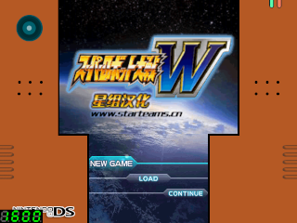
DraStic logo
400x150 pixels (in resources/logo/ folder)
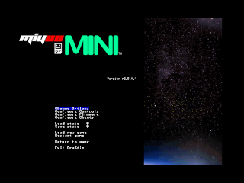
Stylus pen (L2: change to stylus mode/dpad mode, SELECT + Y: change image for stylus pen)
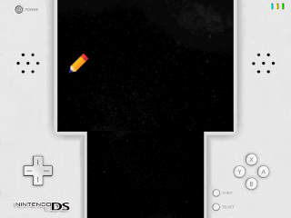
The moving speed is set in resources/settings.json file. SPEED = time_cur – time_init / (xv, yv)


xxx_lt.png (_lt: Left-Top)
The touch point is located at left-top.


xxx_lb.png (_lb: Left-Bottom)
The touch point is located at left-bottom.


xxx_rt.png (_rt: Right-Top)
The touch point is located at right-top.

xxx_rb.png (_rt: Right-Bottom)
The touch point is located at right-bottom.

Hotkey (in dpad mode) | Functionality
R2 | Swap screen
L2 | Change stylus mode / dpad mode
SELECT + X | CPU clock +50MHz
SELECT + B | CPU clock -50MHz
SELECT + Y | Change wallpaper
SELECT + START | Change display mode

Hotkey (in stylus mode) | Functionality
L2 | Change stylus mode / dpad mode
DPAD | Move the stylus pen
A | Touch screen
SELECT + Y | Change image for stylus pen

RC4 (2023/09/11)
1. Improved the sound performance.
https://github.com/steward-fu/archives/releases/download/miyoo-mini-plus/drastic_rc4.zip

RC3 (2023/09/11)
1. Fixed the last button user pressed will be reported again when VOL-/VOL+ is pressed.
2. Fixed the issue of 1.5 times speed by setting the frameskip to 2 (4 by default).
3. Fine-tuned the sound library.
https://github.com/steward-fu/archives/releases/download/miyoo-mini-plus/drastic_rc3.zip

RC2 (2023/09/10)
1. Added "noaudiofix: 1" option in config.json for Stock system
2. Added "stop_audioserver.sh" command in launch.sh for Onion system
https://github.com/steward-fu/archives/releases/download/miyoo-mini-plus/drastic_rc2.zip

RC1 (2023/09/10)
1. Implemented the customized version of alsa library for DraStic emulator.
2. User can change the background image:
bg_s.png: background image for single screen (without stretch mode)
bg_v.png: background image for vertical screen (without stretch mode)
bg_h.png: background image for horizontal screen (without stretch mode)
bg_vh.png: background image for vertial/horizontal screen (with stretch mode)
3. User can change the image of stylus pen:
pen.png: stylus image (no matter what WxH size you use, 32x32, 64x128 are all fine)
4. User can change the stretch mode by pressing SELECT+START
5. User can swap the screen by pressing R2
6. User can use stylus pen by pressing L2
In this mode, only the buttons of L2, D-PAD and A work.
User need back to D-PAD mode by pressing L2 again.
https://github.com/steward-fu/archives/releases/download/miyoo-mini-plus/drastic_rc1.zip

