In this tutorial we will create a simple class and display the data in a ListView.

1. Create a new WPF project,

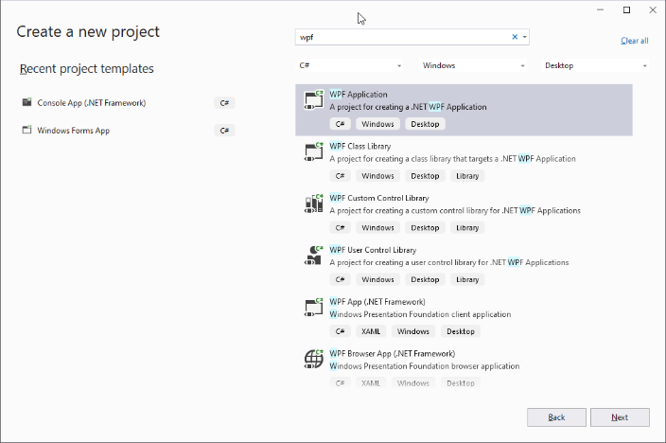

1. Type in the project name and select the Framework.

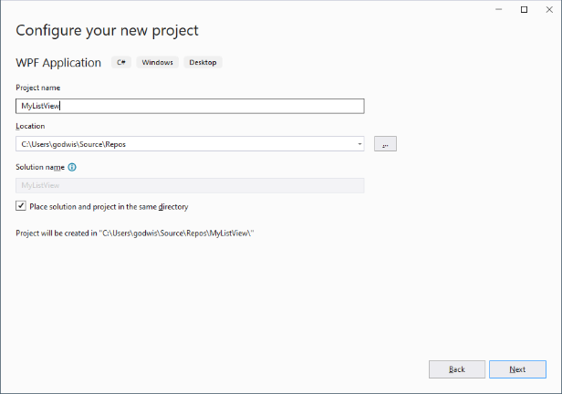 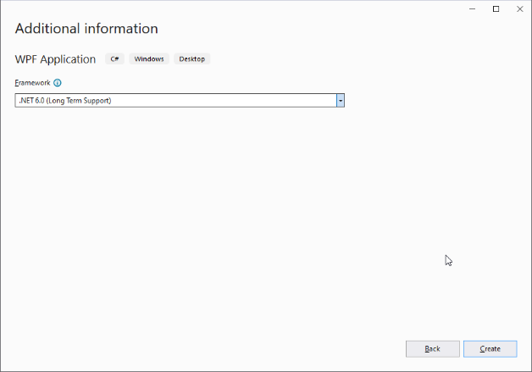

1. Add several TextBoxes and one ListView to the MainWindow.

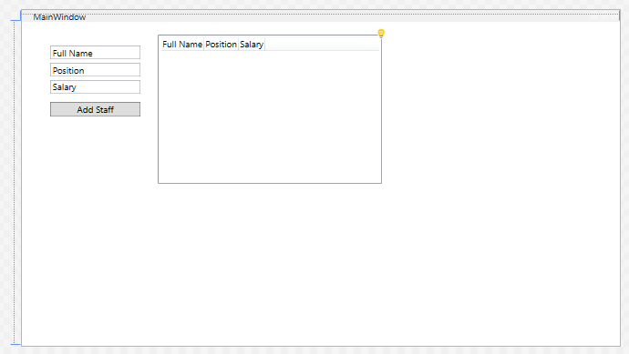

This is the XAML code

<Window x:Class="MyListView.MainWindow"

xmlns="http://schemas.microsoft.com/winfx/2006/xaml/presentation"

xmlns:x="http://schemas.microsoft.com/winfx/2006/xaml"

xmlns:d="http://schemas.microsoft.com/expression/blend/2008"

xmlns:mc="http://schemas.openxmlformats.org/markup-compatibility/2006"

xmlns:local="clr-namespace:MyListView"

mc:Ignorable="d"

Title="MainWindow" Height="450" Width="800">

<Grid Margin="0,0,0,0">

<TextBox x:Name="FullName" HorizontalAlignment="Left"

Margin="38,32,0,0" TextWrapping="Wrap"

Text="Full Name" VerticalAlignment="Top" Width="120"/>

<TextBox x:Name="Position" HorizontalAlignment="Left"

Margin="38,55,0,0" TextWrapping="Wrap" VerticalAlignment="Top"

Text="Position" Width="120"/>

<TextBox x:Name="Salary" HorizontalAlignment="Left"

Margin="38,78,0,0" TextWrapping="Wrap"

Text="Salary" VerticalAlignment="Top" Width="120"/>

<ListView x:Name="DisplayStaff" Width="300" Height="200" Margin="182,17,318,217" >

<ListView.View>

<GridView>

<GridViewColumn Header="Full Name" DisplayMemberBinding= "{Binding StaffName}" />

<GridViewColumn Header="Position" DisplayMemberBinding="{Binding StaffPosition}"/>

<GridViewColumn Header="Salary" DisplayMemberBinding="{Binding StaffSalary}" />

</GridView>

</ListView.View>

</ListView>

<Button x:Name="AddStaff" Content="Add Staff" HorizontalAlignment="Left"

Margin="38,107,0,0" VerticalAlignment="Top" Width="120"/>

</Grid>

</Window>

1. Add the following class called StaffDetails.cs

namespace MyListView

{

internal class StaffDetails

{

private string _fullName;

private string _position;

private int _salary;

public string GetName()

{

return _fullName;

}

public void SetFullName(string fullName)

{

_fullName = fullName;

}

public string GetPosition()

{

return _position;

}

public void SetPosition(string position)

{

_position = position;

}

public int GetSalary()

{

return _salary;

}

public void SetSalay(int salary)

{

_salary = salary;

}

}

}

1. Add the following logic code to the MainWindow.xaml.cs file

Add a MousePreviewDown event on the button and a Queue<T> for the drone

namespace MyListView

{

/// <summary>

/// Interaction logic for MainWindow.xaml

/// </summary>

public partial class MainWindow : Window

{

public MainWindow()

{

InitializeComponent();

}

Queue<StaffDetails> QueueStaff = new Queue<StaffDetails>();

private void AddStaff_PreviewMouseDown(object sender, MouseButtonEventArgs e)

{

if(!string.IsNullOrEmpty(FullName.Text) &&

!string.IsNullOrEmpty(Position.Text) &&

!string.IsNullOrEmpty(Salary.Text))

{

StaffDetails staffDetails = new StaffDetails();

staffDetails.SetFullName(FullName.Text);

staffDetails.SetPosition(Position.Text);

staffDetails.SetSalay(int.Parse(Salary.Text));

QueueStaff.Enqueue(staffDetails);

DisplayAllStaff();

ClearTextBoxes();

}

}

private void DisplayAllStaff()

{

ListViewDisplayStaff.Items.Clear();

foreach(StaffDetails staff in QueueStaff)

{

ListViewDisplayStaff.Items.Add(new

{

StaffName = staff.GetName(),

StaffPosition = staff.GetPosition(),

StaffSalary = staff.GetSalary()

});

}

}

private void ClearTextBoxes()

{

FullName.Clear();

Position.Clear();

Salary.Clear();

}

}

}

IMPORTANT This is not fully error trapped!