Hxecom Linux Setup Guide
Version 0.90
August 23, 2005

This document is useful for configuring hxecom on Linux machines. It also helps in knowing basic errors of hxecom and common tasks and configurations needed for stressing and then debugging the errors of the network interface cards.

Sahul Hameed Majid
Document Owner
Dept E38
IBM, India software Labs
Table of Contents
1 About Hxecom 2
1.1 What is hxecom? 2
1.2 What is rules file of hxecom? 3
1.3 How to run hxecom in stand alone mode? 3
1.4 Common Terms in hxecom Test 4
1.4.1 Testnet : 4
1.4.2 Comnet: 4
1.4.3 Types of Hxecom Setups: 4
2 Hxecom Test Configuration 5
2.1 Multi System Test Configuration 5
2.1.1 Multi System Test Setup 5
2.1.2 Figure for Multi System Understanding 5
2.1.3 Multi System Test Configuration at test1.austin.ibm.com 6
2.1.4 Multi System Test Configuration at test2.austin.ibm.com 8
2.2 Multisystem test (more than two system) 8
2.2.1 Setup 8
2.2.2 Configuration 8
2.3 Multi System Single Adapter Test configuration 9
2.3.1 Test Setup 9
2.3.2 Figure for Multi System Single Adapter Understanding 9
2.3.3 Configuration for test1.austin.ibm.com. 10
2.3.4 Configuration for test2.austin.ibm.com 11
2.4 Single System Test 11
2.4.1 Test Setup 11
2.4.2 Figure for Single System Test 11
2.4.3 Phantom (Virtual) IP Addresses 12
2.4.4 Configuration for test.austin.ibm.com 13
3 FAQ 13
3.1 What is checklist to start hxecom test? 13
3.2 Why is hxecom erring out as hung? 14
3.3 What is hxecom miscompare error? 14
3.4 Enable trap to KDB on hxecom miscompare 15
3.5 Read failed and IO_ALARM_TIME timed out error 16
3.6 Write failed – Broken pipe error 16

About Hxecom

What is hxecom?
Hxecom is a network card stress exerciser. It sends TCP/IP packets across network cards under test and compares the received packet with the expected. It reports miscompare if they don’t match. It comes as binary in HTX package. The hxecom is run for each card under stress with its parameters. It also includes support scripts like build_net to configure network before the start of the test. In HTX Linux when you type ‘htx’ after ‘su – htx’ build_net will be run first and it asks about hxecom configuration.

What is rules file of hxecom?
Each interface has a rules file if it is configured for hxecom test.
The rules file gives the parameter with which the hxecom should test the interface.
Pattern file is one of the important parameter, default pattern is present in the file ‘default’ as the following line.
PATTERN_ID=HEX255.
If you want to change the pattern for testing you have to change the above line in the ‘/usr/lpp/htx/rules/reg/hxecom/default’ file.

The pattern files are normally present in ‘/usr/lpp/htx/pattern’ directory.

Note: All brownish red text and in < > is explanation comment for your understanding.

The following is the default rules file for hxecom test:
RULE_ID=00000000
PATTERN_ID=HEX255 < Pattern file, the pattern (data) in it is used as data by test network to transfer and compare >
COMNET_NAME=comnetXX < Communications Network for Acknowledgements and other communication. >
TESTNET_NAME=testnetXX < Name of the network between the cards in test. >
BUFMIN=5000 < Starting size of buffer (which is the minimum) >
BUFMAX=5000 < Maximum size of buffer after which again it starts from minimum >
BUFINC=1 < Increment for next packet data size >
MASTER=Y
LAYER=TCP < Uses TCP sockets for test network send and receive >
IO_ALARM_TIME=300 < Read operation time out.>
SHUTDOWN_FLAGS=0x0000 < These flags define how hxecom should respond for various conditions like “trap to HTX on miscompare”>
WRITE_SLEEP=0 < sleep time between consecutive writes in milliseconds >
REPLICATES=1 < Number of readers and writers. >
NUM_OPER=1000

How to run hxecom in stand alone mode?
Stand alone mode is running hxecom exerciser alone without HTX supervisor and other exerciser.
The general format for stand alone run of hxecom is :
hxecom /dev/<device name> OTH <rules file>

Take the following example of the stand alone run
hxecom /dev/eth1 OTH /usr/lpp/htx/rules/reg/hxecom/101net
OTH represents stand alone mode. It has to be run for each interface separately.

Common Terms in hxecom Test

Testnet :
The name of the network between the cards under the test. It is like 101net , 102net , 200net , etc., You will understand more when you see the actual configuration in the coming sections.

Comnet:
The name of the network used for other pre-test protocol, configurations and acknowledgements. In short all communication other than test packets go through comnet network. Normally comnet is IBM network interface which has default gateway to reach any IBM machine. If the machine is in isolated network then you have to create a network IP for one card which is accessible to all other machines in multi system hxecom test.
Note: If a card is not to be tested on hxecom it should be configured with ‘none’.

Types of Hxecom Setups:
There are two types of hxecom setups multi system and single system.
Multi system can be further classified into three discussed below.

Multi System
In Multi System as the name suggests the network test (hxecom) is run between more than one system.

Single Adapter Test
If the system involved in the test has only one network interface card then it is called single adapter multisystem system test.

Multi System (Two system)
This is typical multisystem test configuration. There are only 2 systems involved in the network test (hxecom).

Multi System (more than two systems)
In this configuration there are more than two systems involved in the network test.

Single System
The network test involves only one system then it is called single system test. The cards on the machine are connected in a network through a switch or direct cable to form the test network.

For more information you can refer configuration topics for each in the next chapter (2).

Hxecom Test Configuration

Multi System Test Configuration

Multi System Test Setup

In Multi System test we run hxecom between 2 systems (or more).

Consider the example where we want to run hxecom along with all other exercisers between test1.austin.ibm.com and test2.austin.ibm.com.

test1.austin.ibm.com test2.austin.ibm.com
Comnet (IBM) eth0 (9.3.50.149) ----- eth0 (9.3.50.159)
Testnet(101) eth1 (101.1.2.149) <-> eth2 (101.1.2.159)
Testnet(102) eth2 (102.1.2.149) <-> eth1 (101.1.2.159)
Not in test (none) eth3 eth3

We can see that eth3 are on both machines are not in test and eth1 and eth2 and vice versa are connected.

The interfaces are connected through direct cables or through a hub. The interfaces should be ping able after the test configures the IP addresses for them. If the interfaces are not ping able then there is some connection problem, please check the connections.

Figure for Multi System Understanding
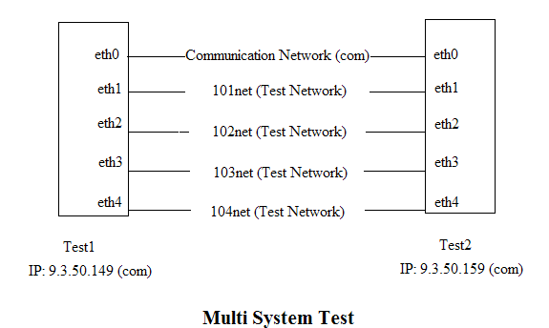

Multi System Test Configuration at test1.austin.ibm.com
Below description takes you through the step by step process for configuring mutisystem test.
All blue color text is user input (which we have to enter).
All brownish red text and in < > is explanation comment for your understanding.
All black text is system output text.

[htx@] /usr/lpp/htx# htx
do you want to build network for hxecom (y/N)?
y <type y to configure the hxecom test>

Is this a one system test? y or n
n <If you running single system test type y or else type n>

Are you using the site network for comnet? y or n
y <Enter ‘n’ to configure the communication network. Normally it is
already configured for IBM network >

Is the machine already configured on the site network? y or n
y

System says host name is ts4.austin.ibm.com. Is this correct? y or n
y

Your comnet ip address is 9.3.50.149
Your host id is set to 149
What are the hostnames or ip addresses of the other systems in this test .
Enter like this: tuscanyp04:tuscanyp05 or 9.3.242.4:9.3.242.5
Max of 8 systems
test2.austin.ibm.com <Give the name of the machine with which u want to start the test
you can even give its ip address as well. If more than two machines are under test give their names or ip addresses separated by ‘:’ as shown in the example given above>

What stresslevel do you want? 1.....5
1 <stress level increases the packet size and number of readers and writers for testing the network>

Bond device not present
would you like to configure bond device? y or n
n
no bonding device will be used

...............................Found eth0 in location dummy
Enter the network id, 100...220.
Or 'com' for comlink.
Or 'none' if network adapter is not in test.
....com <The interface is on the IBM network or local network>
Your comnet ip address is 9.3.50.149
PROF: eth0 com

...............................Found eth1 in location dummy
Enter the network id, 100...220.
Or 'com' for comlink.
Or 'none' if network adapter is not in test.
....101 < Interface eth1 is in 101 test network >

...............................Found eth2 in location dummy
Enter the network id, 100...220.
Or 'com' for comlink.
Or 'none' if network adapter is not in test.
....102 < Interface eth2 is in 102 test network >

...............................Found eth3 in location dummy
Enter the network id, 100...220.
Or 'com' for comlink.
Or 'none' if network adapter is not in test.
....none < eth3 interface is not in test>
net_count:2
PROF: eth2 102
PROF: eth1 101
COMNET eth0 already configured.
Configure the eth1 network... rule 101net
hostname 101net149
do you want to append mdt.net to any mdt (y/N)?
y <If you want to run hxecom with all other exercisers you have to append by saying ‘y’ here. If you want to run hxecom test alone or other exercisers alone without hxecom enter ‘n’ >

Which mdt file should I add net.mdt to?
mdt mdt.all mdt.kas mdt.loopback net.default
>>mdt.all <We append hxecom test stanza in net.mdt to mdt.all file >

Adding 1 devices to mdt
Open /usr/lpp/htx/mdt/mdt.all to insert the new lines
Done OK
/usr/lpp/htx/mdt
mdt mdt.all mdt.kas mdt.loopback mdt_net net.default net.mdt
Enter the desired mdt test file to copy to "mdt".
mdt.all <We are running test for all devices along with hxecom (net device) by inputing ‘mdt.all’ . If you want to run hxecom(net device) test alone input ‘net.mdt’ .
Present key board input is main input file to HTX. It starts test for all the devices which have stanzas in this file (mdt.all). We appended hxecom (net device) stanzas to mdt.all in earlier step. The mdt.all file has all devices except net devices (hxecom) by default. >

Do you want to run save.default, which formats and compresses log files (y)?
y

Multi System Test Configuration at test2.austin.ibm.com

Similarly we can configure for test machine 2 (test2.austin.ibm.com). We enter ‘test1.austin.ibm.com’ as input for other systems in test and enter corresponding test network id for interfaces.
For test2.austin.ibm.com eth1 = 102 test network,
eth2 = 101 test network,
And eth3 = none (not in test).

Multisystem test (more than two system)

Setup
More than 2 systems are involved in this test. Each card on a system is involved in test with other cards of other systems.

Consider the following example:
System1 , System2 and System3 are involved in hxecom Multisystem test.

test1 test2 test3

Comnet (IBM) eth0 (9.45.78.1) ----- eth0 (9.45.78.2) ------ eth0 (9.45.78.3)
Testnet(101) eth1 (101.1.2.1) <-> eth1 (101.1.2.2) <-> eth1 (101.1.2.3)

So hxecom is run among the network cards configured with 101 network.

Configuration
The configuration is similar to Multi system test except for the case of
“for other systems in test”
we enter ‘test2.austin.ibm.com:test3.austin.ibm.com’ as input for test1.austin.ibm.com.
Similarly ‘test1.austin.ibm.com:test3.austin.ibm.com’ as input for test2.austin.ibm.com.
And ‘test1.austin.ibm.com:test2.austin.ibm.com’ as input for test3.austin.ibm.com.

Multi System Single Adapter Test configuration

Test Setup

In Multi System single adapter test there is only one adapter on each system and we run hxecom between 2 systems (or more).

Consider the example where we want to run hxecom along with all other exercisers between test1.austin.ibm.com and test2.austin.ibm.com.

test1 test2
Testnet(101) eth0 (101.1.2.50) <-> eth0 (101.1.2.100)
<9.1.2.50> <9.1.2.100>

The original IP addresses of eth0 are displayed in brownish red color above

Note: In single adapter test we have to run the test from console. So we can’t telnet or SSH to the test machine.

The interfaces are connected through direct cables or through a hub. The interfaces should be pingable after the test configures the IP addresses for them. If the interfaces are not pingable then there is some connection problem , user has to check the connections.

Figure for Multi System Single Adapter Understanding
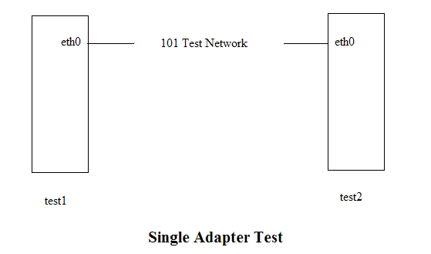

Configuration for test1.austin.ibm.com.

All blue color text is user input (which we have to enter).
All brownish red text and in < > is explanation comment for your understanding.
All black text is system output text.

# htx
do you want to build network for hxecom (y/N)?
y

There is only One card on system.
After configure Hxecom you will lose network to system,
Run HTX from console.
What is the last nibble of this hosts ip address.1...254
This is the host id of this system.50 <This is the host identifier for hxecom. Usually it is last nibble of it IP address. In this case 9.1.2.50.The script will detect there is only one network interface in the system and it will also ask you to run from console>

what are the ip addresses of the other systems in this test .
Enter like this: 1.2.3.45.
( Only the last nibble in this case 45 is only significant. Then the System's IP will be 45.1.2.<TESTNET>.)
9.1.2.100

What stresslevel do you want? 1.....5
1

Bond device not present
would you like to configure bond device? y or n
n
no bonding device will be used

...............................Found eth1 in location dummy
Enter the network id, 100...220.
Or 'com' for comlink.
Or 'none' if network adapter is not in test.
....101
net_count:0
PROF: eth1 101
Configure the eth1 network... rule 101net
hostname 101net50

<And the rest is similar to multisystem test setup>

Configuration for test2.austin.ibm.com
The configuration is similar to test1.austin.ibm.com except that in the above configuration instead of 50 we have to give 100 the last nibble of test2.austin.ibm.com’s ip address (9.1.2.100) and the other system id’s IP address as 9.1.2.50.

Single System Test

Test Setup
In single system test as the name suggests we have one system involved in the test. We run hxecom (network exercisers) between the interfaces of the same machine.
Consider for example we want to run single system test on test.austin.ibm.com between eth1 and eth2.
test1 Phantom IP address
Comnet (IBM) eth0 (9.3.50.149) -
Testnet(101) eth1 (101.1.2.1) 101.1.2.2
Testnet(101) eth2 (101.1.3.1) 101.1.3.2
Not in test eth3 -

In this case eth1 and eth2 interfaces are connected across so as to form a network.
In Linux to enable communication between cards on the same system we use the ip_crossover module. So the single system hxecom test is dependent on ip_crossover kernel module where as multisystem is not. There is a limitation of EEH injection while ip_crossover is loaded (i.e., single system). Please use multi system test to test EEH injection and recovery.

Figure for Single System Test

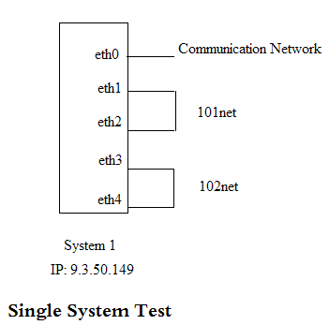

Phantom (Virtual) IP Addresses

To explain Phantom IP address created by ip_crossover module to enable single system hxecom test consider the following example:

On the system eth0-eth1 and eth2-eth3 are being put in single system test.
The ip_crossover module is loaded with eth0 and eth1 as parameter.
It creates 2 phantom ip addresses for each interface like
eth0 (156.1.1.1) Phantom IP : 156.1.1.2
eth1 (156.1.2.1) Phantom IP : 156.1.2.2
You can observe that phantom (or virtual) IP address is just 1 increment of the last octet in the original IP address.
Phantom IP of eth0 (156.1.1.2) is gateway for any packet coming out of eth0 (156.1.1.1) which will reach eth1. And similarly phantom IP of eth1 (156.1.2.2) is default gateway for any packet coming out of eth1 (156.1.2.1) which will reach eth0.

The packet is carried across from Phantom IP (156.1.1.2) to Phantom IP (156.1.2.2) and vice versa by the ip_crossover.ko kernel module.

And similarly for the pair eth2 and eth3.

Important Point to Note:
- To test the ping across the cards in single system we have to ping the phantom IP address of the respective cards. Example: ping –I eth0 156.1.1.2 , we are trying to ping the phantom IP of eth0 (which connects to Phantom IP of eth1) from eth0 interface. Similarly ping –I eth1 156.1.2.2.

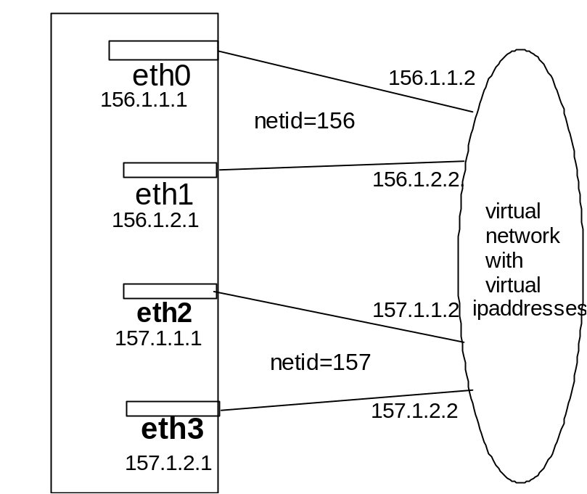

Configuration for test.austin.ibm.com

#htx
do you want to build network for hxecom (y/N)?
y
Is this a one system test? y or n
y <for single system test we have to enter ‘y’ . If ‘n’ it is Multi System Test>
What stresslevel do you want? 1.....5
1

If Interface Ipaddress is 192.168.1.2 then
netid will be 192
netid should be between 100 and 220
Please enter the CLASS C net id for pair of cards.
101

Choose 2 of the following ethernet cards
eth1
eth2
eth3

Give the name of the 1st Ethernet Card :eth1
Give the name of the 2nd Ethernet Card :eth2
No more pairs left.

<Similarly for other cards if there are more>

<Rest of the test is similar to multi system test . Refer Multi System Test setup.>

FAQ

What is checklist to start hxecom test?
The following is the checklist for proper start of hxecom test:

- Make proper connections between cards you intend to run the test between. You can directly connect the cables between the cards or you can connect through a hub.
- Make sure com network (communication network) is configured proper IP address and proper host name is assigned to the system if you running multi system test.
- Make sure there are proper entries in /etc/hosts file. The hostname should have proper functional IP address assigned. This is important for multisystem.
- Check for proper net mask and broad cast address for the comnet. It should be same as the other machine’s comnet.
- Configure the hxecom to start test between cards you intend to run. Refer to the configuration of various types of hxecom test in the section 2. This is done when you type ‘htx’ after ‘su – htx’ command in Linux.
- Try pinging across the test network cards as the test IP address are already assigned to the interfaces. If it does not ping please recheck your cable connections. At HTX menu choose option ’11’ to come to the command prompt for checking the ping.
- If it is pinging you can start the test in the HTX menu by opting choice ‘1’.

Note:
Please check with the limitations page of HTX before opening a defect.

Why is hxecom erring out as hung?
Normally most of the hangs turn out to be hxecom setup issue or connection issue.
In many cases there are no cycle count and hxecom errors out after some time as hung with errors as shown below.

htx_messages Jun 30 18:53:12 2005 err=00000000 sev=4 hang_monitor
hxecom for eth1 is HUNG!
Max run time (set in mdt) = 7200 seconds.
Current elasped time = 7260 seconds.

htx_messages Jun 30 18:53:12 2005 err=00000000 sev=4 hang_monitor
hxecom for eth2 is HUNG!
Max run time (set in mdt) = 7200 seconds.
Current elasped time = 7260 seconds.

This is normally setup issue or improper connections. After checking the connections restart the test with proper configuration. Even then if the test gives the same error then open a defect for further debug to conclude if it is a hardware or a software problem.

What is hxecom miscompare error?
This is highest form of error for hxecom exerciser. If the received packet data is different from what is expected then hxecom gives a miscompare error.
It looks like the following:

/dev/eth1 Nov 30 12:31:13 2001 err=00e30000 sev=4 hxecom
R(201.1.1.118.33097) connected to W(201.1.1.16.33018)
Miscompare with packet 1, data size = 20000.
Miscompare at displacement (decimal) = 13996
wbuf = d9dadbdbe1e2e3e4e5e6e7e8e9eaebecedeeeff0
rbuf = 303032000092010203040506070809000b0c0d0e

As you can see it is dumping read buffer(rbuf) and write buffer(wbuf) from the miscompare point
(displacement).
And the exerciser will exit with error flag = 1.

The following are the files used in debug:
- /tmp/htxcom.config file lists the machines (by TCP/IP address) with which it transferred data
- Read and write buffer files of hxecom useful at times of miscompare are of the format;
/tmp/htx*.wbuf* and /tmp/htx*.rbuf*

Action Needed:
5 steps to debugging CRASHES on miscompare.
NOTE: There is nothing that can be done to debug this problem from the
kdb session produced when hxecom crashes the system. It just crashes the system so you can't ignore a potentially serious problem for our customers.
So you can power the system and begin the debugging steps yourself right now.
No need to wait for someone to look at the KDB.
If it took longer than 24 hours for this error to occur you may want to consider replacing both cards in the network test and going straight to step 4 first, or this will take you a long time.
1. First rerun the trial to make sure it reproduces. At this point you should let the defect owner take a look to see if this is a duplicate of some known miscompare problem.
2. If it still fails replace one of the adapters in that network and rerun the trial to see if it reproduces. If the trial passes mark the adapter bad and return it to IO development for analysis.
3. If it still fails replace the other adapter in the network and rerun the trial to see if it reproduces. If the trial passes mark the adapter bad and return it to IO development for analysis.
4. If it still fails move both cards to another slot and change cable. If the trial passes then the problem is in the slots and system development needs to be involved.
5. If it still fails comment your defect with what you have already done and the defect owner will take over your machine to debug the problem from this point unless it is a dup of another defect.

Enable trap to KDB on hxecom miscompare
To enable/disable trap to KDB on hxecom miscompare we have to edit the line
SHUTDOWN_FLAGS=0x0000 to make the flags = 0x1000 in the file
‘/usr/lpp/htx/rules/reg/hxecom/default’

Read failed and IO_ALARM_TIME timed out error
This is reader timeout error. The timeout value of 900 seconds was exceeded and we don’t have any activity on the reader side. So the exerciser’s reader is giving an error and it is exiting with error flag = 2.

/dev/eth3 Apr 11 15:13:43 2005 err=00da0004 sev=4 hxecom
R(200.1.2.128.32816) connected to W(200.1.2.127.32807)
2. Read failed - Interrupted system call.
IO_ALARM_TIME = 900 seconds was exceeded.
Resetting writer to i=528, bsize=20000, timestamp=1, pak=528.
For stanza 0, TCP connection, bufmin=20000, bufmax=20000, bufinc=1
Consecutive prior good reads= 72582528, good bytes read= 1452521550336

/dev/eth3 Apr 11 15:13:43 2005 err=00d80000 sev=4 hxecom
Shutting down testing due to error flag - 2
R(200.1.2.128.32816) connected to W(200.1.2.127.32807)
For stanza 0, TCP connection, bufmin=20000, bufmax=20000, bufinc=1
Consecutive prior good reads= 0, good bytes read= 0

This error could be because the connection is not reachable for long time. It happens when network is down it can be for various reasons like hub is not functional, heavy congestion, loose cabling, I/O bus errors, card error , slot error or driver problem.

Write failed – Broken pipe error
This is a writer side error. This happens when a writer gets a broken pipe error and find that the network is no longer ping able it errors out with the following error.

/dev/eth1 Mar 21 14:55:12 2005 err=01040020 sev=1 hxecom
W(100.1.2.16.32807) connected to R(100.1.2.251.32811)
Write failed - Broken pipe.
Connection will no longer ping, its locked! Exiting
For stanza 0, TCP connection, bufmin=10, bufmax=9000, bufinc=1001
Consecutive prior good writes= 2615411, good bytes written= 10526964008

It also happens when network is down it can be for various reasons like hub is not functional, heavy congestion, loose cabling, I/O bus errors, card error , slot error or driver problem.

Action needed:
Here is standard way to debug broken pipes:
5 steps to debugging broken pipes with hxecom.
If it took longer than 24 hours for this broken pipe to occur you may
want to consider replacing both cards and going straight to step 4 first or this will take you a long time.
1. First rerun the trial to make sure it reproduces.
2. If it still fails replace one of the adapters in that network and rerun the trial to see if it reproduces. If the trial passes mark the adapter bad and return it to IO development for analysis.
3. If it still fails replace the other adapter in the network and rerun the trial to see if it reproduces. If the trial passes mark the adapter bad and return it to IO development for analysis.
4. If it still fails move both cards to another slot and change cable. If the trial passes then the problem is in the slots and system development needs to be involved.
5. If it still fails comment your defect with what you have already done and the defect owner will take over your machine to debug the problem from this point.

There is absolutely nothing that hxecom can tell you about the cause of this broken pipe. Hxecom is a user level exerciser, it just tells the socket interface to write and read data. On broken pipe messages the only error code returned to me is "broken pipe".
This can happen if card locks up after EEH hit, or pci slot locks up, or pci bus or bridge chip locks up, or device driver leaks all its memory away of messes up hit stack of pointers and on and on and on.

