ASSIGNMENT 4

Stewart Wilson

2022-04-22

# Markdown Basics

## Favorite Foods

1. Ramen
2. Thai Curry
3. Seitan

## Images

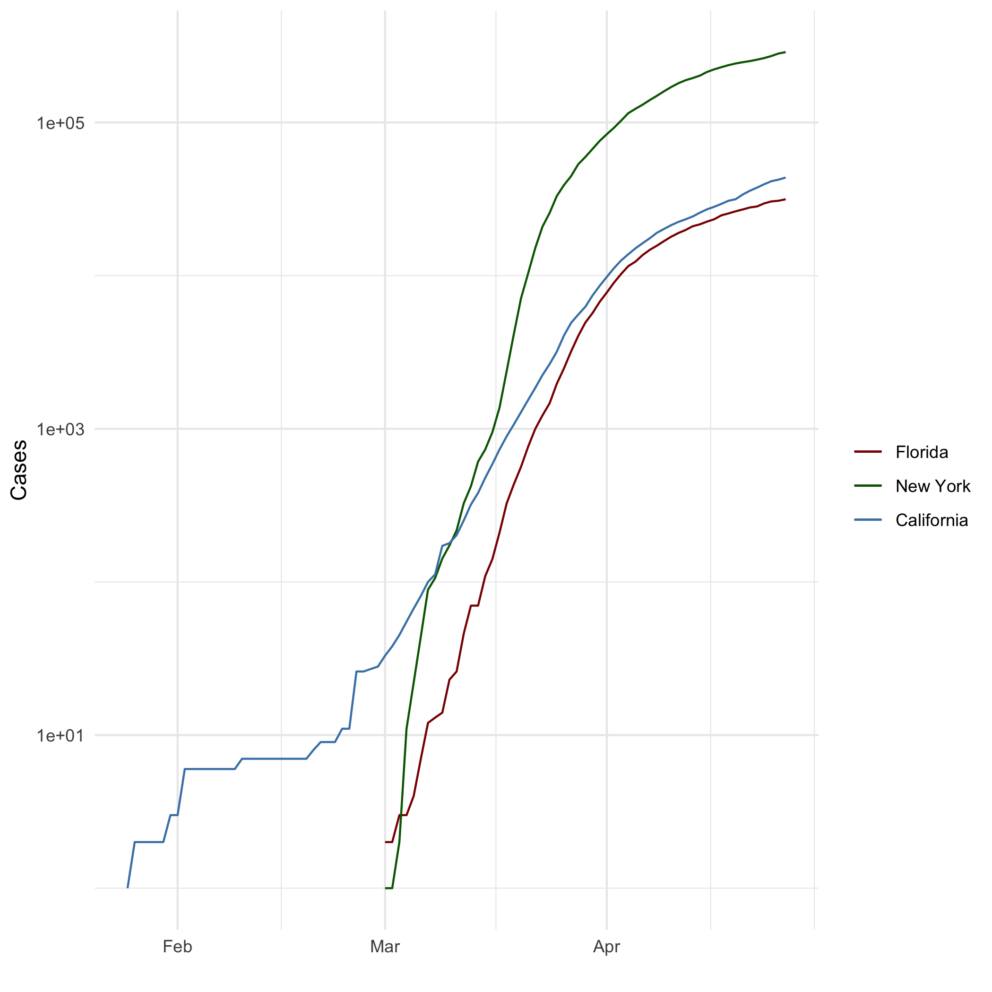

All Cases (Log Plot)

## Add a Quote

Whoever fights monsters should see to it that in the process he does not become a monster. And if you gaze long enough into an abyss, the abyss will gaze back into you.

-Nietzsche

## Add an Equation

$c^{2}=a^{2}+b^{2}$

## Add a Footnote

Look it’s a footnote![1]

## Add Citations

* R for Everyone (Lander2014)
* Discovering Statistics Using R (Field, Miles, and Field 2012)

# Inline Code

library(ggplot2)  
heights_df <- read.csv("C:/Users/Stewart/Documents/GitHub/dsc520/data/r4ds/heights.csv")  
covid_df <- read.csv("C:/Users/Stewart/Documents/GitHub/dsc520/data/nytimes/covid-19-data/us-states.csv")  
covid_df$date <- as.Date(covid_df$date)  
california_df <- covid_df[which( covid_df$state == "California"),]  
ny_df <- covid_df[ which(covid_df$state == "New York"),]  
florida_df <- covid_df[ which (covid_df$state == "Florida"), ]

## NY Times COVID-19 Data

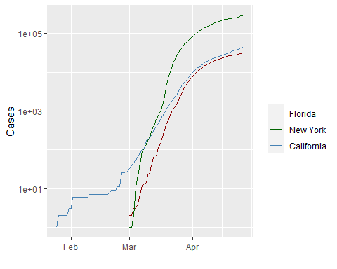

## R4DS Height vs Earnings

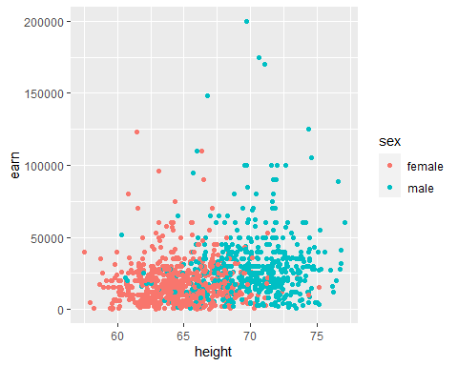

# Tables

## Knitr Table with Kable

One Ring to Rule Them All

| name | race | in_fellowship | ring_bearer | age |
| --- | --- | --- | --- | --- |
| Aragon | Men | TRUE | FALSE | 88 |
| Bilbo | Hobbit | FALSE | TRUE | 129 |
| Frodo | Hobbit | TRUE | TRUE | 51 |
| Galadriel | Elf | FALSE | FALSE | 7000 |
| Sam | Hobbit | TRUE | TRUE | 36 |
| Gandalf | Maia | TRUE | TRUE | 2019 |
| Legolas | Elf | TRUE | FALSE | 2931 |
| Sauron | Maia | FALSE | TRUE | 7052 |
| Gollum | Hobbit | FALSE | TRUE | 589 |

## Pandoc Table

library(pander)  
pandoc.table(characters_df, style="rmarkdown")

##   
##   
## | name | race | in_fellowship | ring_bearer | age |  
## |:---------:|:------:|:-------------:|:-----------:|:----:|  
## | Aragon | Men | TRUE | FALSE | 88 |  
## | Bilbo | Hobbit | FALSE | TRUE | 129 |  
## | Frodo | Hobbit | TRUE | TRUE | 51 |  
## | Galadriel | Elf | FALSE | FALSE | 7000 |  
## | Sam | Hobbit | TRUE | TRUE | 36 |  
## | Gandalf | Maia | TRUE | TRUE | 2019 |  
## | Legolas | Elf | TRUE | FALSE | 2931 |  
## | Sauron | Maia | FALSE | TRUE | 7052 |  
## | Gollum | Hobbit | FALSE | TRUE | 589 |

# References

Field, A., J. Miles, and Z. Field. 2012. *Discovering Statistics Using R*. SAGE Publications. <https://books.google.com/books?id=wd2K2zC3swIC>.

Lander, J. P. 2014. *R for Everyone: Advanced Analytics and Graphics*. Addison-Wesley Data and Analytics Series. Addison-Wesley. <https://books.google.com/books?id=3eBVAgAAQBAJ>.

1. R Markdown is very simple to learn but very useful