AgentFlow — System Architecture Specification
Pharmacy & Retail POS / Inventory Management Platform | Tanzania (TZS)
AgentFlow is a robust, production-ready Django application engineered for pharmacy and retail management in Tanzania. Operating on Eastern Africa Time (Africa/Dar_es_Salaam) and standardizing transactions in Tanzanian Shillings (TZS), the system features integrated Point-of-Sale (POS) operations, inventory tracking, role-based access control (RBAC), proforma workflows, and automated stock alerts.

1. Project Directory Structure
The repository follows a clean, modular Django layout structured into specialized domain applications:
agentflow/
├── manage.py
├── agentflow/ ← Project configuration (settings, URLs, WSGI/ASGI)
├── accounts/ ← User auth, custom profile, login activity & permissions
├── core/ ← Branch settings, system logs, backups & notifications
├── inventory/ ← Product catalog, stock tracking, categories & alerts
├── purchases/ ← Supplier purchase orders & stock ingestion
├── sales/ ← POS, customers, sales, credit management & loyalty
│ └── pos/cart.py ← Cache-backed real-time session shopping cart
├── chat/ ← Placeholder module (inactive)
├── templates/ ← Global and modular application HTML templates
├── static / staticfiles/ ← Source and WhiteNoise collected assets
├── media/ ← Uploaded prescriptions, profiles, and product images
├── database/data.sqlite3 ← SQLite relational database
└── backups/ ← Automated system backup archives

2. High-Level System Architecture
The system implements a tiered architecture separating presentation, core middleware execution, business application services, and persistent storage layers.
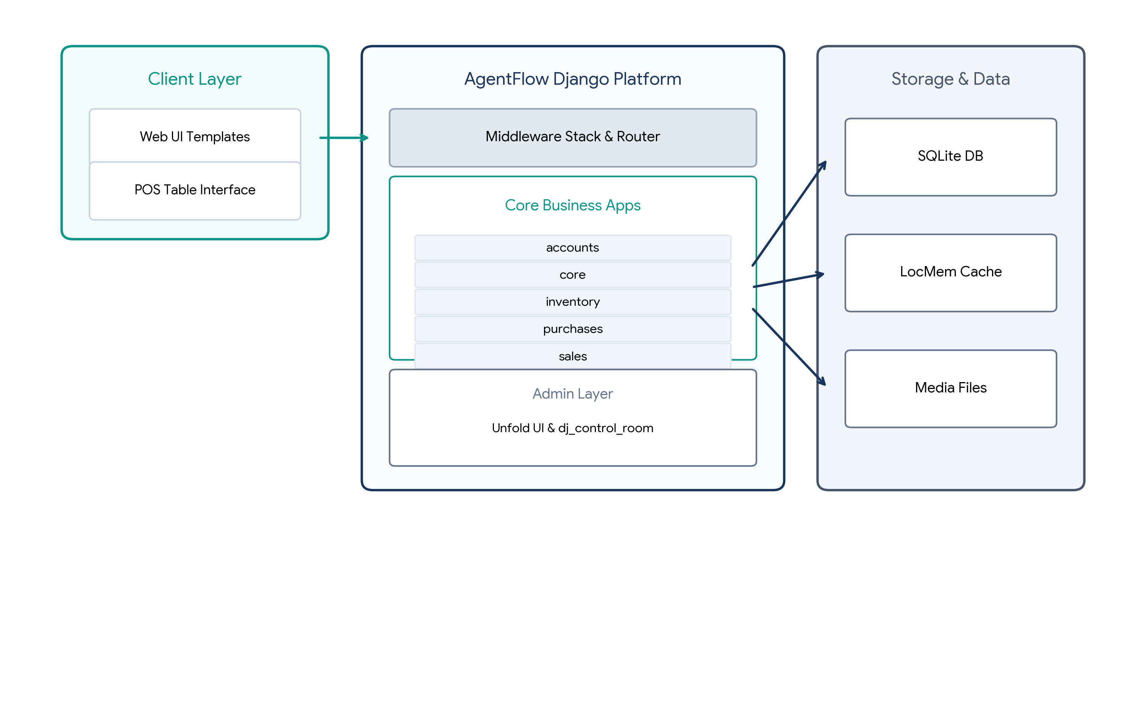
Figure 1: AgentFlow High-Level System Architecture Diagram
3. Installed Apps & Third-Party Stack
AgentFlow integrates industry-standard Django third-party packages to extend administrative UI, form handling, and security capabilities:
Layer / Domain | Components & Packages
Admin UI & Theme | unfold (Custom filters, forms, inlines, import_export, guardian, simple_history)
Developer Tools | dj_control_room, dj_control_room_base, dj_urls_panel, dj_signals_panel
Authentication | django.contrib.auth, allauth.account, custom accounts.User model
Form Processing | crispy_forms, crispy_bootstrap5
Static File Engine | whitenoise (CompressedManifestStaticFilesStorage)
Business Modules | accounts, core, inventory, purchases, sales

Middleware Pipeline Architecture
Requests traverse through a strict sequence of middleware components ensuring enterprise security and activity tracking:
SecurityMiddleware ➔ WhiteNoiseMiddleware ➔ SessionMiddleware ➔ CommonMiddleware ➔ CsrfViewMiddleware ➔ AuthenticationMiddleware ➔ MessageMiddleware ➔ XFrameOptionsMiddleware ➔ AllauthMiddleware ➔ ActivityLogMiddleware
4. URL Routing Map
The URL configuration routes incoming client requests through modular application namespaces. The primary user landing target following successful login is the interactive POS interface.
App Namespace | Base URL Route | Key Views & Endpoint Destinations
sales: | / | POS Table (/pos-table/), Checkout (/pos/save-sale/), Sales History (/sales/), Customers (/customers/), Credit Ledger (/credits/), Proformas (/proformas/)
inventory: | /inventory/ | Product Catalog (/products/), Stock Balances (/stock/), Low-Stock Alerts (/reports/low-stock/)
purchases: | /purchases/ | Purchase Orders List (/orders/), Create Purchase Order (/orders/create/)
accounts: | /accounts/ | Authentication Login (/login/), User Management (/users/), Profile (/profile/), Audit Logs (/activity-log/)
core: | /core/ | Dashboard (/dashboard/), Company Settings (/settings/), Notifications (/notifications/), System Backups (/backup/)

Authentication Flow: Posting credentials to accounts:login redirects users directly to sales:pos_table for immediate checkout readiness.
5. Data Model (Entity Relationships)
The relational model connects users, multi-branch business settings, stock tracking, and financial sales entities.
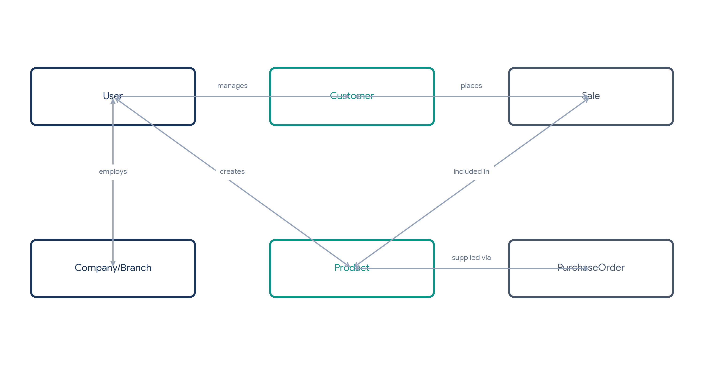
Figure 2: Key Entity-Relationship Diagram (ERD)
Database Models by Domain App
Domain App | Implemented Database Models
accounts | User (Custom UUID PK), UserProfile, UserActivityLog, LoginAttempt
core | Company, Branch, SystemSetting, Notification, EmailTemplate, Document, ActivityLog, Backup
inventory | Category, Product, StockMovement, StockAlert, InventoryAdjustment
purchases | PurchaseOrder, PurchaseOrderItem
sales | Customer, Sale, SaleItem, Payment, SaleReturn, SaleReturnItem, CreditRecord, LoyaltyCard, LoyaltyTransaction

6. Business Logic Flow
AgentFlow incorporates multi-step business logic routines for sales completion, quote generation, purchasing, and automated stock monitoring.
Sales & Proforma Checkout Workflow
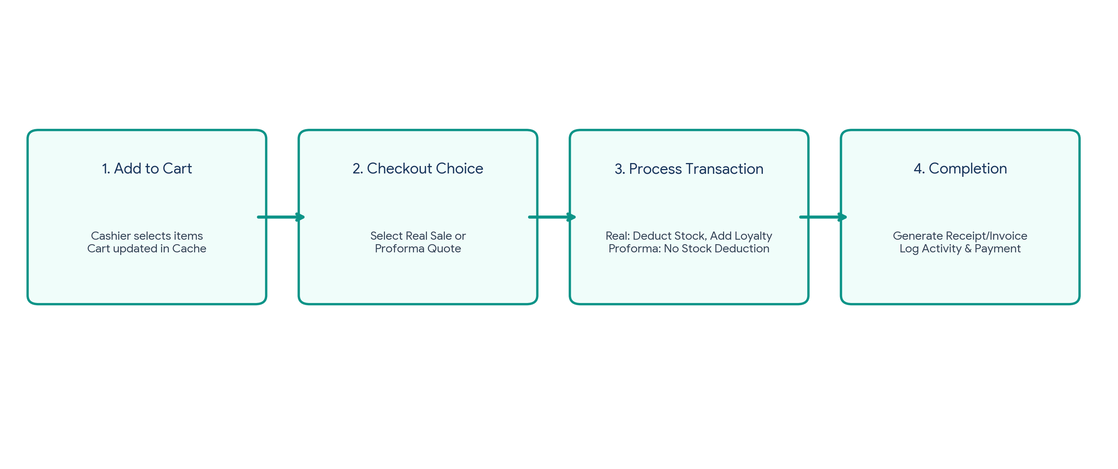
Figure 3: POS Sales & Proforma Checkout Processing Pipeline
Real Sale vs. Proforma Quote: When committing a direct transaction, the system calculates line item totals, deducts current product stock, logs an explicit StockMovement record (type=sale), and credits customer loyalty points. If saved as a Proforma, stock levels remain unaffected until explicitly converted to a final sale.
Inventory Monitoring & Automated Signals
The inventory/signals.py module listens to post_save events on the Product entity:
• Low Stock Thresholds: Triggers when quantity drops below minimum threshold; issues system Notification to administrators.
• Expiry Monitoring: Calculates batch expiration dates; flags items expiring within 90 days.
• Expired Goods Lockdown: Automatically locks expired medication batches from POS selection.
7. Role-Based Access Control (RBAC)
Access authorization is governed by custom permissions checked via has_permission() and can_access_page() wrappers across five key user roles:
User Role | Scope of Authorization & System Privileges
Administrator | Full system access, core configuration, backups, user management, audit trails.
Manager | Sales, inventory oversight, financial reports, read-only user directory access.
Pharmacist | Product catalog management, stock adjustments, POS sales, prescription tracking.
Cashier | POS terminal execution, customer management, view inventory stock balances.
Auditor | Read-only access to sales ledgers, credit records, reports, and activity logs.

8. Cross-App Dependencies & Technical Configuration
The modular system components interact through foreign key relationships and signals across application boundaries:
• Sales ➔ Inventory & Core: Sales references Inventory (Product FK) for stock deductions, Core for activity logs, and Accounts for transaction author FKs.
• Purchases ➔ Inventory: Purchases references Inventory for stock ingestion upon order completion.
• Inventory ➔ Core: Inventory alerts dispatch notifications managed by Core.
System Configuration Summary
Configuration Key | Deployment Value / Setting
AUTH_USER_MODEL | accounts.User (UUID Primary Key, Email Login)
Database Engine | SQLite3 (database/data.sqlite3)
Timezone Setting | Africa/Dar_es_Salaam (EAT / UTC+3)
Local Currency | Tanzanian Shilling (TZS / TSh)
Cache Strategy | LocMem Cache (POS Cart storage, 24-hour TTL)
Static Serving | WhiteNoise with Compressed Manifest Storage
Admin Interface | Unfold Admin Suite ('AgentFlow Secretariat')
Default View | sales:pos_table (Redirect post-login)

