
Robby one Pharmacy
P.O.BOX 1719 Dar es salaam
- +255 650966255
- +255 650966255
Email: robbyonepharmacy@hotmail.com

Bill to
Customer Information
DATE: | INVOICE NO:
Imvoice date
TIN: 105-134-703
Status if is invoice or cash

S/NO | NAME | QUANTY | PRICE(TZS) | PACK | BATCH | EXP | TOTAL(TZS)
1 |  |  |  |  |  |  | = PRICE * QUANTY
2
3
4
TOTAL
Total | IN - TZS
The total of all purchased products
products
Thanks for doing business with you we are looking ford to works with you

YOU CAN PAY ON CASH OR BANK ACCOUNT
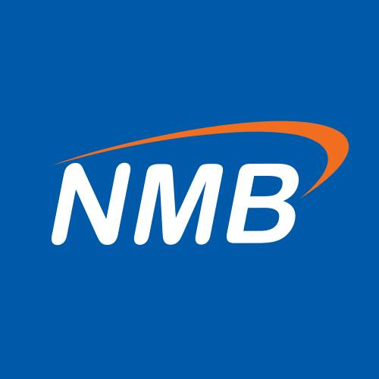
ACCOUNT NAME: ROBBY ONE PHARMACY
ACCOUNT NO: 20410014716

ACCOUNT NAME: ROBBY ONE PHARMACY
ACCOUNT NO: 121209000866

