Alex Stuart

Homework 3

9/20/2015

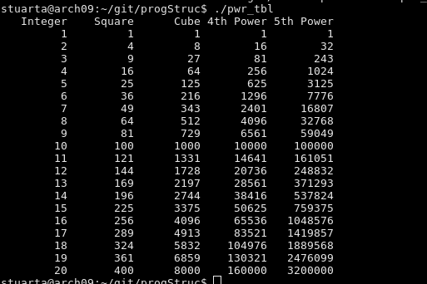
A)

#include <stdio.h>

int main(){

printf(" Integer Square Cube 4th Power 5th Power \n");
for(int i=1; i<21;i++){
printf("%10d%10d%10d%10d%10d\n",i ,i*i,i*i*i,i*i*i*i,i*i*i*i*i);

}
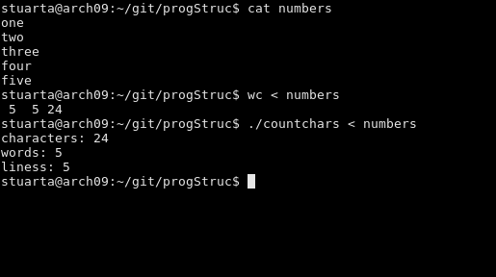
}

B)

#include <stdio.h>
#include <stdlib.h>

int main(){
char c;
int lines = 0;
int words =0;
int space_prev =0;
int chars =0 ;

while( (c = getchar()) != EOF ){
if(c == 10){
lines++;
words++;
chars++;
}
else if(c == ' '){
if(!space_prev){
words++;
}
space_prev = 1;
}
else{
space_prev = 0;
chars ++;
}
}
printf("characters: %d\n",chars);

printf("words: %d\n",words);

printf("lines: %d\n",lines);

}
C)
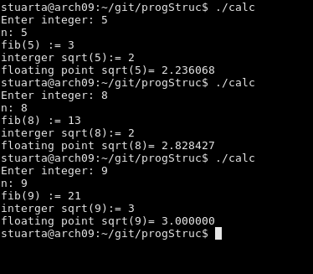

#include <stdlib.h>
#include <stdio.h>
#include <math.h>

int fib(int);
int isqrt(int);

int main()
{
char line[82];
int n;

printf("Enter integer: ");
fgets(line, sizeof line, stdin);

n = atoi(line);

printf("n: %i\n", n);
printf("fib(%i) := %i\n", n, fib(n));
printf("interger sqrt(%i):= %i\n", n, isqrt(n));
printf("floating point sqrt(%i)= %f\n",n,sqrt((float)n));
}
isqrt(int n)
{
int result = 1;
for( int i = 1; i*i <= n; ++i )
result = i;
return result;
}
int fib(int n){

int first = 0, second = 1, next, c;

for ( c = 0 ; c < n ; c++ )
{
if ( c <= 1 )
next = c;
else
{
next = first + second;
first = second;
second = next;
}

}
return next;
}

D) 1) Yeilds correct results for strings of length 1.
2) The error in this function comes from the second index integer being one to high. The index is zero based but the length is one based.
3) For strings of less than length 1 the for loop doesn't even execute once, automatically returning 1
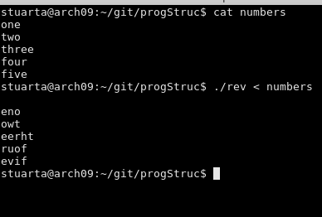
E)

#include <stdio.h>
#include <stdlib.h>
#include <string.h>

int main(){

char line[5000];
int n;

while( fgets(line, sizeof line, stdin)!= NULL){;
n = strlen(line);
for (int i =0; i<n;++i){
printf("%c",line[n-1-i]);
}}
printf("\n");
}

