This demonstrate how to use a rest service on camel, which is hooked with ldap service also running on top of camel route

The route of endpoint ([http://localhost:port/ldap/rest/check?user=<userid>&acl=<role](http://localhost:port/ldap/rest/check?user=%3cuserid%3e&acl=%3crole)>) and

The endpoint of rest service are defined in blueprint.xml

Which means if you call endpoint [http://localhost:port/ldap/rest/check?user=<userid>&acl=<role](http://localhost:port/ldap/rest/check?user=%3cuserid%3e&acl=%3crole)>

It will be redirected to bean id =”restService”

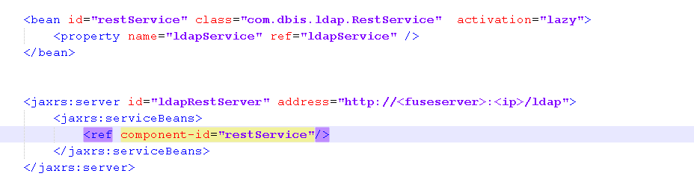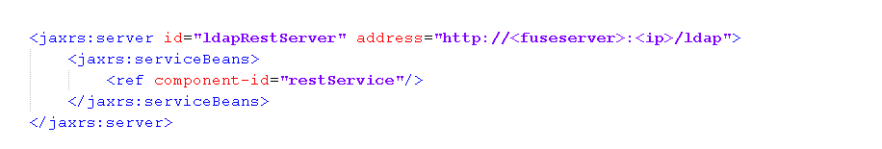

The route of ldap is defined in MyBuilder ‘s configure method instead of in blueprint.xml

ldapService use the route (from direct-vm to ldap:ldapserver) to do check up.

restService replies on ldapService

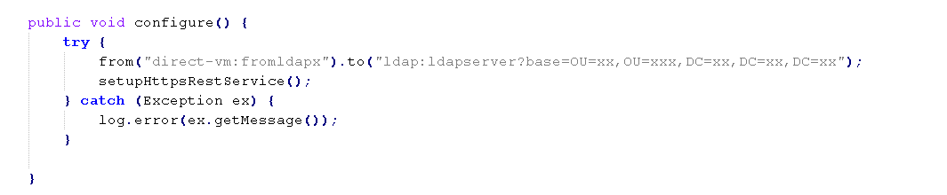

this demonstrate how to uee a rest service which supports https

<https://localhost:port/service?abe=xxx&dafsdabc>

the endpoint of https://<FUSE>:<PORT>/service and MyBookService is defined in MyRouteBuilder.java also with one way SSL

