Title Page

A Robust Deep Learning Framework for Automated Fetal Behavioral State Classification: Leveraging Multi-Center Datasets to Improve Antepartum Heart Rate Monitoring

Giulio Steyde¹, Isabelle Mueller^{2,a}, Margaret C. Shair^{2a}, Edoardo Spairani⁴, Luca Subitoni¹, Marta Campanile³, Giovanni Magenes⁴, William P. Fifer^{2,a,b}, Nicolò Pini^{2,a}, Maria G. Signorini¹

1 Department of Electronics, Information and Bioengineering, Politecnico di Milano, 20133 Milano, Italy
2 Department of Psychiatry, Columbia University Irving Medical Center, New York 10032, USA
a Division of Developmental Neuroscience, New York State Psychiatric Institute, New York 10032, USA
b Department of Pediatrics, Columbia University Irving Medical Center, New York 10032, USA
3 Department of Obstetrical-Gynecological and Urological Science, Federico II University, Napoli, Italy
4 Department of Electrical, Computer and Biomedical Engineering, Università di Pavia, 27100 Pavia, Italy

Corresponding author. Giulio Steyde
E-mail address: giulio.steyde@polimi.it
Address: Piazza Leonardo da Vinci, 32, 20133 Milano MI
Tel: +39 022399 3322

Highlights
- Fetal behavioral states provide a window into the developing brain and its functional organization.
- A deep neural network was pre-trained on a large-scale FHR dataset and fine-tuned on multi-center labeled dataset.
- The model matches expert-level annotations with over 90% Macro F1-score and Balanced Accuracy in the detection of Active and Quiet states.
- The model lays the groundwork for innovative tools in electronic fetal monitoring and behavior analysis.

Graphical Abstract

A Robust Deep Learning Framework for Automated Fetal Behavioral State Classification: Leveraging Multi-Center Datasets to Improve Antepartum Heart Rate Monitoring

Abstract.

Fetal behavioral states reflect the developing brain’s capacity to organize behavior into distinct sleep state patterns and are a window to evaluate the maturation of the nervous system throughout gestation. This study presents a deep learning-based methodology for the identification of behavioral states from fetal heart rate traces (FHR) recorded via cardiotocography (CTG). A Recurrent Residual Attention U-Net was pre-trained on a large unlabeled dataset of over 7,000 FHR recordings and fine-tuned on a multi-center dataset comprising 236 FHR signals with labeled states. These signals were collected across multiple countries using different cardiotocographs and annotated by clinicians with diverse backgrounds. The model showed high agreement with expert clinicians on a stratified hold-out test set, averaging a Macro F1 score of 91% and Balanced Accuracy of 93% in distinguishing between Active and Quiet states. The model has the potential to enhance the evaluation of fetal behavior states in clinical practice by assisting clinicians and ensuring objective, rapid reproducible results and future enhancements in electronic fetal monitoring.

Keywords: Electronic fetal monitoring, behavioral states, cardiotocography, signal segmentation

- INTRODUCTION

By approximately 32 weeks of gestation, the human fetus displays well-organized behavioral states, which are characterized by a combination of fetal eye and body movements and heart rate patterns. Fetal behavioral states (FBSs) serve as precursors to early neonatal behavioral states, highlighting the continuity from the fetal to the neonatal period [1], [2], [3], [4], [5]. FBSs are traditionally classified into four distinct classes based on the visual observation of a combination of multidimensional constructs, namely fetal heart rate (FHR) patterns, body movements, and eye movement traces, as first described by Nijhuis and colleagues [6] and summarized in Table I [1], [7], [8]. The key FHR features utilized for identifying FBS are accelerations and variability. Accelerations are defined as abrupt increases in FHR above the baseline, exceeding 15 bpm in amplitude and lasting between 15 seconds and 10 minutes. The variability parameter quantifies the fluctuations of the FHR around the mean and is defined as the average bandwidth amplitude of the signal in one-minute segments [9].

Table I Fetal Behavioral State characteristics.
 | Quiet Sleep 1F | Active Sleep 2F | Quiet Awake 3F | Active Awake 4F
Fetal Heart Rate | -Reduced variability  -Isolated accelerations | -Normal variability  -Frequent accelerations | -Higher variability than 1F  -No accelerations | -Increased Heart Rate  -High variability  -Large and long-lasting accelerations
Body Movements | Isolated/Sporadic Movements | Frequent gross body movements | Absence of gross movements | Regular gross movements
Eye movements | No | Yes | Yes | Yes
Sleep State precursor | Non-REM sleep | REM sleep | Awake | Awake
Proportion represented at 36 weeks GA [%] | ~17% | ~63% | ~1% | ~19%

From a clinical standpoint, it is common to collapse fetal behavioral states into two broader categories: Quiet State (by combining 1F and 3F) and Active State (by combining 2F and 4F) [1], [7], [8].
The emergence of a well-defined architecture of FBSs in late gestation and early infancy plays a crucial role in brain development. Indeed, FBSs are early markers of neurodevelopmental trajectories closely linked to fetal brain maturation [6], [10] and are characterized by marked individual differences [4]. In fact, FBSs reflect the developing fetal brain’s capacity to organize behavior into distinct sleep state patterns, offering valuable insights into the maturation of the central and autonomic nervous system throughout gestation [11]. For instance, altered patterns, such as increased time in quiet sleep and decreased active sleep in growth-restricted fetuses (FGR), may signal potential clinical risk, allowing for timely interventions [8], [12], [13].

Due to inherent constraints, conventional polysomnography cannot be performed on the human fetus. Moreover, the approach developed by Nijhuis et al. [6], which combines FHR monitoring (via cardiotocography [CTG]) with ultrasonic imaging of body and eye movements, presents significant practical limitations. To address these challenges, independent research groups have demonstrated that a reduced subset of physiological signals—namely, FHR and indices of fetal movements—can reliably classify states with accuracy and precision comparable to traditional approaches [14], [15], [16]. Furthermore, FHR and fetal movements are routinely evaluated in electronic fetal monitoring via CTG, facilitating the classification of FBSs from clinical data. Indeed, evaluating these states has increasingly become a key part of antepartum monitoring.
An example of a fetal heart rate (FHR) signal recorded via CTG, where Active and Quiet states are distinguishable based on variability and accelerations, is shown in Figure 1. However, the distinction between FBSs is not always as pronounced, given that FHR patterns are often less distinct, and recording noise may further obscure signal clarity. Despite these limitations, the gold standard for FBS classification in CTG requires expert visual scoring of FHR and fetal body movements. This method is inherently time-consuming, requires clinical expertise, and is subject to inter- and intra-observer variability, limiting its utility. Developing an automated, reliable, and reproducible method for fetal state classification based on FHR would greatly enhance the objectivity and efficiency of electronic fetal monitoring.

Initial efforts to automate fetal behavioral state (FBS) classification were made by Vairavan and colleagues [17] using a threshold-based algorithm based on FHR variability and accelerations or decelerations. This approach demonstrated good agreement with expert clinicians in identifying active states but only moderate agreement in detecting quiet states. Similarly, Frank et al. [18] explored permutation entropy for FBS classification. However, both methods were developed and evaluated exclusively on magnetocardiographic (MCG) recordings, which offer high FHR signal quality but require costly instrumentation unsuitable for routine monitoring. Furthermore, many prior studies have relied on single-center datasets collected using a single type of instrumentation and often annotated by a single clinician [17], [18], [19]. This poses a significant limitation, as FHR signals can vary considerably depending on the recording device, and potential differences may exist across data collection protocols. Additionally, some FHR-derived parameters are highly susceptible to noise, making feature-based methods particularly vulnerable to artifacts and reducing their robustness.
Here, we build on our previous work by introducing a deep learning-based framework capable of automatically obtaining FHR-derived FBSs with performance comparable to annotations contributed by expert clinicians. Previously, we developed a Hidden Markov Model (HMM) that utilized multiple features extracted from CTG-recorded FHR signals [19]. This model demonstrated good agreement with a single expert clinician, achieving approximately 84% accuracy. In this work, we move beyond the HMM by adopting a deep neural network (DNN) approach while leveraging the existing model for pretraining. Preliminary efforts on this topic were presented in our previous published work [20]. Here, we substantially advance this model by: (1) exploring novel and more flexible model architectures to improve performance; (2) incorporating multiple types of noise during training to increase robustness against signal artifacts; (3) utilizing multi-center datasets collected from four distinct geographical locations with different equipment for training and evaluation; and (4) integrating annotations from multiple expert clinicians.
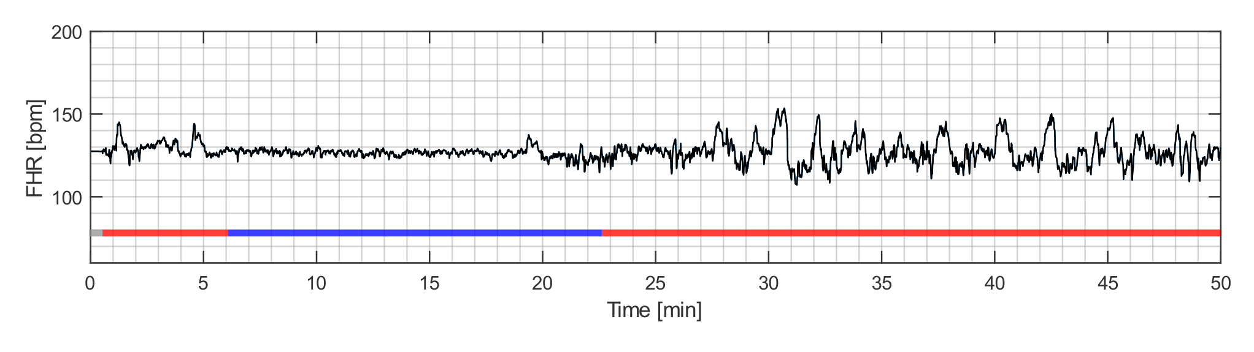Figure 1. A Fetal heart rate trace recorded via CTG. The overlaid line indicates clinician-scored fetal behavioral states: Active (red), Quiet (blue), and Indeterminate (gray).

2. METHODS

2.1 Overview of the proposed methodological solution

Annotating FHR signals into behavioral states is a time-consuming task that requires expert knowledge, making it challenging to obtain sufficiently large, annotated datasets for successfully training deep architectures. To overcome such limitations, we employed a semi-supervised approach for training the DNN, which will be detailed in the next sections. This framework was employed as it allows leveraging both (a) large non-annotated datasets – which are relatively easy to retrieve – alongside (b) smaller labeled datasets [21].

Figure 2 offers a high-level overview of the methods section. Section 2.2 outlines the pre-training phase, including a description of the large non-annotated dataset (2.2.1); data augmentation techniques (2.2.2); the DNN architectures implemented (2.2.3); and the pre-training strategy (2.2.4). Section 2.3 focuses on the training of the final model, detailing the annotated multicenter dataset (2.3.1); the annotation procedure (2.3.2); and the fine-tuning of the DNN (2.3.3).

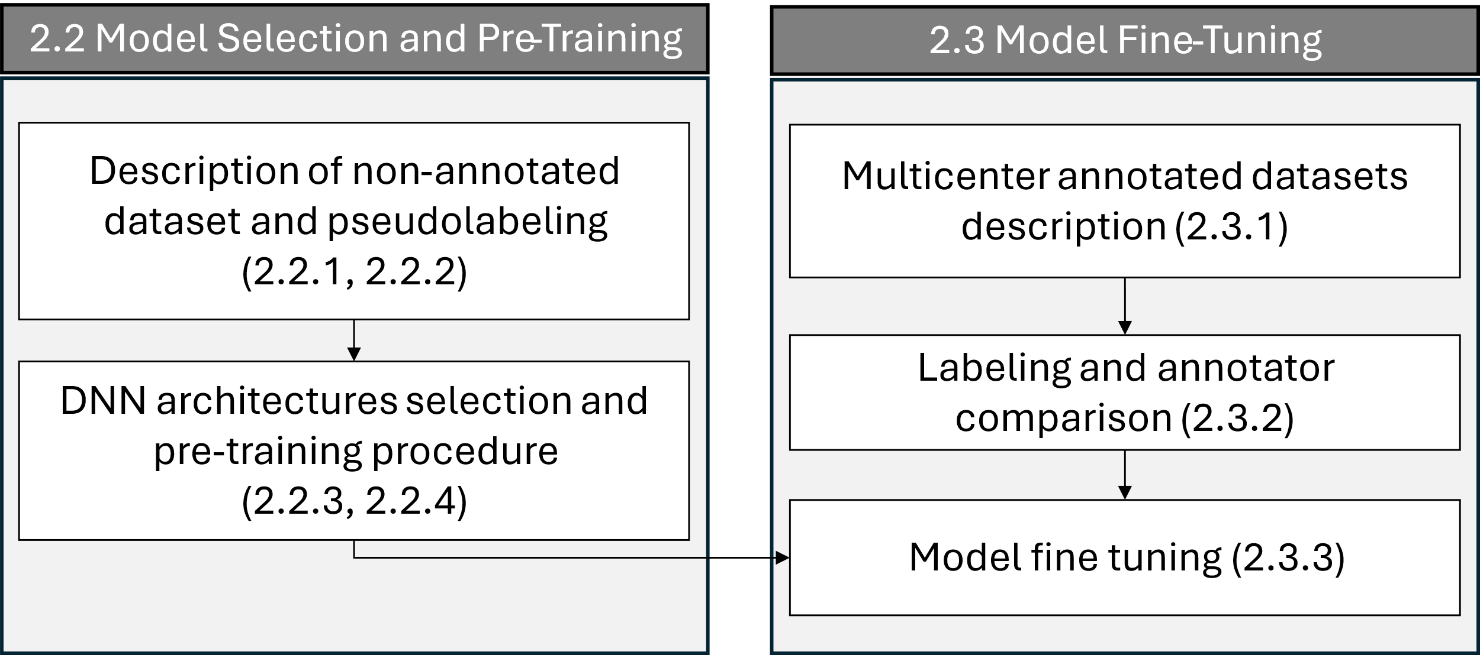
Figure 2 Structure of the “Methods” section.

2.2 Model Selection and Pre-Training

The DNN was selected and pre-trained on a pretext task closely aligned with the final objective and serves as the basis for the actual training. In particular, the pretext task is to imitate the unsupervised Hidden Markov Model (HMM) described in [20], which identifies FBSs and previously showed good agreement with human-made annotations.
Despite its convenience for the purpose of pretraining, the described HMM presents some limitations: 1) it relies on the extraction of a wide set of features, 2) it has a tendency of overestimating the “Quiet” class at the expenses of “Activity”, 3) shows good but sub-optimal results. For these reasons, replicating the HMM is not the final goal, but rather only a preliminary step.

2.2.1 Pre-training Dataset

The characteristics of the dataset used for pre-training are described elsewhere [22], [23]. In brief, clinicians have collected ultrasound-based CTG data as part of routine clinical practice at the University Hospital Federico II in Naples, Italy, since 2003. Written informed consent was obtained from all participants prior to performing the CTG recording. The FHR signals were recorded using Philips Avalon cardiotocographs and stored via the 2CTG2 software [24], which reads the values of the FHR and Fetal Movements Profile (FMP) signals at 2 Hz. This sampling frequency was selected as the best compromise to represent all relevant FHR spectral components and limit the number of identical consecutive samples. FHR signals were then subject to a standard pre-processing procedure to identify insufficient-quality points, which are corrected through linear interpolation [24]. For the pre-training phase, 7,600 FHR signals from fetuses whose gestational age (GA) was great or equal to 32 weeks and whose traces had less than 10% of interpolated points were included. Signals were standardized by subtracting the global mean (139.96 bpm) and dividing by the global standard deviation (11.64 bpm), both computed as the average of the means and standard deviations across the sample population.

2.2.2 Data Augmentation

FHR signals are susceptible to various sources of noise, including signal loss and outliers attributable to beat misidentification. Signal loss is commonly handled through linear interpolation, which, though simple, results in segments with artificially reduced FHR variability. Conversely, outliers can artificially introduce high variability into the signal. In our context, these artifacts can mimic episodes of Quiet or Active states, which the model needs to recognize and disregard, effectively distinguishing between genuine and spurious variability.

A commonly used approach to increase model robustness against noise, and in general to improve performance, is to employ data augmentation techniques. We performed random transformations on the input data in the magnitude domain, according to the taxonomy proposed by Iwana et al. [25].

Specifically, we randomly applied two noise types to replicate realistic artifacts found in FHR data.

- Linear Interpolations: to simulate signal loss, portions of the input FHR signals were randomly removed and linearly interpolated. The noise level is adjusted by changing the number and length of the interpolated segments.
- Random Outliers: to simulate beat misdetections, random isolated samples of the input signals were perturbed by adding gaussian noise. The noise level is adjusted by varying the number of perturbed samples and the magnitude of the perturbation.
Data augmentation was applied at specific stages throughout the pipeline injecting different levels of noise, as will be detailed in the next sections.

2.2.3 Development of Model Architecture

The Deep Neural Network (DNN) developed in this study significantly advances prior work by our research group [20] by exploring more recent architectures and a larger hyperparameters space.
All models developed assign to each FHR sample the probability of Active state (p(A)) and quiet state (p(Q)), with the two probabilities summing to 1, i.e., p(A) + p(Q) = 1. The probability values can be easily converted into class labels by rounding, which means this task can be interpreted as a signal segmentation problem. In the pretraining phase, the labels are generated by the HMM: segments scored as "Active" and “Quiet” by the HMM were assigned {p(A) = 1, p(Q) = 0} and {p(A) = 0, p(Q) = 1}, respectively.
Three types of architecture were adapted to the FHR signal segmentation task and evaluated in this study. All the implemented architectures follow a 1D encoder-decoder design with skip connections and have been tailored to process signals of 2400 samples — equivalent to 20-minute segments — and generate a segmentation mask of the same length. More specifically, the final output layer applies a softmax activation function, which assigns to each signal sample the probabilities of being in an Active and Quiet state. The choice of a 20-minute input-output window aligns with the minimum required duration for a non-stress test [26].
- U-Net:
Ever since its introduction in 2015 [27], the U-Net architecture has been widely used for medical image segmentation [28]. Moreover, it has demonstrated good performances in signal segmentation tasks, as described in [29]. This DNN is built using sequential blocks of 1D convolutional layers, alternated with batch normalization layers. The encoder branch incorporates max pooling for feature down-sampling, while the decoder branch employs transposed convolutions to restore the original resolution of the signal. Hidden layers utilize a Leaky ReLU activation function.
- Attention U-Net (AU-Net):
The Attention U-Net (AU-Net) [30] incorporates attention gates in the U-Net architecture previously described, enabling the model to identify key signal segments and selectively filter feature responses, retaining only those relevant to the task. More in detail, these attention gates focus on the most informative features extracted by the encoder blocks, dynamically adjusting their importance based on the decoder’s contextual information at coarser scales (i.e., deeper levels). This capability is particularly crucial for our application, where the context in which signal features appear must be carefully considered. For instance, while accelerations are strongly associated with Active states, they can occasionally occur in Quiet states. Whether an acceleration should be attributed to one state or the other depends entirely on the surrounding context.
- Recurrent Residual Attention U-Net (R2AU-Net)
The Recurrent Residual Attention U-Net [31] incorporates attention gates into the U-Net architecture, as in AU-Net, and replaces the convolutional units with recurrent residual convolutional units. The recurrent connections, which are added to each convolutional layer, improve the ability of the DNN to integrate contextual information, while the residual connections are added to improve gradient flow in deep models. This architecture combines the improvements of Attention gates and recurrent-recursive networks, making it very flexible at the cost of increased model size. A graphical representation of this architecture is displayed in Figure 3.

In all the architectures analyzed, the number of filters (N.F.) employed in the convolutions increases as a function of the DNN depth, following $N.F. = F∙2^{D-1}$ , where D is the model depth (i.e., the number of encoder/decoder blocks) and F is a multiplicative factor. The kernel size used for the convolutions is fixed across the DNN.
Figure 3 Schematic representation of the Recurrent Residual Attention U-Net architecture with a depth D of 5.
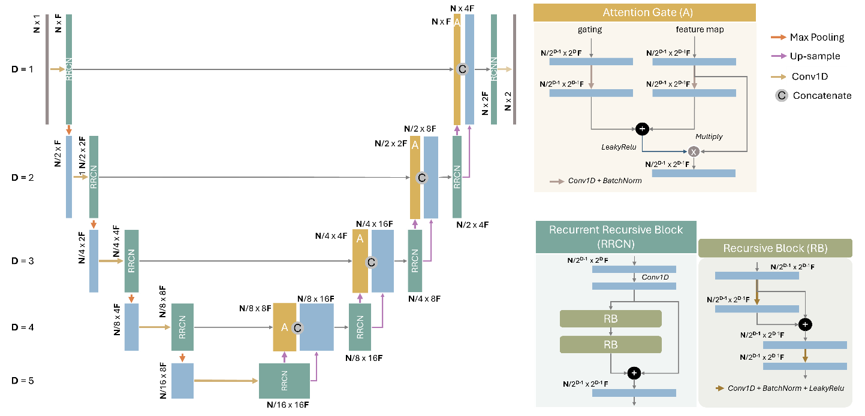

2.2.4 Pre-training strategy

We explored the hyperparameter set presented in Table II by performing a grid search with 5-fold cross-validation. In all trials, we used Kullback-Leibler divergence as the loss function and optimized the model parameters using the Adam optimizer, with a maximum of 300 epochs. Training ended if the validation loss did not improve for more than 15 epochs.

Data augmentation was used at this step. In training, the added noise was increased at each epoch to make the task progressively more difficult and avoid overfitting: the number of added linear segments was varied from 0 to 3, and the length of each from 10 to 360 samples (i.e., from 5 seconds to 3 minutes). The number of samples perturbed with gaussian noise during training varied linearly from 0 to 10% of the signal length and the standard deviation of the gaussian from 0 to 2 (corresponding to 0 - 23.3 bpm). In validation, a constant level of noise was applied to ensure that performance evaluation was not biased by the lower noise levels of early epochs: a single segment of random length between 60 and 360 samples (i.e., from 1 to 3 minutes) was substituted by linear interpolation in half of the input signals and 5% of the signal samples were chosen randomly and perturbed by adding noise with standard deviation of 1.
The choice to include noise in validation at this step was made to encourage the selection of models that are robust to these tailored, physiologically plausible noise perturbations, supporting their generalizability to real-world conditions.

The selected model architecture and hyperparameters were the ones which achieved the highest average Macro F1 score in cross-validation when predicting the pseudo-labels generated by the HMM. The selected model was subsequently trained on the entire pre-training dataset, using the chosen hyper-parameters and applying the same data augmentation strategy.

Table II Model architectures and hyperparameters evaluated in cross-validation.
Model Configuration | Values
Architecture | U-Net, AU-Net, R2AU-Net
Depth | 4,5,6
Filter multiplicative factor (F) | 2,3,4
Kernel Size | 5,13,23
Learning Rate | 10⁻³, 10⁻⁴

Model Fine-Tuning
The model selected and pre-trained in the previous step serves as the basis for the target model, which is tasked with imitating human experts in FBS identification. To achieve this, we fine-tune the pre-trained model using two distinct datasets, each annotated by two expert clinicians.

2.3.1 Dataset characteristics and Preprocessing

NAPAMI

A subset of 140 FHR recordings with gestational ages between 34 and 41 weeks was selected from the same dataset used for pre-training and described in paragraph 2.1.1. Only recordings with less than 10% interpolated samples and from singleton pregnancies were included. Additionally, we ensured that no signal appears in both phases by excluding these 140 traces from the pre-training subset. The selected FHR signals were submitted to the annotators for labeling.

PASS
The Prenatal Alcohol in SIDS and Stillbirth (PASS) dataset was collected in three distinct locations: Cape Town (South Africa), North Dakota (USA) and South Dakota (USA). Detailed cohort characteristics are described in [32]. Institutional Review Board approvals for the Safe Passage Study were obtained from all participating sites, and informed consent was obtained from all participants. FHR and movement data were collected via a Doppler actocardiograph (Toitu MT-320/MT-516). The FHR signal was processed to detect and correct signal loss and artifacts, typically resulting from fetal or maternal movement or repositioning of the transducer. The denoised signals were then down-sampled to 2 Hz for consistency with NAPAMI. For the present study, 96 recordings with less than 10% of interpolated samples were randomly selected by a researcher familiar with the cohort but not associated with this publication. All selected signals originated from singleton pregnancies between 34-38 weeks of gestation and were submitted to the annotators for labeling.
The characteristics of the labeled data from the NAPAMI and PASS datasets included in this study are summarized in Table III. We highlight that GA in the two datasets differ significantly, with PASS associated with lower GA (Wilcoxon rank sum test, p < 0.001).
All the FHR signals were standardized using the mean and standard deviation derived from the pre-training set. To ensure independent assessment of model performance and robustness, we randomly designated a stratified subset of traces for validation. Specifically, we allocated 15% of the recordings collected in Naples, Italy (n=21), and 20% from PASS locations (Cape Town: n=7, South Dakota: n=7, and North Dakota: n=7). These traces were set aside and used exclusively for the evaluation of the final trained model, to ensure they never influenced model development.
Table III FHR signals characteristics
Cohort | Number of Signals [count] | Duration [minutes]  (mean and std) | GA [weeks]  (Median and quartiles)
NAPAMI | 140 | 43.5 ± 9.3 | 37 (36, 38)
PASS | 96 | 48.5 ± 7.7 | 35 (34, 37)

2.3.2 Labeling and Annotator Comparison

The data were annotated by two independent experts, one affiliated with Federico II University Hospital, Italy, one affiliated with Columbia University Medical Center, New York City, USA.
Annotators were asked to score the FHR traces into two distinct states: Active or Quiet state. Segments not assigned to either state—due to poor signal quality or the absence of clear characteristics needed to identify a pattern—were labeled as Indeterminate.
The annotations were formatted as vectors matching the length of the corresponding FHR signal, with each FHR sample labeled as either Active, Quiet or Indeterminate.
The selected measures of agreement were the Macro F1-Score and the Balanced Accuracy. Summary scores were computed both at the participant level and by considering the entire cohort (by concatenating all the annotation vectors).
NAPAMI was completely double coded. A subset of PASS data (32 recordings) was also double coded.

After adequate agreement was reached (Macro F1 Score≥0.7), the remaining data was annotated individually to optimize time efficiency under the assumption that coding consistency was maintained. In the case of limited agreement (Macro F1 score<0.7), disagreement in scoring were discussed until agreement was reached. Portions for which agreement could not be reached were coded as Indeterminate.
Segments labeled as Active were assigned {p(A) = 1, p(Q) = 0}, those labeled as Quiet were assigned {p(A) = 0, p(Q) = 1}, and Indeterminate segments were assigned {p(A) = 0.5, p(Q) = 0.5}.

2.3.3 Model fine-tuning

The model was then fine-tuned with all the annotated data (except for the test set), corresponding to 119 FHR traces from Napami and 75 from PASS. The DNN architecture and hyperparameters used are those selected during the pre-training step, and the batch normalization layers were frozen to preserve the information previously learned. To select the optimal learning rate and number of epochs for fine-tuning, we performed a repeated 5-fold cross-validation with five repetitions, evaluating the following learning rates: [10⁻⁶,10⁻⁵,10⁻⁴,10⁻³]. Moreover, to address class imbalance (see Table I) the loss function was re-balanced using class-balanced weighting based on the effective number of samples [33].
Data augmentation was applied to the training portion of the fine-tuning dataset following the same approach used for pre-training, as described in section 2.2.4, while the validation set was not modified.

3. Results

3.1 Model selection and Pre-training
All models evaluated in the pre-training phase exhibited good performances in the pretext task of imitating the Hidden Markov Model. Figure 4 illustrates the results of the top 15 performing combinations in the pre-train step. The R2AttU-Net consistently outperformed the other architectures, consistently ranking as top performer against the other architectures (8 out of the 10 top positions, including first place).
The best-performing R2Attu-Net model has a depth of 5 encoder/decoder blocks, 3 as a multiplicative factor for the number of filters and a kernel size of 13. The selected learning rate is 10⁻⁴ and the number of epochs 27. This combination reached a Macro F1-Score of 89.95% ± 0.17% in the prediction of the pseudo-labels generated by the HMM.
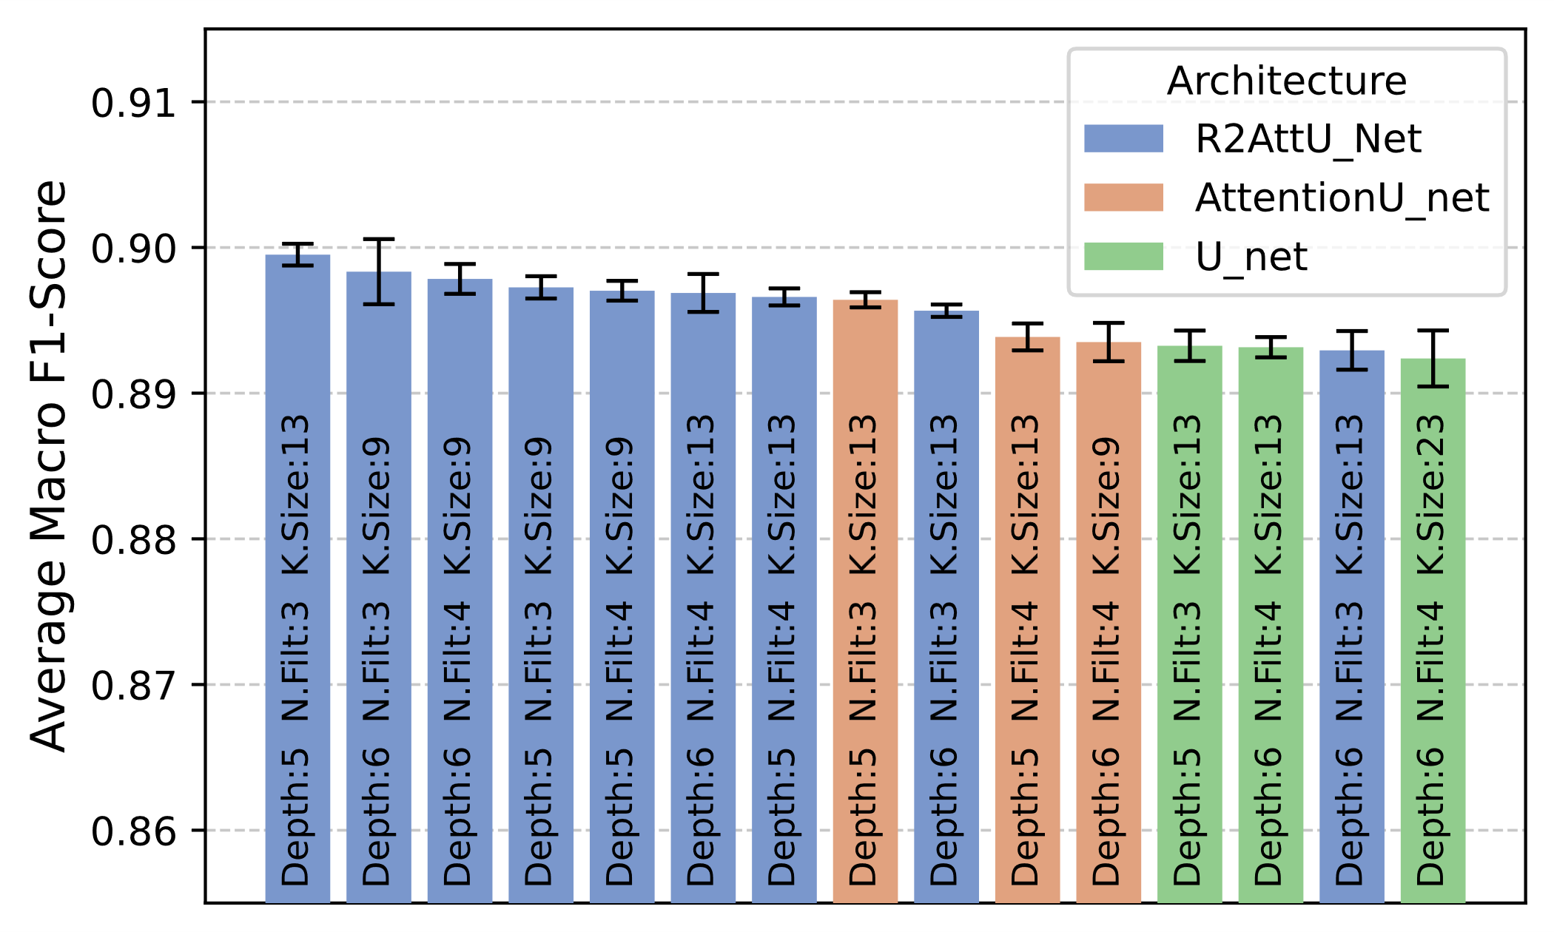
Figure 4 Macro F1-Score (mean and standard error) in the pre-training of the 15 best-performing combinations. Notice that at this step the scores are relative to the pseudo-labels generated by the HMM.

3.2 Annotator comparison

Overall, the agreement between the two annotators was high, with a Macro F1-Score of 88.5% and a Balanced Accuracy of 90.7%. The agreement was comparable across the two datasets: the Macro F1 score was 88.6% for NAPAMI and 84.8% for PASS, while the Balanced Accuracy was 90.4% for NAPAMI and 92.5% for PASS. The most notable difference between the two annotators is that Annotator 1 labeled more segments as “Quiet” compared to Annotator 2 (27.3% vs. 22.9%). As a result, Annotator 1 labeled fewer segments as “Active” (72.3% vs. 75.9%). The prevalence of the “Indeterminate” label was low for both annotators, at 0.4% for Annotator 1 and 1.2% for Annotator 2.
As described in 2.3.2, the ground truth for training and evaluating the model is obtained from the combination of the annotations of Annotator 1 and Annotator 2, and the obtained class distribution is reported in Table IV. The signal segments in which the annotations were inconsistent are marked as “Indeterminate”, resulting in a total of 8.9% of “Indeterminate” in Napami and 4.3% for PASS.

Table IV Percentages of “Active”, “Quiet” and “Indeterminate” states derived after merging the clinicians’ annotations.
 | NAPAMI | PASS
Active | 68.4% | 76.5%
Quiet | 22.7% | 19.2%
Indeterminate [%] | 8.9% | 4.3%

3.2 Model fine-tuning

The repeated 5-fold cross-validation identified 10⁻⁵ as the optimal learning rate, which was associated with a consistent decline in validation loss in all repetitions. Based on the average Macro F1 score in the validation set, the model was fine-tuned for 35 epochs.
Prior to fine-tuning, the pre-trained model achieved a Macro F1-Score of 78.0±4.9% on the validation set containing the annotations made by the clinicians, hence showing the effectiveness of the pre-training step. After fine-tuning, this score increased to 91.9±2.5% averaging across validation set repetitions. Notably, this performance—representing the agreement between the DNN and the annotators—is comparable to the inter-rater agreement between two expert clinicians.

3.3 Model Test

To obtain an unbiased estimate of the model performance, the DNN was evaluated on the hold-out test set, which was selected to include traces from all centers involved in this study. Results are summarized in Table V.
The agreement scores were obtained using the same approach previously applied to annotators. Specifically, the DNN outputs—which have the same length as the FHR signals and assign each FHR sample to either the "Active" or "Quiet" class—were concatenated and compared to the annotations provided by expert clinicians. The portions that were marked as “Indeterminate” by the clinicians were not included in the evaluation since they cannot be assigned to any class.
On both datasets, the DNN reached a Macro F1-Score and Balanced accuracy close or superior to 90%, consistent with intra-annotator variability. Considering the overall distribution of the DNN predictions, it should be noted that the percentage of “Active” is very close to the gold-standard in both datasets, while the “Quiet” class is overestimated with respect to the gold standard, suggesting that the model tends to assign “Quiet” to signal segments which were marked as “indeterminate” , either because clinicians disagreed or because the signal segments was of low quality.

Table V Performance evaluation on the hold-out test sets
 | NAPAMI | PASS
Macro F1-Score | 92.6% | 89.6%
Balanced Accuracy | 92.6% | 94.5%
True Active Rate | 95.2% | 92.9%
True Quiet Rate | 90.0% | 97.4%
False Active Rate | 10.0% | 2.6%
False Quiet Rate | 4.8% | 8.4%
Predicted Quiet Rate | 31.7% | 25.9%
Predicted Active Rate | 68.3% | 74.1%

Model performance was also evaluated on a trace-by-trace basis, with the results presented in Figure 5. An explicative selection of prediction examples is shown in more detail, together with the ground truth, in Figure 6. Except for isolated instances, the scores in both datasets consistently approach 90% for the traces in the hold-out test set. The application of the Wilcoxon rank-sum test did not reveal statistical differences in the scores between the two datasets (Macro F1-Score: p = 0.8307; Balanced Accuracy: p = 0.6781).

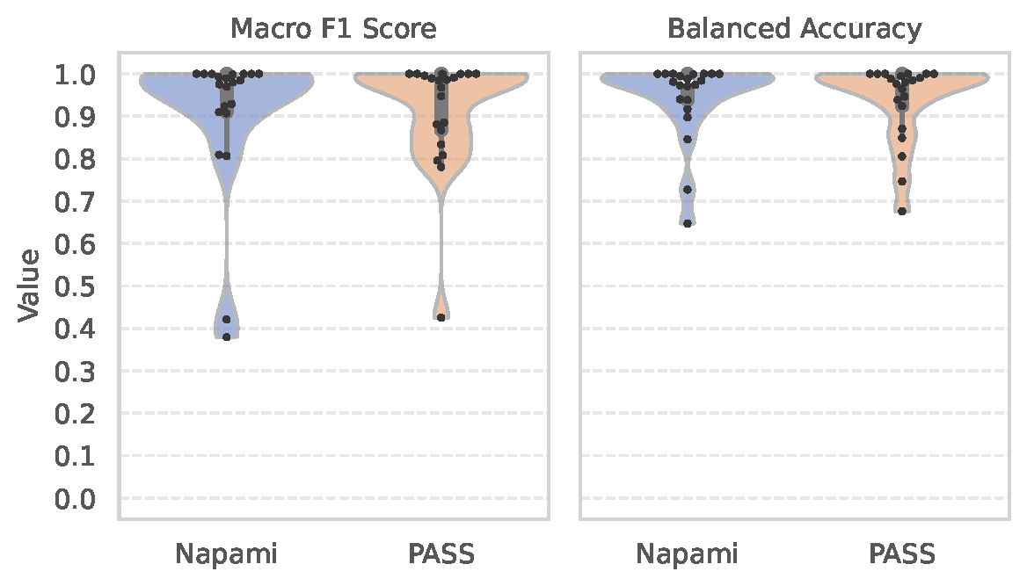
Figure 5 Trace by trace performance evaluation on the hold-out test sets.

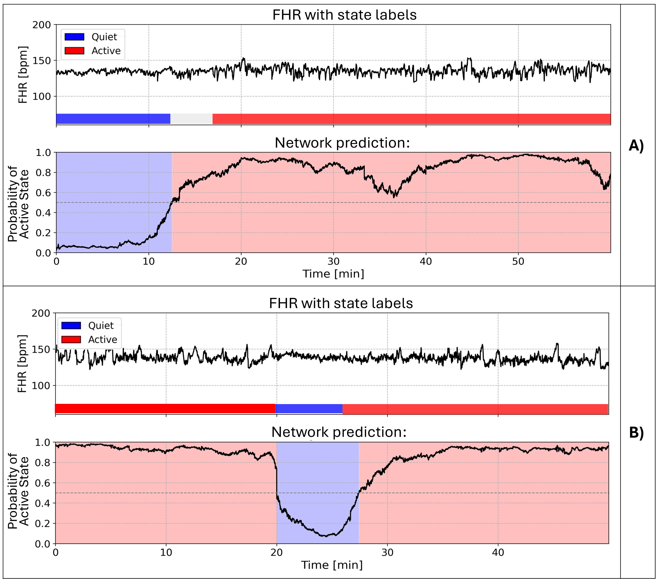
Figure 6 Fetal heart rate (FHR) trace alongside annotated behavioral states (top) and the network's predicted probability of the active state (bottom). The annotated states indicate periods of “Quiet” (blue), “Active” (red), and “Indeterminate” (gray). In Panel A) the network's predictions follow the expected trend, with low probabilities of the active state during the quiet phase and a gradual increase leading up to the active phase, reaching a perfect Macro F1-Score of 100%. In panel B), a steep transition from “Active” to “Quiet” can be observed around the 20th minute, characterized by a reduction in FHR variability and a decreasing baseline. The probability of the “Active” state then increases gradually. The zone of disagreement occurs during this transitional phase and the Macro F1-Score is 94%. The FHR signal in panel a was sampled from the test set of NAPAMI, while the second from PASS.

4. Discussion

The DNN developed and described in this paper was successfully trained to segment and automatically label FHR traces into distinct FBSs, namely "Active" and "Quiet". The model achieved expert-level performance, with a Macro F1 score of approximately 90% across both datasets, demonstrating a high agreement with expert clinician.

The implemented R2AttU-Net model consistently outperformed other architectures during the pre-training phase, achieving a Macro F1-Score of 89.95% ± 0.17% in imitating the HMM. Fine-tuning the pre-trained model using repeated 5-fold cross-validation and a lower learning rate of 10⁻⁵ led to a substantial improvement in the performance, increasing the Macro F1-Score from 78.0% ± 4.9% to 91.9% ± 2.5%, bringing the model's performance in line with inter-annotator agreement. When tested on a hold-out dataset representing all study centers, the model maintained high performance, with Macro F1-Scores and Balanced Accuracies close to or exceeding 90% on both datasets. Finally, a trace-by-trace evaluation confirmed the model’s consistent performance across individual signals, with no statistically significant difference between datasets.

A key methodological advancement of the implemented model is the ability to assign state probabilities versus a binary classification of Active and Quiet states. Assigning probabilities to each state rather than using binary classification captures the uncertainty inherent in real-world data. In a binary classification framework, each input is forced into a rigid "either-or" category, ignoring the ambiguous or transitional nature of many physiological signals—such as fetal heart rate patterns—that do not always clearly align with a single class. By contrast, a probabilistic approach provides a measure of confidence for each predicted FHR sample. This is particularly valuable in instances of low signal quality or with intermediate features between the two states, where even human experts may disagree. Additionally, probabilistic outputs allow for the integration of predictions into downstream decision-making systems that can weigh the confidence of the model’s output, potentially improving interpretability and generalizability in clinical contexts.
Building on these observations, we believe that the DNN presented has the potential to enhance the evaluation of fetal behavior states (FBS) in clinical practice by assisting healthcare providers and ensuring objective, reproducible results. Moreover, it paves the way for further research. For instance, the probabilistic output enables the stratified analysis of FHR features by behavioral states, which would be an important consideration as FHR characteristics are strongly influenced by FBSs [34], [35]. A The DNN's ability to extract context-sensitive morphological features and differentiate among sources of variability (e.g., decelerations versus accelerations) allows for a more meaningful measure of “Activity” than standard metrics like short-term variability (STV). This offers a novel approach to derive clinically relevant insights from FHR traces. For example, a reduced definition of FBSs has been associated with fetal growth restriction [36], [37].

A key strength of this work lies in the robustness and diversity of the training data used to develop the DNN. Recordings were collected across multiple countries, using different cardiotocograph devices, and annotated by clinicians with varied training backgrounds. The dataset spans a broad gestational age range (34-42 weeks), contributing to the model's generalizability across populations and clinical settings. While fetal movement patterns or actograms are often available in CTG and were referenced by the experts of this study during coding, we deliberately excluded this input from the DNN due to its inconsistent availability and format across devices. Notably, the DNN showed strong performance using FHR data alone, underscoring its potential utility in routine clinical practice.
A limitation of the current work is that the DNN focuses on classifying the two primary fetal states commonly assessed in clinical practice: “Active” and “Quiet”. While this simplification omits the full range of the four states originally described by Nijhuis et al. [6], this choice is justified by the observation that the states 3F and 4F are infrequently examined as they have little significance in clinical practice[1], [8]. In addition, our model was developed and validated exclusively on FHR signals derived from ultrasound-based CTG. While this aligns with standard clinical practice, it limits immediate applicability to data obtained with different modalities.

This work lays the foundation for significantly improving antepartum heart rate monitoring. A promising future direction is the application of the proposed model to the analysis of longer durations of fetal heart rate (FHR) recordings, now made feasible by the advent of wearable technologies capable of collecting FHR data outside clinical settings. Applying the model’s probabilistic outputs over extended monitoring periods enables the extraction of an objective distribution of fetal behavioral states - such as Active and Quiet - which are believed to reflect underlying neurological maturation across gestation. This longitudinal quantification of state distributions could serve as a novel, non-invasive biomarker of fetal wellbeing, offering a more dynamic and physiologically grounded alternative to traditional static measures across clinical domains. Furthermore, integrating fetal behavioral states into fetal growth assessments allows for the stratification of growth curves by state, supporting the development of personalized and developmentally sensitive benchmarks. Such an approach recognizes that deviations in behavioral state organization and transitions may signal early indicators of developmental concerns, even when standard physiological parameters remain within normal ranges.

CRediT authorship contribution statement
Giulio Steyde (GS)
Isabelle Mueller (IM)
Margaret Shair (MS)
Edoardo Spairani (ES)
Luca Subitoni (LS)
Marta Campanile (MC)
Giovanni Magenes (GM)
Nicolò Pini (NP)
William P Fifer (WPF)
Maria Gabriella Signorini (MGS)
Term | Definition | Criterion Met
Conceptualization | Ideas; formulation or evolution of overarching research goals and aims | IM, NP, GS, WPF, GM, ES, MGS
Methodology | Development or design of methodology; creation of models | NP, GS, LS, ES
Software | Programming, software development; designing computer programs; implementation of the computer code and supporting algorithms; testing of existing code components | GS, LS
Validation | Verification, whether as a part of the activity or separate, of the overall replication/ reproducibility of results/experiments and other research outputs | GS, LS
Formal analysis | Application of statistical, mathematical, computational, or other formal techniques to analyze or synthesize study data | NP, GS, LS
Investigation | Conducting a research and investigation process, specifically performing the experiments, or data/evidence collection | IM, MS, NP, GS, MC
Resources | Provision of study materials, reagents, materials, patients, laboratory samples, animals, instrumentation, computing resources, or other analysis tools | IM, NP, WPF, GM, MGS
Data Curation | Management activities to annotate (produce metadata), scrub data and maintain research data (including software code, where it is necessary for interpreting the data itself) for initial use and later reuse | IM, MS, NP, GS, LS, MC
Writing - Original Draft | Preparation, creation and/or presentation of the published work, specifically writing the initial draft (including substantive translation) | IM, NP, GS, LS, WPF, MGS
Writing - Review & Editing | Preparation, creation and/or presentation of the published work by those from the original research group, specifically critical review, commentary or revision – including pre-or post publication stages | IM, NP, GS, LS, WPF, MGS, ES, GM, MC
Visualization | Preparation, creation and/or presentation of the published work, specifically visualization/ data presentation | IM, NP, GS, LS
Supervision | Oversight and leadership responsibility for the research activity planning and execution, including mentorship external to the core team | NP, WPF, MGS, GM, MC
Project administration | Management and coordination responsibility for the research activity planning and execution | NP, IM, WPF, MGS
Funding acquisition | Acquisition of the financial support for the project leading to this publication | NP, WPF, MGS

Funding
This work was supported by:
MUSA – Multilayered Urban Sustainability Action –project, funded by the European Union – NextGenerationEU, under the National Recovery and Resilience Plan (NRRP) Mission 4 Component 2 Investment Line 1.5: Strenghtening of research structures and creation of R&D “innovation ecosystems”, set up of “territorial leaders in R&D”;
MIUR PRIN Project Call 2017 “ICT4MOMs” Grant 2017RR5EW3;
National Institute of Child Health and Human Development (NICHD) Grant U01HD055155 “Prenatal Alcohol in Sudden Infant Death Syndrome and Stillbirth (PASS) Network”
National Institute of Alcohol Abuse and Alcoholism (NIAAA) Grant R01AA029159 “Neurodevelopmental Effects of Prenatal Exposure to Maternal Drinking, Smoking and Adverse Psychological Factors: Deep Phenotyping of Infant CNS and ANS Function”.

References

[1] C. Einspieler, D. Prayer, and P. B. Marschik, “Fetal movements: the origin of human behaviour,” Dev Med Child Neurol, vol. 63, no. 10, pp. 1142–1148, Oct. 2021, doi: 10.1111/dmcn.14918.
[2] L. J. Groome, M. J. Swiber, S. B. Holland, L. S. Bentz, J. L. Atterbury, and R. F. Trimm, “Spontaneous motor activity in the perinatal infant before and after birth: Stability in individual differences,” Dev Psychobiol, vol. 35, no. 1, pp. 15–24, Jul. 1999, doi: 10.1002/(SICI)1098-2302(199907)35:1<15::AID-DEV3>3.0.CO;2-U.
[3] R. F. Hume, K. J. O’Donnell, C. L. Stanger, A. P. Killam, and J. L. Gingras, “In utero cocaine exposure: Observations of fetal behavioral state may predict neonatal outcome,” Am J Obstet Gynecol, vol. 161, no. 3, pp. 685–690, Sep. 1989, doi: 10.1016/0002-9378(89)90380-3.
[4] M. Mirmiran, Y. G. H. Maas, and R. L. Ariagno, “Development of fetal and neonatal sleep and circadian rhythms,” Sleep Med Rev, vol. 7, no. 4, pp. 321–334, 2003, doi: 10.1053/smrv.2002.0243.
[5] A. Poblano, R. Haro, and C. Arteaga, “Neurophysiologic Measurement of Continuity in the Sleep of Fetuses during the Last Week of Pregnancy and in Newborns,” 2008. [Online]. Available: www.biolsci.org
[6] J. G. Nijhuis, H. F. R. Prechtl, C. B. Martin, and R. S. G. M. Bots, “Are there behavioural states in the human fetus?,” Early Human Development, vol. 6, no. 2, pp. 177–195, Apr. 1982, doi: https://doi.org/10.1016/0378-3782(82)90106-2
[7] B. Arabin and S. Riedewald, “An Attempt to Quantify Characteristics of Behavioral States,” Am J Perinatol, vol. 9, no. 02, pp. 115–119, Mar. 1992, doi: 10.1055/s-2007-994682.
[8] L. Semeia, K. Sippel, J. Moser, and H. Preissl, “Evaluation of parameters for fetal behavioural state classification,” Sci Rep, vol. 12, no. 1, Dec. 2022, doi: 10.1038/s41598-022-07476-x.
[9] FIGO Intrapartum Fetal Monitoring Expert Consensus Panel, “FIGO consensus guidelines on intrapartum fetal monitoring,” International Journal of Gynecology & Obstetrics, vol. 131, no. 1, 2015, doi: https://doi.org/10.1016/j.ijgo.2015.06.020.
[10] E. R. de Groot, J. Dudink, and T. Austin, “Sleep as a driver of pre- and postnatal brain development,” Pediatr Res, vol. 96, no. 6, pp. 1503–1509, Nov. 2024, doi: 10.1038/s41390-024-03371-5.
[11] A. Dereymaeker et al., “An Automated Quiet Sleep Detection Approach in Preterm Infants as a Gateway to Assess Brain Maturation,” Int J Neural Syst, vol. 27, no. 06, p. 1750023, Sep. 2017, doi: 10.1142/S012906571750023X.
[12] J. A. DiPietro, K. A. Costigan, and E. K. Pressman, “Fetal state concordance predicts infant state regulation,” Early Hum Dev, vol. 68, no. 1, pp. 1–13, Jun. 2002, doi: 10.1016/S0378-3782(02)00006-3.
[13] M. A. T. van Vliet, C. B. Martin, J. G. Nijhuis, and H. F. R. Prechtl, “Behavioural states in growth-retarded human fetuses,” Early Human Development, vol. 12, no. 2, pp. 183–197, Nov. 1985, doi: https://doi.org/10.1016/0378-3782(85)90181-1
[14] K. Maeda, “Fetal monitoring and actocardiogram in the evaluation of fetal behavior,” The Ultrasound Review of Obstetrics and Gynecology, vol. 4, no. 1, pp. 12–25, Mar. 2004, doi: 10.3109/14722240410001713920.
[15] J. Brändle et al., “Heart rate variability parameters and fetal movement complement fetal behavioral states detection via magnetography to monitor neurovegetative development,” Front Hum Neurosci, vol. 9, Apr. 2015, doi: 10.3389/fnhum.2015.00147.
[16] J. A. DiPietro, D. M. Hodgson, K. A. Costigan, S. C. Hilton, and T. R. B. Johnson, “Fetal Neurobehavioral Development,” Child Development, vol. 67, no. 5, pp. 2553–2567, Oct. 1996, doi: https://doi.org/10.1111/j.1467-8624.1996.tb01874.x.
[17] S. Vairavan et al., “A computer-aided approach to detect the fetal behavioral states using multi-sensor Magnetocardiographic recordings,” Comput Biol Med, vol. 69, pp. 44–51, Feb. 2016, doi: 10.1016/j.compbiomed.2015.11.017.
[18] B. Frank, B. Pompe, U. Schneider, and D. Hoyer, “Permutation entropy improves fetal behavioural state classification based on heart rate analysis from biomagnetic recordings in near term fetuses,” Med Biol Eng Comput, vol. 44, no. 3, pp. 179–187, Mar. 2006, doi: 10.1007/s11517-005-0015-z.
[19] E. Spairani, G. Steyde, S. Tagliaferri, M. G. Signorini, and G. Magenes, “Fetal states identification in cardiotocographic tracings through discrete emissions multivariate hidden Markov models,” Comput Methods Programs Biomed, vol. 240, Oct. 2023, doi: 10.1016/j.cmpb.2023.107736.
[20] E. Spairani, G. Steyde, L. Subitoni, G. Magenes and M. G. Signorini, "A semi-Supervised Deep Learning Approach to Automate the Identification of Fetal Behavioral States in Fetal Heart Rate Tracings," 2024 IEEE International Symposium on Medical Measurements and Applications (MeMeA), Eindhoven, Netherlands, 2024, pp. 1-6, doi: 10.1109/MeMeA60663.2024.10596918.
[21] J. E. van Engelen and H. H. Hoos, “A survey on semi-supervised learning,” Mach Learn, vol. 109, no. 2, pp. 373–440, Feb. 2020, doi: 10.1007/s10994-019-05855-6.
[22] M. G. Signorini, N. Pini, A. Malovini, R. Bellazzi, and G. Magenes, “Dataset on linear and non-linear indices for discriminating healthy and IUGR fetuses,” Data Brief, vol. 29, 2020, doi: 10.1016/j.dib.2020.105164.
[23] E. Spairani, B. Daniele, G. Magenes, and M. G. Signorini, “A Novel Large Structured Cardiotocographic Database,” in 2022 44th Annual International Conference of the IEEE Engineering in Medicine & Biology Society (EMBC), IEEE, Jul. 2022, pp. 1375–1378. doi: 10.1109/EMBC48229.2022.9871340.
[24] G. Magenes, M. G. Signorini, M. Ferrario, and F. Lunghi, “2CTG2: A new system for the antepartum analysis of fetal heart rate,” in IFMBE Proceedings, Springer Verlag, 2007, pp. 781–784. doi: 10.1007/978-3-540-73044-6_203.
[25] B. K. Iwana and S. Uchida, “An empirical survey of data augmentation for time series classification with neural networks,” Jul. 01, 2021, Public Library of Science. doi: 10.1371/journal.pone.0254841.
[26] “ACOG Practice Bulletin, Number 229. Antepartum Fetal Surveillance,” Obstetrics & Gynecology, vol. 137, no. 6, pp. e116–e127, Jun. 2021, doi: 10.1097/AOG.0000000000004410.
[27] O. Ronneberger, P. Fischer, and T. Brox, “U-Net: Convolutional Networks for Biomedical Image Segmentation,” in Medical Image Computing and Computer-Assisted Intervention – MICCAI 201, May 2015. doi: https://doi.org/10.1007/978-3-319-24574-4_28.
[28] N. Siddique, S. Paheding, C. P. Elkin, and V. Devabhaktuni, “U-Net and Its Variants for Medical Image Segmentation: A Review of Theory and Applications,” IEEE Access, vol. 9, pp. 82031–82057, 2021, doi: 10.1109/ACCESS.2021.3086020.
[29] M. Perslev, M. H. Jensen, S. Darkner, P. J. Jennum, and C. Igel, “U-Time: A Fully Convolutional Network for Time Series Segmentation Applied to Sleep Staging,” in 33rd Conference on Neural Information Processing Systems (NeurIPS 2019), Vancouver, Canada., Oct. 2019. doi: https://doi.org/10.48550/arXiv.1910.11162 Focus to learn more.
[30] O. Oktay et al., “Attention U-Net: Learning Where to Look for the Pancreas,” in 1st Conference on Medical Imaging with Deep Learning (MIDL 2018), Amsterdam, The Netherlands, Apr. 2018. [Online]. Available: http://arxiv.org/abs/1804.03999
[31] Q. Zuo, S. Chen, and Z. Wang, “R2AU-Net: Attention Recurrent Residual Convolutional Neural Network for Multimodal Medical Image Segmentation,” Security and Communication Networks, vol. 2021, pp. 1–10, Jun. 2021, doi: 10.1155/2021/6625688.
[32] L. C. Shuffrey et al., “Fetal heart rate, heart rate variability, and heart rate/movement coupling in the Safe Passage Study,” Journal of Perinatology, vol. 39, no. 5, pp. 608–618, May 2019, doi: 10.1038/s41372-019-0342-9.
[33] Y. Cui, M. Jia, T.-Y. Lin, Y. Song, and S. Belongie, “Class-Balanced Loss Based on Effective Number of Samples,” in 2019 IEEE/CVF Conference on Computer Vision and Pattern Recognition (CVPR), IEEE, Jun. 2019, pp. 9260–9269. doi: 10.1109/CVPR.2019.00949.
[34] H. Gonçalves, J. Bernardes, A. Paula Rocha, and D. Ayres-de-Campos, “Linear and nonlinear analysis of heart rate patterns associated with fetal behavioral states in the antepartum period,” Early Hum Dev, vol. 83, no. 9, pp. 585–591, Sep. 2007, doi: 10.1016/j.earlhumdev.2006.12.006.
[35] S. Lange et al., “Heart rate features in fetal behavioural states,” Early Hum Dev, vol. 85, no. 2, pp. 131–135, Feb. 2009, doi: 10.1016/j.earlhumdev.2008.07.004.
[36] J. A. DiPietro, “ABSTRACT,” Monographs of the Society for Research in Child Development, vol. 80, no. 3, pp. vii–vii, Jul. 2015, doi: https://doi.org/10.1111/mono.12170.
[37] D. Arduini, G. Rizzo, L. Caforio, M. R. Boccolini, C. Romanini, and S. Mancuso, “Behavioural state transitions in healthy and growth retarded fetuses,” Early Hum Dev, vol. 19, no. 3, pp. 155–165, Jun. 1989, doi: 10.1016/0378-3782(89)90076-5.

