AIXI Control System User Guide

Setting up the System 3
Control Hardware 3
Data Acquisition Hardware 3
Control and Workstation PCs 3
Start the Software 4
Odin-Data 4
Odin-Control 4
Using the Software 5
Metadata and Setup 5
Metadata 5
Triggers and Acquisition Control 6
Furnace Control 7
Heater Controls 7
Monitor Panel 10
Camera Control 11
Monitoring 11
Inferencing 12
Motors 13
Software Configuration 14
livex settings 14
furnace settings 15
trigger settings 17
graph settings 17
live_data settings 18
munir settings 18
metadata settings 19
sequencer settings 20
kinesis/motors settings 20
inference settings 21
Sequencer 22
Sequencer Page 22
Writing a Sequence 23
Accessible Sequence Values 24

Setting up the System
There are 3 components to setting up the system: the control hardware, the data acquisition hardware, and the control and workstation PCs. These should ideally be set up in the order listed so the steps can be done in order.

No DAQ Setup
Required hardware: 2x Power Supply, 2x Power Supply power lead, power supply connection input cables, Furnace control box, furnace control box power lead, Trigger box, trigger box power lead, network switch, network switch power lead, ethernet cable x3, BNC cable, thermocouple amplifiers (2-6). Control machine, control machine power, keyboard+mouse, monitor, monitor power lead, monitor input cable.
Without the AIXI detector and DAQ machines, the setup is greatly simplified.
Connect the furnace, trigger, and control machine to the network switch – they only need to be able to connect to each other, not any other network. Connect the furnace to trigger output 1 via BNC cable. Ensure the switch, furnace, and trigger are all connected to power with the correct connection cables according to the labels.
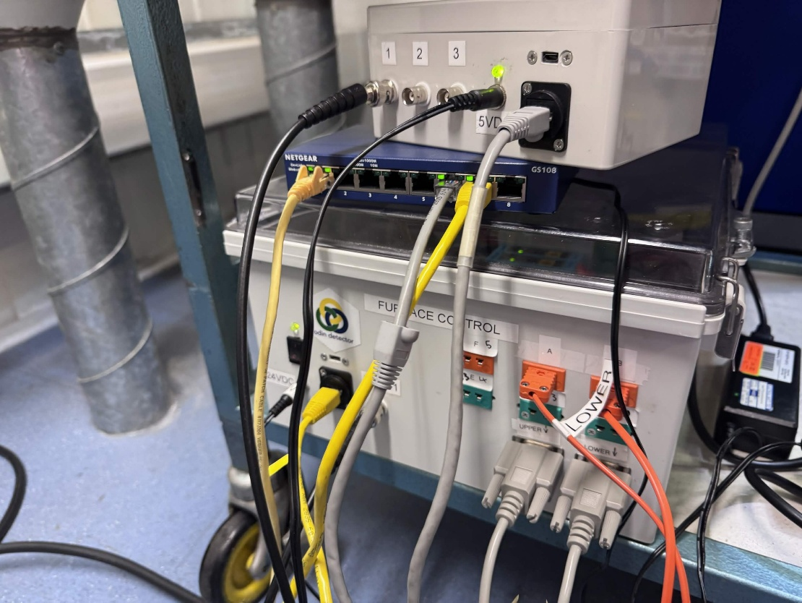
Then connect the power supplies to the furnace and ensure they are connected to power. After this, connect the furnace thermocouples as desired , confirm any relevant settings and start odin-control on the control machine.

Start the Software

Odin-Data
TBC

Odin-Control (one machine)
- Open a terminal, navigate to the installation directory:
  - ~/develop/projects/livex-050
- Start the virtual environment
  - source venv-livex/bin/activate
- Start odin control
  - cd livex/control
  - odin_control --config test/config/livex.cfg
    - Ensure config is correct first. Restart if necessary. Stop odin-control with ctrl+c

Odin-Control (via livexws)
- Through the workstation machine in the beamline control room, open a terminal and connect to livexctrl, and enter the password.
  - ssh livex@livexctrl
- Navigate to the installation directory:
  - ~/develop/projects/livex-XXX/
- Run the following commands to start the virtual environment and run odin control
  - source venv-livex/bin/activate
  - cd livex/control
  - odin_control --config test/config/livex.cfg

Using the Software

Heater safety features
Before talking about the software directly, relevant safety features, in no particular order.
- On the furnace page, the ‘stop all outputs’ button in the top-right corner immediately sets both PID outputs to 0 and disables the PIDs, stopping further heating.
- Disabling a PID in any way immediately sets its output to 0 in the firmware.
- The PID override option can be used to set the PLC output directly, bypassing PID behaviour. This can stop a potential erratic PID loop, but also bypass it entirely if the furnace setup (e.g. thermocouple contact) is unstable or configured poorly. By default, these are set to 0, so turning them on will stop any heating.
- On the metadata/setup page, stopping the ‘furnace’ trigger will pause the heaters. This will prevent further heating but the heater will not respond until the trigger is resumed, as all PID behaviour is contingent on the trigger.
- When the Modbus signal is lost, the PLC firmware will set its own outputs to 0 after 5 seconds, regardless of previous instruction. This can be done by:
  - Stopping odin control
  - Turning off the PC
  - Disconnecting the network connection to the PLC in any way
- The power output scalar setting on the furnace controls can be used to limit the maximum output without affecting the PID behaviour. This allows safe use of more powerful controllers but also helps to avoid risk of over-voltage protection on the power supplies if there is a spike in power due to e.g. a setpoint change

Metadata and Setup
This page has two elements, metadata input and triggers and acquisition control.

Metadata
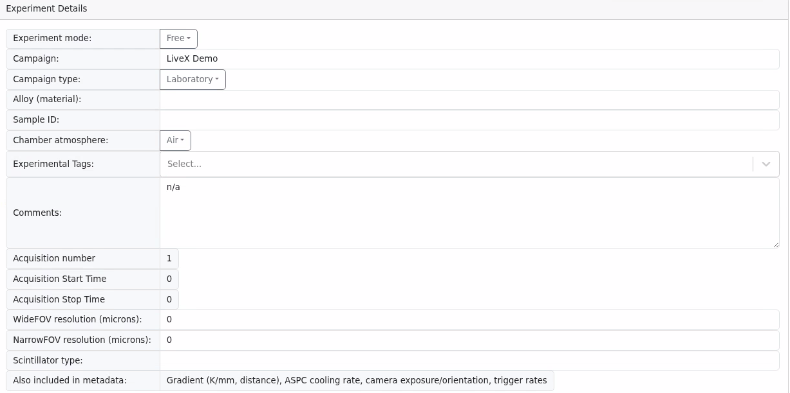
These values are saved when submitted and otherwise are as described in the metadata.json configuration file. The filename is generated from the campaign name and acquisition number and suffixed with a data source name (“_metadata”, “_furnace”, “_widefov”, “_narrowfov”).

Triggers and Acquisition Control
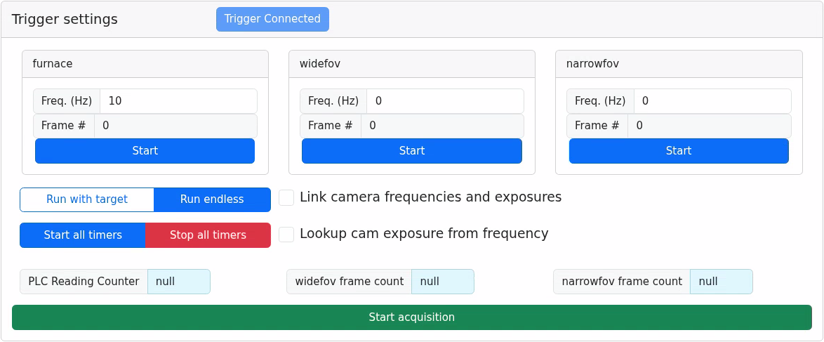
The triggers are derived from the trigger adapter and so the names will changed based on configuration, but should ideally be kept as widefov and narrowfov for consistency (if one instance of the name is changed they should all be). By default, ‘furnace’, ‘widefov’, ‘narrowfov’ refer to trigger outputs 1, 2, and 3, with 4 going unused.
The frame targets are used only in ‘Run with target’ mode and only the furnace target is used, with the frame targets for the cameras scaling off of that value based on the frame rates, so that the acquisition finishes at the same time for them all. The acquisition must still be stopped manually but no more data will be recorded at that point.
The frequency for the furnace determines the rate at which data is acquired and the rate at which the PID is run. As such, this value should usually be 10 or higher to ensure best PID behaviour. The PID will account for difference in time with its terms so theoretically it should not matter.
‘Link camera frequencies and exposures’ links both cameras, so that if one’s exposure or frequency is set the other will immediately change to match it.
‘Lookup cam exposure frequency’ uses a table to associate camera frequency with the fastest exposure that will not skip frames. Frequency is measured in Hz integers.
‘Start all timers’ and ‘stop all timers’ do as said. Note that this will reset any frame targets set when the timers restart.
‘Start acquisition’ sets up the data flow for the furnace and cameras, including incrementing the acquisition number, generating an ‘acquisition start time’, and starting recording with odin data. At this point, the button will reconfigure to ‘stop acquisition’, which closes files and immediately ceases data recording – this is also the point at which the metadata file is written, so values can be changed up to this point but be aware that this may lead to inconsistencies, e.g. if campaign name is changed it will not match the file name.

Furnace Control

Heater Controls
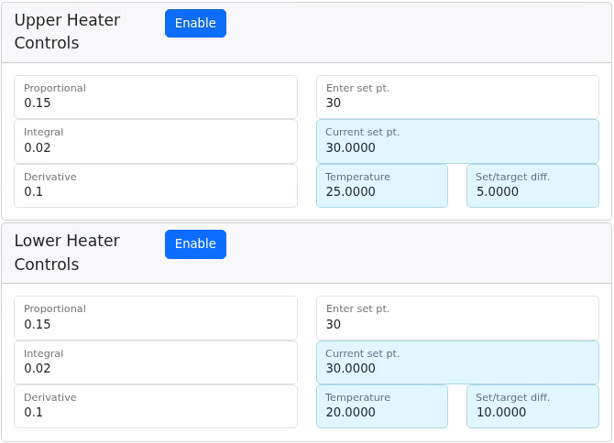
The left values are inputs for the proportional, integral, and derivative terms for each individual heater in the furnace controller.
The right value allows you to input the target setpoint. The ‘Current set pt.’ value beneath it shows the current value in the controller, in case it is being modified by another feature such as the thermal gradient or auto setpoint control.
The temperature shows the current value of the associated thermocouple to the heater, as set in the software configuration, and the ‘set/target diff.’ refers to the current gap between the temperature and the target setpoint.
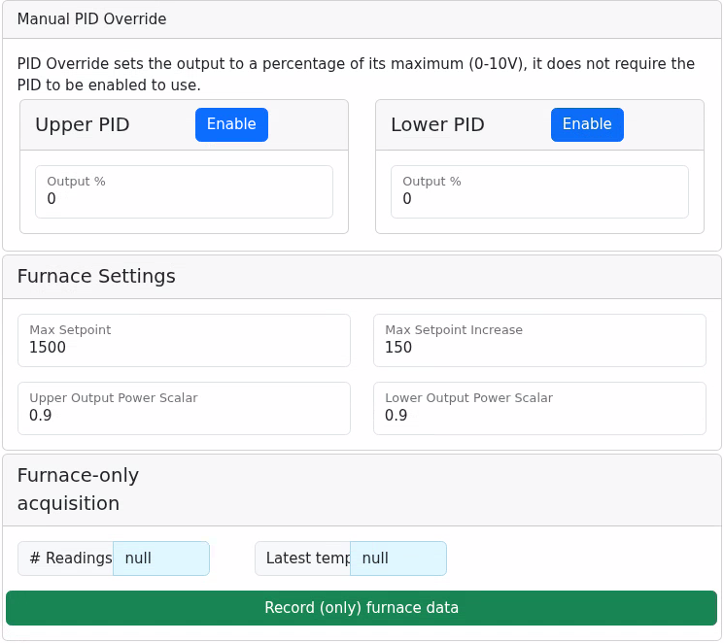
The ‘Manual PID Override’ options, when enabled, set the 1-10V output on the PLC directly to 0-100% of that output. With a 40V supply, a 50% override would provide 20V of heating output. This is only made visible through the adapter configuration, detailed later.
The ‘Furnace Settings’ controls apply to both furnaces. The maximum setpoint is the highest temperature the furnaces are allowed to be set to. The max setpoint increase is the largest amount the setpoint can increase in one step without being rejected by the adapter.
The power scalar values apply to their respective heaters. If the heaters are connected to e.g. a 40V power supply, then a 0.9 power scalar would result in a heater at 100% output only outputting 36V. It acts as a multiplier for the PID output of the PLC; the 0-10V signal that is output to the power supply is multiplied by the power scalars. The value of these must be between 0 and 1.
The furnace-only acquisition will start an acquisition for the furnace only, including metadata. This is only made visible through the adapter configuration, detailed later.
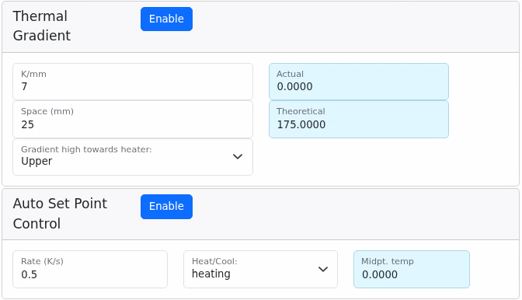
The Thermal Gradient controls allow you to specify a thermal gradient. The gradient (theoretical) value is equal to the K/mm multiplied by the Space (mm) values. ‘Gradient high towards heater’ specifies which heater will be the high end of the gradient – the other heater’s setpoint is reduced by an amount equal to the theoretical gradient.
The actual gradient is read from the real difference between the heater temperatures. The enable button toggles the feature on and off.
Auto Set Point Control will either increase (heat) or decrease (cool) both heaters by the rate specified in the other input when enabled with the button. The midpoint temperature of the two heaters is reported here as well.

Monitor Panel
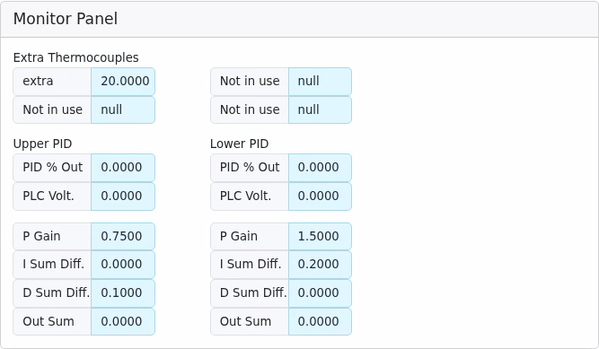
This panel shows the readings of any additional configured thermocouples (up to 4 beyond the two required for the heaters).
It also details PID outputs for the two heaters. The % out is the strength of the output from 0-100%, and this is translated into an approximate voltage output by the PLC (a 0-10V) scale. This value is not read back, but calculated. Adding an accurate reading from the power supply is a future extension of this work. The other details summarise the components of the PID calculation to make it easier to refine the terms if needed.

Camera Control

Monitoring
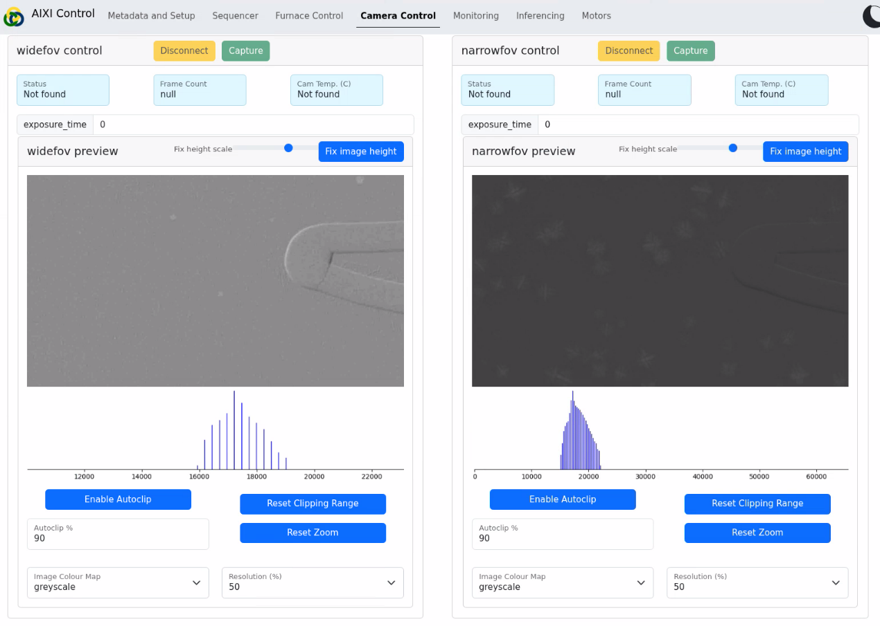
The disconnect/capture buttons at the top will change state accordingly to move the cameras from ‘disconnected’ to ‘connected’ to ‘capturing’ as needed. ‘exposure_time’ changes the exposure on the cameras – if this is too close to the frame rate of the camera then frames will be missed.
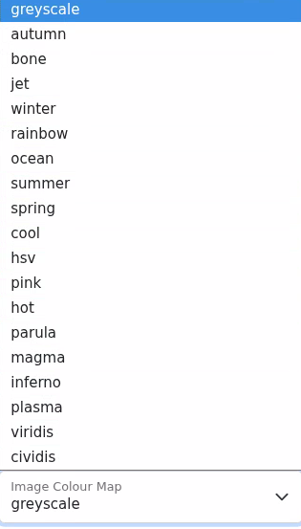
The camera output and histogram each update once per second provided the framerate is at least 1Hz. You can click+drag on the images to zoom in. For the image, this is just a zoom. For the histogram, this affects the clipping range of the image and will limit the pixel values to allow control over the image’s contrast.
Autoclip does this for you, choosing the median selected percentile of the data. For example, 90% would leave out the top and bottom 5% of pixels.
The colourmap changes the colour scale of the values. There are 18 colourmaps to choose from and greyscale.
Resolution previously determined maximum image dimensions but is no longer used.

Inferencing
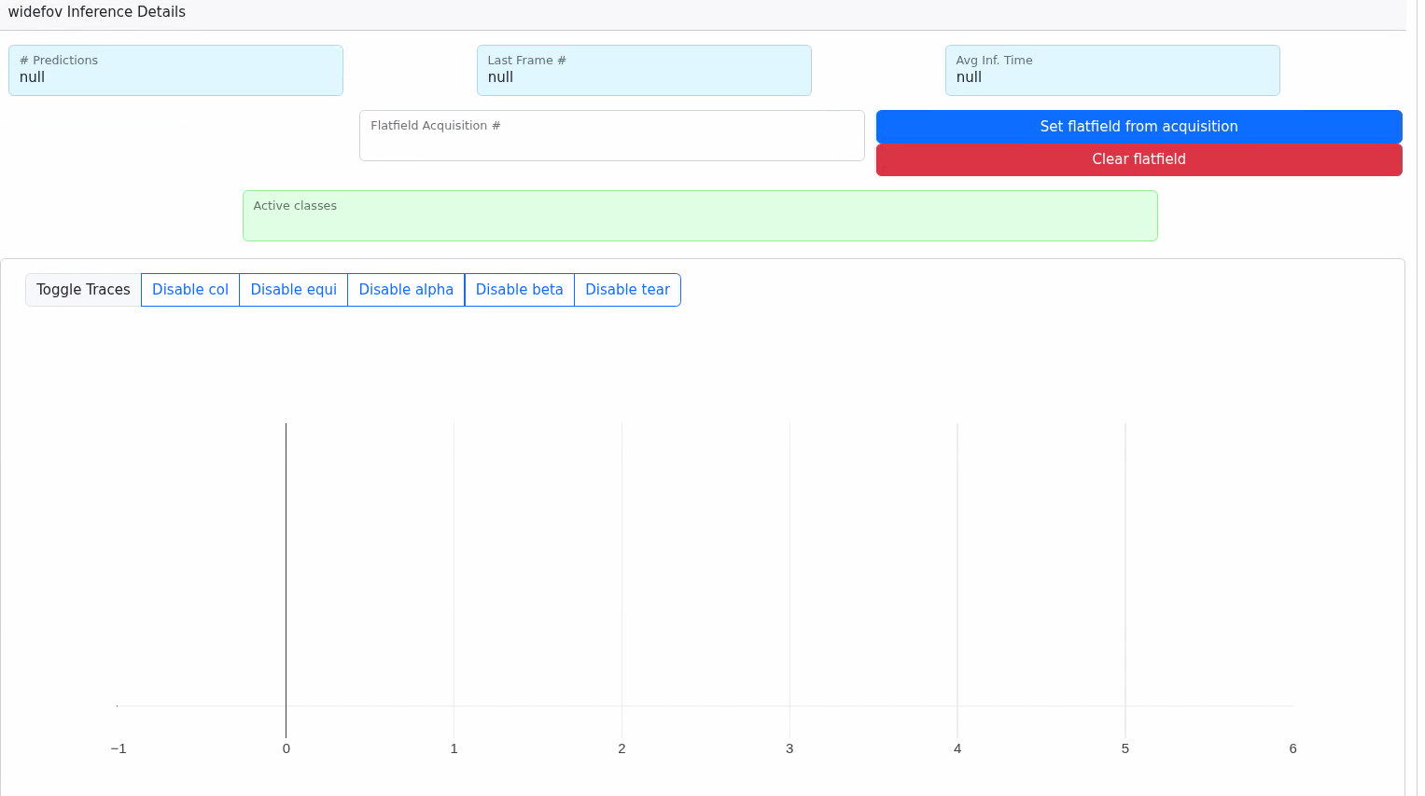
The inference controls are subject to change in the future but will follow the general shape:
- # of predictions in a given frame
- Number of the last frame analysed
- Average time taken to perform the inferencing on each frame
It should also indicate which classes are ‘active’ in a given frame, over a specified threshold. This will also be indicated on the graph when data is present.
There are also the options to select a frame to flatfield the inferencing on. This may change to selecting a dataset and using the first frame on it in future iterations, or the first frame of the current acquisition will be used.

Motors
The motor control page will contain some number of motor control panels, based on how many motors are configured. AIXI only uses KDC101 controllers, so each panel should look like the following image.
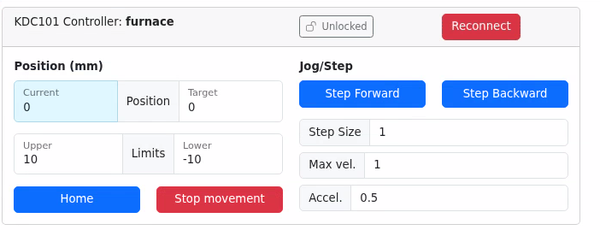
In the ‘Position’ column are values related to the position of the motor. They are measured in millimetres.
Current position indicates the readout value from the motor. Target is the desired position, and when the value is submitted to this field, the motor will move to that position.
The Upper and Lower Limits indicate the values that the motor will not move past. If you set the limit past the motor’s current position, the motor will not be moved back to adjust, and this could affect the ability of the step commands to function. Ideally, this is set before any motor movement is done.
The Home button tells the motor to Home, which will move it to one of the edges of its movement, so be aware if the motor would collide with something on the way. Stop movement stops any current movement of the motor.
In the ‘Jog/Step’ column are values related to the fixed-length movement of the motor, referred to as ‘stepping’. The step size, max velocity, and acceleration are all measured in millimetres. All values must be higher than zero.
‘Step forward’ and ‘Step backward’ can be relabelled in the configuration in the way that makes the most sense. By default, these use the controller-internal ‘forward/reverse’ directions, which may not correspond to increasing or decreasing the numbers as one would intuitively expect. Test these before connecting the motors into a wider system.
The ‘lock’ button at the top prevents movement commands being submitted from the user interface but has no bearing on the adapter controls. Reconnect will attempt to establish a motor connection if it is lost.

Software Configuration
The software is run through a configuration file, `livex.cfg`. In this file, each adapter has its own section where certain parameters can be configured. If the file is edited, the software must be restarted to see the changes.

livex settings
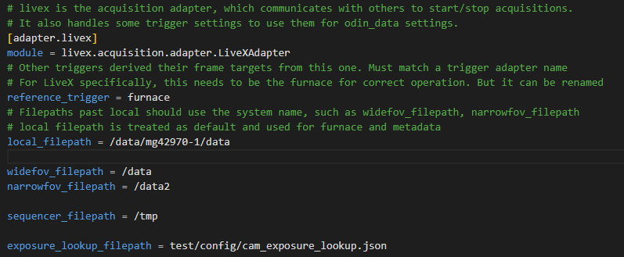
The livex adapter handles communications between other adapters. Its settings are filepaths for the five saved files.
- local_filepath is for the furnace and metadata, which will be saved to the specified directory in /furnace or /metadata
- widefov/narrowfov_filepath is for the cameras and will be saved on the camera machines.
- sequencer_filepath is where any sequencer log files will be saved
- exposure_lookup_filepath should point at the ‘cam_exposure_lookup.json’ file for the benefit of the ‘lookup cam exposure from frequency’ option on the trigger page.
The ‘reference trigger’ is also for the triggers – determining which is the ‘source of truth’ for the frame targets. The reference trigger will be set and the others will base their frame targets off of this based on their frame rates. This should be left as ‘furnace’.

furnace settings
Options here are separated into sections for convenience.
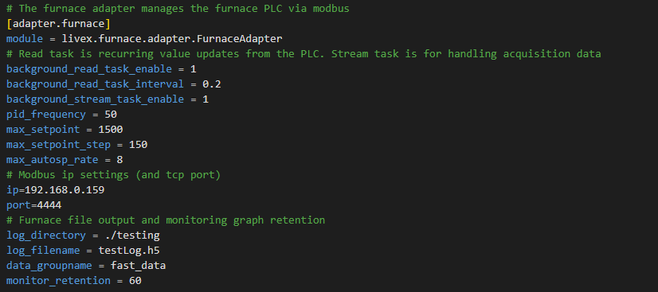
The background_task values determine the frequency (and if at all) the regular furnace-PLC polling updates occur at, and for the streaming task when an acquisition is underway.
The pid_frequency is the initial rate of the furnace PLC’s trigger. This will be updated when the trigger’s frequency is changed.
max_setpoint, max_setpoint_step, and max_autosp_rate the maximum temperature setting, maximum temperature setting increase, and maximum temperature heating or cooling rate. These can be overridden through the interface.
The modbus ip and port settings should not be changed as the PLC’s connection details will not change.
The furnace file settings are the default values for the file name and path and are overwritten in livex adapter behaviour. They would be used if you ran a solo furnace acquisition through the internal start_acquisition function via the sequencer.
Data_groupname and monitor_retention refer to the history of the graphs and should not need editing.
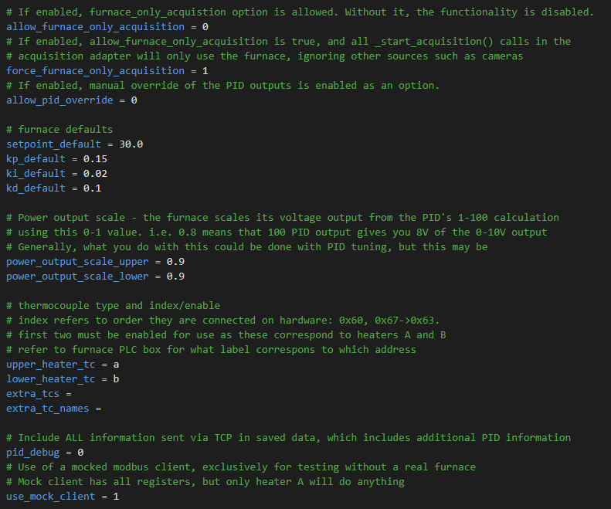
allow_furnace_only_acquisition provides a UI option for a solo furnace acquisition on the furnace page. force_furnace_only_acquisition makes the main ‘start acquisition’ button on the Metadata and Setup page do a furnace only acquisition.
allow_pid_override also adds a component to the furnace page, with a toggle-able %-based output for the 1-10 PLC voltage. This completely overrides PID behaviour when on.
Furnace defaults are simply default values for the PID settings. P0.15, I0.02 and D0.1 seem to work well with most configurations.
power_output_scale_upper/lower scale the PLC 1-10V output from 0-1 representing 0-100%. This reduces the maximum power output, avoiding overvoltage and allowing use of power supplies of different ranges without needing to retune the PID.
upper/lower_heater_tc, extra_tcs and extra_tc_names define the thermocouple connections for the firmware. This is based on the box connections and labels. Upper and lower are mandatory, other thermocouples need a connection point (a-f) and a name of choice.
pid_debug includes extra information on PID behaviour in the saved furnace.h5 data.
use_mock_client is largely for testing, simulating the upper heater when no real furnace connection is available.

trigger settings
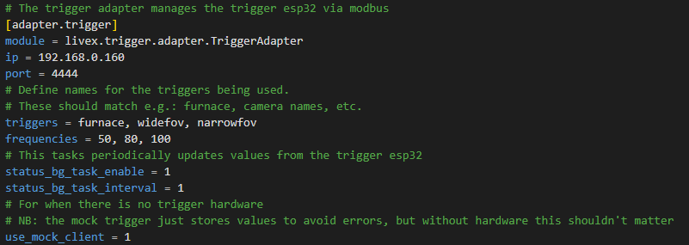
The modbus settings should not need to be changed as with the furnace.
‘triggers’ defines the trigger names. These should not need changing, but if you change one ensure that name is changed anywhere else it appears in the settings at least.
‘frequencies’ defines the initial frequencies of those triggers
The background task settings also should not need adjusting as this ensures the trigger is updating its values from the esp32.
‘use_mock_client’, like the furnace, replaces the trigger with a simulated one. It has no behaviour but stores values.

graph settings
The graph adapter has one setting, ‘config_file’, which is the path to the JSON file. The JSON file has a series of objects like this:
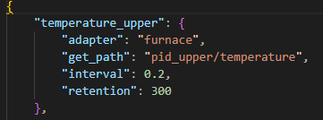
Those objects define the name of the endpoint, and within it the data-source adapter, the path it should read data from, the frequency at which it reads and how many data points to retain. In this example, the upper heater temperature is read 5 times per second and 300 entries are retained, leaving 60 seconds of real-time data.
These graphs are used on the monitoring page.

live_data settings

livedata_endpoints are the zmq address for the machine, endpoint_name is the respective name of the endpoint.
camera_resolution is another comma-separated expression of the image dimensions, same for both in the current setup. camera_pixel_size is the same, bytes_per_pixel.
<endpoint_name>_orientation is for where the top of the image is, unrotated. So, ‘up’ changes nothing, ‘right’ rotates 90 degrees counterclockwise, down rotates 180 degrees, and ‘left’ rotates 90 degrees clockwise.
<endpoint_name>_mirror mirrors the image on a given axis. The value should x, y, or x,y. Any other value will be ignored.

munir settings
Munir settings control odin-data and so should not need to be edited.
Subsystems names the connected data endpoints.
<subsystem_name>_endpoints is the connection URL for the subsystems.
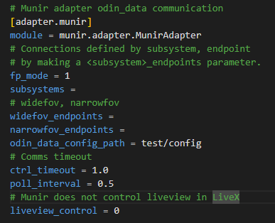
odin_data_config_path directs to a JSON file with a series of odin-data settings in it, used when certain commands are sent in the acquisition adapter.
ctrl_timeout and poll_interval both relate to odin-data communications. Timeout dictates how long a message should wait before being considered failed, and poll_interval determines how often the subsystem should get information from odin-data.

metadata settings
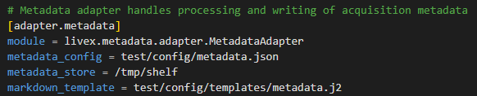
Metadata settings point at where files should be saved. The store is for persistent data across software uses (but is cleared on system restart). The markdown template determines how the metadata is written to a file.
Metadata config points at a JSON file that looks like this:
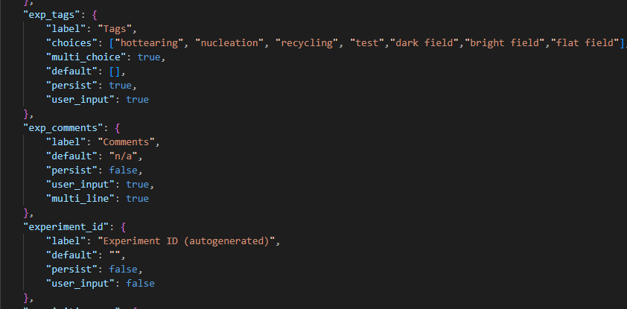
Each metadata option has these options necessarily:
- label, default, persist, and user_input. User_input options will show on the Metadata and Setup page. Label is the label on that page. Default is the default value but is overridden by a persisted value if there is one.
Other options may be present:
- ‘choices’ is a list of options and converts a metadata value to a selection dropdown.
- ‘multi_choice’ allows multiple selections is an input is a choice
- ‘multi_line’ converts an option to a multi-line text input field.

sequencer settings
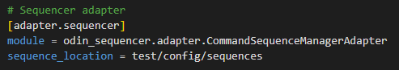
The only option here is the directory where the sequences are stored. Normally, this directory will be adjacent to the livex.cfg file along with the other configuration files to keep things simple. For more information on sequences, see the Sequencer section.

kinesis/motors settings
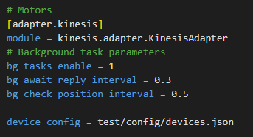
The background tasks in the kinesis adapter handle motor communications – how often replies are checked for most messages, and how often the position of the motor is polled in separate task. Making the position update too fast could affect the other task.
Device_config points at a JSON configuration file that looks like this:
The first part of the object (“furnace” in this example) is the name of the controller.
- ‘device_type’ is the model of the controller
- ‘port’ is the USB connection for that controller, e.g. “KDC101”
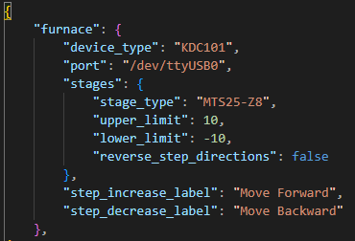
- ‘stages’ refers to all connected motor stages. For KDC101 controllers, that’s just one
- Each stage has a name, e.g. “heater_a”
- ‘stage_type’ is the model of the stage, e.g. “MTS50-Z8”
- ‘upper/lower_limit’ are the positional limits imposed by software. The motor will not willingly move or step past these limits
- ‘step_in/decrease_label’ allow you to change the label of the step commands in the GUI to let them suit the furnace setup better.

inference settings
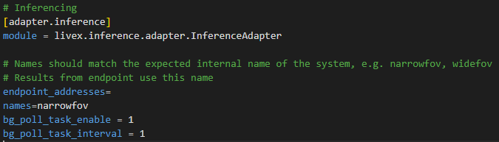
The settings here are for the inference endpoint address, the name of the endpoint (separated with commas as with the cameras and live_data).
The background task concerns how frequently the endpoint polls for information. It should only normally be sent information once per second.

Sequencer

Sequencer Page
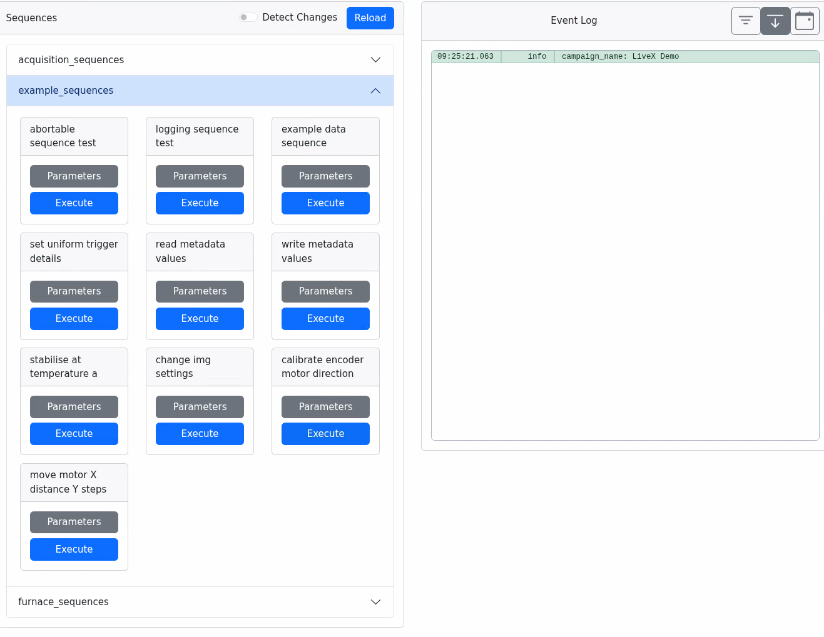
The left column contains the sequences. The dropdowns are the python files in the sequences directory, and the sequences within it are the functions made available through the `provides=[‘function_name’]` behaviour within a sequence file.
‘Parameters’ brings up a small submenu where you can edit the values for the sequences based on the python function’s arguments, strictly limited by the type of the default value of the parameter. ‘Excecute’ then runs the sequence.
Also in the left column are the ‘detect changes’ and ‘Reload’ options. If enabled, ‘detect changes’ will inform you when a sequence file has been edited and saved since it was last loaded. ‘Reload’ will update the sequences – without pressing this, any changes you make to your sequences will not be available in the application unless you restart it.
Any outputs within the sequence, including errors, appear in the log in the right column of the page. The log has three options: ‘filter’, which allows you to limit what log levels appear and sort by timestamps/dates; ‘auto scroll’, which will move the log to show the latest log event; and ‘show date’ which will include the date in DD/MM/YYYY format on the left of the log. To use the log in your sequences, see the following section.

Writing a Sequence
Sequences are functions written in Python.
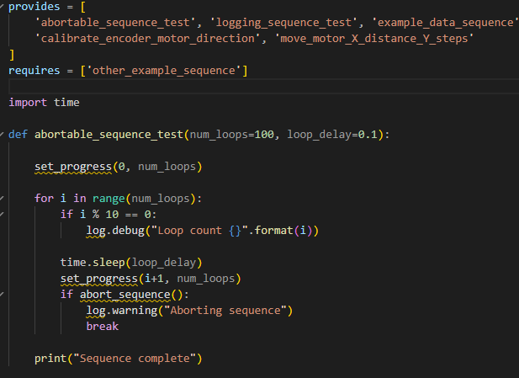
‘provides’ at the top makes the function visible to the sequencer.
‘requires’ allows you to use functions in other sequencer files in that specific file.
To use the events log to display relevant updates or information during a sequence, you can use python’s normal `print` function, which prints to the log at an ‘info’ level. Or you can use `log.debug/info/warning/error`, which behaves very similarly but prints at other levels which you can filter using the log console.
You can also use `set_progress(x, y)` to set the sequence’s progress to a percentage, calculated as 100* (x/y). For long sequences this can be useful to make it clear that the sequence is still progressing and has not hung, frozen, or crashed in some way. That may look like the example image below: a simple sequence that counts to 100 and reports progress.
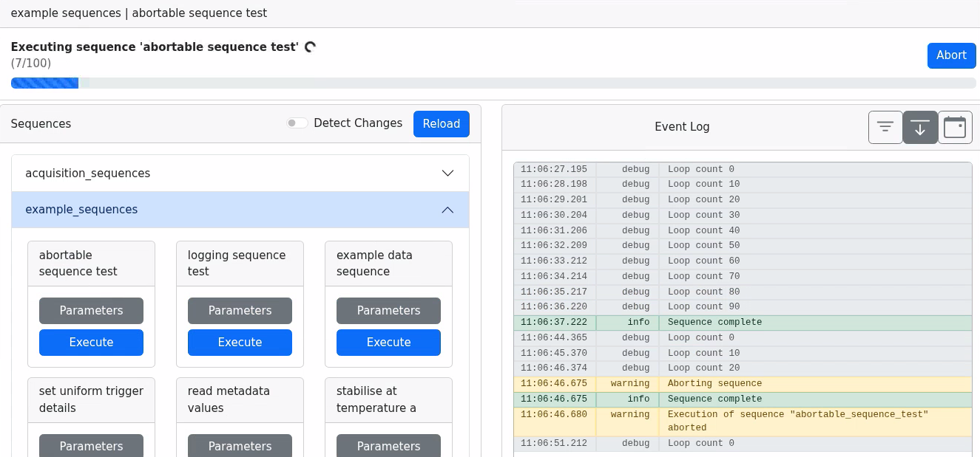
Note that if a sequence runs without any delays, events and progress will likely lag behind the actual progress of the sequence by some amount. The interface will only fetch the values periodically, so a fast sequence may have lots of progress or multiple event logs become visible at once.

Accessible Sequence Values
The document describing these values for the AIXI project is available at the following URL: https://github.com/stfc-aeg/LiveX/blob/main/docs/LiveX_Sequencer.md
To use these within a sequence, you can do this through the `get_context` function like so: `livex = get_context('livex')` for the livex/acquisition adapter, `furnace = get_context(‘furnace’)` for the furnace adapter, etc.

