Eden Astronomy Society
NEWSLETTER · ISSUE 3/2026 · SEPTEMBER 2026
Dear members and friends,
the short nights are over, and with September our observing season begins. In this issue we look back at the solar eclipse of 12 August, invite you to a talk on the return to the Moon, and present the treasurer’s report for the first half of the year. Clear skies, the committee.

Talk: Back to the Moon
On 26 September Dr Miriam Falk of the city planetarium speaks about the Artemis missions and about what has changed in technology and ambition since Apollo. The talk starts at 7:30 pm in the society rooms; admission is free, and a donation towards the speaker’s travel is welcome.
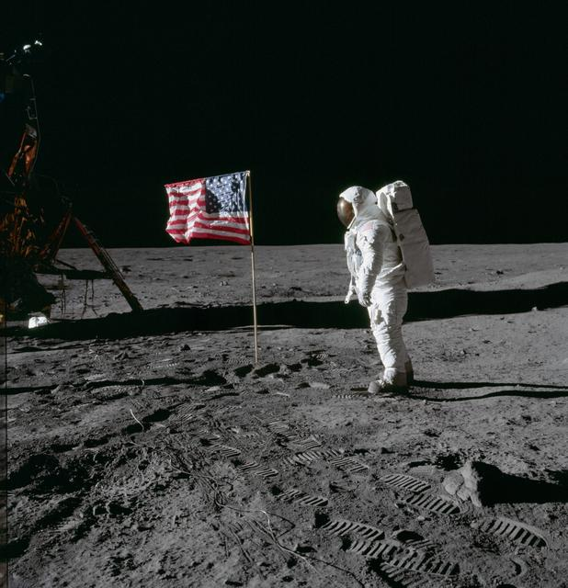
Figure 1: Edwin “Buzz” Aldrin beside the flag, Apollo 11, July 1969. Photo: NASA.
For those who want to prepare: the society archive holds the original photographs of the landings in high resolution, along with maps of the landing sites. The 8-inch Newtonian shows the regions well on a waxing Moon, best two or three days after first quarter, when the terminator runs across the Sea of Tranquillity.

Looking back: the eclipse in Spain
Fourteen members travelled to northern Spain for the total solar eclipse on 12 August. After an overcast morning the sky cleared an hour before second contact, and the one minute and forty seconds of totality were seen in full from the high ground near Burgos. The corona showed three long streamers, and a prominence on the eastern limb was visible to the naked eye.
The group’s photographs are on the members’ pages of the website. A slide show follows at the members’ evening in December.

Picture of the month
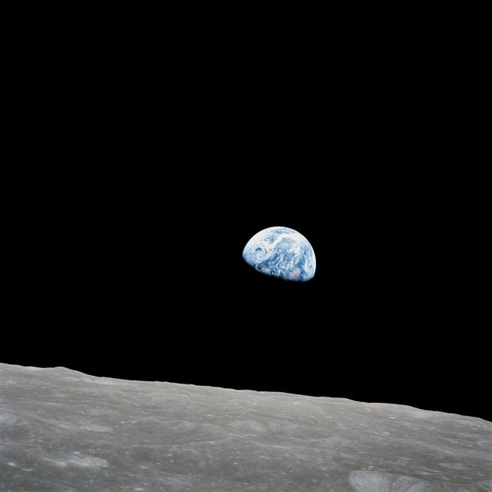
Figure 2: Earthrise, photographed from Apollo 8 on 24 December 1968. Photo: NASA.
This month not a picture from the observatory but a historic one: the Earthrise that William Anders photographed in 1968 on the fourth orbit of the Moon. It fits the theme of the talk, and it is a reminder of why we look up in the first place.

Observing nights this autumn
Observing nights take place at the Oak Hill observatory whenever the sky is clear. Whether an evening goes ahead is decided by the leader by 5 pm; the announcement is then on the website and in the members’ group. Dress warmly and bring a red torch.
Date | Objects | Instrument | Led by
19 September | Saturn, Neptune | 8-inch Newtonian | K. Brandt
3 October | Andromeda Galaxy, the Double Cluster | Binoculars, refractor | S. Öztürk
17 October | Moon (waxing), Jupiter | 8-inch Newtonian | K. Brandt
31 October | Pleiades, Orion Nebula | Refractor | A. Lindgren
14 November | Leonids, Uranus | Binoculars | S. Öztürk

For the Leonids on 14 November we meet at 11 pm; the meteors are most frequent after midnight. Members bringing their own telescope will find power sockets on the east side of the observatory.

Treasurer’s report, first half of 2026
The society is on a sound footing. Subscriptions cover the running costs; the telescope service was a one-off expense met from the reserve. The totals in the table are computed from the individual items.
Dates this autumn
- 12 September
Members’ evening, 7:30 pm
- 26 September
Talk: “Back to the Moon”
- 10 October
Public observing night, observatory
- 7 November
Annual general meeting
Guests are welcome at every event.
Item | Income (€) | Expenditure (€)
Subscriptions | 2450.00
Donations | 380.00
Talks and events | 215.50
Telescope service |  | 640.00
Rent, society rooms |  | 900.00
Insurance |  | 210.00
Total | 3045.50 | 1750.00
Balance | 1295.50

The full report will be available at the annual general meeting on 7 November. The treasurer is happy to answer questions by e-mail beforehand.
Imprint: Eden Astronomy Society, Oak Hill Observatory. Edited by the committee. Published four times a year. Contributions for the next issue to the editors by 15 November.

