Gate 3 - Design Document Approval and Gate Participants

**Project: *Bluetooth –* *Android Intern Project***

Date(s): *Summer 2013*

Project Manager: *Blaine Tiernan*

Prepared by: *Lee Easton*

Document status: _**X**_ Draft __ Proposed __ Validated __ Approved

**Change Log**

|  |  |  |  |
| --- | --- | --- | --- |
| **Version** | **Changes Description** | **Author** | **Date** |
| 1 | First draft | L Easton | 2013,June 6 |

Contents

NOTE 1

1. Introduction 2

1.1 Intended Audience 2

1.2 References 2

1.3 Acronyms and Abbreviations 2

1.4 Assumptions 2

2. System Design 3

2.1 System Overview 3

2.1.1 Development of TotalFlow Android Application 3

2.1.2 Development of Remote Access App pages 3

2.1.3 Development of Adaptation layer 3

2.1.4 Design for application page development for test automation 4

2.1.5 TotalFlow.apk (Flash) Changes 4

2.2 Deployment Diagram 4

2.3 Solution Architecture 4

2.4 UI Information Model 6

2.5 UI Screens Summary 10

2.5.1 Phase 1 Screens 10

3 TotalFlow Android Application Design 10

NOTE

The Document Author has to remember the Gate 3 is the Agreement on Product Design. This is the most important milestone, as once this gate is passed the project moves out of into coding and testing phases. A comprehensive document must be produced, outlining the technical design.>

1. Introduction

This document provides details over the technical architecture and design for implementing the ABB TotalFlow Android application. It baselines the sub-systems and implementation approach for the UI and the middleware layers which is followed during the application development.

1.1 Intended Audience

This document is targeted at team management, application developers, and testers involved in implementing ABB TotalFlow Android application.

1.2 References

1. ABB_NGHLA_Layout_Specs_220812.pdf
2. Intern Project – Tcox with Elaine.docx
3. Project_Requirements_Document.doc

1.3 Acronyms and Abbreviations

| **Term** | **Definition** |
| --- | --- |
| AGA-3 | American Gas Association Report No. 3, Orifice Metering of Natural Gas. Method for calculating gas volume across an Orifice Plate. This method requires tow pressure readings, Differential Pressure (DP) and Static Pressure (SP). |
| AGA-7 | American Gas Association Report No. 7, Measurement of Gas by Turbine Meters. Method for calculating gas volume using a Pulse Meter. This method requires one pressure reading, Static Pressure (SP). |
| AJAX | Asynchronous JavaScript And XML |
| API | Application Programming Interface |
| CSS | Cascading Style Sheet |
| DES | Data Encryption Standard |
| HTML | Hyper Text Markup Language |
| HTTP | Hyper Text Transfer Protocol |
| HTTPS | Hyper Text Transfer Protocol Secure |
| IP | Internet Protocol |
| JS | Java Script |
| LAN | Local Area Network |
| RBAC | Role Based Access Control |
| SSL | Secure Socket Layer |
| TCP | Transmission Control Protocol |
| TLS | Transport Layer Security |
| UI | User Interface |
|  |  |

1.4 Assumptions

1. Target screens for the current scope have been based on the marketing requirement document (Intern Project – Tcox with Elaine.docx) and the corresponding NGHLA Website. Any further screen modifications, addition and deletion will need fresh analysis and review from both effort and schedule perspective.
2. All the Remote Access development and testing will consider the Android devices (and their versions) as documented in the requirement document.
3. This document assumes that BLAHBLAH web server shall be used to host the web services on Android device.
4. It is assumed that no language other than English is supported for the Android application.
5. Android device is only going to read the AGA-3 tubes in the G4.

2. System Design

2.1 System Overview

This section captures the overall ABB TotalFlow Android application context and associated entities. ABB Android application is developed to enable users to browse, monitor, and share various trends and statistical values of the TotalFlow device.

Scope of Remote Access development work includes:

1. Development of User Interface
2. Development of TotalFlow Android application.
3. Development of Adaptation layer in which application uses Bluetooth to communicate with G4 device.
4. Design for Application page development for multiple Android devices and test automation.
5. Design for the Application Register/File Access methods (User Management, Alarm, Events and other flash changes).

Key Activities involved in the Local Access implementation are described in subsequent sub sections.

2.1.1 Development of TotalFlow Android Application

Application code is integrated into the android OS which sends data request to the G4 device over wireless connection. The wireless connection runs as separate thread(s) within the existing registers and the trends are hosted on the flash file system. The existing RBAC is not used for this communication.

2.1.2 Development of Remote Access App pages

Remote Access is developed as set of application pages. These application pages will be deployed on the Android device and will consist of XML pages along with JS and CSS files.

2.1.3 Development of Adaptation layer

The Adaptation layer abstracts the use of Serial Port Profiles (SPP), Transmission Control Protocol (TCP/IP), and Radio frequency communication (RFCOMM). If at any point of time the TotalFlow native calls change or get modified then the Android application is not impacted. If we decide to change the Android application API or use a different mobile device only this adaptation layer needs to be modified and no change would be needed in the underlying TotalFlow native calls.

2.1.4 Design for application page development for test automation

Application page development to support multiple Android OS versions and application page testing is automated to successfully run on various supported Android devices. Look & Feel (minor differences might be there), UI elements layouts and functionality of the page should be consistent across all the Android devices so that no functionality gets blocked or the layout gets disturbed or look misaligned.

2.1.5 TotalFlow.apk (Flash) Changes

* The flash code is enhanced to support the Application Register and File Access methods. These functions include the getting and setting of Application registers.
* Provide support for the user creation/deletion/password changing, these are used to access Remote pages.
* Changes related to implementing the retrieval of the Alarm log, Current alarms and unacknowledged Alarms.
* Changes related to implementing the retrieval of the Event log.

Details of these changes are mentioned in Chapter .

## 

## 2.2 Deployment Diagram

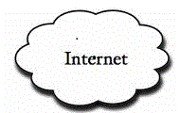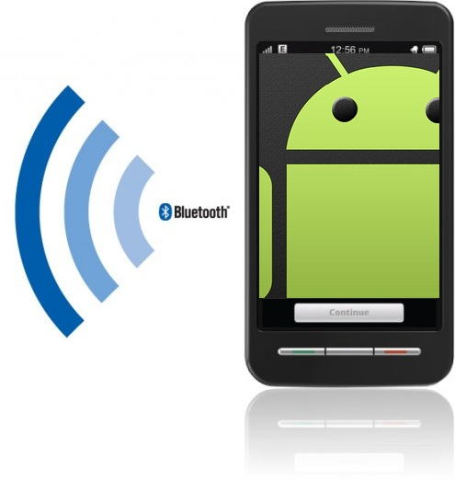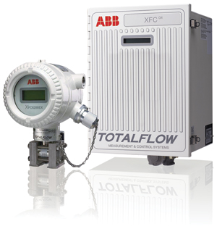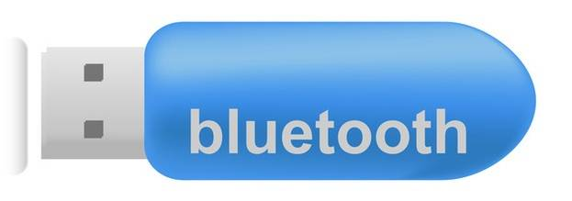

## 2.3 Solution Architecture

ABB TotalFlow Bluetooth/TCP solution is developed as a set of data pages and is deployed on abb.com (running on Android device). This application is accessible to end users from the Android device. The access to the G4 device data is expected to be from physically co-located Android device; however, the data pages can be saved and accessed again for viewing at a later time.

Remote Access enables users to monitor and store configuration and statistical data from the TotalFlow device.

Remote Access interfaces with other applications in TotalFlow.exe to get and update the content and data associated with all the screens.

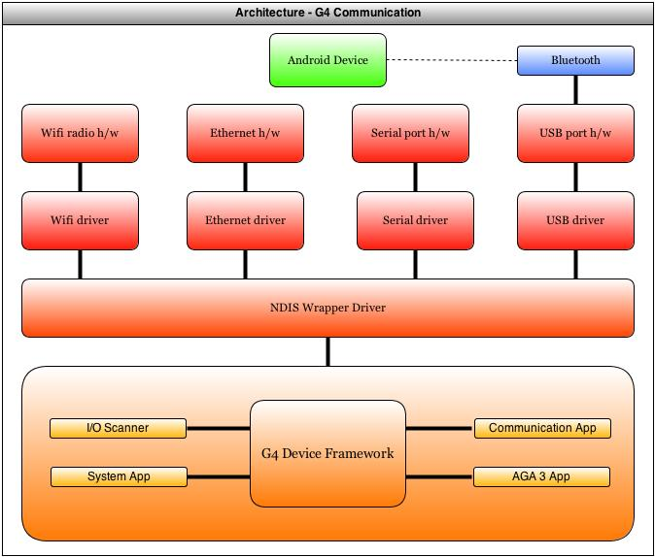

Figure 1 Solution Architecture – G4 Device

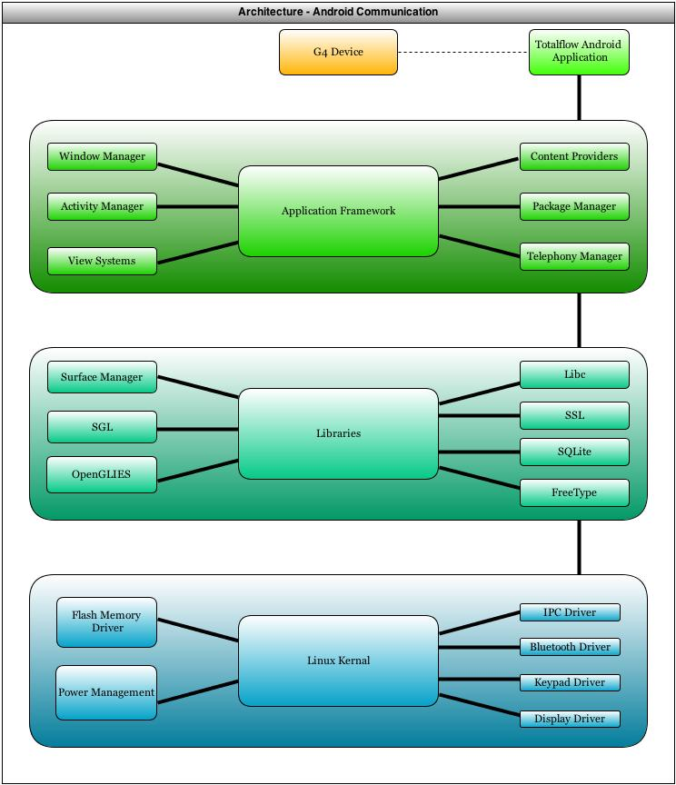

Figure 2 Solution Architecture – Android Device

## 2.4 UI Information Model

The TotalFlow Android application UI can be divided into two sets of information pages, Current Data and Settings and these are further divided into various information pages.

* Current Data
* Settings

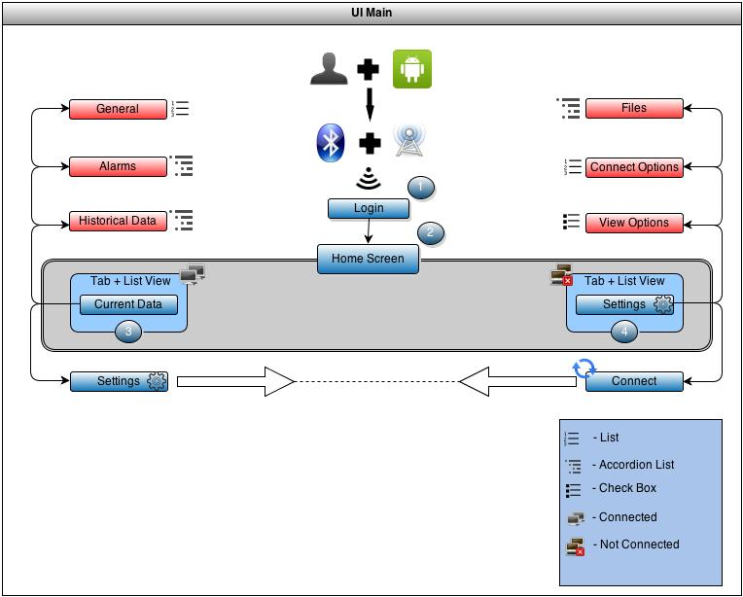

Figure 3 Login, Home Screen

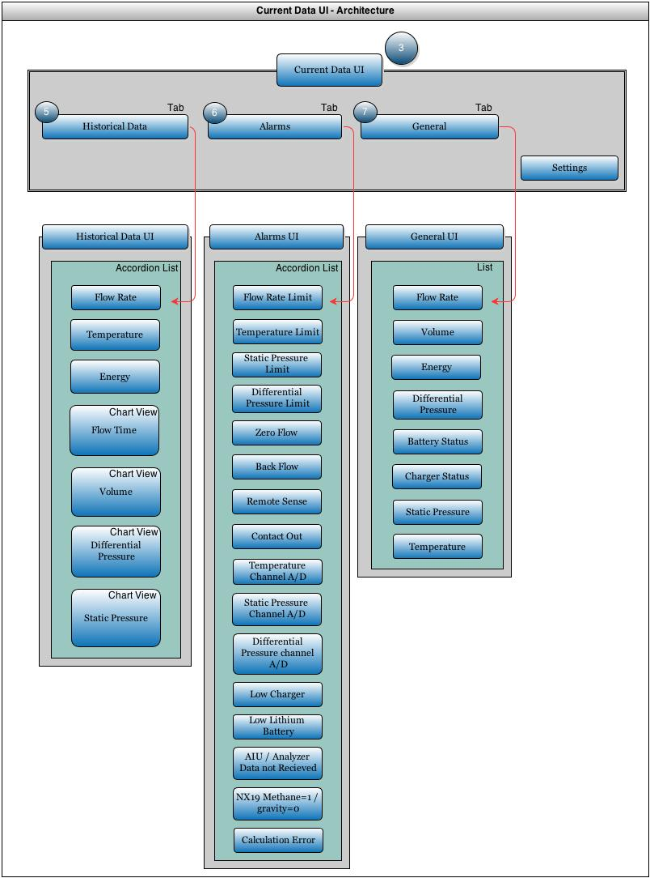

Figure 4 Current data UI, Historical data UI, Alarms, and General

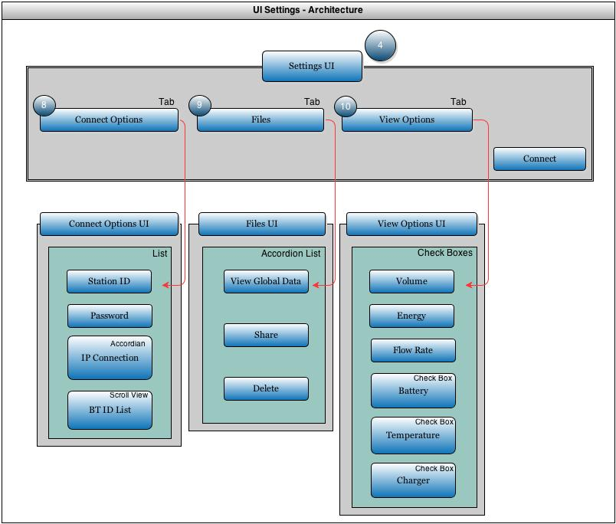

Figure 5 Connect Options UI, Files UI, and View Options UI

## 2.5 UI Screens Summary

## 2.5.1 Phase 1 Screens

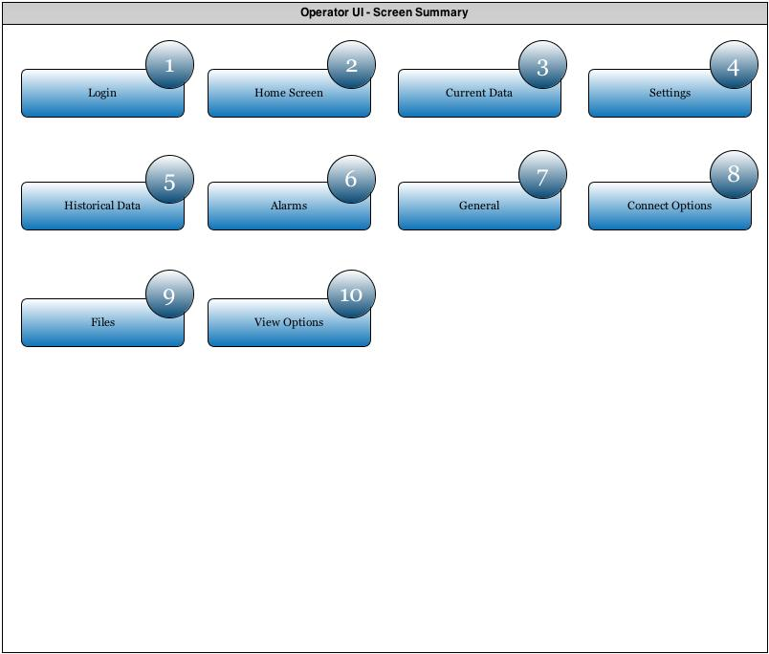

Figure 6 Remote Access UI Pages

3. TotalFlow Android Application Design

TotalFlow Android application is an application running under the context of TotalFlow process which is responsible for providing similar functionality to PCCU software. This application is responsible for accessing different registers that contain current alarms and current/historical flow measurement. The data is then stored on the Android’s external memory for accessing at a later time. The TotalFlow Android application connects to the G4 devices via Bluetooth Serial Port Protocol as well as the option of TCP/IP if the G4 device sits on a network connection.

## 3.1 TotalFlow Android Application Modules

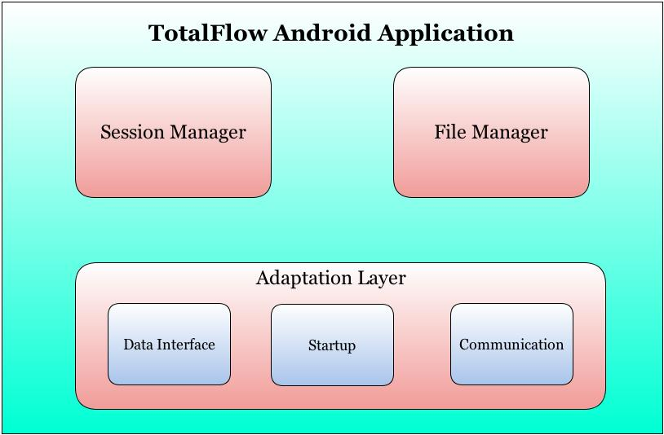

Figure 7 TotalFlow Web Application Modules

Following are the modules in TotalFlow Android application

* Session Manager
  + Session Manager is responsible for creation and validation of user sessions.
* File Manager
  + File manager is responsible for providing user access to historical files.
* Adaptation Layer

This layer acts as a broker between web server and TotalFlow application framework and vice-versa. It is responsible for communicating with other TotalFlow applications to get and change the data related to various application. It provides interfaces to the flash for the following functionalities:

* Starting the Android application
* Starting the Remote connection
* Storing the various data in the phone’s external memory
* Switching between communication protocols.

## 3.2 TotalFlow Android Application Page Lifecycle

The TotalFlow Android application page lifecycle allows for activity functionality throughout the various pages of the application.

* **Activity Launched** calls creating and starting the process of the application. The user has selected which method of connection will be used to the G4 device. Redundancy throughout the lifecycle allows for all process to return to this point.
* **Activity Running** used in the syncing page after the process has been launched and the user has selected which method of connection will be used. The activity is running in the foreground and may be paused, then sent back to the start by the user if he/she shall decide to change pages and return to the activity running. There is multiple redundant paths for the user to stop the application and restart the activity by navigating to the sync button from any page. If the user decides to re-sync then the activity will be routed to **App Process Killed** and the user will then be able to create a new process.
* **App Process Killed** allows the user to re-sync their Android device and establish a new connection at the sync page. There will only be one process running at a time, when it is killed; it is then removed from the phone’s volatile memory.
* **Activity Shut Down** is reached after the process has stopped and the user decides to close the Android application. The Totolflow Android application only has one process running at a time, so any time they navigate pages in the app it is never destroyed and shutdown until they completely close out of the application.

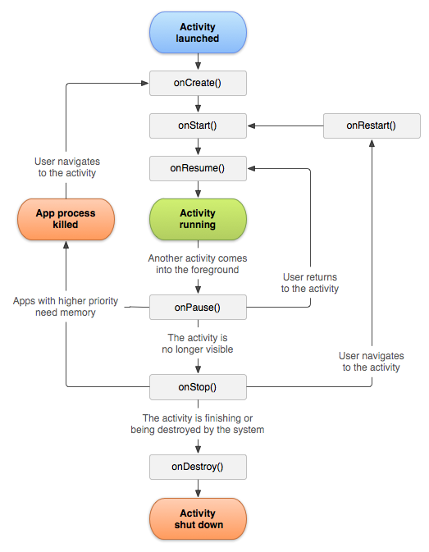

fddsfdddddddddddddddddddddddddddddddd