Week of: June 2, 2013

Risks and Issues (RAG View):

|  |  |  |  |  |  |  |  |  |
| --- | --- | --- | --- | --- | --- | --- | --- | --- |
| Risk Description | Schedule Impact | Scope  Impact | Budget  Impact | **Total  Impact** | Likelihood Mutliplier | Quantitative Risk Value (w/ RAG) | Status | Mitigation |
| Inexperience with Android  Development Environment | 3 | 4 | 3 | **10** | 100.00% | 10 | In Progress | Scheduled 2 Weeks Research |
| Inexperience with Bluetooth | 3 | 4 | 3 | **10** | 100.00% | 10 | In Progress | Scheduled 1 Week Research |
| Inexperience w/ C Language and its Translation to Java | 3 | 4 | 3 | **10** | 100.00% | 10 | Closed | Scheduled 1 Week Research |
| Android Constraints on Bluetooth Connectivity | 4 | 5 | 4 | **13** | 80.00% | 10.4 | In Progress | 2 Weeks of Bluetooth to Android Connectivity and Security Research |
| Android Firmware Incompatibility | 1 | 1 | 1 | **3** | 30.00% | 0.9 | Closed | Testing Application for  the Most Popular Firmware Releases: 3.0 and 4.3 |
| Bluetooth High/Low Current  Setting Doesn't Work | 1 | 2 | 1 | **4** | 70.00% | 2.8 | Closed | Not Necessary to Meet Marketing Requirements |
| Assuming Only One G4 Device Per Site | 3 | 1 | 3 | **7** | 50.00% | 3.5 | Closed | Not a problem as long as each G4’s Bluetooth name is differentiable |
| Bluetooth Dongles Left Active In G4 Devices Will Draw Enough Current to Kill the Solar Powered Battery | 1 | 2 | 1 | **4** | 50.00% | 2 | Closed | Not Necessary to Meet  Marketing Requirements |

Accomplishments / Work-in-Progress Activities:

**Lee Ellis Easton**

1. Finished Technical Requirements document and scheduled review meeting. (4/28)
2. Started development on a project Wiki page for the Android Development Group.
3. Continued development of Wiki Portal for the Android Development Group.
4. First revision of Technical Requirements Document.
5. Adding final sections to the Technical Requirements Document
6. G4 and X-Series Training Undertaken.
7. Testing alternatives for Bluetooth/Android connectivity using SPP.

**Victoria Som de Cerff**

1. Acquired DB2 Register Request Protocol Example Source Code.
2. Finished porting DB2 source code (C++) to Java.
3. Learned that trend data from the G4 devices aren’t Register oriented.
4. Successfully paired Android phone over Bluetooth.
5. Coding Bluetooth Serial Port to communicate with device coding Read/Write functions.

**Jeff Szcinski II**

1. Android programming language and architecture training: (60% Finished. Estimated time to Complete: 3 Days)
2. Designing the Android application itself as well as the GUI, creating locations to house the results received by the transmitting G4 Totalflow device. (5% Finished. Estimated Time to Complete: 4.4 weeks.)

**Blaine Tiernan**

1. Submitted Project Development Plan for critique. (5/25)
2. Applied Suggestions and Scheduled PDP Review Meeting. (5/31)
3. Acquired ‘Protocol Sniffer’ for Project Team.
4. Acquired USB cables to allow for ‘Protocol Sniffer’ system integration.
5. Revised Risk Assessment Document.
6. Revised Gantt chart with current pace and Gates 4 and 5.
7. Preparing Gate 1 Presentation for Wednesday at 4:00pm.

Recent and Upcoming Milestones:

* Deliverables for Gate 1 were completed on time and will be presented in Room 134 on Wednesday June 7th at 4:00pm.
* Deliverables for Gate 2 were compiled and passed review. A meeting time for the Gate presentation is to be scheduled by Friday June 14th.
* In preparation for Gate 3, scheduled for July 9th, the project team has been instructed to begin accumulating individual content for the Design Document, a Gate 3 deliverable. Generally, Lee is covering Bluetooth, Victoria is covering communication, and Jeff is covering the GUI. Over the next five weeks the project team will be working together to bring the product from theory to reality, and documenting every step of the way.

Gantt Chart w/ Action Items:

**Gantt Chart v1.0 (5-21-13):**

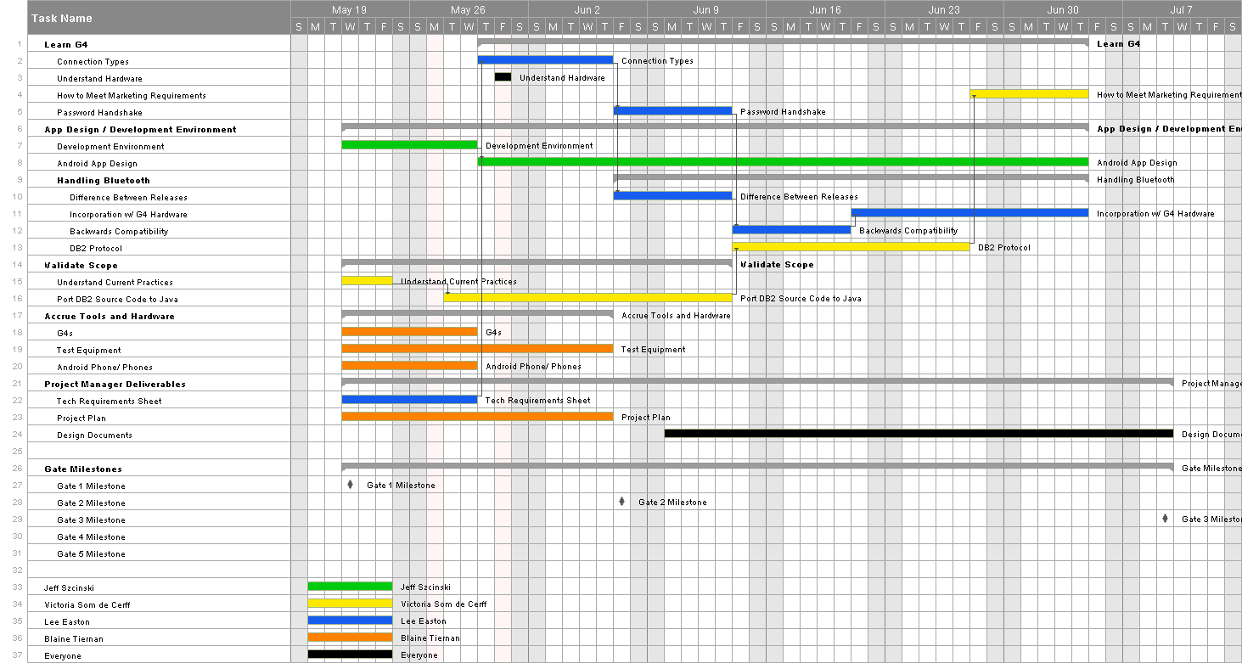

**Revised Gantt Chart v2.0 (6-2-2013):**

