Gate 2 - Requirements Document Approval and Gate Participants

Project: Bluetooth – Android Intern Project
Date(s): Summer 2013
Project Manager: Blaine Tiernan
Prepared by: Lee Easton

Document status: __ Draft _X_ Proposed _ Validated __ Approved

Change Log
Version | Changes Description | Author | Date
1 | First draft | L Easton | 2013,September 23

Index
1. Introduction 3
1.1 Purpose of This Document 3
1.2 How to Use This Document 3
R 1.2-1 Types of Reader 3
R 1.2-2 Technical Background Required 4
R 1.2-3 Overview Sections 4
1.3 Scope of the Product 4
2.1 Product Perspective 5
2.2 Product Functions 5
2.3 User Characteristics 6
2.4 General Constraints 6
2.5 Assumptions and Dependencies 6
3. Specific Requirements 7
3.1 User Requirements 7
3.2 Technical Requirements (referencing the Marketing Requirement List) 8
3.3 System and Integration Requirements 9
R 3.3-1 Android OS Requirements 9
R 3.3-2 Android Device Requirements 9
R 3.3-3 Totalflow G4 System Requirements 10
3.4 Security Requirements 10
3.5 Deployment Requirements 10
3.6 User Interface Requirements 11
4. High-Level Technology Architecture 12
5. Customer Support 13
6. Appendices 13
7. Glossary 13
8. References 14

1. Introduction
This document contains the system requirements for Bluetooth – Android Intern Project Extension. These requirements have been derived from the MRS (MRS – VSOMM with Blaine).

1.1 Purpose of This Document
This document is intended to guide development of Bluetooth – Android Intern Project. It will go through several stages during the course of the project:
- Draft: The first version, or draft version, is compiled after requirements have been discovered, recorded, classified, and prioritized.
- Proposed: The draft document is then proposed as a potential requirements specified for the project. The proposed document should be reviewed by several parties, who may comment on any requirements and any priorities, either to agree, to disagree, or to identify missing requirements. Readers include end-users, developers, project managers, and any other stakeholders. The document may be amended and re-proposed several times before moving to the next stage.
- Validated: Once the various stakeholders have agreed to the requirements in the document, it is considered validated.
- Approved: The validated document is accepted by representatives of each party of stakeholders as an appropriate statement of requirements for the project. The developers then use the requirements document as a guide to implementation and to check the progress of the project as it develops.

1.2 How to Use This Document

We expect that this document will be used by people with different skill sets. This section explains which parts of this document should be reviewed by various types of readers.

R 1.2-1 Types of Reader

Project Managers – The entirety of this document is pertinent to the project manager to gather the overview of business, marketing, and technical aspects of the product requirements.

Software Engineers – Read section three to gather the technical information required for the product. Read section four to look at a visual overview of the product requirements for better understanding. Read section eight to know what documents can be used for referencing the technical information required for the product.

Marketing/Sales – Read section two to ensure that the business and marketing requirements are met. Read section five to ensure that the customer support requirements are met. Read section seven for referencing any terminology not understood while reading sections two or five.

Customer Support – N/A

R 1.2-2 Technical Background Required

- Basic understanding of software to hardware protocols for communication
- Experience using C++, Java, and Android developing environment
- Understanding of integration between Bluetooth driver into Totalflow µFlo
- Experience with PCCU software used to collect data from Totalflow G4 series devices
- General knowledge on the software development lifecycle

R 1.2-3 Overview Sections

To gather an overall understanding of the project, read just the following sections:
- Section 2 – Product General Description
- Section 4 – High Level Technology Architecture
- Section 7 – Glossary
- Section 8 – References

1.3 Scope of the Product

The extension of the original project shall include the ability to remember connection information from previously connected devices. It shall also include the ability to read as well as write on plunger lift options, gas lift and valve control. Pulse accumulator shall also be added to the applications list representing flow rate today’s volume and yesterday’s volume. A more comprehensive and task oriented Help menu shall also be included to make navigation less confusing to those new to android.

If the tasks above are successfully completed and time remains the stretch scope would include the conversion of the android application to the Objective C programming language to run on Apple devices.

1.4 Overview of the Requirements Document

This product is feasible in all cases requiring field technicians of our customers to use when collecting various trends of data from the G4 devices.

Backwards Compatible for old files will be viewable from app updates (MRS1).

Remember previous device connections when selecting the Bluetooth or Wifi option to connect (MRS2).

Ability to write to registers in the G4 device from the Android MCCU application (MRS3).

Help page explaining application functionality (MRS4)
- Keyword Searchable
- Task Oriented

System settings allowing the user to toggle data on/off for the Data View page (MRS5).

Read and Write ability for additional Flow apps (MRS6):
- AGA3
- AGA7
- AGA3SU
- AGA7SU
- APILIQUIDSU
- VCONE
- VCONESU
- CORIOLUSSU
- NOZZLE
- NOZZLESU

Read and Write ability for additional Automation apps (MRS7):
- Gas Lift Application
- Plunger Lift Application
- Valve Control Application
- Pulse Accumulator Application (flow rate, today vol., y’day vol.)

Read and Write ability for other apps:
- IO Simulation
- XMV Interface

2. General Description
This section will give the reader an overview of the project, including why it was conceived, what it will do when complete, and the types of people expected will use it. It also lists constraints that were faced during development and assumptions made about how to proceed.

Currently the ABB (Totalflow) G4 Product line uses a PC Client based software (PCCU version 7.29) for local and remote configuration via serial and IP bases connections. The purpose of this project will be to continue development on the android application that will provide a subset of PCCU functions to a field person for access via an IP or Bluetooth connection. This application will not provide all of PCCU functionality but only the features defined in the scope section of this document.

2.1 Product Perspective

The development of this product will resolve issues of field technicians ineffectively using time to connect to G4 devices via direct cable connection. The customer will solely benefit by the use of this product when doing any pipeline measurement readings locally and through the use of the android application over network connection or with a Bluetooth dongle.

The stakeholders for this product are internal. Research and Design must use this document for reference this document when tracing back to marketing requirements. The quality and support of the product must therefore be internal and explicitly documented.

2.2 Product Functions

The product takes measurement data from the ABB Totalflow G4 devices and displays the data on the user’s Android mobile device. The application will allow the write back to registers and edit the Current settings on the G4 device. The user will now be able to remain in their vehicle while taking measurement readings.

The product shall be easy for any user to navigate to all of the main features providing the main functions below:
- Android User Interface
- Low Power Bluetooth Connection
- Wireless Data Transfer

2.3 User Characteristics

Field Technicians taking select data measurements from G4 devices can use product. The primary method of use shall be for connecting to any G4 device that does not have a networked connection already established to transfer the data to the web server.

Technicians need familiarity with G4 series including models: XFC, XRC, and uFlo.

Users need familiarity with Android OS; 3.1 (Honeycomb), 4.0 (Ice Cream Sandwich), and 4.1 (Jelly Bean).

Technicians shall have basic understanding of establishing a Bluetooth connection between two devices. Documentation shall be provided with Bluetooth being purchased along with G4 device.

Technicians shall have basic understanding of establishing a Network connection from their mobile device.

Obstacles encountered may include: loss of Bluetooth connection due to out-pacing the effective range of the Bluetooth connection and loss of IP connection from issues on the network. Specialized skills may include: troubleshooting Bluetooth connectivity and troubleshooting Network problems.

2.4 General Constraints

The product shall be designed using Android development environment, Android SKD. The necessary tools in the Android SDK allow for creation of the user interface to show the required measurements coming from the connection to G4 device. Interface shall be made between the application and Android Bluetooth settings.

DB2 Protocol shall be used as a resource for gathering and sending information to and from the registers necessary for sharing information from the G4 device. The code used in the G4 devices shall then be ported over to the Android SDK to replicate the process for the Android application.

G4-µFlo Device shall be used to test the final product for gathering necessary information listed in the Overview of Requirements (Section 1.4).

The Bluetooth dongle shall be used on the G4 devices to establish a connection to the Android device and application. A Bluetooth adapter will either be provided as an option included with purchase of G4 device or part number shall be listed for Bluetooth dongle needed to perform connection to Android device and application.

IP connection will need to be tested on a G4 device that is properly connected to a network. The IP information, port number, and device name will be required for the mobile device to connect using mobile network as well as Wi-Fi.

2.5 Assumptions and Dependencies

The Bluetooth connection seems more feasible in remote locations that do not have a network connection.

Some customers may be leaving their Bluetooth dongles connected to the G4 devices at all times. This will factor into the amount of power needed to constantly run the Bluetooth device.

All customers will be using the IOGEAR USB Bluetooth Adapter. These devices are subject to change over time.

The Wi-Fi connection mentioned in the scope will also be possible over IP when using cellular data.

Possible Server hosting using cellular network would allow for remote access via IP connection.

Product would be used in regions of extreme weather conditions, of temperatures from (±) forty degrees Fahrenheit to one hundred and forty degrees Fahrenheit.

All Marketing requirements of application specifications will be developed in the Android SDK.

Android MCCU application should remember all previous connections to G4 Devices.

The G4 Totalflow device randomly switches connection mode from Local to Remote.

Write registers on G4 devices should be fully compatible with the latest version of MCCU.

Bluetooth will pass 10/10 connection tests.

Android firmware will remain compatible with MCCU updated version.

Data view page will properly display the data on top of G4 Device Background image. The sizing will automatically adjust to the screen resolution for the provided mobile device. Data labels will correctly map as seen in PCCU Entry page.

There will be an introductory tour that shows the user easy steps for navigating through the MCCU application.

3. Specific Requirements
This section of the document lists specific requirements for Android Intern Project. Requirements are divided into the following sections:
- User requirements. These are requirements written from the point of view of end users, usually expressed in narrative form.
- System and Integration requirements. These are detailed specifications describing the functions the system must be capable of doing.
- Security Requirements
- User Interface requirements. These are requirements about the user interface, which may be expressed as a list, as a narrative, or as images of screen mock-ups.

3.1 User Requirements
- Android device running version 4.0 or higher with Bluetooth/Wi-Fi functionality.
- Totalflow G4 Application installed on the Android device.
- User must have the 4 digit alpha-numeric security code to connect via Bluetooth or Network.
- Flash version must be up to date (3.03 for TCI).
- G4 device must have either USB connection for Bluetooth dongle (USB 1.0 HUB) or G4 with pre-manufactured Bluetooth hardware using serial stack interface (part no. 1803203-001).
- User needs to be within a 20 foot range of G4 devices during use.

3.2 Technical Requirements (referencing the Marketing Requirement List)

Terms and Definitions
DRS | Derived Requirement Specifications
MRS | Marketing Requirement Specifications
SM | Safety Manual
SRS | Safety Requirement Specifications
TRS | Technical Requirement Specifications

Priority
M Mandatory (no release without this feature)
D Desirable (nice to have, release without this feature possible)
F Future (not covered by this project)
O Obsolete (not covered by this project)

Stability
C Committed
N Not yet agreed
L Likely to change
O Obsolete (not covered by this project)

Application and Connection | Status | Source
[TRS1] Files are Backwards Compatible  Files must be able to open on every version of the MCCU app as updates are pushed out. | Priority:  M  Stability:  C | MRS 1
[TRS2] Remember Devices  It must be possible to connect to previously synced G4 devices without inputting connection information each time. | Priority:  M  Stability:  C | MRS 2
[TRS3] Write to Registers  User must be able to change Current values and write back to registers from MCCU. | Priority:  D  Stability:  N | MRS 3
[TRS4] Searchable Help Page  Be able to look up topics in help page based on keywords. | Priority:  M  Stability:  C | MRS 4
[TRS5] Task Oriented Help Page  Be able to look through help topics based on tasks done from the MCCU application. | Priority:  M  Stability:  C | MRS 4

Application and Connection | Status | Source
[TRS6] System Settings  User must be able to change preferences for navigation and data views in the MCCU application. | Priority:  M  Stability:  C | MRS 5
[TRS7] Additional Flow Apps  *  - AGA3  - AGA7  - AGA3SU  - AGA7SU  - APILIQUIDSU  - VCONE  - VCONESU  - CORIOLUSSU  - NOZZLE  - NOZZLESU | Priority:  M  Stability:  C | MRS 6
[TRS8] Automation Apps  *  - Gas Lift Application  - Plunger Lift Application  - Valve Control Application  - Pulse Accumulator Application | Priority:  M  Stability:  C | MRS 7

3.3 System and Integration Requirements

R 3.3-1 Android OS Requirements
The Android operating system shall allow for proper functionality with the Totalflow G4 Application. The Application will be tested using various OS versions from various phones. The following OS versions will be able to integrate Bluetooth features with the Totalflow G4 Application:

Version | Codename | API | Distribution
2.2 | Froyo | 8 | 2.2%
2.3.3 -  2.3.7 | Gingerbread | 10 | 28.5%
3.2 | Honeycomb | 13 | 0.1%
4.0.3 -  4.0.4 | Ice Cream Sandwich | 15 | 20.6%
4.1.x | Jelly Bean | 16 | 36.5%
4.2.x | Jelly Bean | 17 | 10.6%
4.3 | Jelly Bean | 18 | 1.5%

R 3.3-2 Android Device Requirements
All models of Samsung, LG, HTC, Motorola, Asus, and Sony devices running the OS versions mentioned above (R 3.3-1) shall correctly integrate with the Totalflow G4 Application and Bluetooth connection.

R 3.3-3 Totalflow G4 System Requirements
The following G4 models should have the necessary Bluetooth/IP hardware and drivers integrated in the system to correctly function with the Totalflow G4 Application (Product No. 1803203-001):

- XFC 6200 EX
- XFC 6201 EX

All other models of the XFC, XRC, and uFlo are manufactured with the USB hardware and drivers for the user to connect via Bluetooth dongle.

All packaged options to ship with Bluetooth dongle should include necessary documentation for the long-range and short-range Bluetooth devices.

Long-range Bluetooth option shall ship with the Parani UD100 and UD1000. The UD100 acts as the client and the UD1000 acts as the host for connectivity. Documentation for these products is listed in the References (section 8).

Short-range Bluetooth option shall ship with the IOGEAR USB Adapter (model #GBU321). Documentation for these products is listed in the References (section 8).

3.4 Connection Requirements

User will navigate from application Home page to the Wi-Fi or Bluetooth page. From the connection pages, the user will select a previous device they have connected to from the Configured Devices list. The MCCU application will sync with that device and not require the user to input any connection credentials (TRS2).

From the connection pages, the user will select Add New Device button. Within the New Device dialogue, the user will then be able to input their station ID, IP address, port, and four-digit security code.

Navigating to the Data View page will allow the user to write-back to registers on the G4 device. Tabs across the top of the Data View page will contain different information based on the application of the device they have synced. The user will be allowed to input information that changes values on the registers of the G4 device (TRS 3).

3.5 Deployment Requirements

The Totalflow G4 Application shall be published to: ABB App Store, Google Play, and Windows Marketplace

The latest version of the ABB MCU application is located on the Wiki Development website: https://code.google.com/p/abb-interns-2013/wiki/mainpage

The following link will be used to send all logos, images, and APK files to the ABB Application publishing process: http://www150.abb.com/spaces/ABB-Mobility/SitePages/Application%20publishing%20process.aspx

3.6 User Interface Requirements

The Help page should be sorted in terms of tasks done from the MCCU application. Not only shall the user be able to search their topics, they shall also be able to scroll through and select the task in which they would like to search (TRS5). The Help page is found from the home screen as question mark icon in the top right corner of the screen:

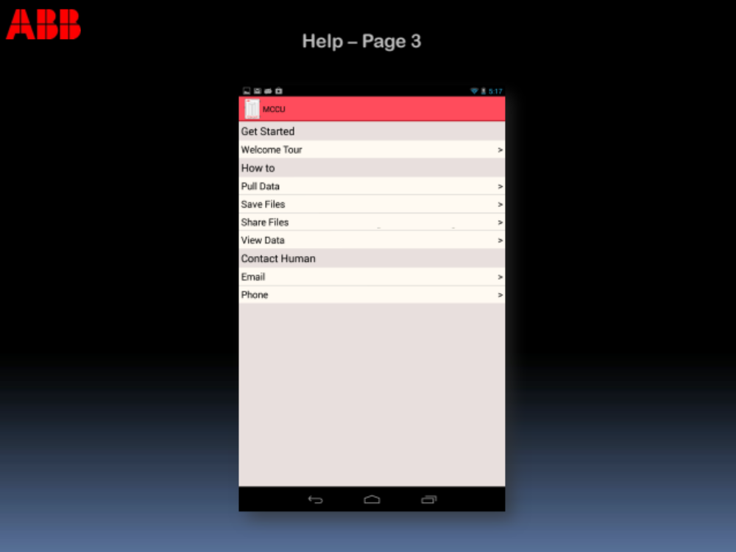

The user shall be able to quickly connect to previous connections made from the Bluetooth or Wi-Fi connection page (TRS2).

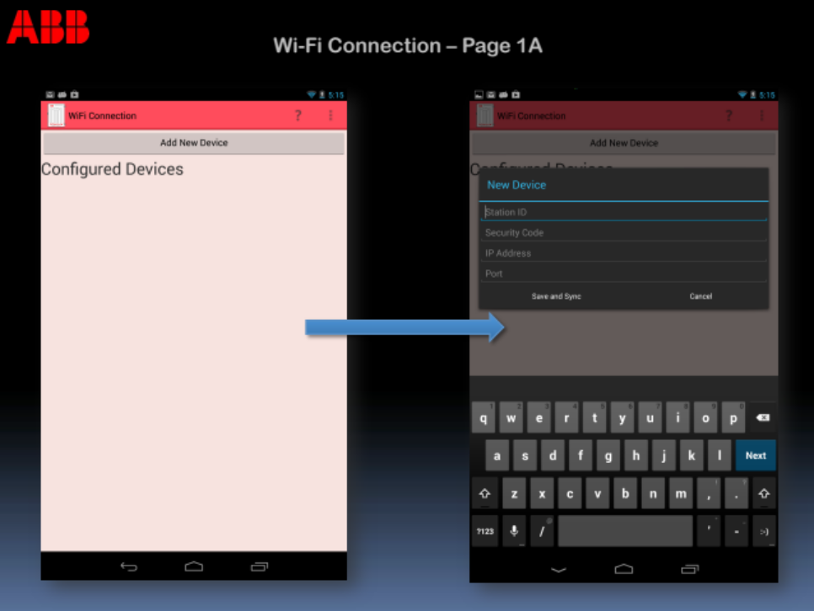

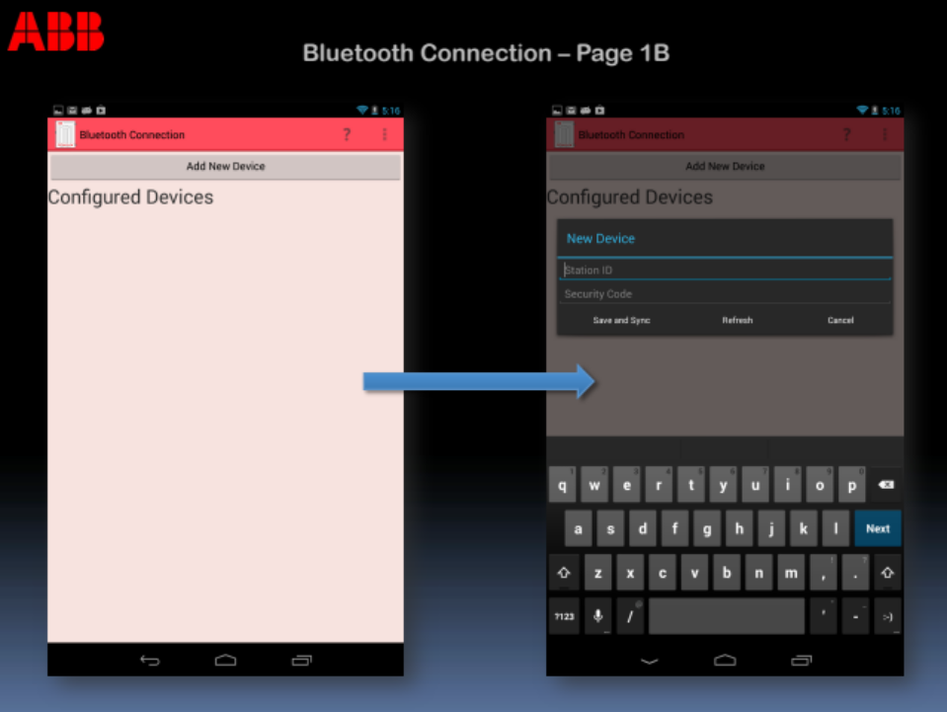

When viewing the Home screen, the user must be able to adjust settings for viewing data on the MCU application. The settings tab shall be available with the list of main application functions (TRS6).

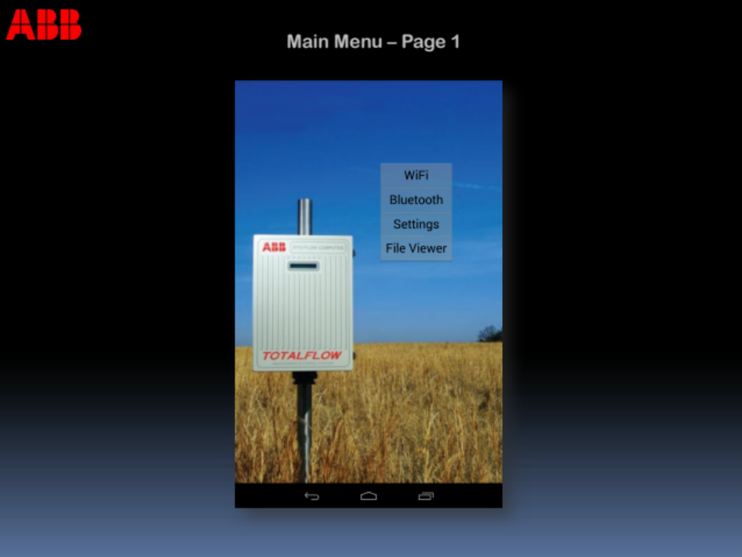

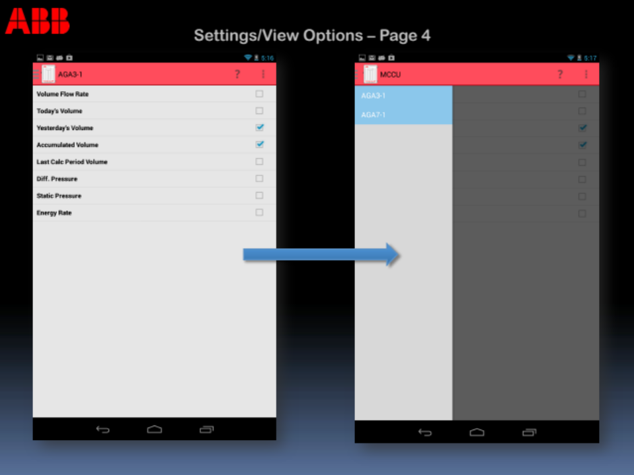

4. High-Level Technology Architecture

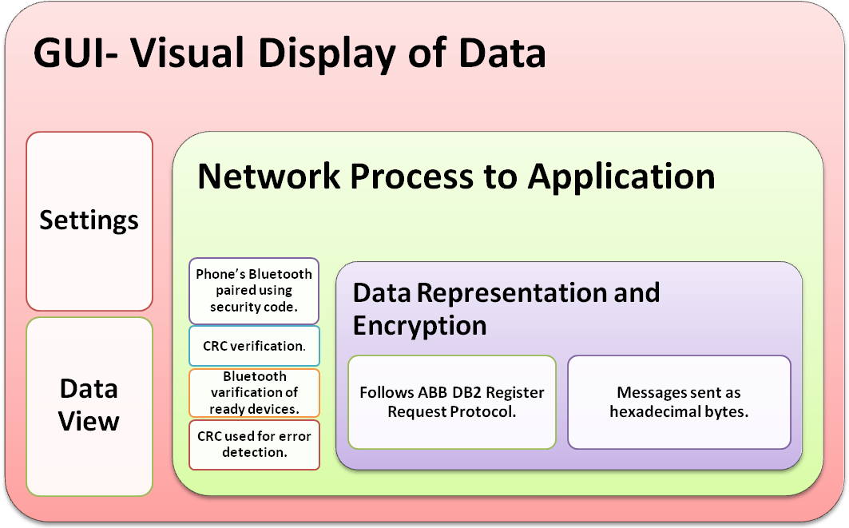

5. Customer Support
N/A

6. Appendices
N/A

7. Glossary

ABB Totalflow G4 series – Low-power, microprocessor-based units designed to meet a wide range of measurement, automation, monitor, control, and alarming applications for a variety of remote oil and gas systems.

Android – Linux-based operating system designed primarily for touchscreen mobile devices such as smart phones and tablet computers.

Bluetooth – Wireless technology standard for exchanging data over short distances from fixed and mobile devices, creating personal area networks with high levels of security.

CRC – Cyclic Redundancy Check. A common technique for detecting data transmission errors.

Honeycomb – Android operating system version 3.0 – 3.2.

Ice Cream Sandwich – Android operating system version 4.0 – 4.0.4

Jelly Bean – Android operating system version 4.1 – 4.2.x

OS – Operating System is a collection of software that manages computer hardware resources and provides common services for computer programs.

PCCU – Portable Calibration Collection Unit is an ABB Totalflow software application that provides a local interface to all ABB field products – from NGCs to RTUs and everything in between. PCCU Local Configuration and Collection software enables you to configure, collect, and view historical data files, perform diagnostics, troubleshooting, and much more.

RBAC – Role Based Access Control.

SDK – Software Development Kit. Typically a set of software development tools that allows for the creation of applications for a certain software package, framework, platform, computer system, game console, operating system, or similar development platform.

TCI – Totalflow Communication Interface

uFlo – MicroFLO 6200 series models are low-power, high-reliability, microprocessor-based units designed to meet a wide range of measurement, monitor, and alarming applications for remote gas systems.

WinCCU – Network-based software product provides connectivity among facilities in order to gather and manage gas volume and energy data.

XFC – Totalflow XSeries Flow computers are low-power, microprocessor-based units designed to meet a wide range of measurement, automation, monitor, control, and alarming applications for a variety of remote oil and gas systems.

XRC – The XRC Series is made up of full-featured units without an integrated Multivariable Transducer (XIMV). In its base configuration, each unit is equipped with standard I/O designed to meet the requirements of many low-cost measurement and automation projects. The base I/O includes five analog inputs (0-10 volts DC), four digital outputs, and four digital inputs which can be configured as either status or pulse accumulator inputs.

8. References
G4 XRC User manual:
G:\BVO-ATPA-ALL\CustDoc\Manuals\Manuals-Released\XRC G4 User manual (AA)
INTERN PROJECT – Tcox with Elaine.docx

IOGEAR USB Bluetooth Adapter:
http://www.iogear.com/support/manual/GBU221-321.pdf
Other User Manuals:
G:\BVO-ATPA-ALL\CustDoc\Manuals\Manuals-Released
Parani UD100 Long-Range Bluetooth Adapter:
http://www.sena.com/download/manual/manual_parani_ud100_B-v2.0.1.pdf
Parani UD1000 Long-Range Bluetooth Adapter:
http://www.sena.com/download/manual/manual_parani_sd1000-v1.0.1.pdf
TCI Toolkit:
G:\BVO-ATPA-ALL\DV&S\Staging\Work In Progress\2100838-021 (TCI v3.04)

