Gate 2 - Requirements Document Approval and Gate Participants

Project: Bluetooth – Android Intern Project
Date(s): Summer 2013
Project Manager: Blaine Tiernan
Prepared by: Lee Easton

Document status: __ Draft __ Proposed x_ Validated __ Approved

Change Log
Version | Changes Description | Author | Date
1 | First draft | L Easton | 2013,May 17
2 | All sections have been revised allowing for omission of redundancy within document. | L Easton | 2013,May 21
3 | Technical Requirements table has been added as section 3.2 | L Easton | 2013,May 22
4 | Deployment Requirements has been added as section 3.4 | L Easton | 2013,May 28

Index
1. Introduction 3
1.1 Purpose of This Document 3
1.2 How to Use This Document 3
R 1.2-1 Types of Reader 3
R 1.2-2 Technical Background Required 4
R 1.2-3 Overview Sections 4
1.3 Scope of the Product 4
2.1 Product Perspective 5
2.2 Product Functions 5
2.3 User Characteristics 6
2.4 General Constraints 6
2.5 Assumptions and Dependencies 6
3. Specific Requirements 7
3.1 User Requirements 7
3.2 Technical Requirements (referencing the Marketing Requirement List) 8
3.3 System and Integration Requirements 9
R 3.3-1 Android OS Requirements 9
R 3.3-2 Android Device Requirements 9
R 3.3-3 Totalflow G4 System Requirements 10
3.4 Security Requirements 10
3.5 Deployment Requirements 10
3.6 User Interface Requirements 11
4. High-Level Technology Architecture 12
5. Customer Support 13
6. Appendices 13
7. Glossary 13
8. References 14

1. Introduction
This document contains the system requirements for Bluetooth – Android Intern Project. These requirements have been derived from the project outline.

1.1 Purpose of This Document
This document is intended to guide development of Bluetooth – Android Intern Project. It will go through several stages during the course of the project:
- Draft: The first version, or draft version, is compiled after requirements have been discovered, recorded, classified, and prioritized.
- Proposed: The draft document is then proposed as a potential requirements specified for the project. The proposed document should be reviewed by several parties, who may comment on any requirements and any priorities, either to agree, to disagree, or to identify missing requirements. Readers include end-users, developers, project managers, and any other stakeholders. The document may be amended and re-proposed several times before moving to the next stage.
- Validated: Once the various stakeholders have agreed to the requirements in the document, it is considered validated.
- Approved: The validated document is accepted by representatives of each party of stakeholders as an appropriate statement of requirements for the project. The developers then use the requirements document as a guide to implementation and to check the progress of the project as it develops.

1.2 How to Use This Document

We expect that this document will be used by people with different skill sets. This section explains which parts of this document should be reviewed by various types of readers.

R 1.2-1 Types of Reader

Project Managers – The entirety of this document is pertinent to the project manager to gather the overview of business, marketing, and technical aspects of the product requirements.

Software Engineers – Read section three to gather the technical information required for the product. Read section four to look at a visual overview of the product requirements for better understanding. Read section eight to know what documents can be used for referencing the technical information required for the product.

Marketing/Sales – Read section two to ensure that the business and marketing requirements are met. Read section five to ensure that the customer support requirements are met. Read section seven for referencing any terminology not understood while reading sections two or five.

Customer Support – N/A

R 1.2-2 Technical Background Required

- Basic understanding of software to hardware protocols for communication
- Experience using C++, Java, and Android developing environment
- Understanding of integration between Bluetooth driver into Totalflow µFlo
- Experience with PCCU software used to collect data from Totalflow G4 series devices
- General knowledge on the software development lifecycle

R 1.2-3 Overview Sections

To gather an overall understanding of the project, read just the following sections:
- Section 2 – Product General Description
- Section 4 – High Level Technology Architecture
- Section 7 – Glossary
- Section 8 – References

1.3 Scope of the Product

Using the Android development environment (Android SDK), we shall develop an application that is to be used with the android based mobile phones running platform versions of Honeycomb (OS version 3.1.0) up to Jelly Bean (OS version 4.2.x).

This application shall provide a user interface to the existing G4 product line via Bluetooth (MRS1).

Using the Android App Store or other means, user shall be able to download the Totalflow G4 Application to their mobile device.

It shall present the data points as defined in the Overview (section 1.4) with the ability to turn on or off data points for display (MRS3).

Application shall have a general settings page for general configurations settings such as Communication settings for Bluetooth and Security (MRS3).

1.4 Overview of the Requirements Document

This product is feasible in all cases requiring field technicians of our customers to use when collecting various trends of data from the G4 devices.

Default outputs option is what shall be used to determine the data on the G4 device from the Android device (MRS2).

Bluetooth or IP connectivity for an android phone to G4 products allows for following data collection (MRS2):
  - Flow Rate Trends
  - Today’s Volume
  - Yesterday’s Volume
  - Energy Rate Trends
  - Current Alarms
  - Trend for last 14 days of flow
  - Battery Status (Voltage)
  - Charger Status (Voltage)
  - Trend DP pressure

Access to machine from 20 ft away shall allow for field technicians to collect measurement data from a comfortable distance without inconvenience of a wire (MRS4).

2. General Description
This section will give the reader an overview of the project, including why it was conceived, what it will do when complete, and the types of people we expect will use it. We also list constraints that were faced during development and assumptions we made about how we would proceed.

Currently the ABB (Totalflow) G4 Product line uses a PC Client based software (PCCU version 7.29) for local and remote configuration via serial and IP bases connections. The purpose of this project will be to develop an android application that will provide a subset of PCCU functions to a field person for access via an IP or Bluetooth connection. This application will not provide all of PCCU functionality but only the features defined in the scope section of this document.

2.1 Product Perspective

The development of this product will resolve issues of field technicians ineffectively using time to connect to G4 devices via direct cable connection. The customer will solely benefit by the use of this product when doing any pipeline measurement readings locally and through the use of the android application with a Bluetooth dongle.

The stakeholders for this product are internal. Research and Design must use this document for reference this document when tracing back to marketing requirements. The quality and support of the product must therefore be internal and explicitly documented.

2.2 Product Functions

The product takes measurement data from the ABB Totalflow G4 devices and displays the data on the user’s Android mobile device. The user will now be able to remain in their vehicle while taking measurement readings.

The product shall be easy for any user to navigate to all of the main features providing the main functions below:
- Android User Interface
- Low Power Bluetooth Connection
- Wireless Data Transfer

2.3 User Characteristics

Field Technicians taking select data measurements from G4 devices can use product. The primary method of use shall be for connecting to any G4 device that does not have a networked connection already established to transfer the data to the web server.

Technicians need familiarity with G4 series including models: XFC, XRC, and uFlo.

Users need familiarity with Android OS; Gingerbread, Honeycomb, Ice Cream Sandwich, and Jelly Bean.

Technicians shall have basic understanding of establishing a Bluetooth connection between two devices. Documentation shall be provided with Bluetooth being purchased along with G4 device.

Obstacles encountered may include: loss of Bluetooth connection due to out-pacing the effective range of the Bluetooth connection. Specialized skills may include: troubleshooting Bluetooth connectivity.

2.4 General Constraints

The product shall be designed using Android development environment, Android SKD. The necessary tools in the Android SDK allow for creation of the user interface to show the required measurements coming from the connection to G4 device. Interface shall be made between the application and Android Bluetooth settings.

DB2 Protocol shall be used as a resource for gathering information on the registers necessary to gather information from the G4 device. The code used in the G4 devices shall then be ported over to the Android SDK to replicate the process for the Android application.

G4-µFlo Device shall be used to test the final product for gathering necessary information listed in the Overview of Requirements (Section 1.4).

Bluetooth dongle shall be used on the G4 devices to establish a connection to the Android device and application. Bluetooth adapter will either be provided as an option included with purchase of G4 device or part number shall be listed for Bluetooth dongle needed to perform connection to Android device and application.

2.5 Assumptions and Dependencies

Only one Flow Computer at each site, and now taking into account that there may be multiple G4 devices at each site.

The connection needed for the application is Bluetooth only and not IP connection. The Bluetooth connection seems more feasible in remote locations that do not have a possible network connection.

The customers are purchasing the Bluetooth enabled G4 devices. The already equipped Bluetooth G4 devices shall have necessary power requirements to run the Bluetooth devices.

Some customers may be leaving their Bluetooth dongles connected to the G4 devices at all times. This will factor into the amount of power needed to constantly run the Bluetooth device.

All customers will be using the same exact Bluetooth dongle; either the Parani UD100 and SD1000 or the IOGEAR USB Bluetooth Adapter.

The IP connection mentioned in the stretch scope will not be as feasible as Bluetooth based on the power consumption of Wi-Fi versus Bluetooth.

Product would be used in regions of extreme weather conditions, of temperatures from negative and forty degrees Fahrenheit to one hundred and forty degrees Fahrenheit.

Assumptions based on Business case mentioned in Overview of Requirements Document (section 1.4).

The Bluetooth connection tests show that Totalflow G4 Application pairs with G4 device by using the 4 digit alpha-numeric security code.

The Totalflow G4 Application should store the security code information used when Bluetooth pairing with Totalflow G4 Application.

All Marketing requirements of application specifications will be developed in the Android SDK.

Use of TCI toolkit will not be necessary and DB2 Protocol will be better to hard code the register read and write for the Android application.

3. Specific Requirements
This section of the document lists specific requirements for Bluetooth – Android Intern Project. Requirements are divided into the following sections:
- User requirements. These are requirements written from the point of view of end users, usually expressed in narrative form.
- System and Integration requirements. These are detailed specifications describing the functions the system must be capable of doing.
- Security Requirements
- User Interface requirements. These are requirements about the user interface, which may be expressed as a list, as a narrative, or as images of screen mock-ups.

3.1 User Requirements
- Android device running version 3.1.0 or higher with Bluetooth functionality.
- Totalflow G4 Application installed on the Android device.
- User must have the 4 digit alpha-numeric security code to connect via Bluetooth.
- Flash version must be up to date (3.03 for TCI).
- G4 device must have either USB connection for Bluetooth dongle (USB 1.0 HUB) or G4 with pre-manufactured Bluetooth hardware using serial stack interface (part no. 1803203-001).
- User needs to be within a 20 foot range of G4 device during use.

3.2 Technical Requirements (referencing the Marketing Requirement List)
//Bluetooth Certifications
Terms and Definitions
DRS | Derived Requirement Specifications
MRS | Marketing Requirement Specifications
SM | Safety Manual
SRS | Safety Requirement Specifications
TRS | Technical Requirement Specifications

Priority
M Mandatory (no release without this feature)
D Desirable (nice to have, release without this feature possible)
F Future (not covered by this project)
O Obsolete (not covered by this project)

Stability
C Committed
N Not yet agreed
L Likely to change
O Obsolete (not covered by this project)

Application and Connection | Status | Source
[TRS1] Bluetooth/IP connectivity for an Android phone to G4 products  * For IP connectivity, see [TRS2] | Priority:  M  Stability:  C | MRS 1
[TRS2] IP connectivity for Networked G4 products  It must be possible to connect to G4 device but not Mandatory to use IP for connectivity. | Priority:  D  Stability:  N | MRS 1
[TRS3] Bluetooth Certification for Networked G4 products | Priority:  D  Stability:  N | MRS 1
[TRS4] Default Outputs Option  *Section 1.4 | Priority:  M  Stability:  C | MRS 2
[TRS5] Screens Similar to Webpage | Priority:  M  Stability:  C | MRS 3
[TRS6] Connectivity to G4 Product from 20 feet away | Priority:  M  Stability:  L | MRS 4

3.3 System and Integration Requirements

R 3.3-1 Android OS Requirements
The Android operating system shall allow for proper functionality with the Totalflow G4 Application. The following OS versions will be able to integrate Bluetooth features with the Totalflow G4 Application:

Version | Code name | Release date | API level | Distribution (March 4, 2013)
4.2.x | Jelly Bean | November 13, 2012 | 17 | 2.3%
4.1.x | Jelly Bean | July 9, 2012 | 16 | 26.1%
4.0.x | Ice Cream Sandwich | December 16, 2011 | 15 | 27.5%
3.2 | Honeycomb | July 15, 2011 | 13 | 0.1%
3.1 | Honeycomb | May 10, 2011 | 12

R 3.3-2 Android Device Requirements
All models of Samsung, LG, HTC, Motorola, Asus, and Sony devices running the OS versions mentioned above (R 3.3-1) shall correctly integrate with the Totalflow G4 Application and Bluetooth connection.

R 3.3-3 Totalflow G4 System Requirements
The following G4 models should have the necessary Bluetooth hardware and drivers integrated in the system to correctly function with the Totalflow G4 Application (Product No. 1803203-001):

- XFC 6200 EX
- XFC 6201 EX

All other models of the XFC, XRC, and uFlo are manufactured with the USB hardware and drivers for the user to connect via Bluetooth dongle.

All packaged options to ship with Bluetooth dongle should include necessary documentation for the long-range and short-range Bluetooth devices.

Long-range Bluetooth option shall ship with the Parani UD100 and UD1000. The UD100 acts as the client and the UD1000 acts as the host for connectivity. Documentation for these products is listed in the References (section 8).

Short-range Bluetooth option shall ship with the IOGEAR USB Adapter (model #GBU321). Documentation for these products is listed in the References (section 8).

3.4 Security Requirements

The Current RBAC Model that is enforced at the protocol level shall not be used or enforced for the Totalflow G4 Application. This means RBAC shall be used when connecting to the device.

User will navigate from application Home page to the Settings page. From the Settings page the user will select the Profiles tab. Within the Profiles tab, the user will then be able to input their station ID and four digit security code (MRS3).

Bluetooth will have a handshake method taking the four digit security code to form a secure connection with the G4 device using CRC Protocol.

Storage of information on the client side (such as log in security code) shall be handled by the application. This shall be necessary to fulfill Bluetooth connection feature requirement.

3.5 Deployment Requirements

The Totalflow G4 Application shall be published to: ABB App Store, Google Play, and Windows Marketplace

The following link will be used to send all logos, images, and APK files to the ABB Application publishing process: http://www150.abb.com/spaces/ABB-Mobility/SitePages/Application%20publishing%20process.aspx

3.6 User Interface Requirements

The application shall have a Home page allowing the user to navigate to the trends, alarms and general settings tab.

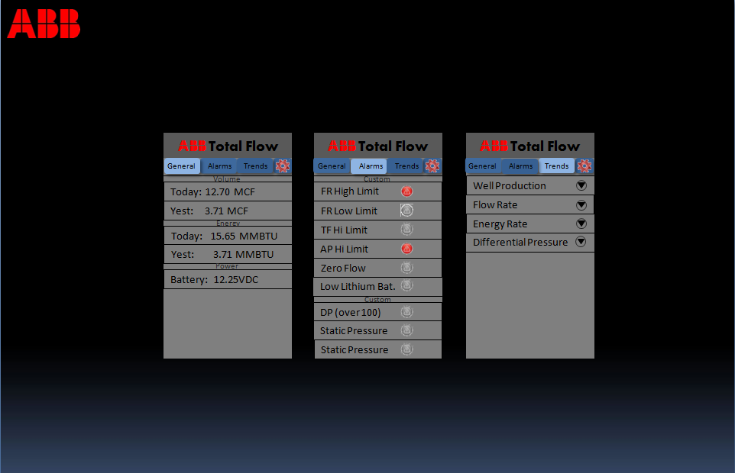

The user shall be able to click through different pressure measurements to see the historical data displayed in landscape mode on the Android device.

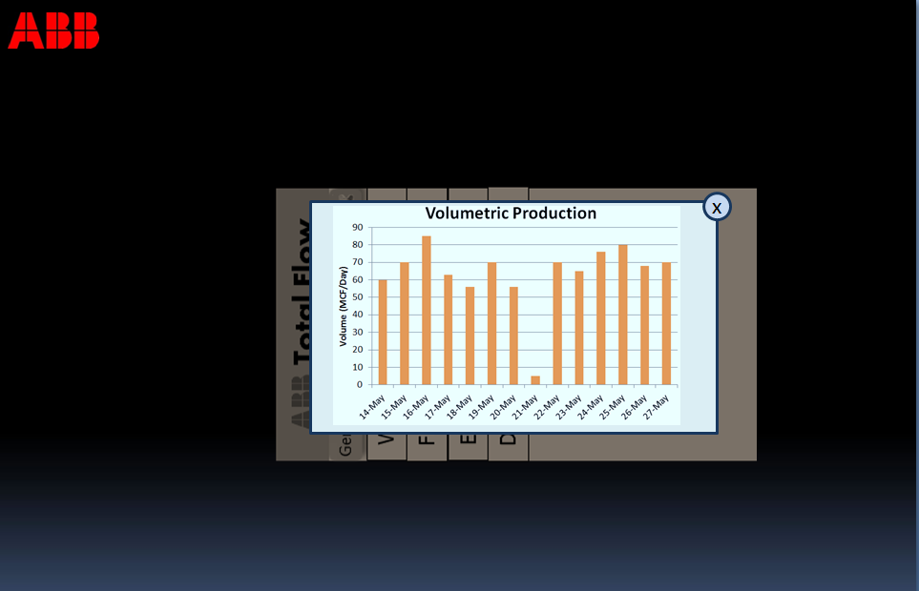

When on the settings tab, the user may select the data to be measured, the Bluetooth connection preferences, and the security ID to be used with that G4 device.

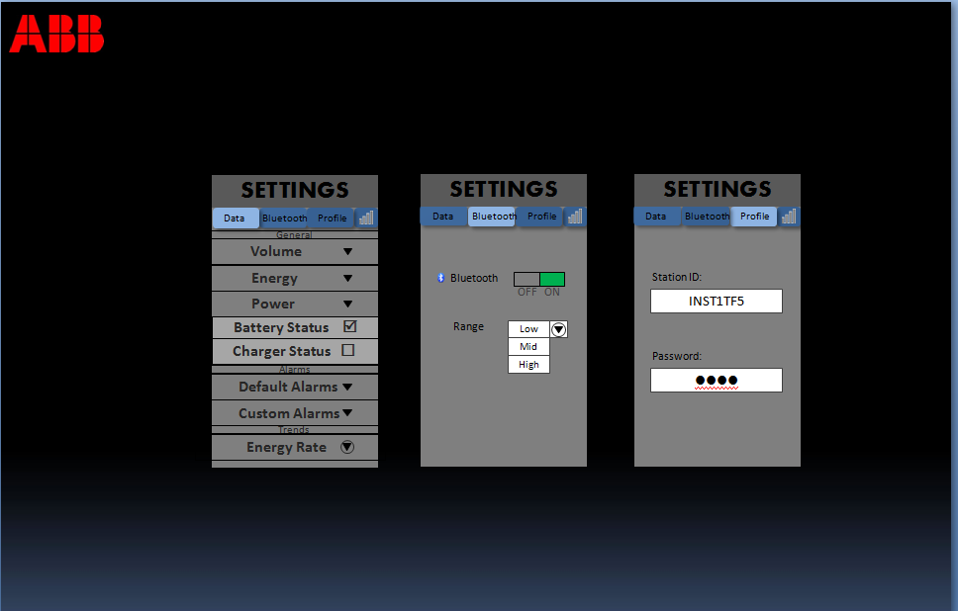

4. High-Level Technology Architecture

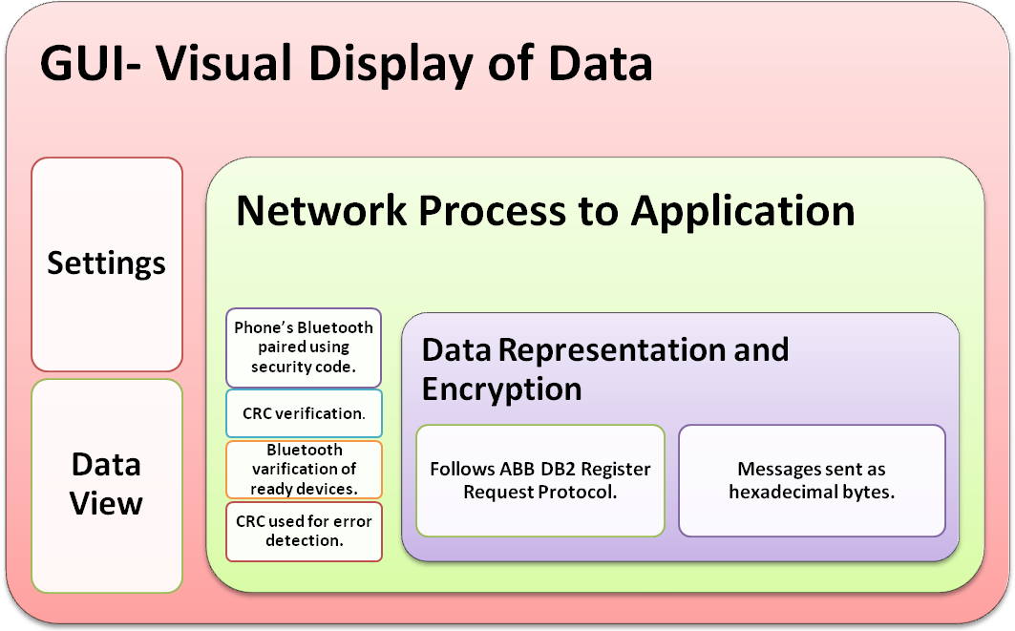

5. Customer Support
N/A

6. Appendices
N/A

7. Glossary

ABB Totalflow G4 series – Low-power, microprocessor-based units designed to meet a wide range of measurement, automation, monitor, control, and alarming applications for a variety of remote oil and gas systems.

Android – Linux-based operating system designed primarily for touchscreen mobile devices such as smart phones and tablet computers.

Bluetooth – Wireless technology standard for exchanging data over short distances from fixed and mobile devices, creating personal area networks with high levels of security.

CRC – Cyclic Redundancy Check. A common technique for detecting data transmission errors.

Honeycomb – Android operating system version 3.0 – 3.2.

Ice Cream Sandwich – Android operating system version 4.0 – 4.0.4

Jelly Bean – Android operating system version 4.1 – 4.2.x

OS – Operating System is a collection of software that manages computer hardware resources and provides common services for computer programs.

PCCU – Portable Calibration Collection Unit is an ABB Totalflow software application that provides a local interface to all ABB field products – from NGCs to RTUs and everything in between. PCCU Local Configuration and Collection software enables you to configure, collect, and view historical data files, perform diagnostics, troubleshooting, and much more.

RBAC – Role Based Access Control.

SDK – Software Development Kit. Typically a set of software development tools that allows for the creation of applications for a certain software package, framework, platform, computer system, game console, operating system, or similar development platform.

TCI – Totalflow Communication Interface

uFlo – MicroFLO 6200 series models are low-power, high-reliability, microprocessor-based units designed to meet a wide range of measurement, monitor, and alarming applications for remote gas systems.

WinCCU – Network-based software product provides connectivity among facilities in order to gather and manage gas volume and energy data.

XFC – Totalflow XSeries Flow computers are low-power, microprocessor-based units designed to meet a wide range of measurement, automation, monitor, control, and alarming applications for a variety of remote oil and gas systems.

XRC – The XRC Series is made up of full-featured units without an integrated Multivariable Transducer (XIMV). In its base configuration, each unit is equipped with standard I/O designed to meet the requirements of many low-cost measurement and automation projects. The base I/O includes five analog inputs (0-10 volts DC), four digital outputs, and four digital inputs which can be configured as either status or pulse accumulator inputs.

8. References
G4 XRC User manual:
G:\BVO-ATPA-ALL\CustDoc\Manuals\Manuals-Released\XRC G4 User manual (AA)
IOGEAR USB Bluetooth Adapter:
http://www.iogear.com/support/manual/GBU221-321.pdf
Other User Manuals:
G:\BVO-ATPA-ALL\CustDoc\Manuals\Manuals-Released
Parani UD100 Long-Range Bluetooth Adapter:
http://www.sena.com/download/manual/manual_parani_ud100_B-v2.0.1.pdf
Parani UD1000 Long-Range Bluetooth Adapter:
http://www.sena.com/download/manual/manual_parani_sd1000-v1.0.1.pdf
TCI Toolkit:
G:\BVO-ATPA-ALL\DV&S\Staging\Work In Progress\2100838-021 (TCI v3.04)

