# Predicting Kickstart Project State

March 11, 2018

DePaul University

CSC 478 Final Project

Tung, Rebecca

Fox, Sidney

Introduction

The purpose of this document is to outline our approach in predicting the status of different projects presented to the public using the Kickstarter platform. The group leveraged many algorithms and functions available in the sklearn library to operationalize the defined machine learning workflow. This document will provide an overview of the dataset leveraged to complete the machine learning project, as well as an in-depth analysis of the methodologies implemented, the requisite results, and any conclusions, as well as constraints or blockers, the group was able to identify while completing the project.

# Overview

The dataset used to complete the group's analysis can be found on the Kaggle website as a competition dataset.[1] There are two datasets listed under the competition page. After a comparison of both datasets, it was determined that both datasets contain the same information in terms of relevant data points. The most recent dataset, entitled "ks-projects-201801.csv", contains a "cleansed" dataset, where all of the misnomers and formatting issues have been removed and / or rectified. After conducting this analysis, the group determined that the only dataset required to complete the project was the ks-projects-201801.csv. All of the analysis presented throughout this document solely references this dataset. After settling on the ks-projects-201801.csv dataset, the group created a GitHub repository and uploaded the .csv file in question to said repository. The group used GitHub to build their analysis leveraging the same base dataset, and complete the necessary objectives independently, within a central repository.

Concerning an overview of the features of the dataset specifically, the table below contains relevant high-level statistics in terms of row count and number of columns below:

|  |  |
| --- | --- |
| Statistic | **Value** |
| Number of Rows | 378,661 |
| Number of Columns | 15 |

In addition to the number of rows and columns, the feature names and corresponding data types can be found below.

|  |  |  |
| --- | --- | --- |
| **Sequence Number** | **Column Name** | **Data Type** |
| 1 | ID | Numeric |
| 2 | name | String |
| 3 | category | String |
| 4 | main_category | String |
| 5 | currency | String |
| 6 | deadline | DateTime |
| 7 | goal | Numeric |
| 8 | launched | DateTime |
| 9 | pledged | Numeric |
| 10 | state | String |
| 11 | backers | Numeric |
| 12 | country | String |
| 13 | usd pledged | Numeric |
| 14 | usd_pledged_real | Numeric |
| 15 | usd_goal_real | Numeric |

Once the dataset was identified, the group conducted a deeper dive of the data – analyzing features as well as observations.

# Analysis of Features and Observations

To gain better insight into the data, the group produced a series of histograms to show distributions by different segments of the data. Please find a histogram, as well as a summary table, of project status below.

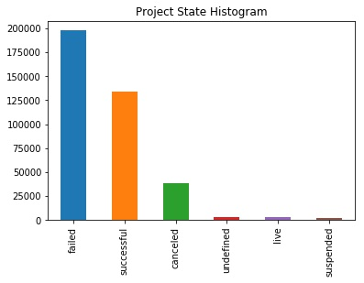

|  |  |
| --- | --- |
| **Project State** | **Observation Count** |
| failed | 197,719 |
| successful | 133,956 |
| canceled | 38,779 |
| undefined | 3,562 |
| live | 2,799 |
| suspended | 1,846 |

From the information presented in this histogram and corresponding summary table, one can easily determine that most projects fail, with projects succeeding being the second most frequent project state. Aside from projects succeeding, applicable statuses include '"canceled", "undefined", "live", and "suspended". The group decided to keep all statuses aside from undefined and live, due to the ambiguity associated with the undefined project state, and the in-flight status of a live project.

Removing the undefined status reduced the total dataset record count to 375,099. Aside from removing observations where the project state was equal to undefined, the group also removed features "goal", "pledged", and "usd pledged". The dataset contains Kickstarter campaigns from a number of different countries, with the stated goal and pledged values in the native currency. The creator of the dataset converted the goal and pledged amounts to United States Dollars (usd). This conversion is represented in the dataset as "usd_pledged_real" and "usd_goal_real". Removal of the aforemtioned columns reduces the number of numeric variables to three – usd_pledged_real, usd_goal_real, and backers. Summary statistics for these variables can be found on the next page.

|  |  |  |  |
| --- | --- | --- | --- |
| **Statistic** | backers | usd_goal_real | usd_pledged_real |
| count | 375099.000000 | 3.750990e+05 | 3.750990e+05 |
| mean | 106.620436 | 9.123935e+03 | 4.584708e+04 |
| std | 911.423593 | 9.140142e+04 | 1.158404e+06 |
| min | 0.000000 | 0.000000e+00 | 1.000000e-02 |
| 25% | 2.000000 | 3.100000e+01 | 2.000000e+03 |
| 50% | 12.000000 | 6.250000e+02 | 5.500000e+03 |
| 75% | 57.000000 | 4.050180e+03 | 1.600000e+04 |

After producing high level summary statics for the numeric variables, the group produced a correlation matrix using the pearson method to view any weak or strong relationships within the data. A heatmap was also produced to present the relationships graphically. Please find the correlation matrix and corresponding heatmap on the following page.

|  |  |  |  |  |  |  |  |  |  |  |  |  |  |
| --- | --- | --- | --- | --- | --- | --- | --- | --- | --- | --- | --- | --- | --- |
|  | **ID** | **name** | **category** | **main_category** | **currency** | **deadline** | **launched** | **state** | **backers** | **country** | **usd_pledged_real** | **usd_goal_real** | duration |
| **ID** | 1.000000 | 0.991702 | -0.001266 | 0.003227 | -0.000461 | 0.010542 | 0.010580 | -0.003325 | 0.025534 | -0.000714 | 0.122894 | 0.101211 | -0.002766 |
| **name** | 0.991702 | 1.000000 | -0.001798 | 0.004790 | -0.000130 | 0.010622 | 0.010403 | -0.003056 | 0.026620 | -0.000379 | 0.123884 | 0.100289 | -0.002516 |
| **category** | -0.001266 | -0.001798 | 1.000000 | 0.239782 | 0.037822 | -0.056483 | -0.052595 | -0.024760 | -0.057384 | 0.037786 | -0.067791 | 0.031354 | -0.017923 |
| **main_category** | 0.003227 | 0.004790 | 0.239782 | 1.000000 | 0.075106 | -0.039784 | -0.047838 | -0.028576 | 0.027066 | 0.076710 | 0.010796 | 0.071892 | -0.014940 |
| **currency** | -0.000461 | -0.000130 | 0.037822 | 0.075106 | 1.000000 | -0.021692 | -0.021845 | -0.045832 | -0.011019 | 0.944500 | -0.002854 | 0.348965 | -0.024466 |
| **deadline** | 0.010542 | 0.010622 | -0.056483 | -0.039784 | -0.021692 | 1.000000 | 0.304547 | 0.035392 | -0.005645 | -0.022703 | 0.001208 | -0.034246 | 0.078976 |
| **launched** | 0.010580 | 0.010403 | -0.052595 | -0.047838 | -0.021845 | 0.304547 | 1.000000 | 0.030601 | -0.019064 | -0.023052 | -0.011738 | -0.033243 | 0.079399 |
| **state** | -0.003325 | -0.003056 | -0.024760 | -0.028576 | -0.045832 | 0.035392 | 0.030601 | 1.000000 | 0.331426 | -0.041640 | 0.450139 | -0.071894 | 0.110521 |
| **backers** | 0.025534 | 0.026620 | -0.057384 | 0.027066 | -0.011019 | -0.005645 | -0.019064 | 0.331426 | 1.000000 | -0.010042 | 0.567818 | 0.009474 | 0.023029 |
| **country** | -0.000714 | -0.000379 | 0.037786 | 0.076710 | 0.944500 | -0.022703 | -0.023052 | -0.041640 | -0.010042 | 1.000000 | 0.001240 | 0.346439 | -0.022561 |
| **usd_pledged_real** | 0.122894 | 0.123884 | -0.067791 | 0.010796 | -0.002854 | 0.001208 | -0.011738 | 0.450139 | 0.567818 | 0.001240 | 1.000000 | 0.057608 | 0.027341 |
| **usd_goal_real** | 0.101211 | 0.100289 | 0.031354 | 0.071892 | 0.348965 | -0.034246 | -0.033243 | -0.071894 | 0.009474 | 0.346439 | 0.057608 | 1.000000 | -0.033865 |
| **duration** | -0.002766 | -0.002516 | -0.017923 | -0.014940 | -0.024466 | 0.078976 | 0.079399 | 0.110521 | 0.023029 | -0.022561 | 0.027341 | -0.033865 | 1.000000 |

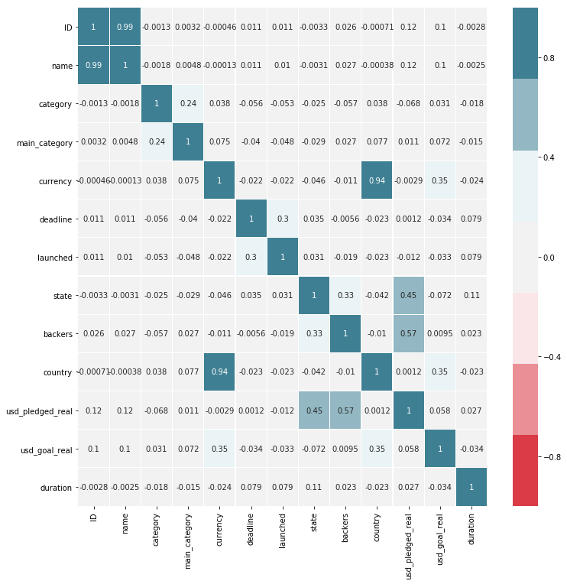

The elicited results show strong relationships between ID and name (99 percent), as well as country and currency (94 percent). There are also marginally strong relationships between launched and deadline (30 percent), usd_pledged_real and state (45 percent), as well as backers (57 percent). Based on the operational understanding of the data, this is to be expected. The number of backers positively drive the amount pledged for a given project, and are influential in a project being successful.

Once correlations were identified, the group focused their analysis on the relationship between main_category and category. The main_category feature is a parent of the category feature, with 170 categories available and fifteen distinct main categories. A breakdown of observations by main_category can be found on the next page.

|  |  |
| --- | --- |
| Main Category | Observation Count |
| Art | 28,153 |
| Comics | 10,819 |
| Crafts | 8,809 |
| Dance | 3,767 |
| Design | 30,068 |
| Fashion | 22,813 |
| Film & Video | 62,731 |
| Food | 24,602 |
| Games | 35,230 |
| Journalism | 4,755 |
| Music | 49,684 |
| Photography | 10,778 |
| Publishing | 39,412 |
| Technology | 32,566 |
| Theater | 10,912 |

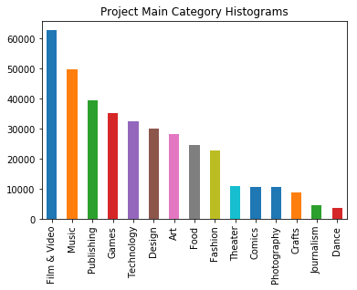

Based on this analysis, the top three categories in terms of observation count are "Film & Video", "Music", and "Publishing".

In addition to reviewing project status and category, the project group also reviewed the country of origin for each Kickstarter project. Please find a breakdown of projects by country, as well as a corresponding histogram, on the following page.

|  |  |
| --- | --- |
| Country | Observation Count |
| AT | 597 |
| AU | 7,839 |
| BE | 617 |
| CA | 14,756 |
| CH | 761 |
| DE | 4,171 |
| DK | 1,113 |
| ES | 2,276 |
| FR | 2,939 |
| GB | 33,672 |
| HK | 618 |
| IE | 811 |
| IT | 2,878 |
| JP | 40 |
| LU | 62 |
| MX | 1,752 |
| N,0" | 235 |
| NL | 2,868 |
| NO | 708 |
| NZ | 1,447 |
| SE | 1,757 |
| SG | 555 |
| US | 292,627 |

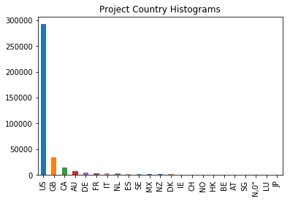

The three most frequent countries in the Kickstarter dataset are the United States (US), Great Britain (GB), and Canada (CA). Completing this analysis brought to the group's attention a misnomer in the data – 235 observations with a country value of "N,0"", which is not a valid country code. These observations were removed from the dataset.

Transformations

In addition to the analysis completed on the categorical and numeric features found within the Kickstarter dataset, two transformations were completed before algorithm application. The first transformation addressed Kickstarter campaigns without names, or titles. This issue impacted four records, and the group converted the name to the value of "Unknown". The second transformation dealt with invalid data types for the dataset. The Pandas library applied the wrong data type to a few of the features. The impacted features included "deadline", "launched", "usd_goal_real", and "usd_pledged_real". The "deadline" and "launched" features were converted to dates, removing time from the observations. The "usd_goal_real" and "usd_pledged_real" features were converted to integer data types. Transformations were applied to align the working dataset with the data types presented on the project's Kaggle site.

In the end, the group created a calculated column called duration, defined as the difference in days between the deadline and launched dates for a project. The group felt as though duration was a better feature to use than taking two arbitrary dates associated with the project. After completing transformations, the group reviewed which features were most important using recursive feature elimination and extra trees classifier.

Feature Importance

The group applied logistic and linear regression independently on the dataset to identify which features were most important, and to compare and contrast the results of both approaches. Deadline, launched, ID, and currency were removed from this analysis. It was determined that ID held very little predictive power, if at all. The currency feature was highly correlated with country and may potentially skew the results of the algorithm. The group also converted all non-numeric values to numeric using the LabelEncoder method of the sklearn library. The inputs of the recursive feature importance algorthims must be importance. After numeric transformation, the features were split into two subsets – features and target. Every feature that may influence the result of the project state were assigned to the "feature" subset, and the state feature was assigned to the "target" subset. After executing the recursive feature elimination algorithm, leveraging logistic regression and linear regression, the top three features are as follows:

|  |  |
| --- | --- |
| Recursive Feature Elimination Methodology | Top Three Features |
| Logistic Regression | backers, country, duration |
| Linear Regression | main_category, country, duration |

In addition to recursive feature elimination, the group also executed extra trees classifier to identify the associated feature importance of every feature in relation to the project's state. Please find a graph and table of the algorithm results on the following page.

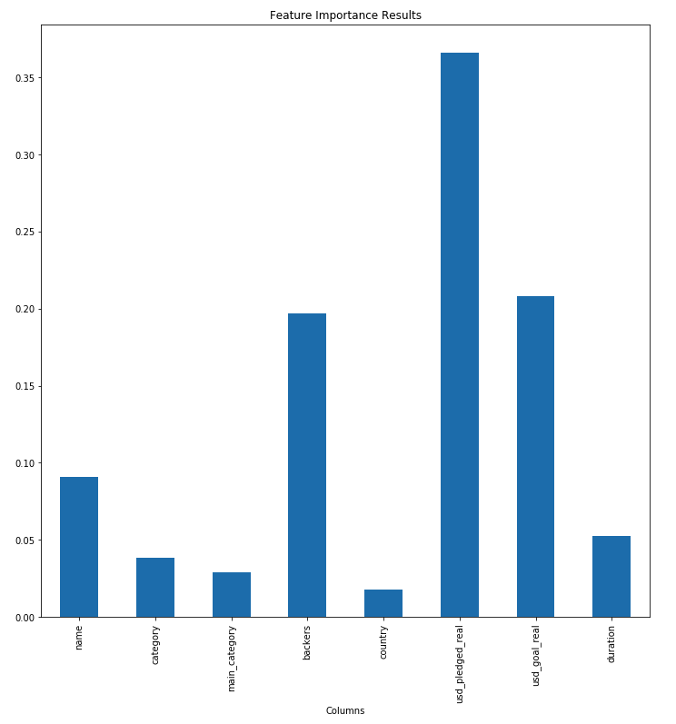

|  |  |
| --- | --- |
| **Columns** | Feature Importance |
| name | 0.090784 |
| category | 0.038613 |
| main_category | 0.029132 |
| backers | 0.196733 |
| country | 0.017424 |
| usd_pledged_real | 0.366285 |
| usd_goal_real | 0.208244 |
| duration | 0.052784 |

The top three features according to extra trees classifier are usd_pledged_real, usd_goal_real, and backers. Of the eight features submitted to the feature importance algorithms, only the backers feature was selected in as a top three feature by each algorithm.

After filtering and transforming the data, as well as analyzing the importance of each feature to the target variable, the group applied machine learning algorithms to the dataset.

Model Execution and Analysis of Results

Before splitting the dataset into test and train subsets, a few transformations were applied to the data. First, project state was reduced to True and False, where projects with a state "of successful" were set to true. All other projects states were set to False. The rationale behind this transformation was to reduce the complexity of project state and reduce the outcomes from six values to two.

In addition to transforming project state, the country values were transformed using the OneHotEncoder method of the sklearn.preprocessing library. This method is especially useful when feeding categorical data into a sklearn pipeline. Once the necessary transformations were applied, K-Nearest Neighbors (KNN) and logistic regression were applied to the dataset. The data went through many iterations of each test, with different parameters tweaked – mainly the number of neighbors in the KNN algorithm. The best performing model was a KNN algorithm with a leaf size of 30 and the number of neighbors set to five, using the minkowski distance metric. Two summary tables containing the best performing algorithms by micro and overall F1 score, respectively, can be found below.

|  |  |  |  |  |
| --- | --- | --- | --- | --- |
| **Model Parameters** | false | true | micro | Sum of Class F1 |
| **N=5-Basic&Country** | 1.0 | 1.00 | 1.0 | 3.00 |
| **N=15-Basic&Country** | 1.0 | 0.99 | 1.0 | 2.99 |
| **N=11-Basic&Country** | 1.0 | 1.00 | 1.0 | 3.00 |
| **N=13-Basic&Country** | 1.0 | 0.99 | 1.0 | 2.99 |
| **N=3-Basic&Country** | 1.0 | 1.00 | 1.0 | 3.00 |

*Best performing models, sorted by micro parameter*

|  |  |  |  |  |
| --- | --- | --- | --- | --- |
| **Model Parameters** | false | true | micro | Sum of Class F1 |
| **N=5-Basic&Country** | 1.0 | 1.0 | 1.0 | 3.0 |
| **N=11-Basic&Country** | 1.0 | 1.0 | 1.0 | 3.0 |
| **N=3-Basic&Country** | 1.0 | 1.0 | 1.0 | 3.0 |
| **N=7-Basic&Country** | 1.0 | 1.0 | 1.0 | 3.0 |
| **N=9-Basic&Country** | 1.0 | 1.0 | 1.0 | 3.0 |

*Best performing models, sorted by overall F1 score*

The best performing tops both lists and accurately predicted a project's success, or lack thereof, 99 percent of the time. To further underscore model performance, please find two confusion matrices that show the frequency / percentage of predicting the true label, as well as the frequency / percentage of predicting the false label, on the next page.

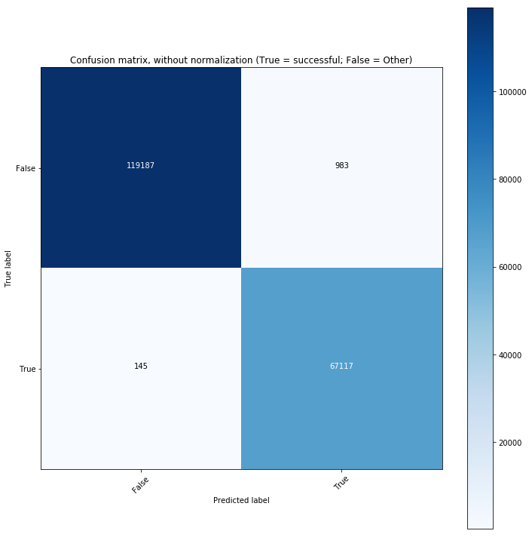

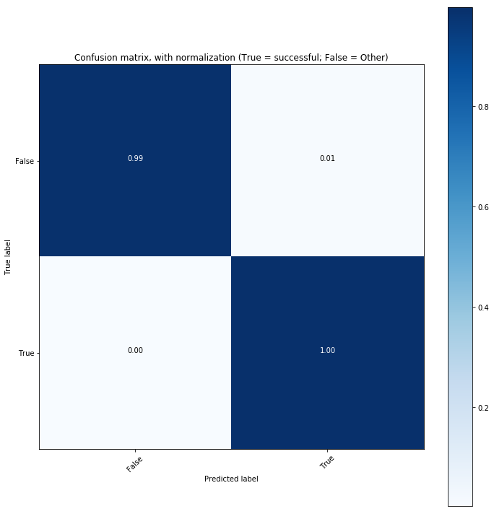

To underscore the performance of the model, please find a high-level classification report below.

|  |  |  |  |  |
| --- | --- | --- | --- | --- |
|  | precision | recall | f1-score | support |
| Failed/Cancelled/Live/Suspended | 1.00 | 0.99 | 1.00 | 119,240 |
| successful | 0.99 | 1.00 | 1.00 | 66,793 |
| avg / total | 1.00 | 1.00 | 1.00 | 186,033 |

# Conclusion

In conclusion, the project group achieved the stated objective of predicting the success of a kickstart project based on the features provided. The top performing model was KNN with five neighbors, which accurately predicted if a project would succeed or fail 99 percent of the time. In addition to model execution, the project group also applied a series of algorithms to identify the most important features, derived the correlations between each feature in the dataset, and filtered or transformed anomalies in the data. Please find the requisite code used to complete the project within the following Appendix section.

Appendix

# coding: utf-8

# # Kickstarter Projects

# ### CSC 478 Final Project

# #### Contributors:

# * [Rebecca Tung (1448196)](https://github.com/rtungus)

# * [Sidney Fox (1524992)](https://github.com/stfox13)

#

# ## Libraries used through the project:

get_ipython().magic(u'matplotlib inline')

import matplotlib.pyplot as plt

import numpy as np

import pandas as pd

import seaborn as sns

import os

import math

import requests

import datetime as dt

import matplotlib as mpl

import io

from pandas import Series, DataFrame

from sklearn.pipeline import Pipeline

from sklearn.neighbors import KNeighborsClassifier

from sklearn.linear_model import LogisticRegression, LinearRegression

from sklearn import preprocessing

from sklearn.preprocessing import StandardScaler, Imputer

from sklearn.ensemble import ExtraTreesClassifier

from sklearn import preprocessing

from sklearn import svm

from sklearn.metrics import f1_score, confusion_matrix, accuracy_score, classification_report

import itertools

from sklearn.feature_selection import RFE

from collections import defaultdict

from IPython.core.interactiveshell import InteractiveShell

InteractiveShell.ast_node_interactivity = "all"

#Set graph size

mpl.rcParams['figure.figsize'] = (12,12)

np.set_printoptions(suppress=True)

# ## Load raw data as Pandas DataFrame:

url = 'https://raw.githubusercontent.com/stfox13/CSC478FinalProject/master/Data/ks-projects-201801.csv'

kickproj_org= pd.read_csv(url)

len(kickproj_org)

# ## Define Useful Functions

def roundup(x, y):

return int(math.ceil(float(x) / float(y)) * y)

#Define a fuction to print and plot confusin matrix

def plot_confusion_matrix(cm, classes,

normalize=False,

title='Confusion matrix',

cmap=plt.cm.Blues):

"""

This function prints and plots the confusion matrix.

Normalization can be applied by setting `normalize=True`.

"""

if normalize:

cm = cm.astype('float') / cm.sum(axis=1)[:, np.newaxis]

else:

pass

plt.imshow(cm, interpolation='nearest', cmap=cmap)

plt.title(title)

plt.colorbar()

tick_marks = np.arange(len(classes))

plt.xticks(tick_marks, classes, rotation=45)

plt.yticks(tick_marks, classes)

fmt = '.2f' if normalize else 'd'

thresh = cm.max() / 2.

for i, j in itertools.product(range(cm.shape[0]), range(cm.shape[1])):

plt.text(j, i, format(cm[i, j], fmt),

horizontalalignment="center",

color="white" if cm[i, j] > thresh else "black")

plt.tight_layout()

plt.ylabel('True label')

plt.xlabel('Predicted label')

#Define a fuction to calculate and print TP, TN, FP, and FN for each category

def show_statistics(test_y, y_pred, matrix):

TP = np.diag(matrix)

FP = np.sum(matrix, axis=0) - TP

FN = np.sum(matrix, axis=1) - TP

TN = []

for i in range(len(matrix)):

temp = np.delete(matrix, i, 0) # delete ith row

temp = np.delete(temp, i, 1) # delete ith column

TN.append(sum(sum(temp)))

temp_dic = {'TP': TP, 'FP' : FP,

'TN' : TN, 'FN' : FN}

scoreMatrix = DataFrame.from_dict(temp_dic)

return scoreMatrix

# Define a fuction to print F1 Score for each class and global (micro)

def formatResult(preResult, columnNames):

resultDF = DataFrame(preResult.values(), columns=columnNames, index=preResult.keys())

resultDF.loc['sum'] = np.sum(preResult.values(), axis=0)

resultDF['Sum of Class F1'] = np.append(np.sum(preResult.values(), axis=1), np.NaN)

return resultDF

#######KNN############

#Define a function to run KNeighborsClassifier with different n_neighbors and store f1 score

def runKNN(trainX, trainY, testX, testY, number, f1_only = False, trainSetName = '', dic_result_knn = {}):

i = 3

cls = KNeighborsClassifier(n_neighbors=i)

while i <= number:

#print i

cls = KNeighborsClassifier(n_neighbors=i)

cls.fit(trainX, trainY)

predY = cls.predict(testX)

result = f1_score(testY, predY, average=None).round(2)

result = np.append(result, f1_score(testY, predY, average='micro').round(2))

#print results

dic_result_knn['N=' + str(i) +'-' + trainSetName] = result

#print "n_neighbors = " + str(i) + " : " + result

i = i + 2

return dic_result_knn

#######LogisticRegression############

# Define a function to run LogisticRegression with different class_weight settings and store f1 score

def runLogistic(trainX, trainY, testX, testY, f1_only = False, trainSetName = '', dic_result_log = {}):

cls = LogisticRegression()

cls.fit(trainX, trainY)

predY = cls.predict(testX)

result = f1_score(testY, predY, average=None).round(2)

result = np.append(result, f1_score(testY, predY, average='micro').round(2))

#print results

dic_result_log['CWeight = None - ' + trainSetName] = result

cls = LogisticRegression(class_weight='balanced')

cls.fit(trainX, trainY)

predY = cls.predict(testX)

result = f1_score(testY, predY, average=None).round(2)

result = np.append(result, f1_score(testY, predY, average='micro').round(2))

#print results

dic_result_log['CWeight = balanced - ' + trainSetName] = result

return dic_result_log

#######SVM############

# Define a function to run SVM with different kernel settings and store f1 score

def runSVM(trainX, trainY, testX, testY, f1_only = False, trainSetName = '', dic_result_log = {}):

C = 1.0 # SVM regularization parameter

svc = svm.SVC(kernel='linear', C=C, decision_function_shape='ovr').fit(trainX, trainY)

predY = svc.predict(X_plot)

result = f1_score(testY, predY, average=None).round(2)

result = np.append(result, f1_score(testY, predY, average='micro').round(2))

print results

dic_result_log['SVCKernel = linear - ' + trainSetName] = result

svc = svm.SVC(kernel='rbf', C=C, decision_function_shape='ovr').fit(trainX, trainY)

predY = svc.predict(X_plot)

result = f1_score(testY, predY, average=None).round(2)

result = np.append(result, f1_score(testY, predY, average='micro').round(2))

print results

dic_result_log['SVCKernel = rbf - ' + trainSetName] = result

return dic_result_log

# ## Check the Y data:

#Plot histogram

kickproj_org['state'].value_counts().plot(kind='bar', title='Project State Histograms')

# ### Drop projects when the state is equal to "undefined":

# Remove state = 'undefined'

kickproj = kickproj_org[(kickproj_org['state'] != 'undefined') & (kickproj_org['state'] != 'live')]

len(kickproj)

kickproj['state'].value_counts().plot(kind='bar', title='Project State Histograms')

kickproj.head(5)

# #### Since we have the goal and pledge amounts converted to US dollars (usd), we will drop the original goal and pledged columns:

kickproj = kickproj.drop(['goal','pledged','usd pledged'], axis=1)

len(kickproj)

kickproj.head(5)

# ## Check the X data:

kickproj.describe()

kickproj.corr()

categoryDF = kickproj.groupby(['category']).size().reset_index(name='counts')

len(categoryDF)

categoryDF.head(5)

kickproj.groupby(['main_category']).size().reset_index(name='counts')

kickproj['main_category'].value_counts().plot(kind='bar', title='Project Main Category Histograms')

cateDF = kickproj.groupby(['main_category', 'category']).size().reset_index(name='counts')

len(cateDF)

cateDF.head(40)

kickproj.groupby(['country']).size().reset_index(name='counts')

kickproj['country'].value_counts().plot(kind='bar', title='Project Country Histograms')

# ### Remove country with invalid value, N,0"

kickproj = kickproj[kickproj['country'] != 'N,0"']

kickproj.groupby(['country']).size().reset_index(name='counts')

kickproj['country'].value_counts().plot(kind='bar', title='Project Country Histograms')

# ### Check null value

null_columns=kickproj.columns[kickproj.isnull().any()]

null_columns

kickproj[null_columns].isnull().sum()

kickproj[kickproj["name"].isnull()][null_columns]

# ### Replace nan with Unknow for name

kickproj["name"].fillna('Unknown', inplace=True)

null_columns=kickproj.columns[kickproj.isnull().any()]

null_columns

# ### Apply correct data types to DataFrame:

print 'Data types do not align with the data types defined in the data dictionary:\n\n', kickproj.dtypes

# Columns that are of date data type:

datecols = ['deadline','launched']

# Columns that are of int data type:

intcols = ['usd_pledged_real','usd_goal_real']

for col in datecols:

kickproj[col] = pd.to_datetime(kickproj[col])

kickproj[col] = [d.date().toordinal() for d in kickproj[col]]

kickproj[intcols] = kickproj[intcols].fillna(0).astype(np.int64)

kickproj['duration'] = abs(kickproj['deadline']-kickproj['launched'])

print 'Review converted data types:\n\n', kickproj.dtypes

# ### Find out correlation among variables

# 1. ** Feature X - backer (0.33), duration (0.11), usd_pledged_real(0.45), usd_goal_real (-0.07), currency (-0.05) and country (-0.04) are strongly correlated with State (Target Variable) **

# 2. ** Currency and Country are highly correlated (0.94). Only one should be used in the model. We decide to go with Country **

# 3. ** Duration is derived from deadline and launched. Duration will be used instead of deadline and launched in the model.**

kickproj.apply(lambda x : pd.factorize(x)[0]).corr(method='pearson', min_periods=1)

print('Heat Map of Correlation Coefficients:')

sns.heatmap(kickproj.apply(lambda x : pd.factorize(x)[0]).corr(method='pearson', min_periods=1), cmap=sns.diverging_palette(10, 220, sep=80, n=7), linewidths=0.1, annot=True, vmin=-1, vmax=1)

# ### Feature Selection Method One: Recursive Feature Elimination

# ** Observation: according to this method, the most important features are:<br>backer, country, duration and main_category<br>**

#Encode non-numeric variables - needed to run most of the models, understand anything feature importance:

le = preprocessing.LabelEncoder

d = defaultdict(le)

le_df = kickproj.drop(['ID', 'currency', 'deadline', 'launched'], axis=1).apply(lambda x: d[x.name].fit_transform(x))

le_df.head(10)

#Split data into two subsets - features and target - looking to predict state of the project:

features = le_df[le_df.columns.drop('state')]

target = le_df['state']

#We'll look at recursive feature elimination (RFE) with logistic regression and select three features:

LogReg_RFE = RFE(LogisticRegression(), 3).fit(features, target)

print('The three most important features according to Logistic Regression:\n'),(np.array(features.columns)[LogReg_RFE.support_])

#We'll look at recursive feature elimination (RFE) with linear regression and select three features:

LinReg_RFE = RFE(LinearRegression(), 3).fit(features, target)

print('The three most important features according to Linear Regression:\n'),(np.array(features.columns)[LinReg_RFE.support_])

#We'll use extra trees classifier to calculate feature importance:

ETC = ExtraTreesClassifier().fit(features, target)

feat_imp_df = pd.DataFrame({'Columns':pd.Series(features.columns)})

feat_imp_df['Feature Importance'] = pd.Series(ETC.feature_importances_)

feat_imp_df.set_index(['Columns'],inplace=True)

# ### Feature Selection Method Two: Feature Importance

# ** Observation: according to the extra trees classifier, the most important features are:<br>usd_pledged_real, usd_goal_real, backers<br>**

print('Column Names and Associated Feature Importance:')

feat_imp_df

feat_imp_df.plot(kind="bar", title="Feature Importance Results", legend = False)

# ### Check the range of usd_pledged_real and usd_goal_real

binrange = range(1, roundup(max(kickproj['usd_pledged_real']),100000), 5000000)

binrange

min(kickproj['usd_goal_real'])

max(kickproj['usd_goal_real'])

min(kickproj['usd_pledged_real'])

max(kickproj['usd_pledged_real'])

# ### Check whether All successful records have usd_pledged_real > 0 - Outliners to be removed

# All successful records have usd_pledged_real > 0? - There is one record with excpetion and we remove it

min(kickproj['usd_pledged_real'])

x = kickproj[(kickproj['usd_pledged_real']==0) & (kickproj['state']=='successful')].index

kickproj.drop(x, inplace=True)

kickproj[(kickproj['usd_pledged_real']==0) & (kickproj['state']=='successful')]

# ### Shuffle the dataset and create training and test datasets

shffled_kickproj = kickproj.sample(frac=1)

# #### Convert the value of state to True (success) or False (Other)

shffled_kickproj['state_cd'] = shffled_kickproj['state'].apply(lambda a: True if a == 'successful' else False)

shffled_kickproj.head(5)

# #### Convert each country to a number

le = preprocessing.LabelEncoder()

le.fit(shffled_kickproj['country'])

shffled_kickproj['country_cd'] = le.transform(shffled_kickproj['country'])

shffled_kickproj.head(5)

num = shffled_kickproj.shape[0]/2

train_x, train_y = shffled_kickproj.iloc[0:num, [8,9,10,11,12,14]], shffled_kickproj.iloc[0:num, 13]

test_x, test_y = shffled_kickproj.iloc[num:, [8,9,10,11,12,14]], shffled_kickproj.iloc[num:, 13]

train_x.head(2)

train_x.shape

train_y.head(2)

train_y.shape

test_x.head(2)

test_x.shape

test_y.head(2)

test_y.shape

# ### Train training set

# #### Convert country using oneHotEncoder

temp_features_train = train_x['country_cd'].reshape(-1, 1) # Needs to be the correct shape

temp_features_test = test_x['country_cd'].reshape(-1, 1) # Needs to be the correct shape

ohe = preprocessing.OneHotEncoder(sparse=False) #Easier to read

#fit on training set only

ohe.fit(temp_features_train)

countryDF_train = DataFrame(ohe.transform(temp_features_train), columns = ohe.active_features_, index = train_x.index)

countryDF_test = DataFrame(ohe.transform(temp_features_test), columns = ohe.active_features_, index = test_x.index)

countryDF_train.head(10)

countryDF_test.head(10)

train_x.shape

countryDF_train.shape

test_x.shape

countryDF_test.shape

train_X1 = pd.merge(train_x.drop(['country','country_cd'], axis=1), countryDF_train, left_index=True, right_index=True)

train_X1.head(10)

train_X1.shape

test_X1 = pd.merge(test_x.drop(['country','country_cd'], axis=1), countryDF_test, left_index=True, right_index=True)

test_X1.head(10)

test_X1.shape

result_Dic = {}

#Call function to run KNeighborsClassifier with different n_neighbors settings (up to 20) and store the f1 score results

result_Dic = runKNN(train_X1, train_y.values.ravel(), test_X1, test_y.values.ravel(), 18, trainSetName = 'Basic&Country', dic_result_knn = result_Dic)

#Call function to run LogisticRegression with different class_weight settings (None or Balance) and store the f1 score results

result_Dic = runLogistic(train_X1, train_y.values.ravel(), test_X1, test_y.values.ravel(), trainSetName = 'Basic&Country', dic_result_log = result_Dic)

#Store number of classes

n_classes = np.unique(shffled_kickproj['state_cd'])

n_classes

resultDF = formatResult(result_Dic, np.append(n_classes, 'micro'))

resultDF.head(10)

# Print out the top 10 Micro (overall) F1 score from all settings

resultDF.drop('sum').nlargest(5, 'micro')

resultDF.drop('sum').nlargest(5, 'Sum of Class F1')

knnClr = KNeighborsClassifier(n_neighbors=5)

knnClr.fit(train_X1, train_y.values.ravel())

final_y_pred = knnClr.predict(test_X1)

# Compute confusion matrix

cnf_matrix = confusion_matrix(test_y, final_y_pred)

np.set_printoptions(precision=2)

# Plot non-normalized confusion matrix

plt.figure()

plot_confusion_matrix(cnf_matrix, classes=[False,True],

normalize=False,

title='Confusion matrix, without normalization (True = successful; False = Other)')

stats = show_statistics(test_y, final_y_pred, cnf_matrix)

strName = map((lambda a: 'successful' if a == True else 'Failed/Cancelled/Live/Suspended'), [False, True])

print "Classificaiton Reprt:"

print classification_report(test_y, final_y_pred, target_names=strName, digits=2)

1. Kemical. "Kickstarter projects." Kaggle.com.

   https://www.kaggle.com/kemical/kickstarter-projects (accessed February 13, 2018).