Asymmetric Insular Connectomics in a Pediatric Population: A Clinical Diffusion Magnetic Resonance Imaging Analysis of Healthy Development

**Authors:** Jacob Levman1,2,3,4*, Zihang Fang1, Katarina Zumwalt5, Liam Cogger4, Lana Vasung1,3, Patrick MacDonald1, Ashley Lim1, Emi Takahashi1,2,3

**Affiliations:**

1 Division of Newborn Medicine, Department of Medicine, Boston Children’s Hospital, 1 Autumn Street #456, Boston, MA 02215, USA.

2 Athinoula A. Martinos Center for Biomedical Imaging, Massachusetts General Hospital, 149 13th Street, Charlestown, MA 02129, USA.

3 Department of Pediatrics, Harvard Medical School, Boston, MA, Boston, MA, 02115, USA.

4 Department of Mathematics, Statistics and Computer Science, St. Francis Xavier University, Antigonish, NS, B2G 2W5, Canada.

5 OceanPath Fellow, Coady International Institute, St. Francis Xavier University, Antigonish, NS, B2G 2W5, Canada.

*Correspondence to:

Jacob Levman, PhD

Boston Children’s Hospital, Harvard Medical School

1 Autumn Street, AU456, Boston, MA, 02215, USA

jacob.levman@childrens.harvard.edu

Number of Pages 30, Number of Figures 4, Number of Tables 1

**Key Words:** asymmetry, insula, healthy development, magnetic resonance imaging, diffusion, connectomics

**Abstract**:

The insula has been implicated in playing important roles in various brain functions including consciousness, homeostasis, perception, self-awareness, and interpersonal experience. Abnormalities of the insula have been observed in patients suffering from addiction, deteriorating language function, anorexia, and emotional dysregulation. We analyzed typical development of insular connections in a large-scale pediatric population using 642 magnetic resonance imaging (MRI) examinations. Interpreting the large quantities of acquired data is one of the major challenges in connectomics. This paper focuses its analysis on the connectivity observed between the insula and many other regions throughout the brain and performs a hemispheric asymmetry analysis comparing localized connectome measurements. Results demonstrate asymmetries in the pathways connecting the insula to the putamen, the superior temporal region etc. Results also demonstrate multiple fiber pathways that exhibit hemispheric dominance in tract length and an inverted hemispheric dominance in tract counts, implying the presence of asymmetric lateralization of some of the brain’s insular pathways. This study illustrates the investigative potential of performing connectomics-style analyses in a clinical context across a large population of children as part of routine imaging, demonstrating the feasibility of using current technologies to perform regionally focused clinical connectivity studies.

**Introduction**

The insula is situated in the lateral sulcus between the parietal, frontal and temporal lobes and is extensively connected to various regions and pathways in the brain. The insula is also a key region of distinction between humans and primates (Bauernfeind, et al., 2013), and has been implicated as a major site for the link ‘between experience, affect, and behavior’ (Mesulam and Mufson, 1985). The insula contains connections to the emotional and viscerosensory regions of the brain (Türe et al., 1999). The posterior regions of the insula receive sensory inputs, while the anterior regions have connections to the brain’s limbic regions (Namkung et. al., 2017). The insular lobe has connections with the cerebral cortex, basal nuclei, amygdaloid body, dorsal thalamus, and other limbic areas (Augustine 1996). Sensory information arrives through the thalamus to the posterior insula and then integrated with emotional, cognitive and motivational signals of the anterior insula (Namkung et. al., 2017). The diversity of insular connections may be linked with the wide variety of brain function and medical conditions that have been associated with abnormalities of the insula.

The insula is a key region of the brain involved in the perception and development of awareness of internal bodily states (Craig, 2002). The insula has been implicated in many aspects of brain function, including, sudden insight, cigarette craving, bowel distension and it may play a fundamental role in awareness as a potential neural correlate of consciousness (Craig, 2009). Activity in the insula has also been associated with temperature sensation (Craig *et al.*, 2000), auditory processing (Bamiou *et al.*, 2003), attempted foot lifting among paraplegics (Nowak *et al.*, 2005), subjects being provided with unfair offers (Sanfey *et al.*, 2003), subjects observing people exhibiting disgust (Wicker *et al.*, 2003), subjects imagining pain (Ogino *et al.*, 2007), subjects observing their own heartbeats (Critchley *et al.*, 2004), risky decision making (Xue *et al.*, 2010) and awareness of causal actions (Farrer and Frith, 2002). Variations in the insula have also been linked with a subject's education level (Teipel *et al.*, 2009). The insula has been implicated in many aspects of brain function, but detailed developmental trajectories of the insula are still elusive.

Structural and functional abnormalities of the insula have been observed in patients with a wide array of medical conditions. Abnormalities of the insula have been implicated in the early stages of psychotic disorders (Hatton *et al.*, 2014), articulatory planning deficits (Dronkers, 1996), psychosis (Hatton *et al.*, 2014), depression (Murphy *et al.*, 2007; Murphy and Frodl, 2011), post-traumatic stress disorder (Lei *et al.*, 2015), autism spectrum disorder (Kennedy and Courchesne, 2008), conduct disorders (Lopez-Larson et al., 2012), schizophrenia (Hoptman et al., 2008), Parkinson’s disease (Christopher et al., 2014), irritable bowel syndrome (Piche et al., 2013) and social anxiety disorder (Qiu *et al.*, 2014). Abnormalities of insular asymmetries have been specifically implicated in depression, bipolar disorder, psychosis and anxiety disorder (Hatton et al., 2012) as well as disorders of language and speech (Cao et al., 2003). These research studies imply that investigation of the insula, and specifically asymmetries of the insula, may elucidate our understanding of a wide variety of pathological conditions.

Traditional magnetic resonance imaging (MRI) acquires information related to the concentration of hydrogen protons distributed across the patient being imaged. In the brain, this supports the imaging of different types of tissues such as white matter (WM), grey matter (GM) and cerebrospinal fluid. Diffusion MRI measures movement of hydrogen protons and acquires multiple diffusion measurements pertaining to diffusion directionality (i.e. fractional anisotropy; FA), overall diffusion (i.e. apparent diffusion coefficient; ADC), as well as additional pathway measures (i.e. fiber tract lengths etc.) that can be localized to an extensive set of region pairs to support connectomics-style data analysis.

Diffusion tensor imaging (DTI) tractography in healthy patients has demonstrated strong connections between the insula and the middle temporal gyrus' sulcus (Xu *et al.*, 2015) as well as interhemispheric connectivity differences between the left and right insula (Jakab *et al.*, 2012). Higher WM integrity in the insula, as assessed with FA has been shown to be associated with more years of education among healthy subjects (Teipel *et al.*, 2009). DTI of the insula has been used to investigate patients with early psychosis, with results indicating reduced FA in short association fibers among patients with early psychosis relative to healthy controls (Hatton *et al.*, 2014). Reduced FA of the insula has also been implicated in patients with depression (Murphy *et al.*, 2007; Murphy and Frodl, 2011). Children with post-traumatic stress disorder have been shown to exhibit decreased mean diffusivity in the insula (Lei *et al.*, 2015). Decreased FA and an increased ADC in the insula have also been linked with social anxiety disorder (Qiu *et al.*, 2014).

High-angular resolution diffusion MR imaging (HARDI) tractography enables identification of complex crossing-fiber tissue coherence in the brain (Tuch et al., 2003), even in immature brains (e.g. Takahashi et al., 2012; Wilkinson et al., 2017; Vasung et al., 2017), which are typically more challenging to segment due to a surplus of unmyelinated fibers (see discussions in Wilkinson et al., 2017). HARDI tractography allows for the reconstruction of water diffusivity in many different directions in each imaging voxel. This technique, theoretically, provides an advantage over DTI (Frank, 2002; Tournier et al., 2004), because there are many places throughout the brain where WM tracts cross and project in many different directions (Tournier et al., 2007). We have previously successfully applied HARDI tractography to insular development in fetal human brains (Das and Takahashi, 2017).

Diffusion MRI of the insula has the potential to assist in the characterization of a variety of pathological conditions as departures from healthy brain development. Many research studies have investigated WM pathways in adults using diffusion tractography (Chao et al., 2009; Jin et al., 2011; Cercignani et al., 2012; Trojsi et al., 2013; Racine et al., 2014; Thong et al., 2014; Varentsova et al., 2014) and only a few studies (e.g. Cancelliere et al., 2013; Uda et al., 2015; Cohen et al., 2016; Wilkinson et al., 2017) investigated WM pathways from infant to adult ages. This study presents a combined structural (T1) and HARDI analysis of the insula in a large clinical pediatric population (642 examinations aged 0.7 to 23.5 years), supporting a focused analysis of the insular connectome. This study provides connectome fiber tract measurements focused on pairing the insula with a wide variety of other brain regions. Connectomics tractography measurements are complemented with FA, ADC, surface area, surface curvature, volume and cortical thickness measurements. This study is intended to demonstrate the feasibility of performing a connectomics-style tract analysis of healthy development of the insula based on large-scale clinical imaging. We aimed to provide a baseline of healthy development of the insula for clinical reference and to support future research and diagnoses of a variety of neurological conditions as departures from healthy insular growth trajectories.

**Materials and Methods**

Patient Population

Following approval by *Boston Children’s Hospital*’s (BCH) Institutional Review Board (informed consent was waived due to the lack of risk to patients included in this retrospective analysis), the clinical imaging electronic database at BCH was reviewed for the present study from 01/01/2008 until 02/24/2016, and all brain MRI examinations were included for further analysis. Examinations deemed to be of low quality (because of excessive patient motion, large metal artifact from a patient's dental hardware, lack of a T1 structural MRI volume providing diagnostically useful axial, sagittal and coronal oriented images etc.) were excluded from the study. Examinations that were inaccessible for technical reasons were also excluded. Healthy patients were previously assembled retrospectively (Levman *et al.*, 2017) by selecting participants on the basis of a normal T1 MRI examination, as assessed by a BCH neuroradiologist, and whose medical records provided no indication of any neurological problems (patients with any known neurological disorder were excluded such as autism, cerebral palsy, traumatic brain injury, brain cancer, developmental delay, multiple sclerosis, tuberous sclerosis complex, stroke, neurofibromatosis, cortical dysplasia, epilepsy, attention deficit hyperactivity disorder, etc.). Patients who did not receive 30 directional DTI with 5 b0 fields (protocol description below) were also excluded. This resulted in 642 examinations of patients aged 0.7 to 23.5 years old (mean 11.7, standard deviation 4.8).

MRI Data Acquisition and Preprocessing

All participants were imaged with clinical 3 Tesla MRI scanners (Skyra, Siemens Medical Systems, Erlangen, Germany) at BCH yielding T1 structural volumetric images accessed through the Children’s Research and Integration System (Pienaar *et al.*, 2014). The clinical T1 imaging approach used in this study has been previously presented (Levman *et al.*, 2017). Examinations with substantial motion artifacts on T1 imaging were carefully excluded based on visual assessment. T1 structural examinations were processed with FreeSurfer (Fischl, 2012). If FreeSurfer results substantially failed, they were excluded from this analysis (Levman *et al.*, 2017).

Diffusion MRI data were acquired using isotropic diffusion-weighted spin-echo echo-planar imaging. Thirty diffusion-weighted measurements (b = 1,000 sec/mm2) and five non-diffusion-weighted measurements (b= 0 sec/mm2) were acquired with TR= 10 sec; TE= 88 msec; δ= 12.0 msec; Δ= 24.2 msec; field of view= 22 x 22 cm; matrix size= 128 x 128, iPAT= 2, spatial resolution 1.72 x 1.72 mm. Diffusion MR images were aligned to FreeSurfer output space (computed from T1 examinations) using FSL's flirt-based image registration to compensate for spatial misalignment between diffusion and T1 images (Jenkinson and Smith, 2001; Jenkinson et al., 2002). FA and ADC images were computed using dti_tracker (Wang et al., 2007) for the left and right hemisphere's white and gray matter of the insula respectively. HARDI reconstruction was performed with an angle threshold of 45 degrees to generate whole brain tractography pathways of each patient by processing the diffusion MRI data in its native input space. The resultant tractography pathways were transformed into FreeSurfer output T1 space using the registration transformation previously computed by FSL flirt with the track_transform algorithm (Wang et al., 2007). Each tractography file was opened for viewing in TrackVis (Wang et al., 2007) and all examinations with visually assessed neural fiber tract reconstruction errors were excluded from the analysis (this includes exams where major neural fiber pathways are visually absent etc.), along with examinations for which the diffusion MRI to T1 alignment was visually observed to fail. This yielded 642 examinations that included both diffusion MRI and volumetric T1.

For each of the four insular ROIs (left and right hemisphere's grey and white matter respectively), the following measurements were extracted from the T1 structural examinations using FreeSurfer (Fischl, 2012): volumes, cortical surface area, average cortical thickness, cortical thickness standard deviation and cortical surface curvature measurements. FreeSurfer ROI maps were also used to extract the mean and standard deviation of FA and ADC in each of the four insular ROIs.

Insular Focused Connectomics and Statistical Analysis

Measurements pertaining to fiber tract connections (tract count, tract length mean, tract length standard deviation) focused on those pathways connecting each of the four main insular ROIs with a wide variety of supported brain regions were extracted with TrackVis (Wang et al., 2007).

Supported regions paired with each of our insular ROIs include both grey and white matter ROIs from both the left and right hemispheres acquired from the banks of the superior temporal sulcus, cingulate (caudal anterior, isthmus, posterior, rostral anterior), caudal & rostral middle frontal, cuneus, entorhinal, fusiform, inferior (parietal, temporal), lateral (occipital, orbitofrontal), lingual, medial orbitofrontal, middle temporal, parahippocampal, paracentral, pars opercularis, orbitalis & triangularis, pericalcarine, postcentral, precentral, precuneus, superior (frontal, parietal, temporal), supramarginal, frontal & temporal pole, transverse temporal and cerebellar regions; left and right hemisphere ROIs were also included for the thalamus, caudate, putamen, pallidum, hippocampus, amygdala, accumbens and the ventral diencephalon; ROIs were also included for the brain stem, optic chiasm, and posterior, mid posterior, central, mid anterior and anterior segments of the corpus callosum.

For each supported region pair (one of our four insular ROIs paired with any of the ROIs outlined above), we compute an asymmetry index defined as the left hemisphere measurement pair’s measurement-of-interest divided by the right hemisphere’s equivalent (for example the fiber tract measurement connecting the left hemisphere’s insular WM to the left hemisphere’s putamen is divided by the same tract measure calculated from the pairing of the right hemisphere’s insular WM with the right hemisphere’s putamen). This process was repeated for all possible pairings supporting all regions described above. Three tract measures were computed for each pairing: the tract count, the average tract length and the standard deviation of the tract lengths. Note that although tract count and length are affected by the diffusion pulse sequence employed, we have used a standardized MRI protocol and we are normalizing the values based on hemispheric asymmetry, creating measurements that may hold across pulse sequence variations. For each hemispheric asymmetry index computed, we also compute a p-value based on the t-test (Student, 1908) for two groups of samples. This resulted in m=1,051 group-wise comparisons, yielding a Bonferroni corrected threshold for achieving statistical significance of p<0.05/m=4.757e-5.

**Results**

**Table 1** summarizes those region pairs that exhibit the strongest asymmetries. All entries in the table exceeded the Bonferroni corrected threshold for statistical significance. An asymmetry index below 1 indicates right dominance and an index above 1 indicates left dominance.

**Table 1**: Leading Asymmetry Connectomics Measurements of the Insula

|  |  |  |  |
| --- | --- | --- | --- |
| **ROI 1** | **ROI 2** | **Measurement Type** | **Asymmetry Index** |
| Insula GM | Supramarginal WM | Tract Count | 0.35 |
| Insula GM | Precentral WM | Tract Count | 0.53 |
| Insula WM | Putamen | Tract Count | 0.54 |
| Insula WM | Supramarginal WM | Tract Length Average | 0.61 |
| Insula GM | Postcentral WM | Tract Count | 0.64 |
| Insula GM | Supramarginal WM | Tract Length Average | 0.67 |
| Insula WM | Pallidum | Tract Count | 0.67 |
| Insula GM | Pars Opercularis GM | Tract Length Average | 0.72 |
| Insula WM | Precentral WM | Tract Length Average | 0.73 |
| Insula GM | Superior temporal GM | Tract Length Average | 0.79 |
| Insula WM | Superior Temporal WM | Tract Length Average | 1.23 |
| Insula WM | Putamen | Tract Length Average | 1.43 |
| Insula WM | Putamen | Tract Length STD | 1.55 |
| Insula GM | Pars Opercularis GM | Tract Count | 1.67 |
| Insula WM | Superior Temporal WM | Tract Count | 1.70 |
| Insula GM | Transverse temporal GM | Tract Count | 1.78 |
| Insula WM | Lateral orbitofrontal WM | Tract Count | 1.89 |
| Insula WM | Insula GM | Tract Count | 2.22 |
| Insula WM | Superior Temporal GM | Tract Count | 2.73 |

WM = white matter, GM = grey matter

Connectivity measurements between the insula and the putamen exhibit both left and right dominance (see **Table 1**). Left dominance was observed in terms of the tract length (average and standard deviation), whereas right dominance was observed in terms of tract count. Similarly, right dominance was observed between the insula and the pars opercularis in terms of tract length, whereas left dominance was observed in terms of tract count.

Example reconstructed tractography pathways based on the techniques used in this analysis are provided in **Figure 1**, demonstrating axial, coronal and sagittal views of the resultant tractography with insular ROIs cast in three dimensions with their surfaces colored.

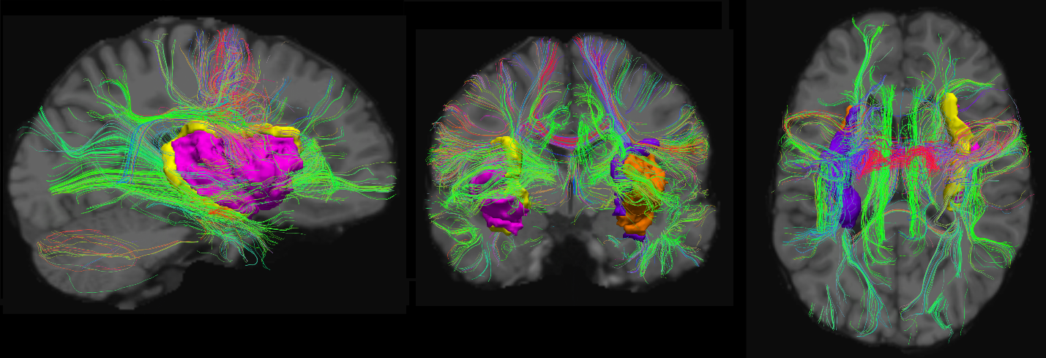

**Figure 1**: Example tractography pathways from a 23-year-old patient included in this study. Sagittal (left), coronal (center) and axial (right) tractographic projections are superimposed on a T1-weighted image (grey scale in the background). Three dimensional views of our four insular ROIs are provided in orange (left insular GM), pink (right insular GM), purple (left insular WM) and yellow (right insular WM). Visualized with TrackVis (Wang et al., 2007).

Scatter plots of the mean and standard deviation of the FA values for the left and right insular white and gray matter is provided in **Figure 2**. Results demonstrate that average FA increases with age in the WM and decreases with age in GM. The variability in FA as assessed with the standard deviation demonstrates similar profiles to the average FA values. FA also demonstrates small asymmetries in average values in the WM exhibiting leftward dominance. Plots of the mean and standard deviation of the ADC values for the left and right insular white and gray matter are also provided in **Figure 2**. Results demonstrate a reduction in average ADC with age in both the white and grey matter as well as an increase in variability of ADC with age. Results also demonstrate modest ADC asymmetries in the WM exhibiting rightward dominance.

**Figure 3** provides scatter plots of volumetric T1 measurements extracted with FreeSurfer (Fischl, 2012), including the gray matter surface area, volume, average cortical thickness, standard deviation of cortical thickness, average surface curvature as well as WM volumes.

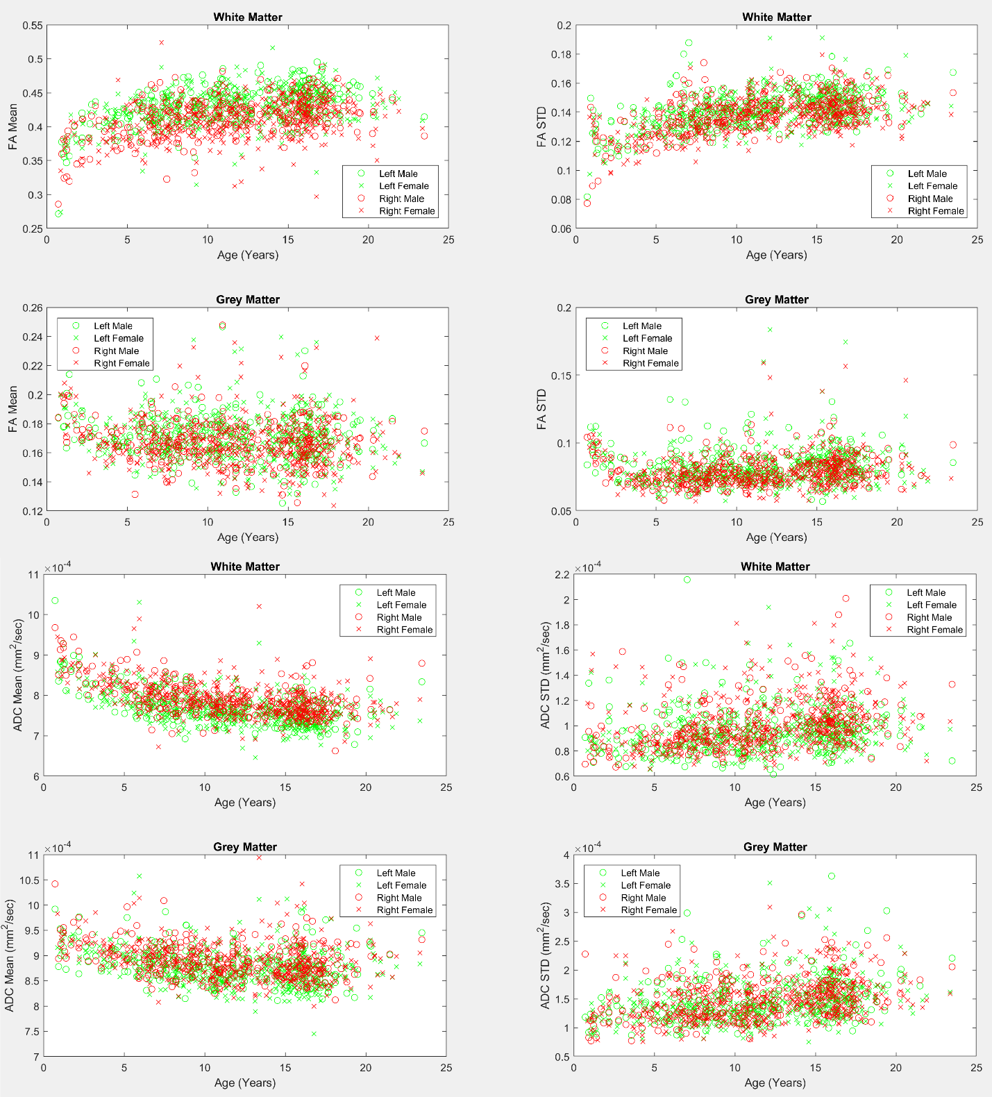

**Figure 2**: Mean and standard deviation of fractional anisotropy and apparent diffusion coefficient values across ages for males and females. Left and right hemisphere measurements are provided on the same subplots. White and grey matter measurements are provided.

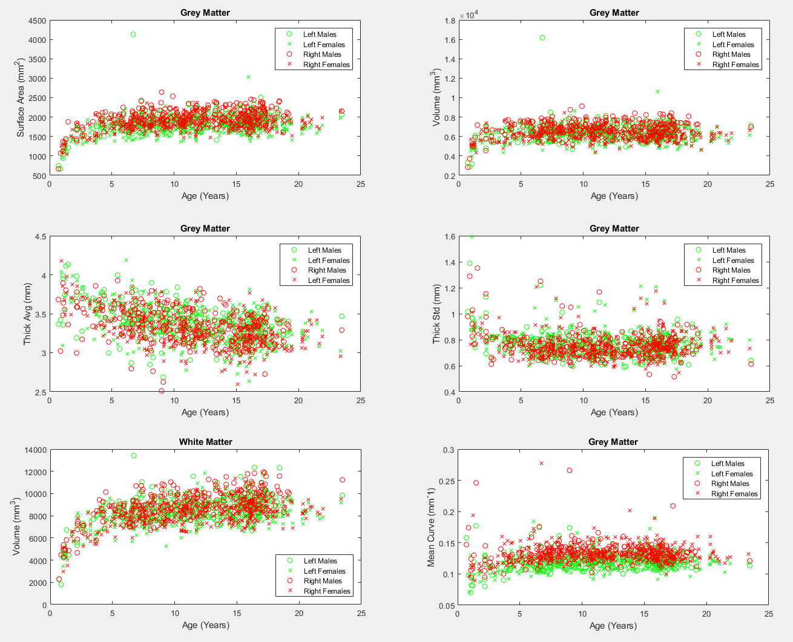

**Figure 3**: T1 structural measurements of the left and right insula from both the grey and white matter. Scatter plots are provided for the GM’s surface area (upper left), volume (upper right), average cortical thickness (ThickAvg, center left), standard deviation of cortical thickness (ThickStd, center right) and average curvature (bottom right). A scatter plot is also provided for the WM volumes (lower left).

Scatter plots of the mean and standard deviation of tract lengths of all pathways detected from/to the insular ROIs (both left and right sides, white and gray matter) are provided in **Figure 4**. Results demonstrate strong rightward asymmetries in the average tract length in the white and grey matter. Detected pathways from/to the insular GM also exhibited asymmetry in the standard deviation of the tract lengths, indicating higher tract length variability on the right side of the brain.

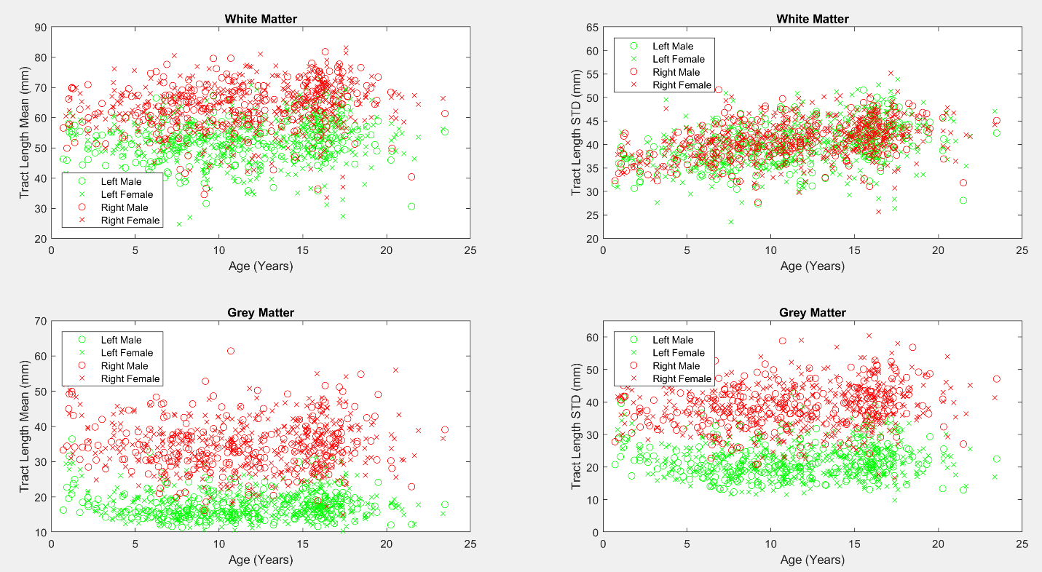

**Figure 4**: Mean and standard deviation of tract length across ages for males and females. Plots were established based on all fiber tracts that intersect with the four insular regions (left and right, white and grey matter).

**Discussion**

We analyzed the development of insular GM and WM in both hemispheres as well as pathways from/to the insular GM and WM using 642 MRI examinations from neurologically healthy subjects aged 0.7 to 23.5 years. We found several examples of left and right dominance in terms of tract count as well as the average and standard deviation of the tract lengths. This includes right dominance in the tract counts of the fiber pathways connecting the insular WM with the putamen, however, left dominance was observed in the tract length mean and standard deviation connecting the insular WM to the putamen, indicating that healthy brain development may consist of a greater quantity of tracts connecting the insula and the putamen in the right hemisphere while having longer tracts with increased variation in length in the left hemisphere. Fiber tract connections between the insular GM and the superior temporal GM have a reversed effect, whereby we observed left dominance in terms of the number of tracts and right dominance in terms of average tract length and tract length variability. Also of interest is an observed left dominance in terms of tract counts linking the insular WM and GM. In order to confirm whether insular WM-GM tract count asymmetries are related to GM surface area, we also calculated the GM surface area asymmetry score of 0.95, indicating slight right dominance in contrast to the tract count asymmetries which exhibited very strong left dominance with an asymmetry score of 2.22.

Numerous studies indicate cytoarchitectonic connectivity-related functional differentiation of the insular region in primates (Mesulam and Mufson 1985). In particular, functional neuroimaging studies indicate that the insula is composed of four functionally distinct regions: the posterior region important for sensorimotor functions, the anterio-ventral region relevant for socio-emotional functions, the central region activated by olfacto-gustatory stimuli, and the anterio-dorsal region relevant for cognition. Each one of these regions has a specific set of connections. In non-human primates, anterio-ventral regions of the insula are tightly connected with the limbic system, the temporal regions, and the orbito-frontal cortex (Mesulam and Mufson 1985); the dorsal parts of the central regions receive input from the thalamus (Craig 2002) and the posterior regions have dense connections with sensory and motor areas while anterio-dorsal ones include bilateral connections with frontal cortices (Mesulam and Mufson 1985). Despite its anatomical and functional segregation, the insula plays an important role in integration of all of the aforementioned functional systems (Craig 2002, Craig 2009, Dolan 2002), and thus, it has been suggested that the insula’s role in function/integration of these systems might represent a correlate of awareness in humans (Craig 2009).

In addition to its functional and anatomical segregation, insular regions also exhibit hemispheric specialization. Empathic processing has been predominantly linked with fMRI activation of posterior regions of insula of the left hemisphere, olfactory stimulation with fMRI activation of central insular regions of the right hemisphere, somatosensory stimuli with fMRI activation of the central region of the insula in the contralateral hemisphere (usually left for right handed subjects), language and speech processing with activation of the left anterior insula, and working memory with bilateral activation of the insula in anterio-dorsal regions (Kurth et al., 2010). Our results also indicate stronger connectivity of the left insula with cortical regions (pars opercularis and transverse temporal GM). In addition, the maturation changes of the insular cortex indicate an accented maturation of the insula predominantly during first five years of life. However, whether or not the stronger anatomical connectivity of the left insula is related, in part, to self-awareness, which predominantly develops in childhood (Rochat 2003), and to the development of language skills or empathy remains to be confirmed by multimodality MRI analysis.

The insula is also known to exhibit leftward structural asymmetries in surface area (Chiarello et al., 2013; Bidula and Kroliczak, 2015). Rightward asymmetries in connectivity strength have also been observed between the insula and the temporoparietal junction (Kucyi et al., 2012), however, our study did not include an ROI for the temporoparietal junction as this was not supported by FreeSurfer (Fischl, 2012). Strong rightward asymmetries were previously observed in the anterior insular cortex in terms of GM volumes (Watkins et al., 2001) which is in concordance with our findings. Additional work has focused on the use of tractography to assess asymmetries in a variety of brain regions, and determined that the insula most likely exhibits right dominance in connectivity between the insula and the putamen (Lee et al., 2014), which we were able to confirm in our experiment with tract count asymmetries. Lee’s study was only able to resolve these connections with diffusion kurtosis imaging (DKI), not with diffusion tensor imaging, however, our experiment demonstrates that with the use of HARDI tractography, these asymmetries can be resolved without DKI. Our results demonstrated, for the first time using DTI, structural connections between the insula and the basal ganglia. These connections have been successfully tracked in primates and have been suggested to serve as a neural correlate of feeding behavior determined by tactile hand and mouth object recognition (Chikama et al., 1997; Friedman et al., 1986; Preuss and Goldman-Rakic, 1989). Previous work has also performed connectomics whole brain asymmetry analyses on a small dataset of older adults (Bonilha et al., 2014). To the best of our knowledge ours is the first study to target the structural development of the insula’s connective pathways with the rest of the brain in an asymmetry enabled connectomics analysis.

Fiber tract reconstruction techniques are known to be imperfect technologies. We used an established method, however, our analytic approach is not dependent on any single fiber tracking methodology and so the technique relied upon can be replaced with any alternative method, including any new developments in this field. The many insular connectomics measurements extracted from paired ROIs in this analysis inevitably assess many spurious pathways (i.e. region pairs where pathways should not be found in a healthy population). In practice, using the methods described in this paper, many region pairs yield no fiber tracts in many of our patients. The asymmetry analysis performed in this study has the added benefit of producing invalid asymmetry indeces when no fiber tracts are detected (the equation: left hemisphere measurement divided by right hemisphere measurement returns an invalid index when the right measurement is zero). This helps us focus our analysis on those region pairs for which the establishment of the existence of fiber tracts is consistent across patients. A potential shortcoming of this approach is that it may result in our analysis not considering interesting neural pathways based on ROI pairs for which current tracking methods are unable to consistently establish existing fiber tracts.

Although we used a consistent pulse sequence for all of our diffusion measurements, our dataset included T1 pulse sequence variation limitations previously discussed (Levman *et al.*, 2017).

Our analysis used Diffusion Toolkit’s default tract seeding (Wang et al., 2007), which initializes the center of each voxel as a potential location to start tracking a neural fiber tract. Thus spatial resolution of the pulse sequence can affect tract count measurements and it is known that tract length measurements are also influenced by spatial resolution issues (higher resolution results in longer tracts). It is also possible that the position of the temporal lobe may affect the length of the reconstructed tracts and represents an additional potential source of error. It should be noted that the same pulse sequence and analysis used in this study can be employed in other centers which would align other experiments to the tract count and length measurements computed herein. Furthermore, we have elected to perform an asymmetry analysis which creates an index normalized between the hemispheres of the brain. This results in relative tract measurements (left vs. right) and so these quantifications may align with other studies performing analyses with alternative diffusion MRI pulse sequences.

Future work will investigate extending this analysis to other regions of the brain, creating connectomics technology for clinical MRI that can compute all possible major neural fiber tracts throughout the brain (instead of just the insula connected to any ROI, we will examine any ROI connected to any ROI). Additionally, clinical populations with directional diffusion MRI examinations allow us to apply connectomics technologies large-scale to children with a wide variety of pathologies. Future work will look at extending this study to the analysis of children with autism, attention deficit hyperactivity disorder, cerebral palsy and more.

**Acknowledgements**

This article was supported financially by the National Institutes of Health grants R01HD078561 and R03NS091587 to ET. This article was also supported financially by a Natural Science and Engineering Research Council of Canada's Canada Research Chair grant, a Canada Foundation for Innovation grant, a Nova Scotia Research and Innovation Trust grant, and a St. Francis Xavier University research startup grant to JL. The authors report no conflicts of interest.

**References**

Augustine JR. Circuitry and functional aspects of the insular lobe in primates including humans. Brain Research Reviews. 1996;22(3):229-244.

Bamiou DE, Musiek FE, Luxon LM. The insula (Island of Reil) and its role in auditory processing: Literature review. Brain Research Reviews 2003; **42**(2):143-154.

Bauernfeind AL, de Sousa AA, Avasthi T, et al. A volumetric comparison of the insular cortex and its subregions in primates. Journal of Human Evolution. 2013;64(4):263- 279.

Bidula SP and Kroliczak G. Structural asymmetry of the insula is linked to the lateralization of gesture and language. The European Journal of Neuroscience 2015; **41**(11):1438-1447.

Bonilha L, Nesland T, Rorden C, Fridriksson J. Asymmetry of the structural brain connectome in healthy older adults. Frontiers in Psychiatry. 2014; DOI: 10.3389/fpsyt.2013.00186.

Cancelliere A, Mangano FT, Air EL, Jones BV, Altaye M, Rajagopal A, Holland SK, Hertzler II DA, Yuan W. DTI values in key white matter tracts from infancy through adolescence. AJNR 2013;**34**:1443-1449.

Cao Y, Whalen S, Huang J, Berger KL, DeLano MC. Asymmetry of subinsular anisotropy by in vivo diffusion tensor imaging. Hum Brain Mapp. 2003; **20**(2):82-90.

Cercignani M, Embleton K, Parker GJ, Bozzali M. Group-averaged anatomical connectivity mapping for improved human white matter pathways visualization. NMR in Biomedicine 2012;**25**:1224-1233.

Chao YP, Cho KH, Yeh CH, Chou KH, Chen JH, Lin CP. Probabilistic topography of human corpus callosum using cytoarchitectural parcellation and high angular resolution diffusion imaging tractography. Hum Brain Mapp 2009;**30**:3172-3287.

Chiarello C, Vazquez D, Felton A, Leonard CM. Structural asymmetry of the anterior insula: Behavioral correlates and individual differences. Brain Lang 2013; **126**(2):109-122.

Chikama M, McFarland NR, Amaral DG, Haber SN. Insular cortical projections to functional regions of the striatum correlate with cortical cytoarchitectonic organization in the primate. J Neurosci 1997; **17**(24):9686-705.

Christopher L, Koshimori Y, Lang A,E., Criaud M, Strafella A,P. Uncovering the role of the insula in non-motor symptoms of parkinson’s disease. Brain 2014; 137(8):2143-2154.

Cohen AH, Wang R, Wilkinson M, MacDonald P, Lim AR, Takahashi E. Development of Human White Matter Fiber Pathways: From Newborn to Adult Ages. Int J Dev Neurosci. 2016;**50**:26-38.

Craig AD, Chen K, Bandy D, Reiman EM. Thermosensory activation of insular cortex. Nature Neuroscience 2000; **3**(2):184-190.

Craig AD. How do you feel - now? The anterior insula and human awareness. Nature Reviews Neuroscience 2009; **10:**59-70.Craig AD. How do you feel? Interoception: the sense of the physiological condition of the body. Nat Rev Neurosci 2002; **3**(8):655-666.

Critchley HG, Wiens S, Rotshtein P, Ohman A, Dolan RJ. Neural systems supporting introceptive awareness. Nature Neuroscience 2004; **7**:189-195.

Das A, Takahashi E. Neuronal Migration and Axonal Pathways Linked to Human Fetal Insular Development Revealed by Diffusion MR Tractography. Cerebral Cortex 2017; Aug 31:1-9. doi: 10.1093/cercor/bhx224. [Epub ahead of print]

Dolan RJ. Emotion, cognition, and behavior. Science 2002; **298**:1191–1194

Dronkers NF. A new brain region for coordinating speech articulation. Nature 1996; **384**:159-161.

Farrer C, Frith CD. Experiencing oneself vs another person as being the cause of an action: The neural correlates of the experience of agency. NeuroImage 2002; **15**(3):596-603.

Fischl B. FreeSurfer. NeuroImage 2012; **62**(2):774-781.

Friedman DP, Murray EA, O’Neill JB, Mishkin M. Cortical connections of the somatosensory fields of the lateral sulcus of macaques: evidence for a corticolimbic pathway for touch. J Comp Neurol 1986; **252**(3):323-47.

Hatton SN, Lagopoulos J, Hermens DF, Hickie IB, Scott E, Bennett MR. Short Association Fibres of the Insula-Temporoparietal Junction in Early-Psychosis: A Diffusion Tensor Imaging Study. PLoS One 2014; **9**(11):e112842.

Hoptman MJ, Nierenberg J, Bertisch HC, et al. A DTI study of white matter microstructure in individuals at high genetic risk for schizophrenia. Schizophrenia Research. 2008;106(2):115-124.

Jakab A, Molnar PP, Bogner P, Beres M, Berenyi EL. Connectivity-based parcellation reveals interhemispheric differences in the insula. Brain Topography 2012; **25**(3):264-271.

Jenkinson M, Smith SM. A global optimization method for robust affine registration of brain images. Medical Image Analysis 2001; **5**(2):143-156.

Jenkinson M, Bannister PR, Brady JM, Smith SM. Improved optimization for the robust and accurate linear registration and motion correction of brain images. NeuroImage 2002; **17**(2):825-841.

Jin Y, Shi Y, Joshi SH, Jahanshad N, Zhan L, de Zubicaray GI, McMahon KL, Martin NG, Wright MJ, Toga AW, Thompson PM. Heritability of White Matter Fiber Tract Shapes: A HARDI Study of 198 Twins. Multimodal Brain Image Anal 2011;35-43.

Kennedy DP, Courchesne E. The intrinsic functional organization of the brain is altered in autism. NeuroImage 2008;39(4):1877-1885.

Kucyi A, Moayedi M, Weissman-Fogel I, Hodaie M, Davis KD. Hemispheric asymmetry in white matter connectivity of the temporoparietal junction with the insula and prefrontal cortex. PLoS One 2012; **7**(4):e35589.

Kurth F, Zilles K, Fox PT, Laird AR, Eickhoff SB. A link between the systems: functional differentiation and integration within the human insula revealed by meta-analysis. Brain Struct Funct 2010; **214**(5-6):519-534.

Lee CY, Bonilha L, Nesland T, Jensen JH, Helpern JA, Spampinato MV, Tabesh A. Human brain asymmetry in microstructural connectivity demonstrated by diffusional kurtosis imaging. Brain Research 2014; **1588**:73-80.

Lei D, Li L, Li L, Suo X, Huang X, Lui S, Li J, Bi F, Kemp GJ, Gong Q. Microstructural abnormalities in children with post-traumatic stress disorder: A diffusion tensor imaging study at 3.0 T. Scientific Reports 2015; **5**:8933.

Levman J, MacDonald P, Lim AR, Forgeron C, Takahashi E. A Pediatric Structural MRI Analysis of Healthy Brain Development from Newborns to Young Adults. Human Brain Mapping 2017; **38**(12):5931-5942.

Lopez-Larson MP, King JB, Terry J, McGlade EC, Yurgelun-Todd D. Reduced insular volume in attention deficit hyperactivity disorder. Psychiatry Research: Neuroimaging. 2012;204(1):32-39.

Mesulam MM, Mufson EJ: The Insula of Reil in man and monkey: architectonics, connectivity, and function. In Cerebral cortex 4. Edited by Peters A, Jones E, Peters A, Jones E. New York: Plenum Press; 1985:179–226.

Murphy CF, Gunning-Dixon FM, Hoptman MJ, Lim KO, Ardekani B, Shields JK, Hrabe J, Kanellopoulos D, Shanmugham BR, Alexopoulos GS. White-matter integrity predicts stroop performance in patients with geriatric depression. Biol Psychiatry 2007; **61**:1007-1010.

Murphy ML, Frodl T. Meta-analysis of diffusion tensor imaging studies shows altered fractional anisotropy occurring in distinct brain areas in association with depression. Biology of Mood & Anxiety Disorders 2011; **1**(1):3.

Namkung H, Kim S, Sawa A. The insula: An underestimated brain area in clinical neuroscience, psychiatry, and neurology. Trends in Neurosciences. 2017;40(4):200-207.

Nowak M, Holm S, Biering-Sorensen F, Secher NH, Friberg L. "Central command" and insular activation during attempted foot lifting in paraplegic humans. Human Brain Mapping 2005; **25**(2):259-265.

Ogino Y, Nemoto H, Inui K, Saito S, Kakigi R, Goto F. Inner experience of pain: Imagination of pain while viewing images showing painful events forms subjective pain representation in human brain. Cerebral Cortex 2007; **17**(5):1139-1146.

Piché M, Chen J, Roy M, Poitras P, Bouin M, Rainville P. Thicker posterior insula is associated with disease duration in Women with irritable bowel syndrome (IBS) whereas thicker orbitofrontal cortex predicts reduced pain inhibition in both IBS Patients and controls. The Journal of Pain. 2013;14(10):1217-1226.

Pienaar R, Rannou N, Haehn D, Grant PE. ChRIS: real-time web-based MRI data collection analysis, and sharing. 20th Annual Meeting of the Organization for Human Brain Mapping 2014;**5**.

Qiu C, Zhu C, Zhang J, Nie X, Feng Y, Meng Y, Wu R, Huang X, Zhang W, Gong Q. Diffusion tensor imaging studies on Chinese patients with social anxiety disorder. BioMed Research International 2014; 860658.

Racine AM, Adluru N, Alexander AL, Christian BT, Okonkwo OC, Oh J, Cleary CA, Birdsill A, Hillmer AT, Murali D, Barnhart TE, Gallagher CL, Carlsson CM, Rowley HA, Dowling NM, Asthana S, Sager M, Bendlin BB, Johnson SC. Associations between white matter microstrucutre and amyloid burden in preclinical Alzheimer's disease: A multimodal imaging investigation. Neuroimage Clin 2014;**4**:604-614.

Rochat P. Five levels of self-awareness as they unfold early in life. Conscious Cogn 2003; **12**(4):717-731.

Sanfey AG, Rilling JK, Aronson JA, Nystrom LE, Cohen JD. The neural basis of economic decision-making in the ultimatum game. Science 2003; **300**(5626):1755-1758.

Student S. The probable error of a mean. Biometrika 1908; **6**(1):1-25.

Takahashi E, Folkerth RD, Galaburda AM, Grant PE. Emerging cerebral connectivity in the human fetal brain: an MR tractography study. Cereb Cortex 2012; 22:455-464.

Teipel SJ, Meindl T, Wagner M, Kohl T, Burger K, Reiser MF, Herpertz S, Moller HJ, Hampel H. White matter microstructure in relation to education in aging and Alzheimer's disease. J Alzheimers Dis 2009; **17**(3):571-583.

Thong JY, Du J, Ratnarajah N, Dong Y, Soon HW, Saini M, Tan MZ, Ta AT, Chen C, Qiu A. Abnormalities of cortical thickness, subcortical shapes, and white matter integrity in subcortical vascular cognitive impairment. Hum Brain Mapp 2014;**35**:2320-2332.

Tournier JD, Calamante F, Connelly A. Robust determination of the fibre orientation distribution in diffusion MRI: non-negativity constrained super-resolved spherical deconvolution. Neuroimage 2007;**35**:1459-1472.

Tournier JD, Calamante F, Gadian DG, Connelly A. Direct estimation of the fiber orientation density function from diffusion-weighted MRI data using spherical deconvolution. Neuroimage 2004;**23**:1176–1185.

Trojsi F, Corbo D, Caiazzo G, Piccirillo G, Monsurrò MR, Cirillo S, Esposito F, Tedeschi G. Motor and extramotor neurodegeneration in amyotrophic lateral sclerosis: a 3T high angular resolution diffusion imaging (HARDI) study. Amyotroph Lateral Scler and Frontotemporal Degener 2013;**14**:553-561.

Tuch DS, Reese TG, Wiegall MR, Wedeen VJ. Diffusion MRI of complex neural architecture. Neuron 2003; 40:885-895.

Türe U, Yaşargil DCH, Al-Mefty O, Yaşargil MG. Topographic anatomy of the insular region. J Neurosurg. 1999; **90**(4):720-733.

Uda S, Matsui M, Tanaka C, Uematsu A, Miura K, Kawana I, Noguchi K. Normal development of human brain white matter from infancy to early adulthood: a diffusion tensor imaging study. Dev Neurosci, 2015;**37**(2):182-94.

Varentsova A, Zhang S, Arfanakis K. Development of a high angular resolution diffusion imaging human brain template. Neuroimage 2014;**91**:177-186.

Vasung L, Raguz M, Kostovic I, Takahashi E. Spatiotemporal Relationship of Brain Pathways During Human Fetal Development using High-Angular Resolution Diffusion MR Imaging and Histology. Front. Neurosci. 2017;**11**:348. doi: 10.3389/fnins.2017.00348

Wang R, Benner T, Sorensen AG, Wedeen VJ. Diffusion toolkit: A software package for diffusion imaging data processing and tractography. Proceedings of the International Society of Magnetic Resonance in Medicine 2007; **15**:3720.

Watkins KE, Paus T, Lerch JP, Zijdenbos A, Collins DL, Neelin P, Taylor J, Worsley KJ, Evans AC. Structural asymmetries in the human brain: A voxel-based statistical analysis of 142 MRI scans. Cerebral Cortex 2001; **11**(9):868-877.

Wicker B, Keysers C, Plailly J, Royet JP, Gallese V, Rizzolatti G. Both of us disgusted in my insula: The common neural basis of seeing and feeling disgust. Neuron 2003; **40**(3):655-664.

Wilkinson M, Lim AR, Cohen AH, Galaburda AM, Takahashi E. Detection and Growth Pattern of Arcuate Fasciculus from Newborn to Adult. Front. Neurosci. 2017;**11**:389. doi: 10.3389/fnins.2017.00389

Xu J, Wang J, Fan L, Li H, Zhang W, Hu Q, Jiang T. Tractography-based parcellation of the human middle temporal gyrus. Scientific Reports 2015; **5**:18883.

Xue G, Lu Z, Levin IP, Bechara A. The impact of prior risk experiences on subsequent risky decision-making: The role of the insula. NeuroImage 2010; **50**(2):709-716.