This is a sample thesis.
Hope you like it!
By
Noah Body
Submitted in partial fulfillment of the
requirements for the degree of
Bachelor of Science with Honours in Mathematics
at
Saint Francis Xavier University
Antigonish, Nova Scotia
May 2008
© Copyright by Noah Body, 2008
Saint Francis Xavier University
Department of
Mathematics, Statistics and Computer Science
The undersigned hereby certify that they have read a thesis entitled “This is a sample thesis. Hope you like it!” by Noah Body in partial fulfillment of the requirements for the degree of Bachelor of Science with Honours.

Dated:

Supervisor:
Dr. Soma Body

Second Reader:
Dr. Alla Body

St. Francis Xavier University
May 2008
Author: Noah Body
Title: This is a sample thesis. Hope you like it!
Department: Mathematics, Statistics and Computer Science
Faculty: Science
Convocation: May 2008
Permission is herewith granted to Saint Francis Xavier University to circulate and to have copied for non-commercial purposes, at its direction, the above title upon request of individuals or institutions.

Noah Body

The author reserves other publication rights, and neither the thesis nor extensive extractions from it may be printed or otherwise reproduced without the author's written permission.
The Author attests that permissions has been obtained for the use any copyrighted material appearing in this thesis (other then of brief excerpts requiring only proper acknowledgement in scholarly writing) and that all such use is clearly acknowledged.
to the one who wrote this
Abstract
This is your abstract. This is your abstract. This is your abstract. This is your abstract. This is your abstract. This is your abstract. This is your abstract. This is your abstract. This is your abstract. This is your abstract.
This is your abstract. This is your abstract. This is your abstract. This is your abstract. This is your abstract. This is your abstract.
Acknowledgements
This is the Acknowledgement section. This is the Acknowledgement section. This is the Acknowledgement section. This is the Acknowledgement section. This is the Acknowl-edgement section.
This is the Acknowledgement section. This is the Acknowledgement section. This is the Acknowledgement section. This is the Acknowledgement section. This is the Acknowledgement section.
Contents
Chapter 1 Introduction 8
1.1 Some hints 9
1.2 Compiling your thesis 9
1.3 Changing fonts 9
1.4 Section 9
1.4.1 Subsection 10
1.4.1.1 Subsubsection 10
Bibliography 11

Introduction
This is the introductory chapter. It provides some ideas of how to use Word to format your document. And now a quote:
“Microsoft Word is a full-featured word processor that includes automatic formatting, easy-to-create tables, and the ability to create and position graphics. Word processing is effortless with features like AutoCorrect that automatically fixes typos, wizards that build newsletters and tables, and step-by-step Mail Merge.”
By default, all text is double spaced; however, quotes and footnotes must be singled spaced. The left margin is wider than the right margin to compensate for binding.
Mathematical formulae are also possible as shown in Equation Error: Reference source not found.
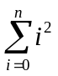 | 1.1

A slightly more complicated equation is given in Equation 1.2.
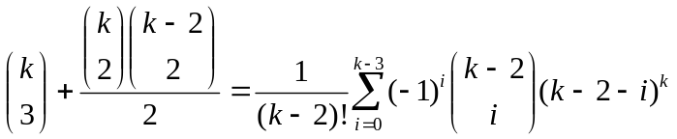 | 1.2

Equation numbers are generated using Insert Reference Caption and choosing Equation in the Label box. References to equations are generated using Insert Reference Cross-reference and choosing Equation in the Reference Type box and Only Label and Number in the Insert Reference To box.

Some hints
- Concentrate on content and not on presentation.
- Discuss with your supervisor in what format he or she wants your thesis written. e.g. Word, LaTeX, etc.
In addition to using Insert Reference Cross-reference to refer to equations, you can also use it to refer to sections and chapters without hard coding the numbers themselves, simply by choosing Numbered Item in the Reference Type box. For example, this is Section of .

Compiling your thesis
To ensure that all labels and cross-reference are correct, you can use Ctrl-A to select the entire thesis, and hit F9 to update the fields, and select Update Entire Table. Otherwise, there is no need to “compile” your thesis using Word, as “what you see is what you get.”

Changing fonts
Changing fonts to Large and small caps is easy.

Section
Section.

Subsection
Subsection.

Subsubsection
Subsubsection.

Tables, Figures, and Diagrams
We can include encapsulated PostScript® figures (.eps) in the document and refer to it using a label. For example, StFX's logo can be seen in Figure 2.1. The caption was created using Insert Reference Caption and choosing Figure in the Label box. The caption was then changed to Figure Caption style. The reference was inserted using Insert Reference Cross-reference and choosing Figure in the Reference Type.

Figure 2.1 StFX’s Logo
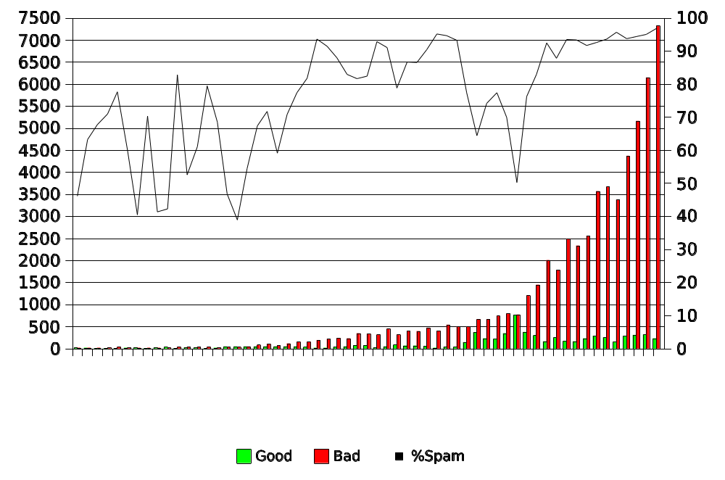
Figure 2.2 This is a spam chart.
Figure 2.2 shows spam volume graph created using the freely available spreadsheet application of the office suite OpenOffice.org. Figure 2.3 shows a Petri net created using the xfig program on Linux.

Tables
We can also do tables, as seen by Table 2.1. Tables and figures can “float” – they may not appear on the page on which they are mentioned.
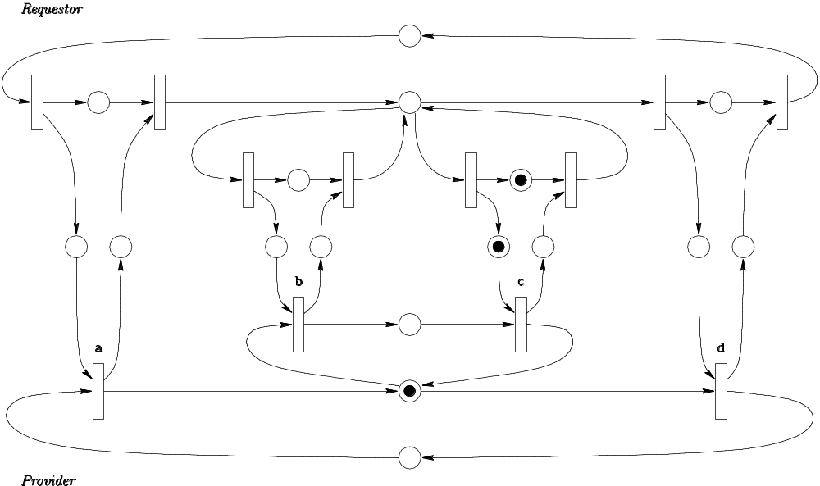
Figure 2.3 A deadlocked Petri net

Year | Students
2000 | 8
2001 | 5
2002 | 5
2003 | 22
2004 | 26
Table 2.1 Population of graduate students

Handling References
We can refer to the journal article and the conference paper in the same way as a book reference. Citing web pages is less standardized, but should include as much information as possible. The Bibliography is created as a numbered list, and then the references are generated using Insert Reference Cross-reference, choosing Numbered Item in the Reference Type box, and finding the reference in the list.

Bibliography
- Microsoft Corporation. Getting Started with Microsoft Office, Version 4.2 and 4.3, Microsoft Corporation, 1992 – 1994.
- Nenad Medvidovic, David S. Rosenblum, David F. Redmiles, and Jason E. Robbins, Modeling software architectures in the unified modeling language, ACM Transactions on Software Engineering and Methodology (TOSEM), 11(1), 2–57, 2002.
- Nenad Medvidovic, Richard N. Taylor, and Richard N. Whitehead Jr. Formal modelling of software architectures at multiple levels of abstraction. In Proceedings of the California Software Symposium, 28–40, April 1996. Available at http://www-old.ics.uci.edu/pub/c2/publications.html.

This is a single spaced footnote. The University requires that footnotes be single spaced and this can be done using Insert Reference Footnote on the menu.
This office suite can be downloaded at no cost from http://openoffice.org/. There are versions for Linux and Microsoft Windows.

