Prog1

Team and class

Report title and subtitle is defined by writing in the fields ”Title” and ”Subject” in Document Properties. (Choose File > Properties > Summary). Right click and choose *Update Field*, to update the actual field (on all subsequent pages).

|  |  |
| --- | --- |
| **Supervisor:** | **Ian Bridgwood** |

|  |  |  |
| --- | --- | --- |
| **Students name** | **Number** | **Signature** |
| Manuel Maestrini | 091961 |  |
| Jeppe Laursen | 091921 |  |
|  |  |  |

Content

1. Introduction 2

1.1 System description

2. Documentation 2

2.1 States

2.2 Events

2.3 Actions

2.4 State transition diagram

2.5 Class diagram

2.5.1 Class description 2

3. Test 2

3.1 Unit Tests

4. Conclusion 2

4.1 About the product

4.2 About the Team work

5. Literature 2

6. Appendixes 2

6.1 Glossary

6.2 Test results

Note: The *Table of Contents* aboveis automatically updated. So, do not change anything on this page. The changes you make on the following pages are updated when you right click on Table of Contents and choose Update field. Remember to format Heading 1, Heading 2 etc. (Choose format and Style)

# Introduction

## System description

...(Provide a brief introduction the overall system)

# Documentation

## States

... (Define the states found. Give a short description of each state and choose an appropriate meaningful name, which is used in the code also.)

## Events

... (Define the events found. Give a short description of each event and choose an appropriate meaningful name, which is used in the code also.)

## Actions

... (Define the actions found. Give a short description of each action and choose an appropriate meaningful name, which is used in the code also.)

## State transition diagram

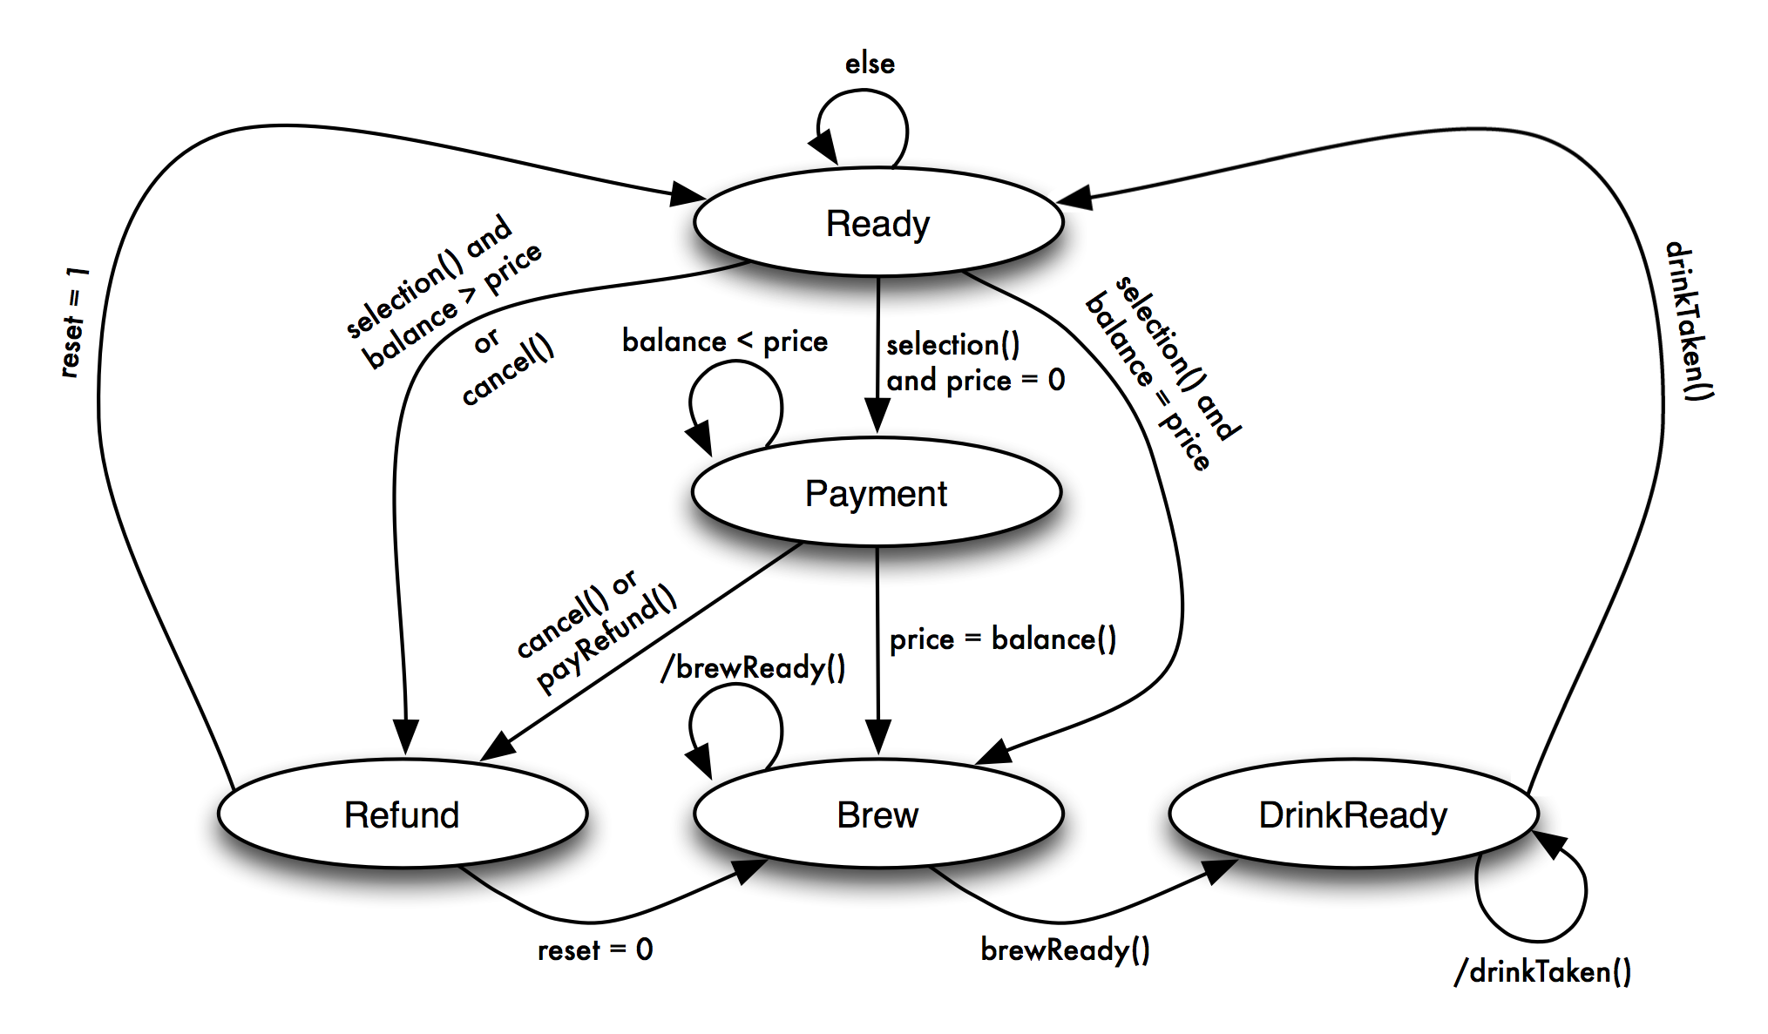

## Class diagram ClassDiagramUI

### Class description

... (Provide a short description of each class. Each class should be documented in the source code using Javadoc)

# Test

JUnit Tests

... (Describe the purpose of each unit test performed)

# Conclusion

## About the product

...

## About the Team work

...

# Literature

...

# Appendixes

## Glossary

...

## Test results

...

## NetBeans Project CD

...(The complete netbeans project should be provided on a CD)