**Name: Girma, Senay CMIS 350/6380 Date: (9/03/2022)**

**Test Scenario 1: Main GUI launch**

**Test Scenario 2: Illegal input check (blank)**

**Test Scenario 3: prefixToPostfix conversion test**

**Test Scenario 4: Enter letter and select OK**

**Test Scenario 5: Extra digit expression exception check**

**Test Scenario 6: Extra operator expression exception check**

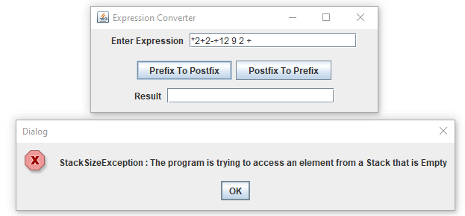

**Summary of Lesson Learned:**

This project has been a little harder than I expected. I wanted to understand more about the problem itself and why the need for the conversion. I learned a lot. In addition to having a firmer grasp of, what I thought was a simple algebraic equation, I had to get myself learn more about parsing and string manipulation. The main lesson however was the fact that working within a certain confinement and limitation is hard. Up until now, my limited programming experience has been to get it to work by any means necessary. Even though having the pseudocode was helpful, also getting constrained by it was a struggle I appreciate. Thank you.