Cover page for the document

**Abstract**

In this report, a description of project party management system has been done. In the beginning of the report, brief introduction of the management system has been described. Likewise, the use of the software has also been shown in the report. There are many advantages and disadvantages of using a software and such kind of things are mentioned in this report. The Entity Relationship Diagram and Architecture of the software has been mentioned in the report.

The report is mainly focused on describing about Party Management System and it’s uses. The report also shows about user manual to teach user’s for fluent use of the software. The main use of the software is to add different kinds of parties held and show organizer and attendees by the admin user. The person who wants to book for the party can inform admin or staff members and register a party.

*Contents*

*1. Introduction 1*

*1.1 Current Scenario 1*

*1.2 Proposed System 1*

*1.3 Features of application 1*

*1.4 Tools used 2*

*2. Background 3*

*3. Architecture of the system 4*

*4. Benefit of the system 5*

*5. Entity Relationship Diagram 6*

*6. User manual 7*

*7. Conclusion and Learning reflection 16*

*8. References 17*

Table of figures

*Figure 1: Architecture of the system 4*

*Figure 2: Entity Relationship diagram ( (Inc, 2021) 6*

*Figure 3: User list user manual 7*

*Figure 4: Party all details user manual 8*

*Figure 5: Create party user manual 8*

*Figure 6: Delete party user manual 8*

*Figure 7: Edit party user manual 9*

*Figure 8: Party Details user manual 9*

*Figure 9: Categories index user manual 10*

*Figure 10: Create categories user manual 10*

*Figure 11: List category details user manual 11*

*Figure 12: Delete Category User manual 11*

*Figure 13: Attendees details user manual 12*

*Figure 14: Create attendees user manual 12*

*Figure 15: Edit attendees user manual 13*

*Figure 16: Delete Attendees user manual 13*

*Figure 17: Organizer details user manual 14*

*Figure 18: Edit organizer details user manual 14*

*Figure 19: Delete organizer user manual 15*

*Figure 20: Create user details user manual 15*

*Figure 21: User details user manual 16*

# Introduction

In today’s world, the quality of restaurants has become one of the most important factors of parties and other management system. The quality of parties and services in the restaurant and hotels cannot grow only in traditional ways of ordering the parties. The developed system is about booking parties or storing parties’ details for the customer by an admin. The owner/worker of the restaurant can add parties’ details in restaurant or any party palace.

## Current Scenario

There are many hotels, restaurants and party palace who are still following traditional methods of ordering and booking the parties. The use of paper becomes hectic and includes more repetitive tasks. The paper form must be given to every customer and it is a loss of time. It a loss of money because the manpower also has worked for the survey of the hotel and restaurant or party palace. There is a high chance that customers may not come to book for parties. So, it does not help the restaurant, hotel or party palace to get exact amount of profit and booking.

## Proposed System

The proposed system is to overcome the problem of paper-based saving order or booking from customer. It solves the problem of repetitive tasks and uses less manpower. The system is also very helpful in saving time and effort of the owner.

## Features of application

* The admin user can log in to the system. So, it has an authentication and permissions feature.
* The admin or staff user can add party, category, organizer and attendees into the system.
* The customer view party details into the system.
* The organizer can view their party details into the system.

## Tools used

* Visual studio 2019

Visual studio 2019 has been used in this project because it is compatible with .NET Framework and contains features like drag and drop. It also creates an environment.

* Microsoft ASP .NET Framework

It has been used in the project because it is the easiest and fastest to build the desktop application.

* Microsoft word

Microsoft has been used to prepare the documentation of the project.

* Dr. explains

It has been used to make all the user manual.

* Draw.io

It has been used to create Use case diagram and system architecture.

* C# programming

It has been used in the project because it more in demand for developing a desktop application.

# Background

It is an application created for Party Management System where a person can add parties as much as he/she can and different kinds of parties. Storing data for recording booking can be difficult to address and cannot find in required time frame. The people who are coming to the parties can view all the information about the parties. The party’s people can be added and shown in the website.

The organizer can do as much as party he wants in any parties in different times as supervised by admin and organizer himself. The application can add the party show it that to the organizer so that it makes organizer to view their work and schedule them. Most of the time organizer can be confused about their schedule but with this application it will help in making schedule after seeing their parties’ details.

A software is developed using ASP .NET Framework. For the data saving and using it, database named as MySql has been used. For frontend part of the web application, html CSS and JavaScript has been used. Overall software has been developed in visual studio using ASP .NET Framework of C#. The following software development architecture has been described below.

A software solution has been set for the hotels, restaurant and other parties palace where parties take place and does not go well. Many party’s palace is opening now a days and spending lot of money in booking off-line ways. But a solution has been prepared using this software. The software can book the system where as customer can call and send their details. In future updates, a feedback system will be created using Artificial Intelligence to know about the restaurant and hotel party’s management ways and their hospitality.

# Architecture of the system

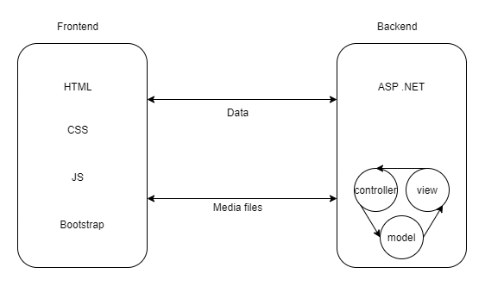

Figure 1: Architecture of the system

There are many benefits of the using MVC architecture. The data can be stored using this pattern which makes easy in coding and more convenient. There are many ways of doing this project in ASP .NET but this is the best pattern to follow because it helps in parallel and rapid development. It is a group work so MVC makes easier working in view by one team member, working in controller by another team member and working in model by one team member for database. The develop can be faster and improve in performance. It is also capable of providing multiple views and support asynchronous technique. The modification can be easily done and does not affect the entire application and SEO friendly application (BrainVire, 2021). In MVC pattern of software development, Entity Framework has been used to develop the software. Entity Framework is an object–relational mapping framework for ADO.NET that is open source. It was originally distributed as part of the.NET Framework. Entity Framework has been distributed independently from the.NET Framework since version 6 (Microsoft, 2021).

# Benefit of the system

1. Makes easier for storing parties’ details
2. Makes easier for showing details about parties.
3. Makes proper management of person coming in parties.
4. Makes proper arrangement of organizer
5. Store information about organizer.
6. Reduce paper work.
7. Growth of the business.
8. Increase technical knowledge.
9. Saves money, time and effort.
10. Easy to maintain.
11. Branding and publicity.
12. Ease in business expansion.
13. Low budget management.
14. Cost saving for human resource.
15. Improves performance.
16. Direct communication to customer.
17. Marketing business.
18. Software has high level of security.
19. Easy customizable.
20. Easy maintenance.
21. Direct feedback from customer.
22. Easy changes in data in future.
23. Easy finding out the customer.

# Entity Relationship Diagram

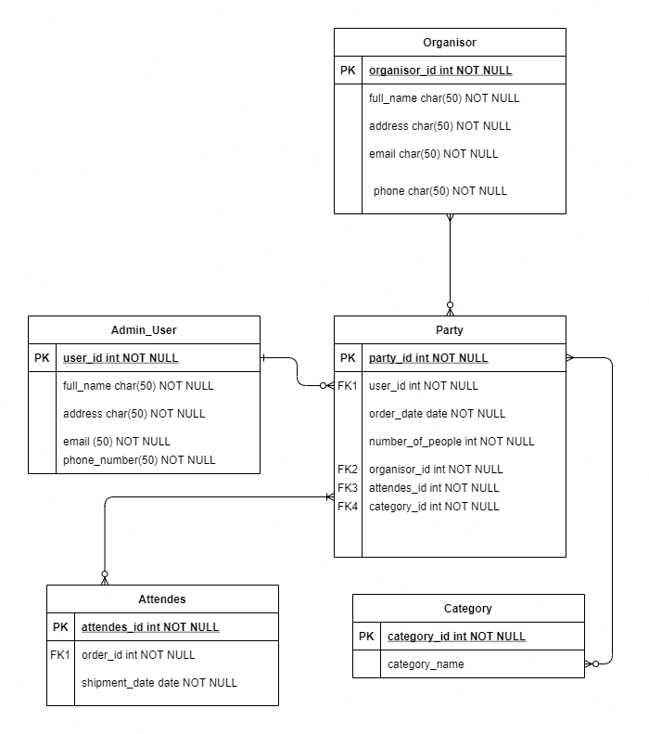

Figure 2: Entity Relationship diagram ( (Inc, 2021)

Admin_user is for storing data for user_id, full_name, address, email and many more details about admin, Party is for storing party details such as user_id as foreign key, party_id and many more foreign keys. Category is for storing category details. Admin_user and Party have one to many relationships. Party and Category have one to many relationships. Attendees and Party have many to many relationships. Organizer and Party have many to many relationships. The relationship between the Entities are not described and developed in normalized form. It is because of there is no any practice of using the system for normalizing the data in database. So, the database has been drawn as per given criteria. The admin user has one to many relationships with party and party has many to many relationships with categories. Attendees has many to many relationships with party and party is also same with attendees. Organizer can manage many party and many party can be managed by one organizer.

# User manual

A user manual, often known as a user guide, is a technical communication document created to teach people about a certain product. They can be written about practically any product, but are especially frequent with computer software and hardware, electrical devices, and video games. They can be published in print or digitally. User manual is mainly created in this report for understanding and using the system more fluently. The user must understand the system and use it. Without understanding it, he/she cannot use the system in fluent manner. A user manual’s importance is not limited with in a software system. The user manual is used by whole world companies to instruct the user how to use the system in proper manner.

(Zenkit, 2021)

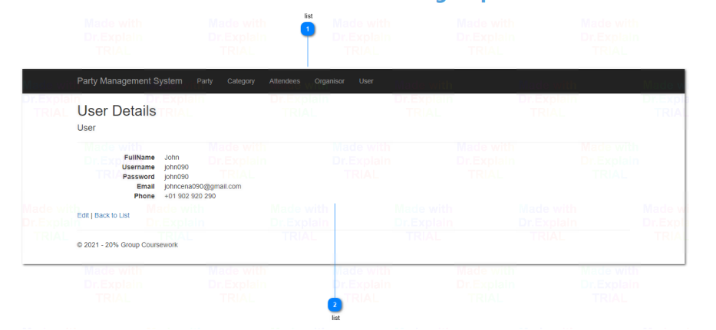

Figure : User list user manual

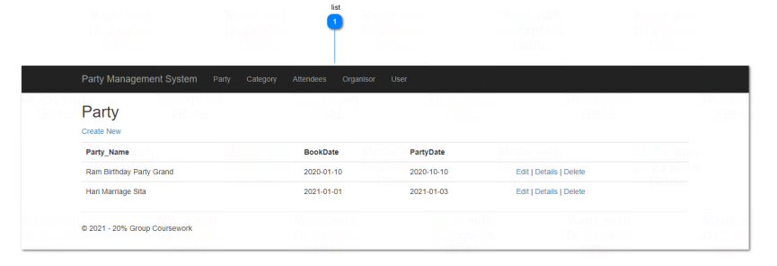

Figure : Party all details user manual

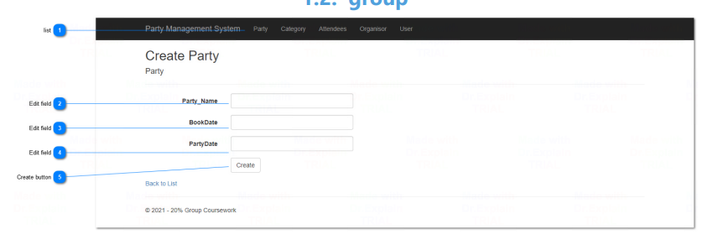

Figure : Create party user manual

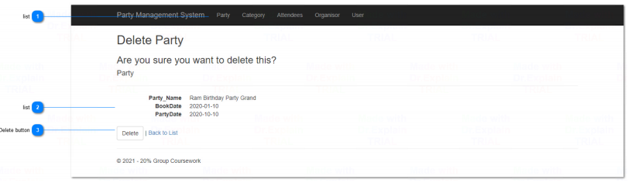

Figure : Delete party user manual

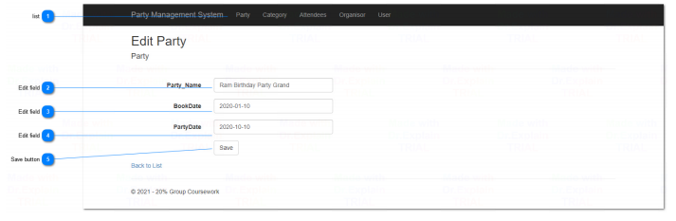

Figure : Edit party user manual

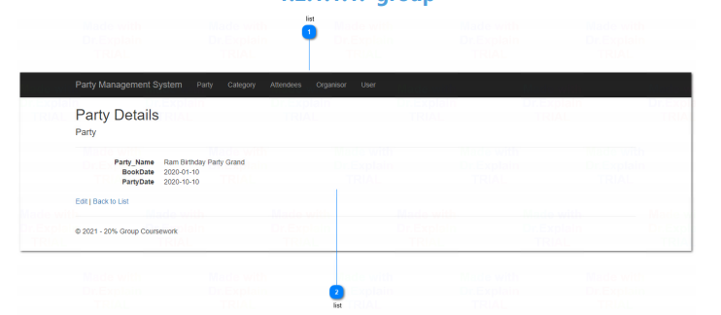

Figure : Party Details user manual

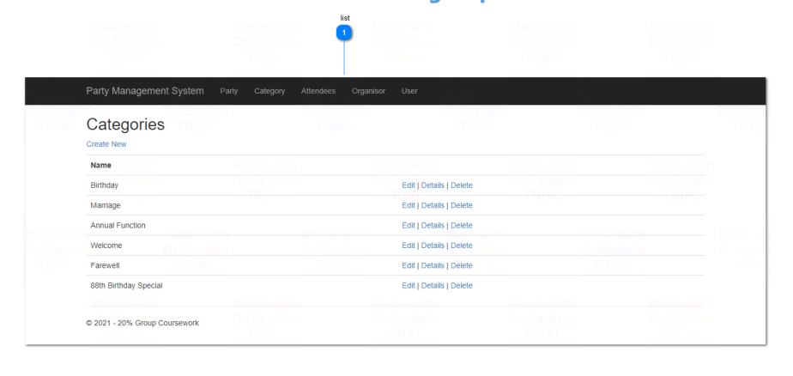

Figure : Categories index user manual

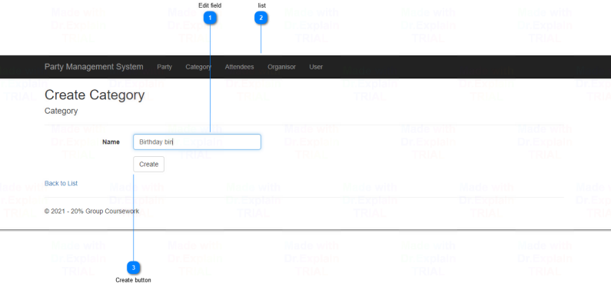

Figure : Create categories user manual

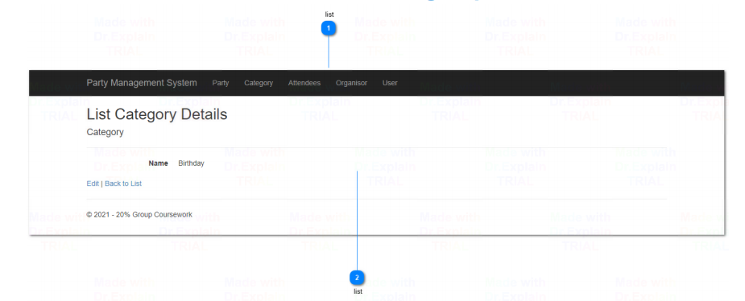

Figure : List category details user manual

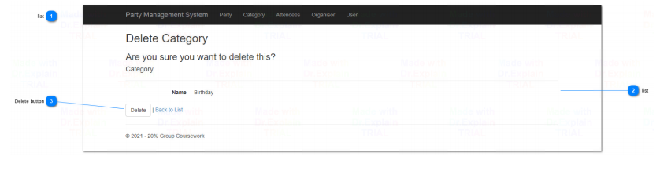

Figure : Delete Category User manual

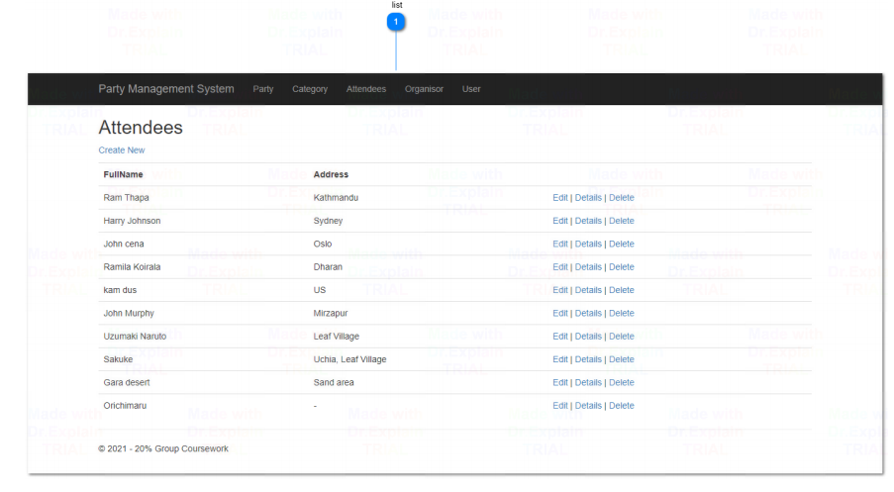

Figure : Attendees details user manual

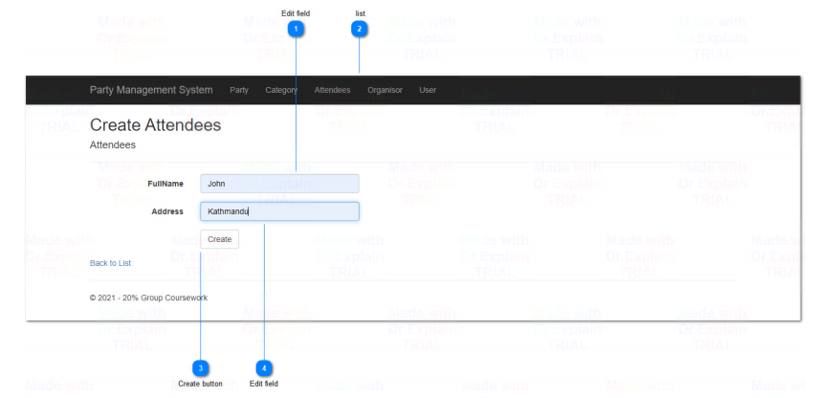

Figure : Create attendees user manual

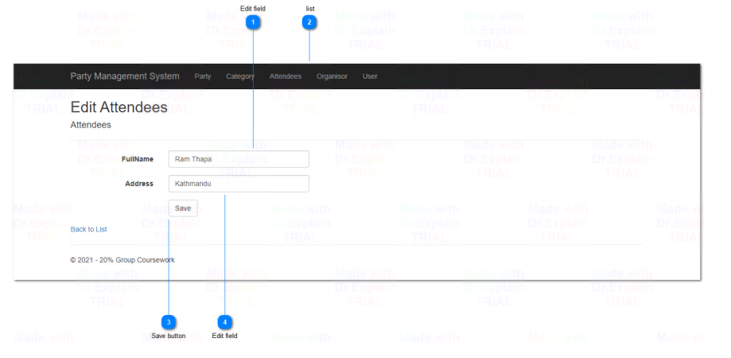

Figure : Edit attendees user manual

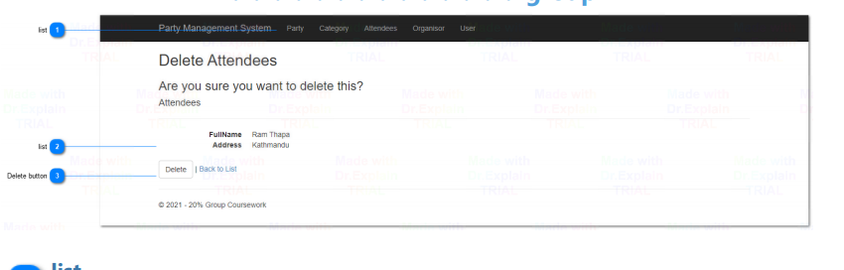

Figure : Delete Attendees user manual

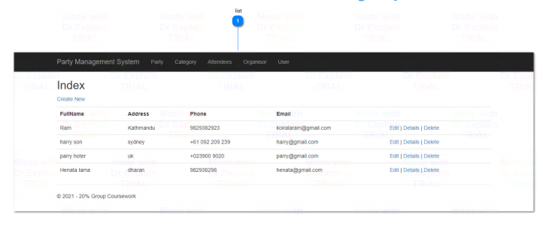

Figure : Organizer details user manual

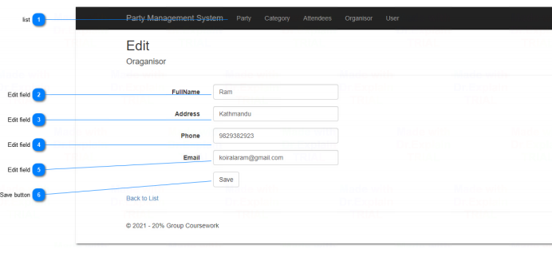

Figure : Edit organizer details user manual

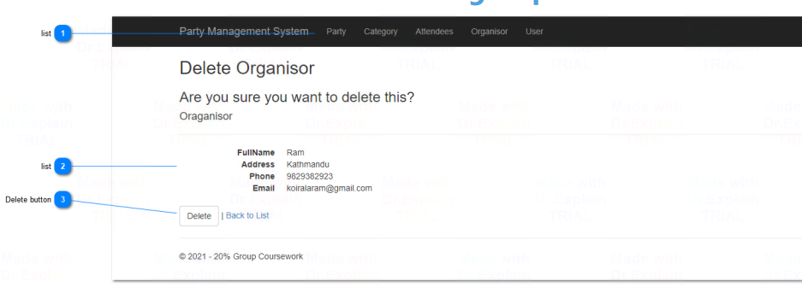

Figure : Delete organizer user manual

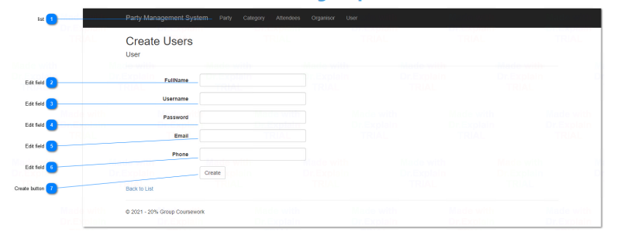

Figure : Create user details user manual

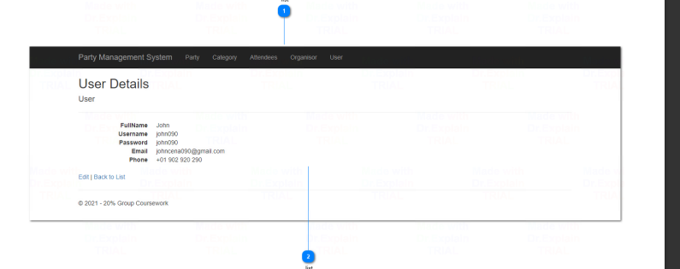

Figure : User details user manual

# Conclusion and Learning reflection

Web applications are more significant for server uses. So, the project has the same scenario that it does need to have server for running the program. The requirements of the project are admin has the authority to add party. The guest user can see the organizer in the party and person coming in the party. A clear and concise user manual has been provided to the user for using the software application.

The development of the application has been accomplished using C# programming language. The framework used in this project is Microsoft ASP .Net. The Integrated Development Environment most of the developers use for C# .Net is the visual studio. So, visual studio has been used for the development of the project. Requirement gathering and clarification are some of the significant parts while developing a project. So, use case diagrams, architecture diagrams, and class diagrams are drawn.

The development of the project was very fruitful because it gave opportunities to learn C# ASP .Net, algorithms, data structures, and many more. There are many functionalities in the usable program but some of them are not completed because of time constraints. In the program, the admin user can add party. But the party cannot be added by booker. This is also one of the bugs of the program which will be handled in the future.

There are many planning for future because system is not completed in fully functional because of time limitation. There are certain parts in software that are really required to be changed. The validations part are not completed for all the parts of the software. The user login system are not available in the system. The customer cannot find the place to add the parties details but that will be changed in future.

# References

BrainVire, 2021. *Six Benefits Of Using MVC Model For Effective Web Application Development.* [Online]   
Available at: https://www.brainvire.com/six-benefits-of-using-mvc-model-for-effective-web-application-development/  
[Accessed 23 September 2021].

Inc, L. S., 2021. *What is an Entity Relationship Diagram (ERD)?.* [Online]   
Available at: https://www.lucidchart.com/pages/er-diagrams  
[Accessed 10 September 2021].

Microsoft, 2021. *Entity Framework documentation.* [Online]   
Available at: https://docs.microsoft.com/en-us/ef/  
[Accessed 17 September 2021].

Zenkit, 2021. *How to Write a User Manual.* [Online]   
Available at: https://zenkit.com/en/blog/how-to-write-a-user-manual/  
[Accessed 20 September 2021].