This picture 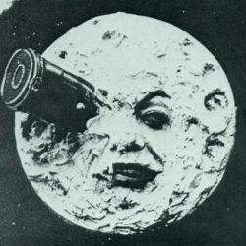 is an identicon.

Here is [one  that](http://www.google.com) links.