Learning Progressive Web Apps

Updated Bing API Creation Instructions

The sample applications used in chapters 3 through 5 use a server application that leverages the Bing News Search API. On October 29, 2020, Microsoft announced that "Bing Search APIs will transition from Azure Cognitive Services to Azure Marketplace on 31 October 2023." You can find the announcement here: <https://docs.microsoft.com/en-us/bing/search-apis/bing-web-search/create-bing-search-service-resource>.

In the announcement, they said:

"The existing instances of the following Bing Search APIs under Azure Cognitive Services will no longer be supported after 31 October 2023. You can continue to create new instances of Bing Search APIs under the Azure Marketplace."

This means that existing Bing Search API keys will continue to work until the 2023 deadline, but Microsoft removed the ability to create new API keys for the service I used in the book and server code. This means that the content and server source code used in Chapter 3 is no longer valid for new readers.

Existing readers who already created their Bing Search API keys to use with the book's code can continue to do so, and all of the existing code in other folders in the repository will continue to operate as expected (until October 31, 2023). After that date, readers must switch to the new API and updated server code.

To make it easier for readers, I added a folder to the book's source code repository called `updated-server` (link to folder: <https://github.com/johnwargo/learning-pwa-code/tree/master/updated-server>); this folder contains the updated server source code that uses the **New Bing Search API Keys**. The folder's readme file contains complete instructions for how to use the updated code plus describes when you must switch to this updated code.

In Chapter 3, where the book tells readers to create a new API key using the following link: <https://portal.azure.com/#create/Microsoft.CognitiveServicesBingSearch-v7>; that no longer works. Readers must use the following link instead: <https://portal.azure.com/#create/Microsoft.BingSearch>.

The remainder of this document illustrates how create the Bing Search API keys using this approach.

When you open the link, your default browser will display the page shown in Figure 1; here you must provide a name for the Bing resource and setup the appropriate billing settings for the resource. As you can see from the figure, I gave the resource a name, then picked the Free Pay-As-You-Go plan.

***Note****: Azure allows you to have one free Bing resource in your account, so if you can’t select the free plan, you likely already have one in your account.*

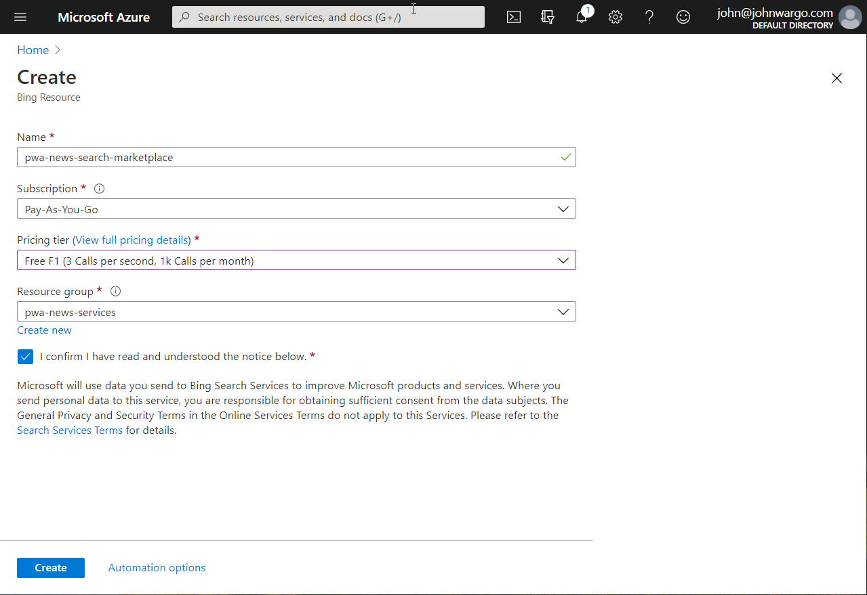

Figure – Create Bing Resource

Click the **Create** button to create the new resource. The Azure Portal will churn and grind for a while, then let you know your deployment completed as shown in Figure 2

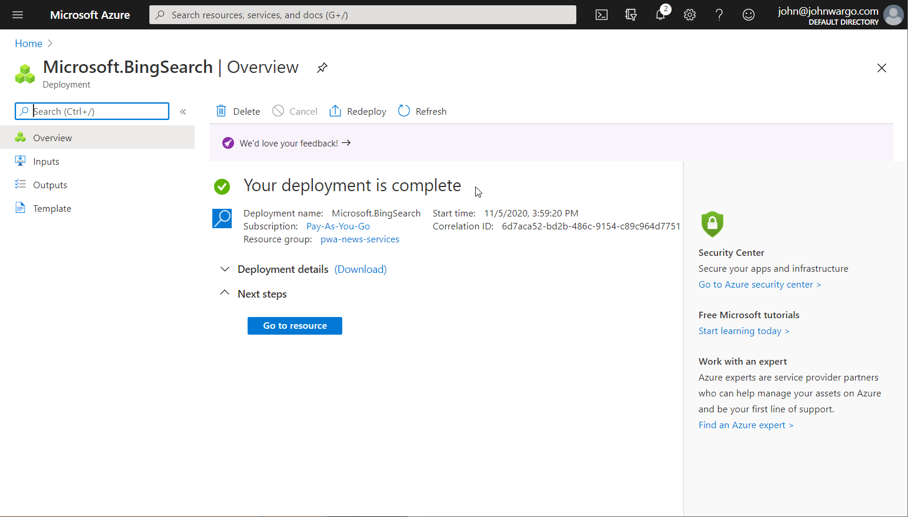

Figure – Azure Resource Deployment Completed

At this point, you need one of the generated API keys for the book’s server application. Click the **Go to resource** button, and your browser will open a page similar to the one shown in Figure 3. Navigate to the **Keys and Endpoint** section of the page; Azure generated two API keys for you, you only need one for our purposes, so pick one of them and click the copy button to the right of your selected key to copy the key to the clipboard.

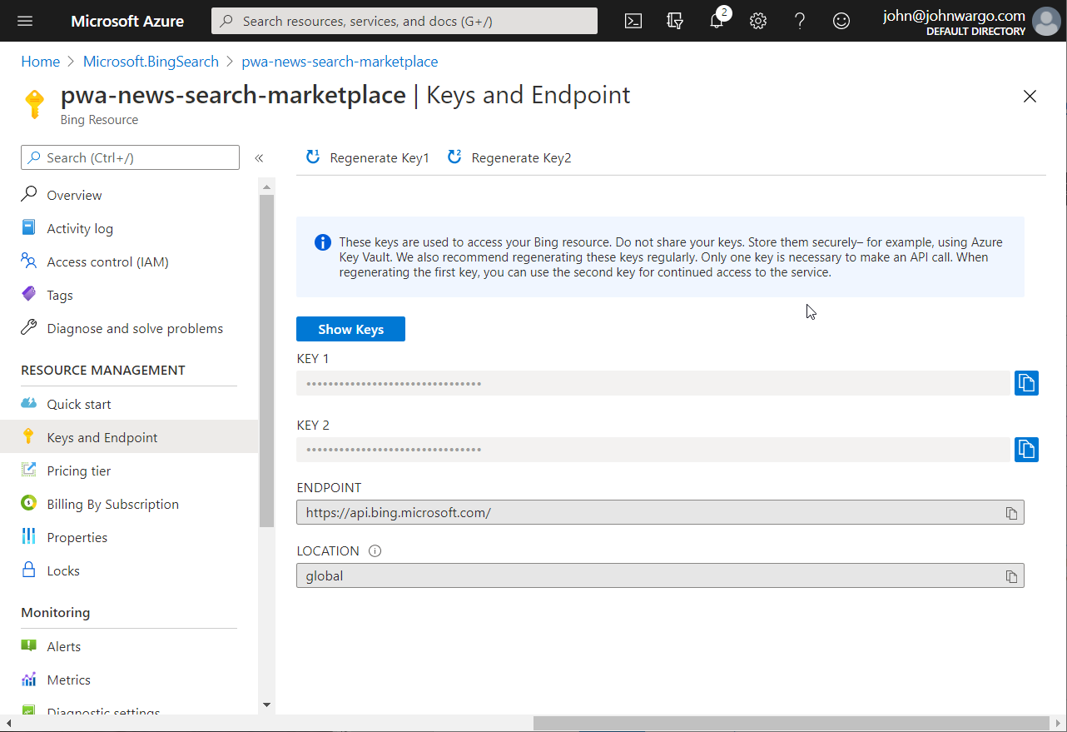

Figure – Azure Resource Details

At this point, use the copied key in the instructions beginning on the bottom of page the book’s page 50 (immediately after the book’s Figure 3.4).