ASSIGNMENT-06
NAME:T. Sthairya
BATCH:14
ENROLLMENT NO:2503A52408
TASK-1: Use an AI tool to generate a Python script that stores user data (name, email, password) in a file.
ANALYZE: Check if the AI stores sensitive data in plain text or without encryption.
INPUT:
import hashlib

name = input("Enter your name: ")
email = input("Enter your email: ")
password = input("Enter your password: ")

# Hashing the password instead of storing it as plain text
hashed_password = hashlib.sha256(password.encode()).hexdigest()

with open("user_data.txt", "w") as file:
file.write("Name: " + name + "\n")
file.write("Email: " + email + "\n")
file.write("Password Hash: " + hashed_password + "\n")

print("\nUser data stored successfully.")
print("Password is stored in hashed form for better security.")
OUTPUT:
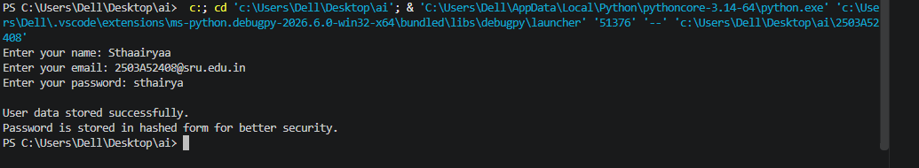
TASK DESCRIPTION-2: Fair Decision Logic Task: Prompt an AI tool to generate a scholarship eligibility checker based on academic score, family income, and location. Examine whether the logic unfairly favors or disadvantages any group.
INPUT:
academicscore = float(input("Enter academic score (0-100): "))
family_income = float(input("Enter annual family income: "))
location = input("Enter your location: ")
if academicscore >= 75 and family_income <= 500000:
result = "Eligible"
else:
result = "Not Eligible"

print("\nScholarship Result:", result)

print("\nFairness Observation:")
print("- Academic score and family income are relevant factors.")
print("- Location is not used to directly approve or reject the student.")
print("- Using location alone could unfairly disadvantage students from certain areas.")
print("- The system should apply the same eligibility criteria to all students.")
OUTPUT:
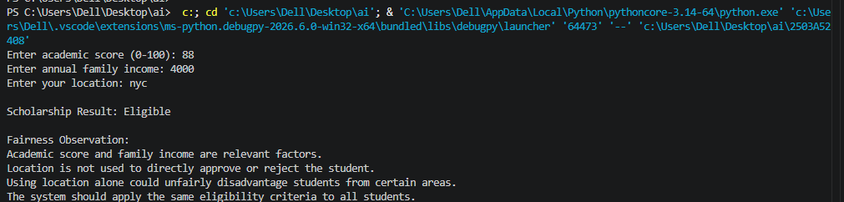

TASK-3(TRANSPARENCY IN AI-BASED ADMISSION SYSTEM): Use an AI tool to generate a Python program that predicts whether a student should be selected or rejected for admission based on factors such as entrance exam score, academic marks, and other relevant admission criteria.
ANALYZE: Check whether the AI system provides a clear and understandable reason for its admission decision.
INPUT:
entrance_score = float(input("Enter entrance exam score (0-100): "))
academic_marks = float(input("Enter academic marks (0-100): "))
entrance_weight = 0.60
academic_weight = 0.40

final_score = (entrance_score * entrance_weight) + \
(academic_marks * academic_weight)

print("\nFinal Admission Score:", round(final_score, 2))

if final_score >= 60:
decision = "Selected"
else:
decision = "Rejected"

print("Admission Decision:", decision)
print("\nReason for Decision:")

if entrance_score >= 60:
print("- Entrance exam score met the required standard.")
else:
print("- Entrance exam score was below the expected standard.")

if academic_marks >= 60:
print("- Academic marks met the expected standard.")
else:
print("- Academic marks were below the expected standard.")

print("- Entrance exam contributes 60% to the final score.")
print("- Academic marks contribute 40% to the final score.")
OUTPUT:
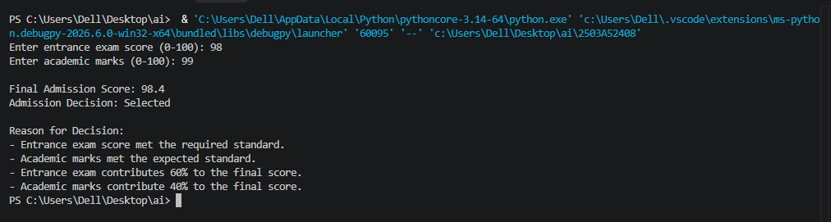
TASK DESCRIPTION-4: Ethical Scoring SystemTask: Generate an employee performance evaluation system using inputs such as project completion rate, teamwork score, and attendance. Analyze the scoring logic for any unethical weighting or hidden bias.
INPUT:

project_completion = float(input("Enter project completion rate (0-100): "))
teamwork = float(input("Enter teamwork score (0-100): "))
attendance = float(input("Enter attendance percentage (0-100): "))
project_weight = 0.40
teamwork_weight = 0.35
attendance_weight = 0.25

performance_score = (
project_completion * project_weight +
teamwork * teamwork_weight +
attendance * attendance_weight
)

print("\nPerformance Score:", round(performance_score, 2))

if performance_score >= 85:
rating = "Excellent"
elif performance_score >= 70:
rating = "Good"
elif performance_score >= 50:
rating = "Average"
else:
rating = "Needs Improvement"

print("Performance Rating:", rating)

print("\nScoring Analysis:")
print("- Project completion: 40%")
print("- Teamwork: 35%")
print("- Attendance: 25%")
print("- The criteria are clearly defined and the weights are visible.")
print("- No hidden personal or sensitive attributes are used.")
print("- Performance should be evaluated using the same criteria for all employees.")
OUTPUT:
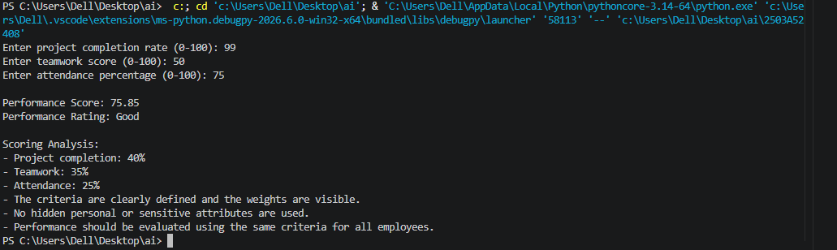
TASK DECRIPTION-5:Accessibility and Inclusiveness Task: Use an AI tool to generate a user feedback form application. Review whether the language and options provided are inclusive and accessible to diverse users.
INPUT:
print(" USER FEEDBACK FORM ")

name = input("Name (optional): ")

print("\nHow would you rate your experience?")
print("1. Very Good")
print("2. Good")
print("3. Neutral")
print("4. Poor")
print("5. Very Poor")
print("6. Prefer not to say")

rating = input("Enter your choice: ")

print("\nHow would you like to provide feedback?")
print("1. Written feedback")
print("2. Verbal feedback")
print("3. Both")
print("4. Prefer not to say")

feedback_type = input("Enter your choice: ")

comments = input("\nEnter your comments (optional): ")

print("\n===== FEEDBACK SUMMARY =====")

if name.strip() == "":
print("Name: Not provided")
else:
print("Name:", name)

print("Rating:", rating)
print("Feedback Type:", feedback_type)

if comments.strip() == "":
print("Comments: Not provided")
else:
print("Comments:", comments)

print("\nThank you for your feedback!")
print("Your responses are voluntary, and you may choose not to provide personal information.")
OUTPUT:
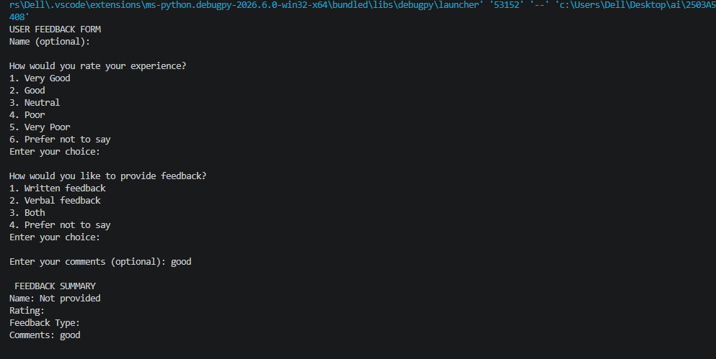
Task Description #6 (Fairness in Loan Approval System)
Task: Use an AI tool to generate a Python program that predicts whether a person should be approved
or rejected for a loan based on information such as income, age, employment status, credit score, and
loan amount.
Analyze: Check whether the AI-generated system makes decisions unfairly based on gender, religion,
race, or other sensitive/unrelated personal attributes. financial factors rather than sensitive attributes.
INPUT:
income = float(input("Enter monthly income: "))
age = int(input("Enter age: "))
employment_status = input("Enter employment status (Employed/Unemployed/Self-employed): ")
credit_score = int(input("Enter credit score: "))
loan_amount = float(input("Enter requested loan amount: "))

if employment_status.lower() == "employed":
employment_score = 20
elif employment_status.lower() == "self-employed":
employment_score = 15
else:
employment_score = 0

score = 0

if income >= 30000:
score += 30

if credit_score >= 700:
score += 30
elif credit_score >= 600:
score += 20

if loan_amount <= income * 20:
score += 20

score += employment_score

print("\n===== LOAN DECISION =====")
print("Financial Score:", score)

if score >= 70:
decision = "Approved"
else:
decision = "Rejected"

print("Loan Decision:", decision)

print("\nFairness Analysis:")
print("- Income is considered because it is relevant to repayment ability.")
print("- Credit score is considered because it indicates credit history.")
print("- Employment status is considered because it relates to income stability.")
print("- Loan amount is considered because it affects repayment risk.")
print("- Gender, religion, race and other sensitive attributes are not used.")
print("- Removing unrelated sensitive attributes helps reduce discrimination.")
OUTPUT:
