ASSIGNMENT- 9.1
NAME: T. Sthairya
BATCH:14
HALL.NO: 2503A52408
Task: • Write documentation for the function in all three formats: (a) Docstring (b) Inline comments (c) Google-style documentation Week5 Monday • Critically compare the three approaches. Discuss the advantages, disadvantages, and suitable use cases of each
INPUT:
def find_max(numbers):
"""Return the maximum value from a list of numbers."""
return max(numbers)

print(find_max([10, 25, 15, 40, 30]))

OUTPUT:
Problem 2: Consider the following Python function: def login(user, password, credentials): return credentials.get(user) == password
INPUT:
def login(user, password, credentials):
"""Check whether the username and password are correct."""
return credentials.get(user) == password

credentials = {"admin": "1234", "student": "abcd"}

user = input("Enter username: ")
password = input("Enter password: ")

if login(user, password, credentials):
print("Login successful")
else:
print("Login failed")
OUTPUT:
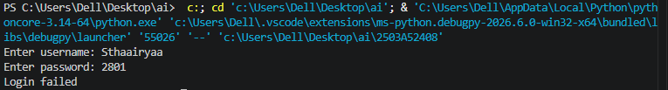

Problem 3: Calculator (Automatic Documentation Generation) Task: Design a Python module named calculator.py and demonstrate automatic documentation generation
INPUT:
def add(a, b):
"""Return the sum of two numbers."""
return a + b

def subtract(a, b):
"""Return the difference of two numbers."""
return a - b

def multiply(a, b):
"""Return the product of two numbers."""
return a * b

def divide(a, b):
"""Return the quotient of two numbers."""
if b == 0:
return "Cannot divide by zero"
return a / b

print(add(10, 5))
print(subtract(10, 5))
print(multiply(10, 5))
print(divide(10, 5))

OUTPUT:
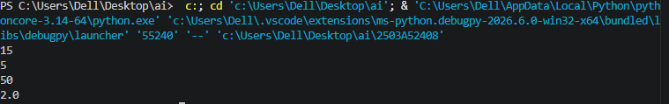

Problem 4: Conversion Utilities Module
def decimal_to_binary(n):
"""Convert decimal to binary."""
return bin(n)[2:]

def binary_to_decimal(b):
"""Convert binary to decimal."""
return int(b, 2)

def decimal_to_hexadecimal(n):
"""Convert decimal to hexadecimal."""
return hex(n)

print(decimal_to_binary(10))
print(binary_to_decimal("1010"))
print(decimal_to_hexadecimal(10))
OUTPUT:
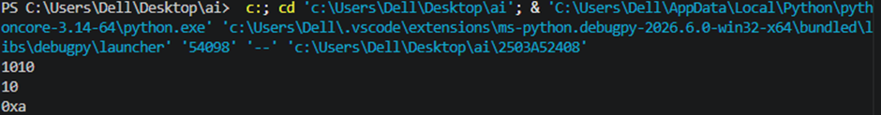

Problem 5 – Course Management Module
INPUT:
courses = {}

def add_course(course_id, name, credits):
"""Add a course."""
courses[course_id] = {"name": name, "credits": credits}
return "Course added successfully"

def remove_course(course_id):
"""Remove a course."""
if course_id in courses:
del courses[course_id]
return "Course removed successfully"
return "Course not found"

def get_course(course_id):
"""Get course details."""
return courses.get(course_id)

print(add_course("C101", "Python", 4))
print(add_course("C102", "Database", 3))
print(get_course("C101"))
print(remove_course("C102"))
print(courses)

OUTPUT:
