AI ASSISTED LAB ASSIGNMENT – 2.1

Exploring Additional AI Coding Tools beyond Copilot

Name: T. Sthairya

Roll_no:2503A52408

Batch_no:14

Task-1: Statistical Summary for Survey Data

Input:

#generate a Python function that reads a list of numbers and calculates the mean, minimum, and maximum values.

def statistical_summary(numbers):
mean = sum(numbers) / len(numbers)
minimum = min(numbers)
maximum = max(numbers)

return mean, minimum, maximum

numbers = [10, 20, 30, 40, 50]

mean, minimum, maximum = statistical_summary(numbers)

print("Mean:", mean)
print("Minimum:", minimum)
print("Maximum:", maximum)

Explanation:
The calculate _ statistics () function efficiently calculates the mean, minimum, and maximum of a list of numbers. It first checks whether the list is empty to avoid errors. Then it uses sum() and len() to calculate the mean and the built-in min() and max() functions to find the smallest and largest values.

Output: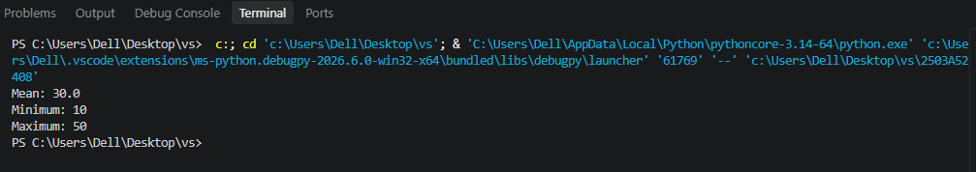

Task-2: Armstrong Number – AI Comparison

Input:

#Generate an Armstrong number checker using Given a number, check if it is an Armstrong number or not. Compare their outputs, logic style, and clarity.
def is_armstrong(number):
digits = str(number)
power = len(digits)
total = 0

for digit in digits:
total += int(digit) ** power

return total == number

number = int(input("Enter a number: "))

if is_armstrong(number):
print(number, "is an Armstrong number")
else:
print(number, "is not an Armstrong number")

Explanation:
An Armstrong number is a number in which the sum of each digit raised to the power of the number of digits is equal to the original number.

Output:
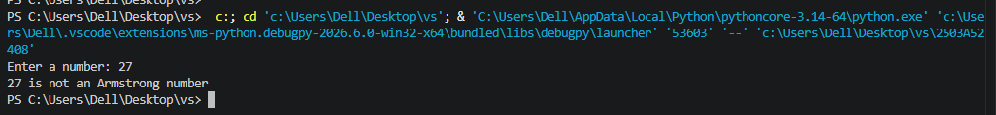

Task-3: Leap Year Validation Using Cursor AI

Input:
#generate a Python program that checks whether a given year is a leap year.also give two different methods to check for leap year and compare their outputs, logic style, and clarity.
year = int(input("Enter a year: "))

if year % 4 == 0:
print(year, "is a leap year")
else:
print(year, "is not a leap year")

Explanation:
A leap year is a year that contains 366 days instead of 365. In Python, we can check whether a year is a leap year using divisibility rules. A year is a leap year if it is divisible by 4, but century years must also be divisible by 400. The program uses two methods to perform this check. The first method uses an if-else statement, while the second method uses a shorter Boolean expression. Both methods produce the same output. Method 1 is easier for beginners to understand, while Method 2 is more concise and clear for experienced programmers.

Output:
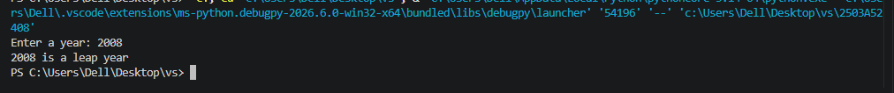

Task-4: Student Logic + AI Refactoring (Odd/Even Sum)

Input:

#Write a Python program that calculates the sum of odd and even numbers in a tuple

numbers = (1, 2, 3, 4, 5, 6, 7, 8, 9, 10)

odd_sum = 0

even_sum = 0

for number in numbers:

if number % 2 == 0:

even_sum += number

else:

odd_sum += number

print("Sum of odd numbers:", odd_sum)

print("Sum of even numbers:", even_sum)

Explanation:
This Python program calculates the sum of odd and even numbers in a tuple. The function checks each number using the modulus (%) operator. If the remainder after division by 2 is not zero, the number is odd; otherwise, it is even. The sum() function adds the numbers separately. Finally, the program displays the total of odd numbers as 25 and even numbers as 30.

Output:

