AI ASSISTED LAB ASSIGNMENT – 3.1

Prompt Engineering

Name: T. Sthairya

Roll_no:2503A52408

Batch_no:14

Task-1: Zero-Shot Prompting (Palindrome Number Program)

Input:

# generate a Python function that checks whether a given number is a
palindrome.
def is_palindrome(number):
number = str(number)
return number == number[::-1]

number = int(input("Enter a number: "))

if is_palindrome(number):
print("Palindrome")
else:
print("Not a Palindrome")

Output:

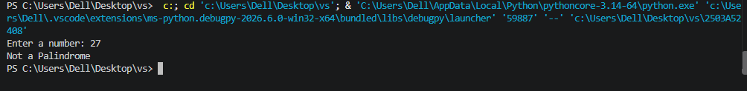

Task-2:One-Shot Prompting (Factorial Calculation)

Input:
def factorial(n):
result = 1

for i in range(1, n + 1):
result *= i

return result

number = int(input("Enter a number: "))

if number < 0:
print("Factorial is not defined for negative numbers")
else:
print("Factorial:", factorial(number))

Explanation:

The Python factorial function uses a loop to multiply all integers from 1 to the given number. Testing with values such as 0, 1, 3, 5, and 10 confirms that it works correctly. Testing also identifies important edge cases such as negative numbers and non-numeric input. Adding input validation and exception handling makes the program safer and more reliable.

Output:

Task-3: Few-Shot Prompting (Armstrong NumberCheck)

Input:

# generating a Python function to check whether a given number is an Armstrong number.
def is_armstrong(number):
digits = str(number)
power = len(digits)
total = 0

for digit in digits:
total += int(digit) ** power

return total == number

number = int(input("Enter a number: "))

if is_armstrong(number):
print("Armstrong Number")
else:
print("Not an Armstrong Number")

Explanation:

Few-shot prompting was used by providing three input-output examples to guide the AI in generating an Armstrong number checker. The examples helped the AI understand both the required calculation and the expected output format. The generated function was tested using values such as 153, 370, 123, 0, 1, 9, and 9474. Invalid inputs such as "abc" and negative numbers were also considered. Finally, exception handling and input validation were added to make the program more robust.

Output:
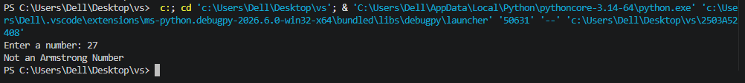

Task-4: Context-Managed Prompting (Optimized Number
Classification)

Input:

#generate an optimized Python program that classifies a
number as prime, composite, or neither.

def classify_number(n):
if not isinstance(n, int):
return "Invalid Input"

if n < 2:
return "Neither"

for i in range(2, int(n ** 0.5) + 1):
if n % i == 0:
return "Composite"

return "Prime"

number = int(input("Enter a number: "))

print(classify_number(number))

Explanation:

Context-managed prompting was used to generate an optimized number-classification program. The prompt clearly specified input validation, special cases, classification rules, and efficiency requirements. The resulting program correctly identifies numbers as Prime, Composite, or Neither Prime nor Composite and uses the square-root optimization to reduce unnecessary calculations.Output:

Output:
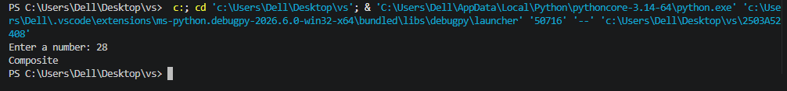

Task-5: Zero-Shot Prompting (Perfect Number Check)

Input:

# generate a Python function that checks whether a given number is a

perfect number.
def is_perfect_number(number):
if number <= 1:
return False

total = 1

for i in range(2, int(number ** 0.5) + 1):
if number % i == 0:
total += i

if i != number // i:
total += number // i

return total == number

number = int(input("Enter a number: "))

if is_perfect_number(number):
print("Perfect Number")
else:
print("Not a Perfect Number")

Explanation:
The generated code correctly identifies common perfect numbers such as 6 and 28, but testing revealed some weaknesses. In particular, it does not explicitly handle zero, negative numbers, or invalid input, and it checks every number up to n-1, making it inefficient for large inputs.

Output:
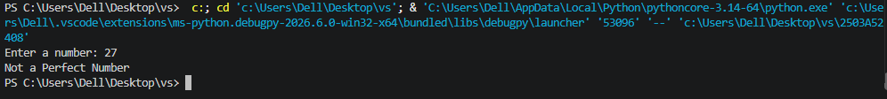

Task-6: Few-Shot Prompting (Even or Odd Classification with

Validation)

Input:
# generating a Python program that determines whether a given number is even or odd, including proper input validation.

def even_or_odd(value):
if not isinstance(value, int):
return "Invalid Input"

if value % 2 == 0:
return "Even"
else:
return "Odd"

try:
number = int(input("Enter a number: "))
print(even_or_odd(number))
except ValueError:
print("Invalid Input")

Explanation:

The objective of this task is to use Few-Shot Prompting to generate a Python program that determines whether a given number is Even or Odd, while also handling invalid inputs properly.

Output:

