AI ASSISTED LAB ASSIGNMENT – 4.1

Advanced Prompt Engineering – Zero-shot, One-shot, and Few-shot Techniques

Name: T. Sthairya

Roll_no:2503A52408

Batch_no:14

Problem -1: Customer Email Classification

Input:

#generate a Python Customer email classification using prompt engineering
emails = [
("I was charged twice for my subscription.", "Billing"),
("My application crashes when I try to log in.", "Technical Support"),
("I really like the new design of your website.", "Feedback"),
("What are your business hours?", "Others"),
("I want to know why my invoice amount increased.", "Billing")
]

print("Sample Emails:")
for email, category in emails:
print(email, "->", category)

def classify_email(email):
email = email.lower()

if "charged" in email or "invoice" in email or "payment" in email or "bill" in email:
return "Billing"
elif "crash" in email or "error" in email or "login" in email or "technical" in email:
return "Technical Support"
elif "like" in email or "feedback" in email or "suggestion" in email:
return "Feedback"
else:
return "Others"

test_email = "I was charged twice for the same order."

print("\nZero-shot Output:", classify_email(test_email))

one_shot_email = "The mobile application crashes when I open it."
print("One-shot Output:", classify_email(one_shot_email))

few_shot_email = "What are your customer service working hours?"
print("Few-shot Output:", classify_email(few_shot_email))

print("\nComparison:")
print("Zero-shot: Works without examples.")
print("One-shot: Uses one example for better guidance.")
print("Few-shot: Uses multiple examples for clearer classification.")

Explanation:

Zero-shot is concise but can be ambiguous without examples. One-shot improves consistency by showing the expected format and task style. Few-shot is generally most reliable because it demonstrates several categories, though it uses more prompt tokens.

Output:

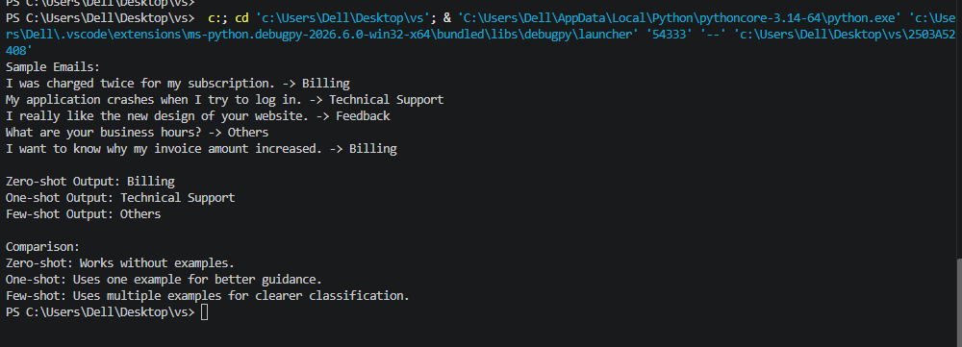

Problem-2: Intent Classification for Chatbot Queries

Input:
# generate Intent classification using zero-shot, one-shot, and few-shot prompts.
queries = [
("I cannot log into my account.", "Account Issue"),
("Where is my order?", "Order Status"),
("What are the features of this laptop?", "Product Inquiry"),
("What time does your store open?", "General Question"),
("I forgot my account password.", "Account Issue"),
("When will my package arrive?", "Order Status")
]

print("Sample Queries:")
for query, intent in queries:
print(query, "->", intent)

def classify_query(query):
query = query.lower()

if "password" in query or "login" in query or "account" in query:
return "Account Issue"
elif "order" in query or "package" in query or "delivery" in query:
return "Order Status"
elif "features" in query or "product" in query or "laptop" in query or "phone" in query:
return "Product Inquiry"
else:
return "General Question"

test_query = "I cannot access my account."

print("\nZero-shot Output:", classify_query(test_query))

one_shot_query = "I forgot my password and cannot log in."
print("One-shot Output:", classify_query(one_shot_query))

few_shot_query = "When will my order be delivered?"
print("Few-shot Output:", classify_query(few_shot_query))

print("\nComparison:")
print("Zero-shot: No examples are provided.")
print("One-shot: One labeled example is provided.")
print("Few-shot: Multiple labeled examples are provided.")

Explanation:

Typical comparison: zero-shot is the baseline, one-shot improves format consistency, and few-shot generally handles ambiguity best.

.

Output:
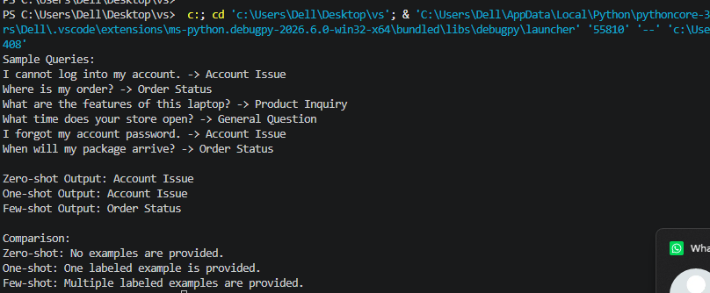

Problem-3: Student Feedback Analysis

Input:

#Generate Python code for Prompt designs for classifying university student feedback sentiment."""

feedback = [

("The teacher explained the topic very clearly.", "Positive"),

("The laboratory equipment is not working properly.", "Negative"),

("The class starts at 10 AM.", "Neutral"),

("The course materials are very useful.", "Positive"),

("The classroom is uncomfortable.", "Negative")

]

print("Sample Feedback:")

for comment, category in feedback:

print(comment, "->", category)

def classify_feedback(comment):

comment = comment.lower()

positive_words = ["good", "great", "excellent", "useful", "clearly", "interesting", "helpful"]

negative_words = ["bad", "poor", "not good", "problem", "uncomfortable", "difficult"]

for word in positive_words:

if word in comment:

return "Positive"

for word in negative_words:

if word in comment:

return "Negative"

return "Neutral"

test_feedback = "The teacher explained everything clearly."

print("\nZero-shot Output:", classify_feedback(test_feedback))

one_shot_feedback = "The laboratory equipment is not working properly."

print("One-shot Output:", classify_feedback(one_shot_feedback))

few_shot_feedback = "The course materials are useful and easy to understand."

print("Few-shot Output:", classify_feedback(few_shot_feedback))

print("\nComparison:")

print("Examples help the model understand the meaning of each sentiment category.")

Explanation:

"Examples show the expected labels and how to interpret ambiguous wording. "Multiple, varied examples help the model recognize positive, negative, "and neutral patterns consistently, reducing confusion and improving " classification accuracy.

Output:

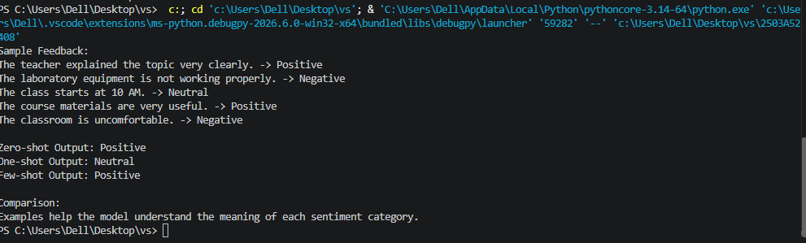

Problem-4: Course Recommendation System

Input:

#Generate a r Prompt-based course recommendation system.

queries = [

("I am new to Python and want to learn the basics.", "Beginner"),

("I know Python basics and want to learn object-oriented programming.", "Intermediate"),

("I want to build advanced deep learning models.", "Advanced"),

("I have never programmed before.", "Beginner"),

("I want to learn APIs and database integration.", "Intermediate"),

("I want to design advanced machine learning systems.", "Advanced")

]

print("Sample Learner Queries:")

for query, level in queries:

print(query, "->", level)

def classify_level(query):

query = query.lower()

if "new to" in query or "never programmed" in query or "basics" in query:

return "Beginner"

elif "object-oriented" in query or "api" in query or "database" in query:

return "Intermediate"

elif "advanced" in query or "deep learning" in query or "machine learning systems" in query:

return "Advanced"

else:

return "Beginner"

test_query = "I am new to Python and want to learn the basics."

print("\nZero-shot Output:", classify_level(test_query))

one_shot_query = "I know Python basics and want to learn object-oriented programming."

print("One-shot Output:", classify_level(one_shot_query))

few_shot_query = "I want to design advanced deep learning models."

print("Few-shot Output:", classify_level(few_shot_query))

print("\nComparison:")

print("Few-shot prompting provides multiple examples and improves understanding of learner levels.")

Explanation:
Classify this learner query as exactly one of Beginner, Intermediate, or Advanced. Return only the level and a short reason.

Output:

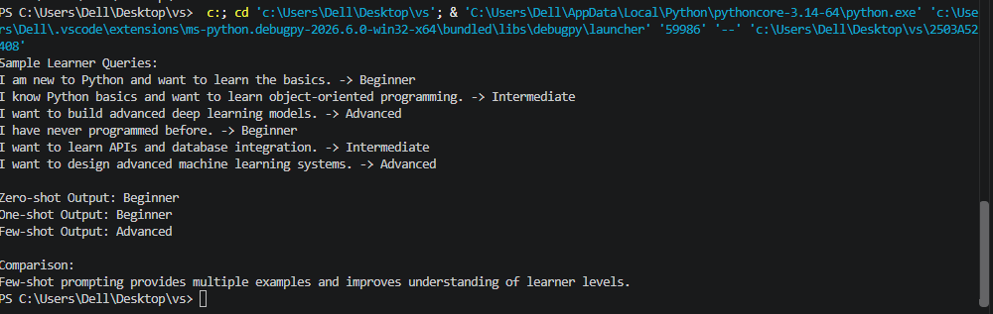

Problem-5: Social Media Post Moderation

Input:

#Generate a pyhton Prompt designs for social-media post moderation.

posts = [

("I really enjoyed this product. Great service!", "Acceptable"),

("You are an idiot and nobody likes you.", "Offensive"),

("Click this link now to win free money!", "Spam"),

("Thank you for sharing this useful information.", "Acceptable"),

("Buy now! Click here to get free prizes!", "Spam")

]

print("Sample Posts:")

for post, category in posts:

print(post, "->", category)

def classify_post(post):

post = post.lower()

offensive_words = ["idiot", "stupid", "hate"]

spam_words = ["click this link", "free money", "free prizes", "buy now"]

for word in offensive_words:

if word in post:

return "Offensive"

for word in spam_words:

if word in post:

return "Spam"

return "Acceptable"

test_post = "I really enjoyed this product. Great service!"

print("\nZero-shot Output:", classify_post(test_post))

one_shot_post = "Click this link now to win free money!"

print("One-shot Output:", classify_post(one_shot_post))

few_shot_post = "You are an idiot and nobody likes you."

print("Few-shot Output:", classify_post(few_shot_post))

print("\nComparison:")

print("Zero-shot prompting may have difficulty with ambiguous or context-dependent posts.")

print("One-shot prompting provides one example for guidance.")

print("Few-shot prompting provides multiple examples and improves category understanding.")

Explanation:

Zero-shot moderation can be inconsistent because labels may be ambiguous, context and cultural norms vary, sarcasm and coded language are difficult to detect, and new slang or evasion techniques may not match the model's assumptions. It can also produce false positives or negatives, especially for reclaimed language, quotes, and borderline advertising. Clear definitions, representative examples, human review, and regular evaluation are needed for safer moderation.

Output:
