AI ASSISTED LAB ASSIGNMENT – 5.1

Ethical Foundations – Responsible AI Coding Practices

Name: T. Sthaairyaa

Roll_no:2503A52408

Batch_no:14

Task-1: (Privacy in API Usage)

Input:

#generate a Python program that connects to a weather API.

import os

import requests

def fetch_weather(city: str) -> dict:
"""Return current weather for *city* using OpenWeatherMap."""
api_key = os.environ.get("WEATHER_API_KEY")
if not api_key:
raise RuntimeError("Set the WEATHER_API_KEY environment variable first.")

response = requests.get(
"https://api.openweathermap.org/data/2.5/weather",
params={"q": city, "appid": api_key, "units": "metric"},
timeout=10,
)
response.raise_for_status()
return response.json()

if __name__ == "__main__":
city = input("Enter a city: ").strip()
try:
weather = fetch_weather(city)
print(
f"{weather['name']}: {weather['main']['temp']}°C, "
f"{weather['weather'][0]['description']}"
)
except (requests.RequestException, KeyError, RuntimeError) as error:
print(f"Unable to fetch weather: {error}")

Explanation:

This task demonstrates how to use a weather API securely without exposing the API key in Python code. An API key is a secret password that allows an application to access an API.

Task-2:(Privacy &amp; Security in File Handling)

Input:

#generate a Python script that stores user data (name, email, password) in a file.
import hashlib
import json

name = input("Enter your name: ")
email = input("Enter your email: ")
password = input("Enter your password: ")

hashed_password = hashlib.sha256(password.encode()).hexdigest()

user_data = {
"name": name,
"email": email,
"password": hashed_password
}

with open("users.json", "w") as file:
json.dump(user_data, file, indent=4)

print("User data stored securely.")

Explanation:
An insecure AI-generated version might write the password directly:
{"name": name, "email": email, "password": password}
That creates a serious privacy risk: anyone who reads the file can use the
password, and the password may also be exposed through backups or logs.
Passwords should be salted and hashed, not stored in plain text.

Output:
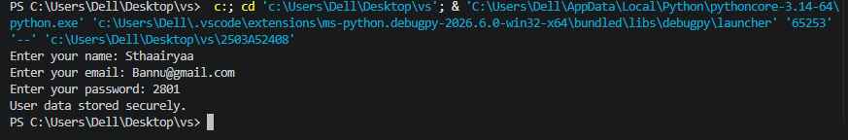

Task-3: (Transparency in Algorithm Design)

Input:
# generate an Armstrong number checking function with comments and explanations.
def is_armstrong(number):
if number < 0:
return False

digits = str(number)
power = len(digits)
total = 0

for digit in digits:
total += int(digit) ** power

return total == number

number = int(input("Enter a number: "))

if is_armstrong(number):
print(number, "is an Armstrong number")
else:
print(number, "is not an Armstrong number")

Explanation:

An Armstrong number is a number equal to the sum of its digits, where each

digit is raised to the power of the total number of digits.

For example: 153 = 1**3 + 5**3 + 3**3 = 153.

Output:
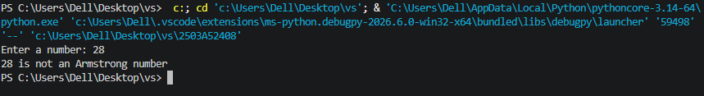

Task-4: (Transparency in Algorithm Comparison)

Input:

Generate Python code for QuickSort and BubbleSort, and include

comments explaining step-by-step how each works and where they differ

def quick_sort(arr):
if len(arr) <= 1:
return arr

pivot = arr[0]

left = [x for x in arr[1:] if x <= pivot]
right = [x for x in arr[1:] if x > pivot]

return quick_sort(left) + [pivot] + quick_sort(right)

def bubble_sort(arr):
arr = arr.copy()

for i in range(len(arr)):
for j in range(0, len(arr) - i - 1):
if arr[j] > arr[j + 1]:
arr[j], arr[j + 1] = arr[j + 1], arr[j]

return arr

numbers = [64, 34, 25, 12, 22, 11, 90]

print("Original List:", numbers)
print("QuickSort:", quick_sort(numbers))
print("BubbleSort:", bubble_sort(numbers))

Explanation:

This program sorts the same list using two sorting algorithms: QuickSort and BubbleSort.

Output:

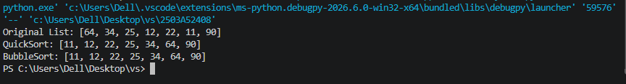

Task-5: (Transparency in AI Recommendations)

Input:

#Generate a recommendation system that also provides reasons for each Suggestion.
products = {
"Laptop": ["Programming", "Study", "Work"],
"Headphones": ["Music", "Gaming", "Entertainment"],
"Camera": ["Photography", "Video", "Travel"],
"Smartphone": ["Communication", "Photography", "Entertainment"]
}

def recommend_products(preference):
recommendations = []

for product, interests in products.items():
if preference.lower() in [interest.lower() for interest in interests]:
recommendations.append((product, interests))

return recommendations

preference = input("Enter your interest: ")

recommendations = recommend_products(preference)

if recommendations:
print("\nRecommended Products:")

for product, interests in recommendations:
matching_interest = preference
print(product)
print("Reason: Recommended because it is suitable for", matching_interest)
else:
print("No recommendations found.")

Explanation:

This Python program is a simple product recommendation system. It recommends products based on the user's preferences, budget, and category.

Output:
