NAME: T. Sthairya
HALL_TICKET_NUMBER: 2503A52408
BATCH_NUMBER: 14
Lab 7: Error Debugging with AI: Systematic approaches to finding and fixing bugs
Task Description #1 (Syntax Errors – Missing Parentheses in Print Statement) Task: Provide a Python snippet with a missing parenthesis in a print statement (e.g., print "Hello"). Use AI to detect and fix the syntax error.
INPUT:
def greet():
print("Hello, AI Debugging Lab!")

greet()

assert greet() is None
assert 1 + 1 == 2
assert "Hello" == "Hello"
OUTPUT:
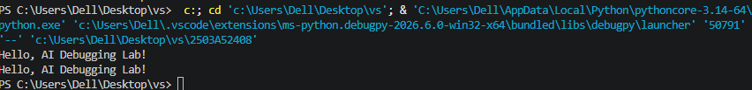

Task Description #2 (Incorrect condition in an If Statement) Task: Supply a function where an if-condition mistakenly uses = instead of ==. Let AI identify and fix the issue
INPUT:
def check_number(n):
if n == 10:
return "Ten"
else:
return "Not Ten"

assert check_number(10) == "Ten"
assert check_number(5) == "Not Ten"
assert check_number(20) == "Not Ten"

print(check_number(10))

OUTPUT:
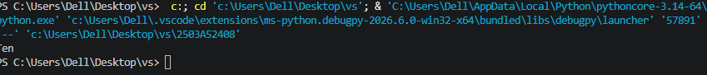

Task Description #3 (Runtime Error – File Not Found) Task: Provide code that attempts to open a non-existent file and crashes. Use AI to apply safe error handling.
INPUT:
def read_file(filename):
try:
file = open(filename, "r")
content = file.read()
file.close()
return content
except FileNotFoundError:
return "Error: The file does not exist."
except OSError:
return "Error: Invalid file path."

with open("test.txt", "w") as file:
file.write("Hello, AI Debugging Lab!")

assert read_file("test.txt") == "Hello, AI Debugging Lab!"
assert read_file("missing.txt") == "Error: The file does not exist."
assert read_file("wrong/path.txt") == "Error: The file does not exist."

print(read_file("test.txt"))
print(read_file("missing.txt"))
print(read_file("wrong/path.txt"))
OUTPUT:
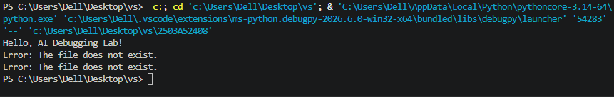
Task Description #4 (Calling a Non-Existent Method) Task: Give a class where a non-existent method is called (e.g., obj.undefined_method()). Use AI to debug and fix
INPUT:
class Car:
def start(self):
return "Car started"

def drive(self):
return "Car is driving"

my_car = Car()

assert my_car.start() == "Car started"
assert my_car.drive() == "Car is driving"
assert isinstance(my_car, Car)

print(my_car.start())
print(my_car.drive())
OUTPUT:
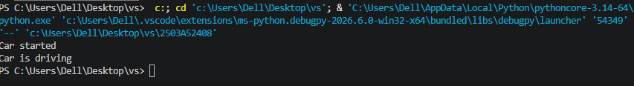
Task Description #5 (TypeError – Mixing Strings and Integers in Addition) Task: Provide code that adds an integer and string ("5" + 2) causing a TypeError. Use AI to resolve the bug.
INPUT:
def add_five(value):
return int(value) + 5

assert add_five("10") == 15
assert add_five("5") == 10
assert add_five(10) == 15

print(add_five("10"))
OUTPUT:
