**1. Sqoop incremental import needs to implemented to import the data from MySQL table(created earlier) into HDFS incrementally.**

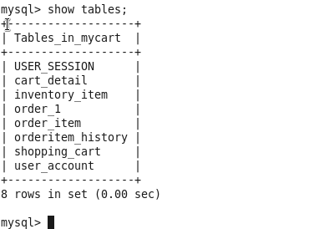

**Create tables**

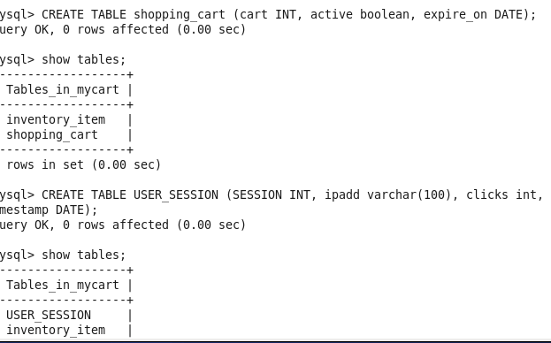

**Insert values**

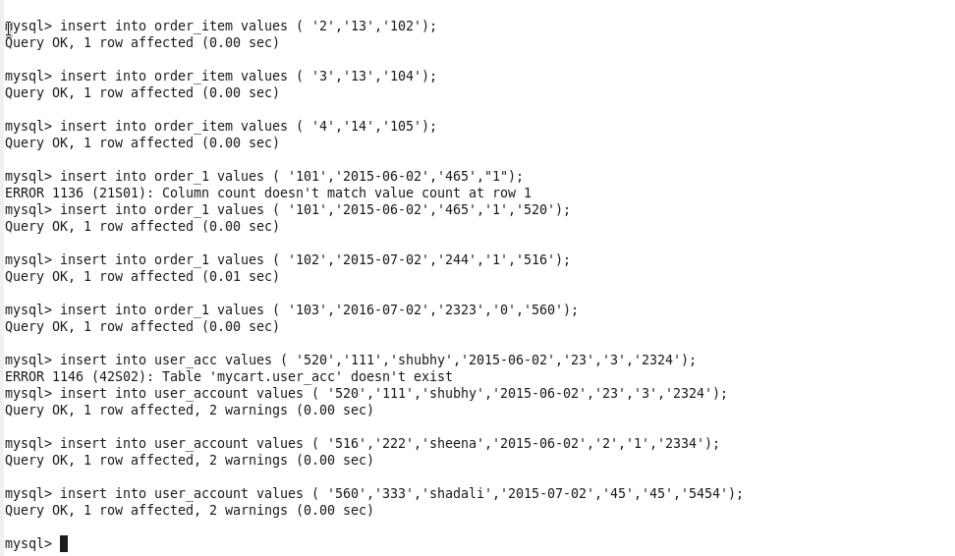

**Tables created**

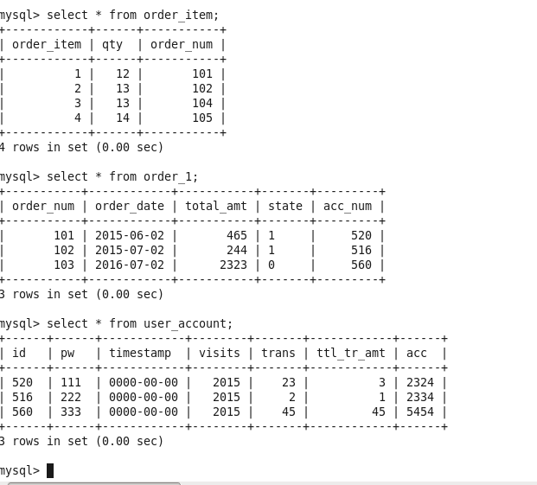

**Import**

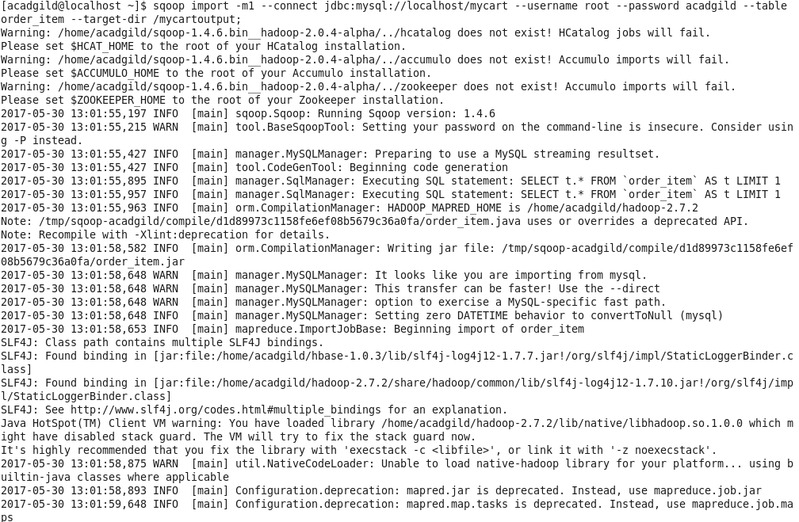

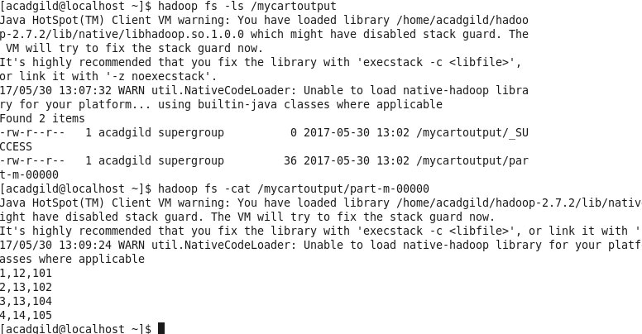

**Add values**

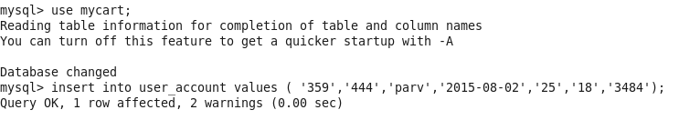

**Import**

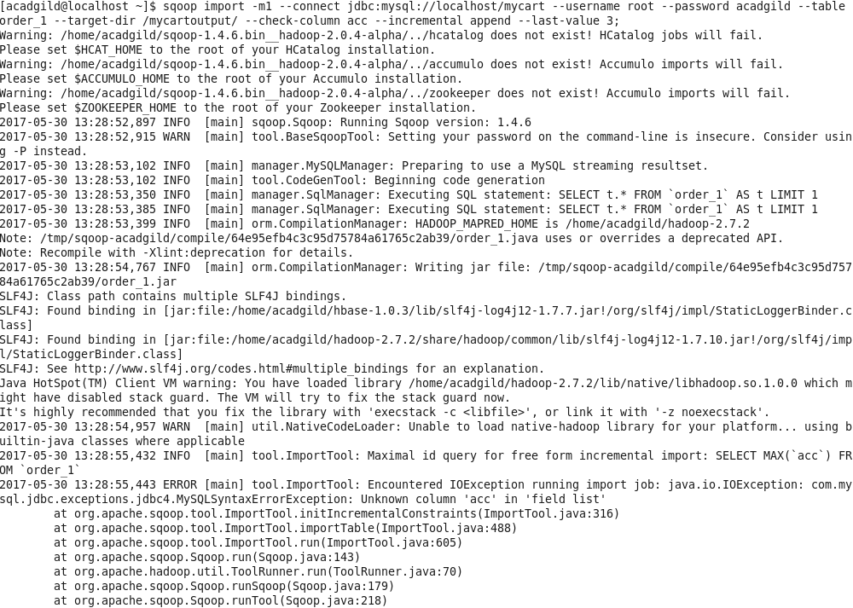

**Question 2**

**Find the details of various items purchased by various customers in the quarters '2015-05-01' -'2015-08-31-'2015-08-31'**

