**ASSIGNMENT 11**

**11.1**

**QUES 1.)**  **What is the total amount of petrol in volume sold by every distributor?**

**COMMANDS:**

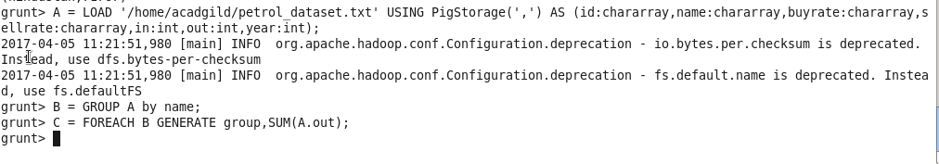

**OUTPUT:**

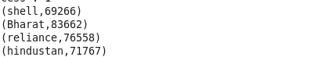

**QUES2.) Which are the top 10 distributors ID's for selling petrol? Also display the amount of petrol sold in volume.**

**COMMANDS:**

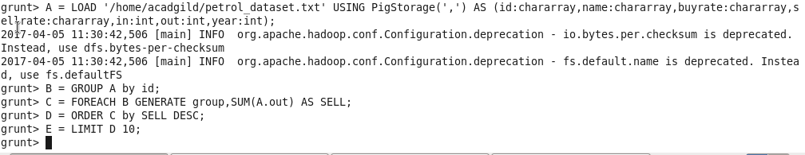

**OUTPUT:**

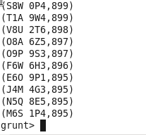

**QUES 3.) List 10 years where consumption of petrol is more with the distributer id who sold it.**

**COMMANDS:**

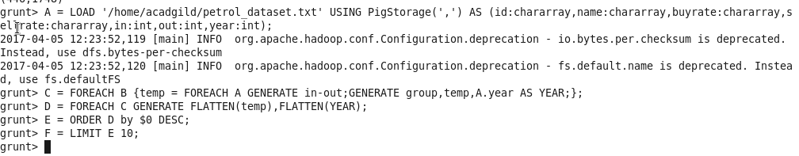

**OUTPUT:**

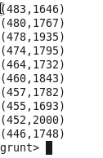

**QUES 4.) Find the distributer name who sold petrol in least amount**.

**COMMANDS:**

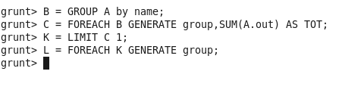

**OUTPUT:**

**C:\Users\613000\Desktop\11.1dout.PNG**