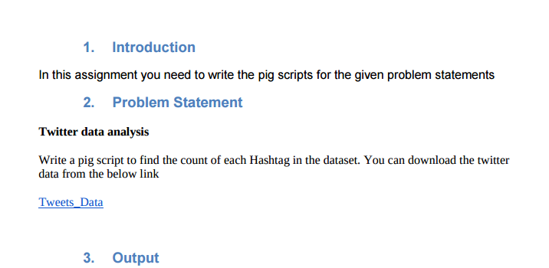

**After doing unrar of our tweet.rar dataset we got following files**

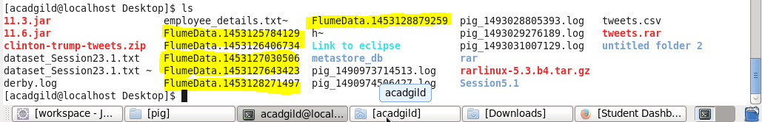

**Pig script**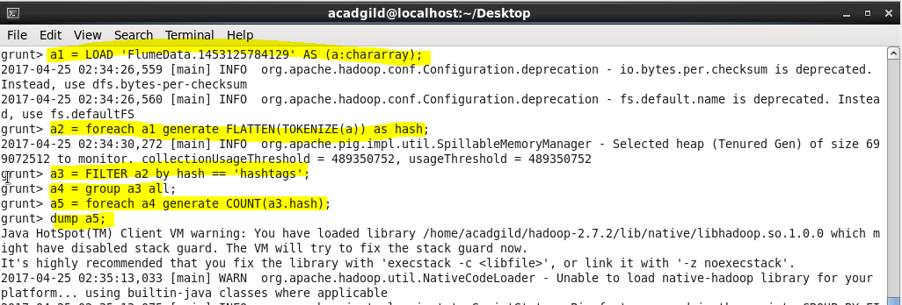

**Output**

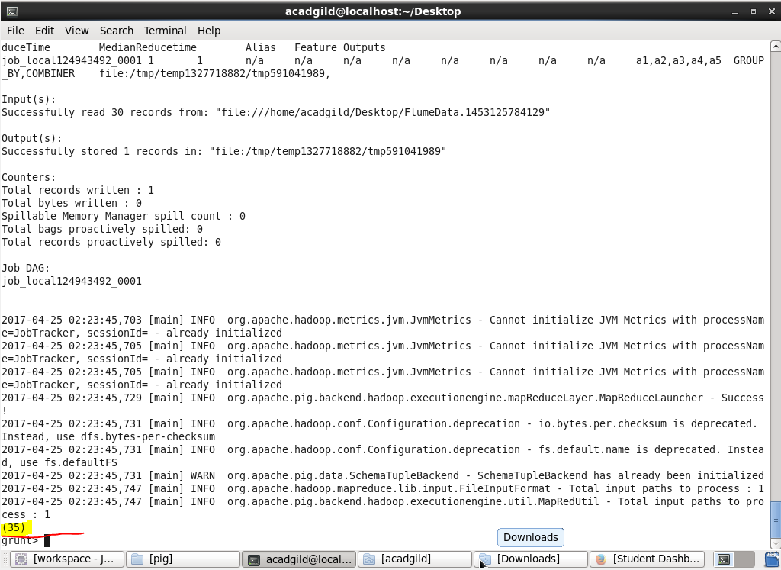

**So in total 35 hashtags in file 1**

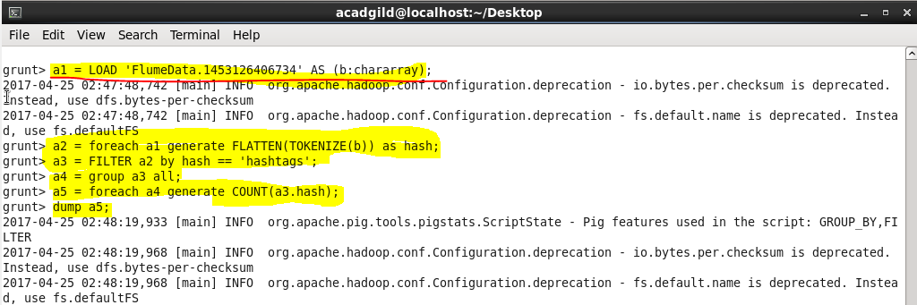

**Output**

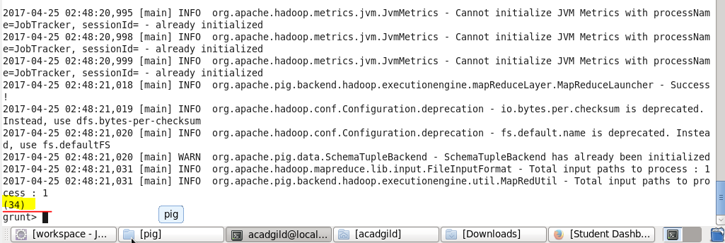

**So in total 34 hashtags in file 2**

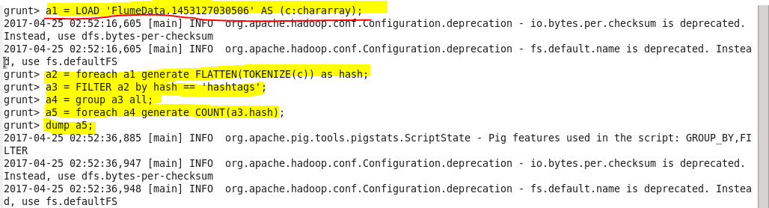

**Output**

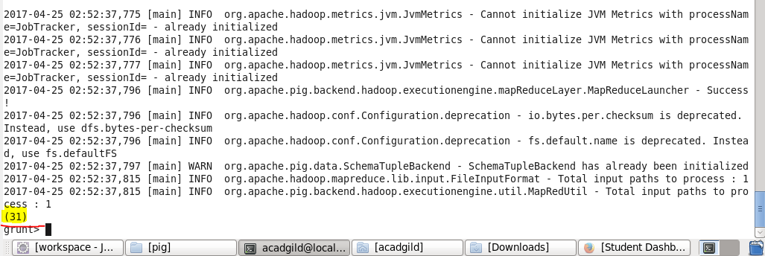

**So in total 31 hashtags in file 3**

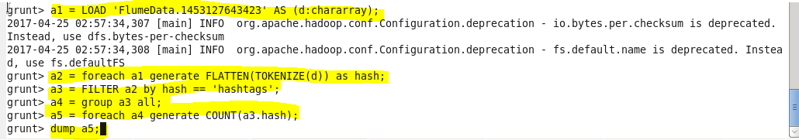

**Output**

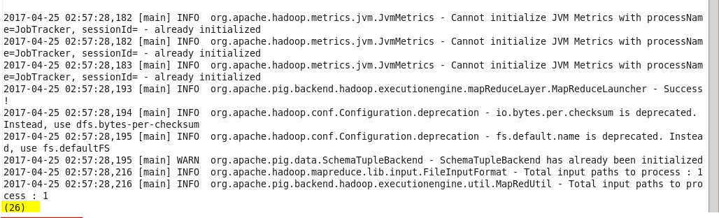

**So in total 26 hashtags in file 4**

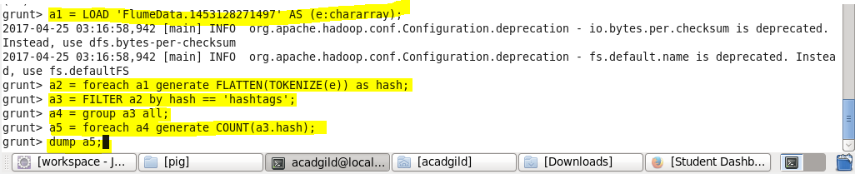

**Output**

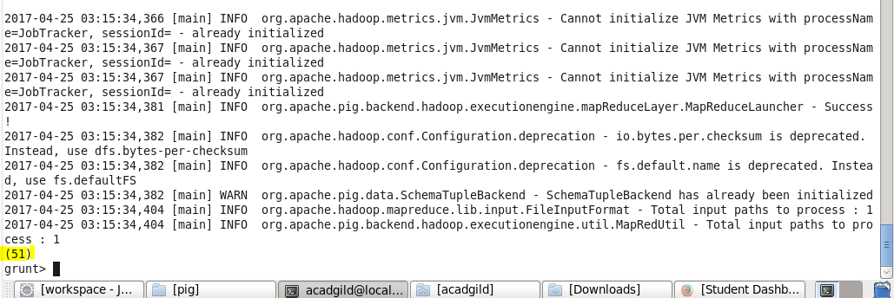

**So in total 51 hashtags in file 5**

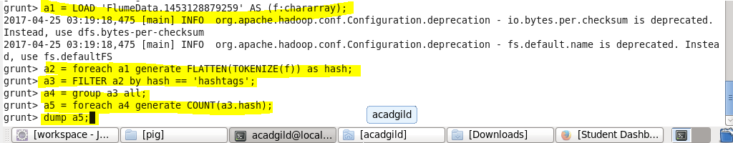

**Output**

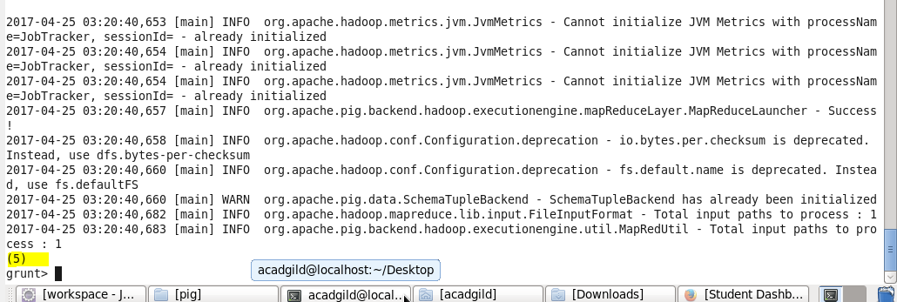

**So in total 5 hashtags in file 6**