Q.1. Create a flume agent that streams data from Twitter and stores it in the HDFS cluster.

Ans. Installed flume via given method on ubuntu .

This is the **flume.conf**

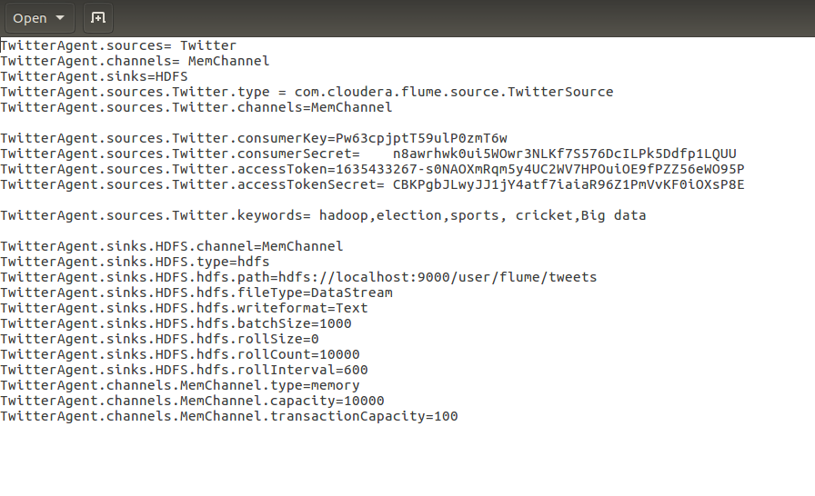

Creating the **twitter app**.

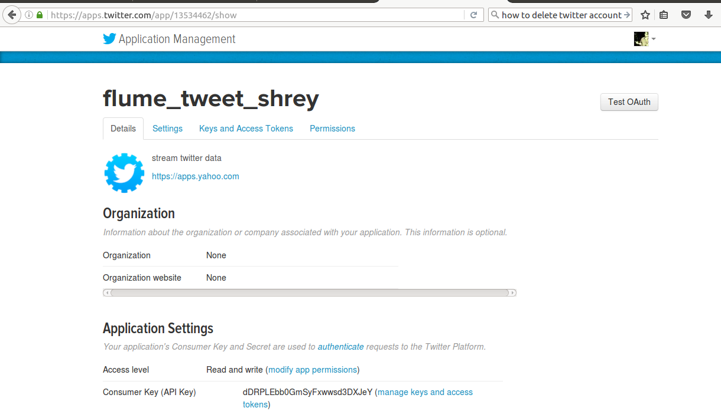

Running the flume agent:

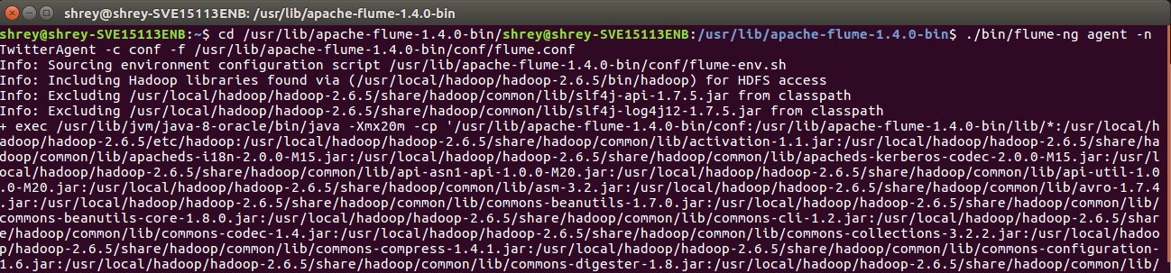

Checking on HDFS:

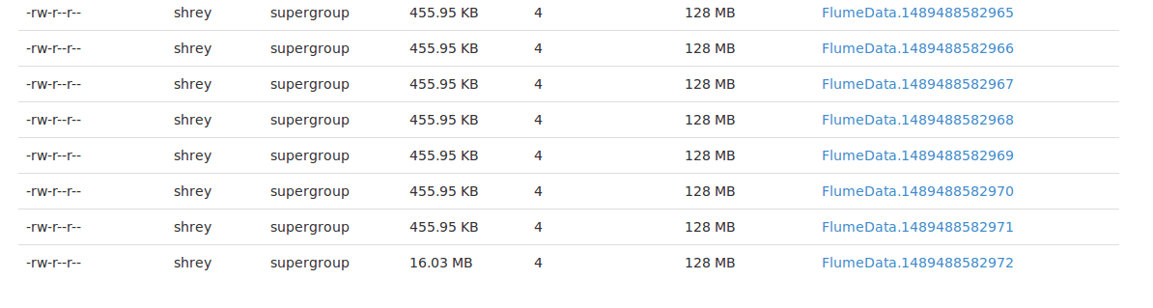

Flume Data file on HDFS:

