**Q.1. Write a program that accepts the job_id as argument and returns a custom counter and a system counter (total records input to the map tasks) associated with that job.**

**Driver**

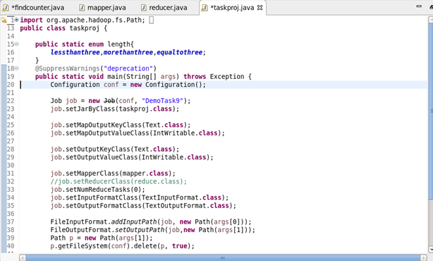

**Mapper**

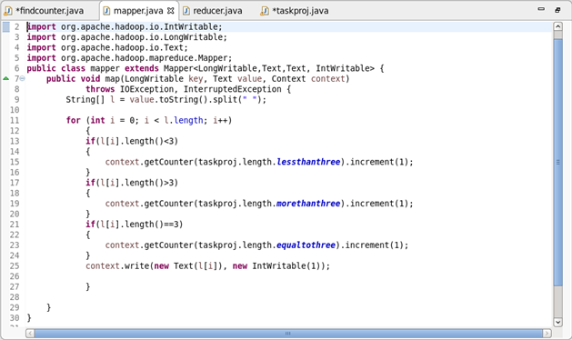

**Reducer**

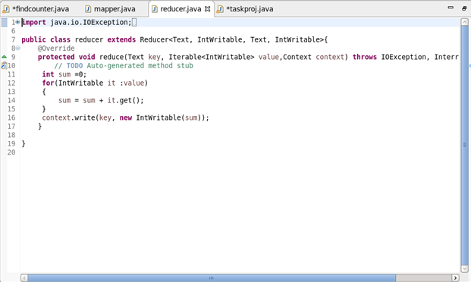

**Job Counter**

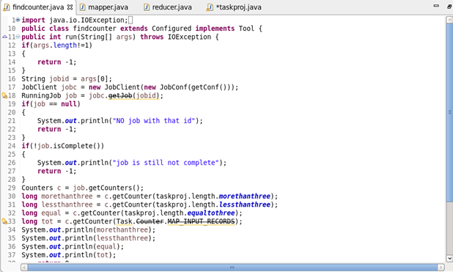

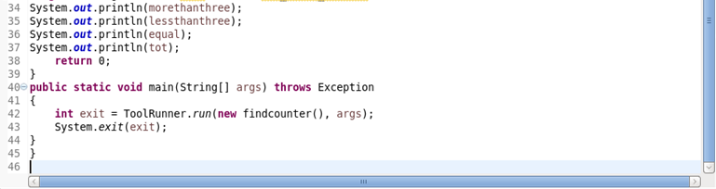

**Output**

