**Q. Write a mapreduce job that takes configuration from command line. Based on the configuration, it should perform count of words from a document and produce only those words in the output whose count is greater than or equal to the configuration.**

**Input file**

Hadoop is a good subject

Hadoop is a good subject

Hadoop is a good subject

Hadoop is a good subject for me

**Solution**

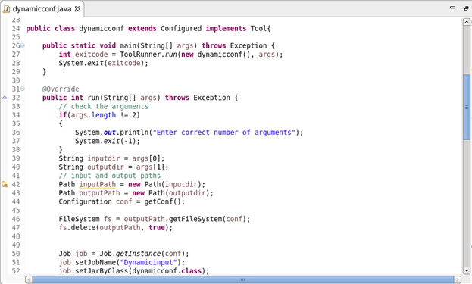

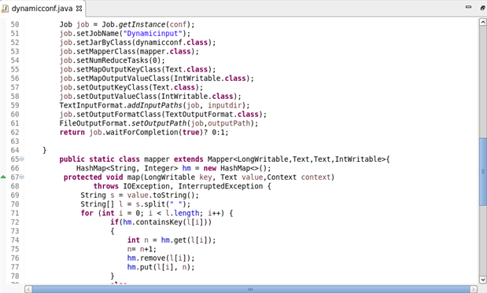

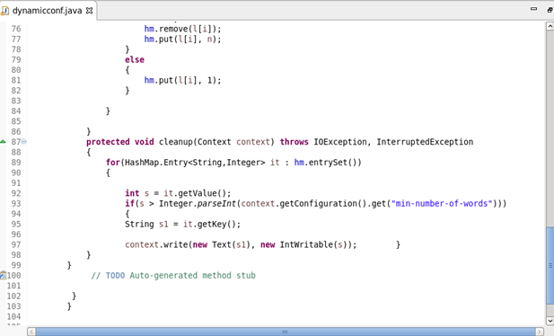

**Output**

