**Q.1. Find out what are the top 5 categories with maximum number of videos uploaded.**

**Driver**

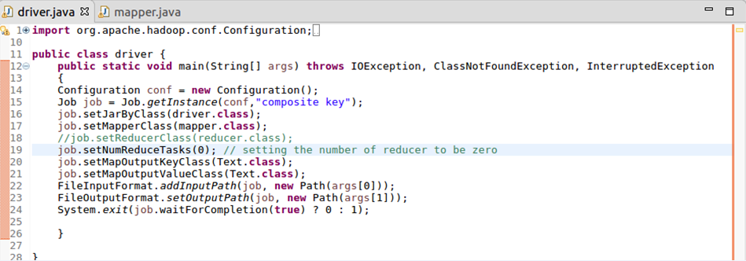

**Mapper**

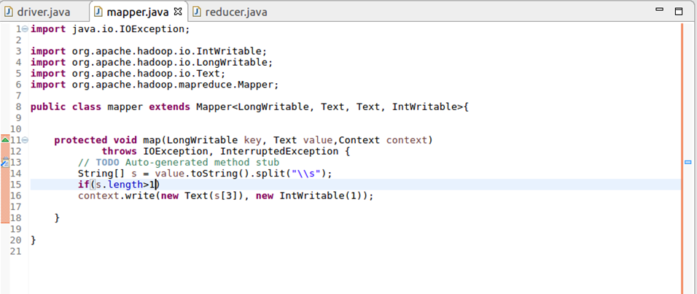

**Reducer**

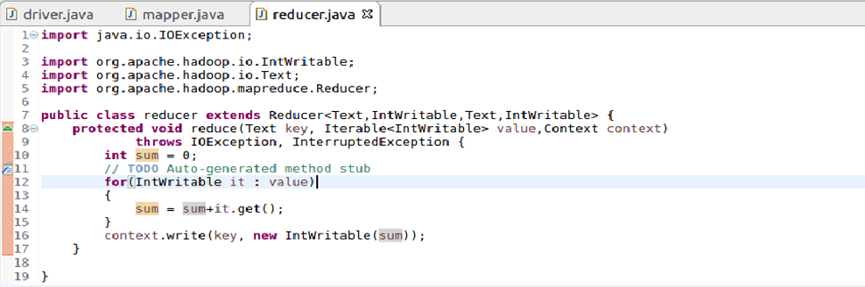

**Output**

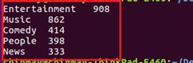

**Q.2. Find the top 10 rated videos in youtube.**

**Driver**

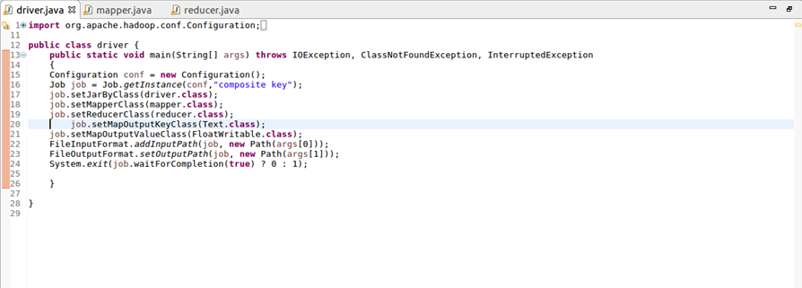

**Mapper**

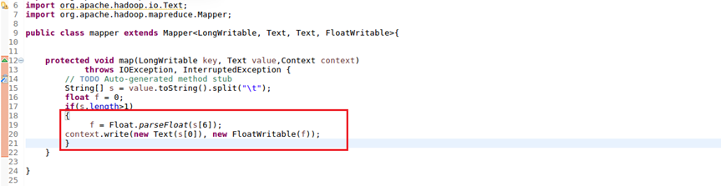

**Reducer**

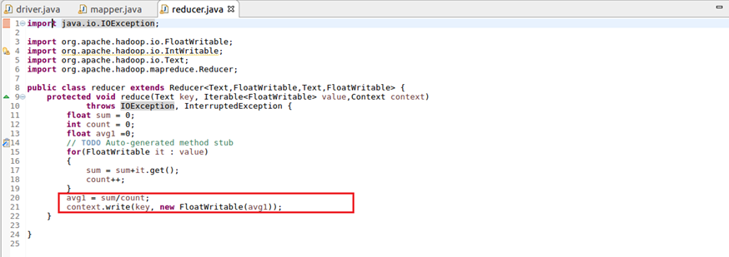

**Output**

