**ASSIGNMENT 23.1**

* **Creating database custom**

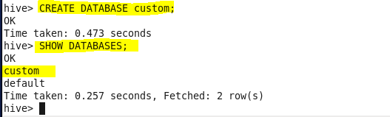

* **Using Database**

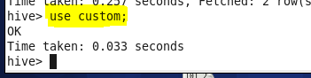

* **Creating table temperature_data**

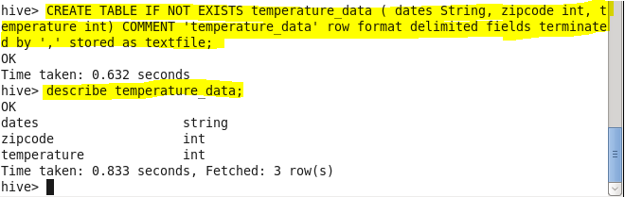

* **Loading data into table**

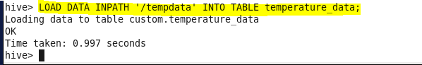

* **Output**

