**ASSIGNMENT 24.2**

* Creating databases

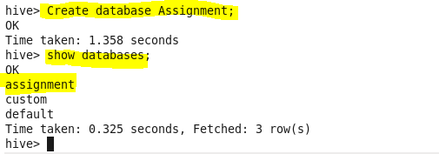

* Creating table

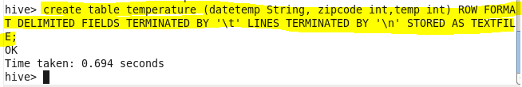

* Loading data from data file

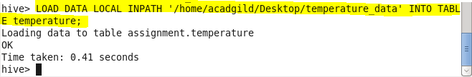

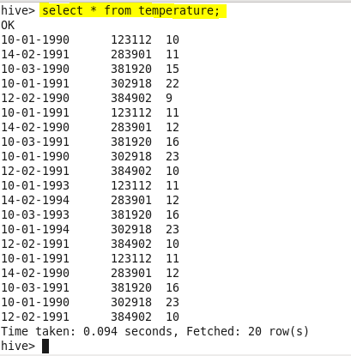

* **Fetch date and temperature from temperature_data where zip code is greater than 300000 and less than 399999.**

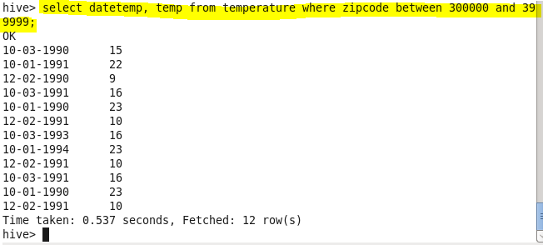

* **Calculate maximum temperature corresponding to every year from temperature_data table.**
* **Extract year from date and group by year**

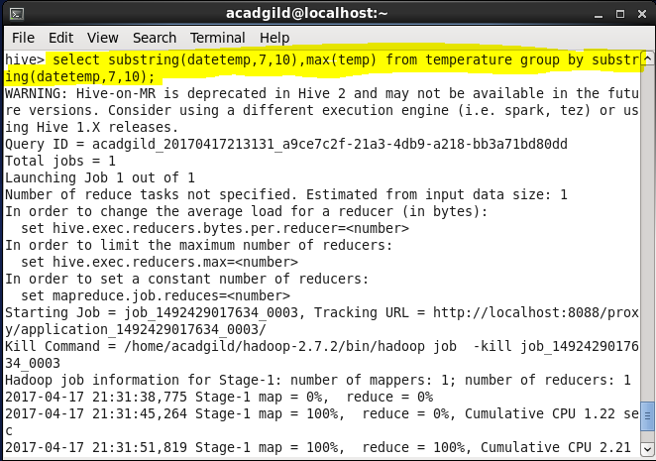

**Output:**

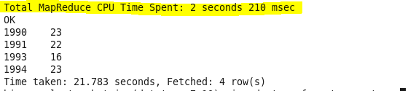

* **Calculate maximum temperature from temperature_data table corresponding to those years which have at least 2 entries in the table.**
* Group by year and count their occurrences. Display the max temperature accordingly.

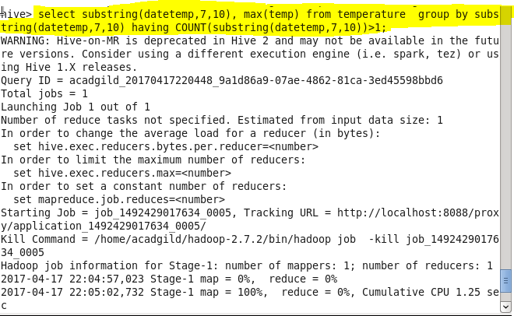

**Output:**

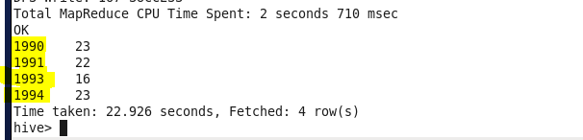

* **Create a view on the top of last query, name it temperature_data_vw.**

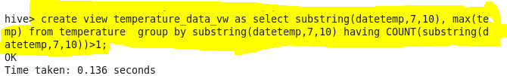

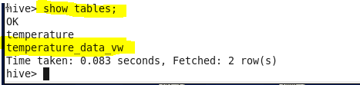

**Output:**

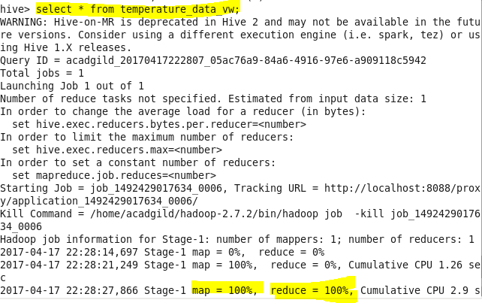

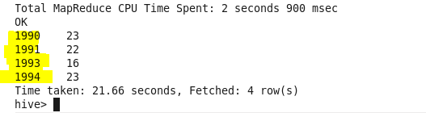

* **Export contents from temperature_data_vw to a file in local file system, such that each file is '|' delimited.**

