**ASSIGNMENT 24.3**

* Using database

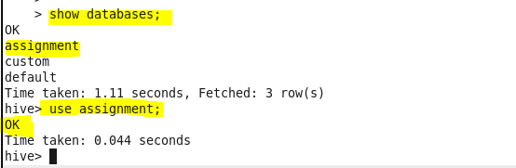

* Creating table

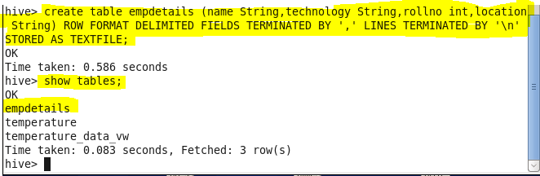

* Loading data from data file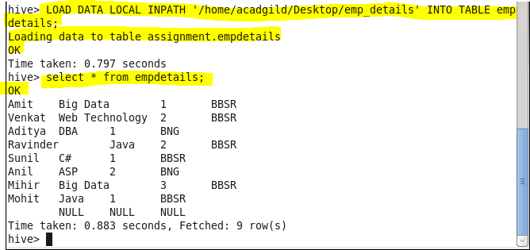
* **Calculate the number of employees corresponding to each skill from the table 'employee' which is loaded in the Demo**.

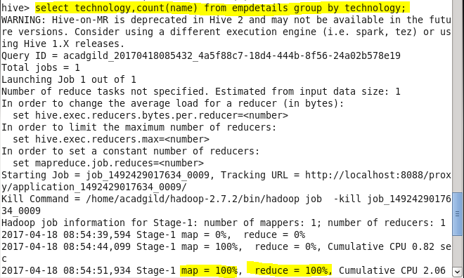

**Output:**

