**ASSIGNMENT 24.4**

* Using database

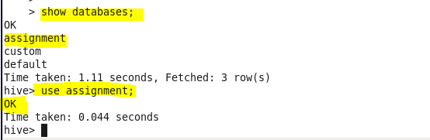

* Creating table

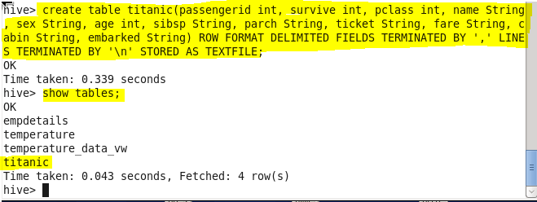

* Loading data from data file

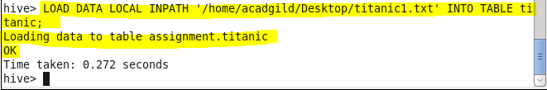

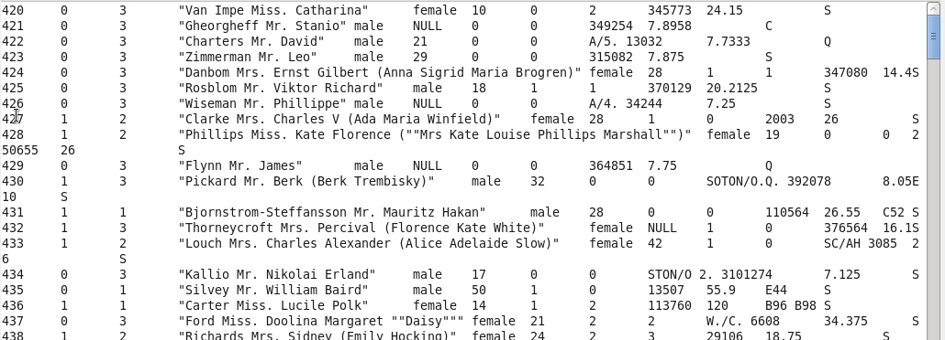

* **Write a hive query find the average age of male and female persons died in the titanic tragedy**

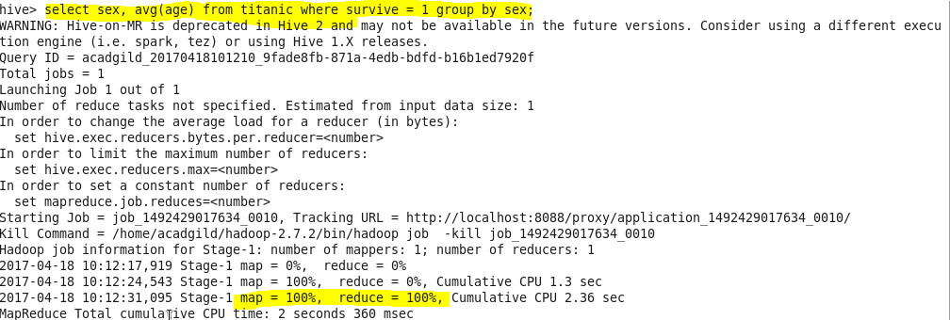

**Output:**

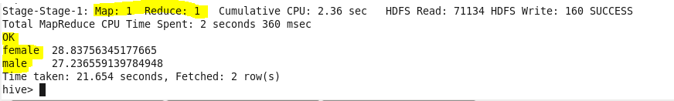

* **Write a hive query to find the number of people died and survived in each class**

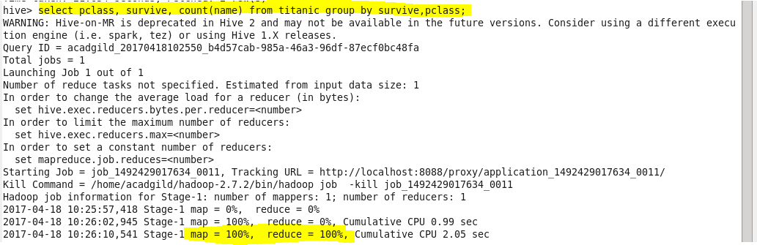

**OUTPUT:**

