**CREATING A TABLE**

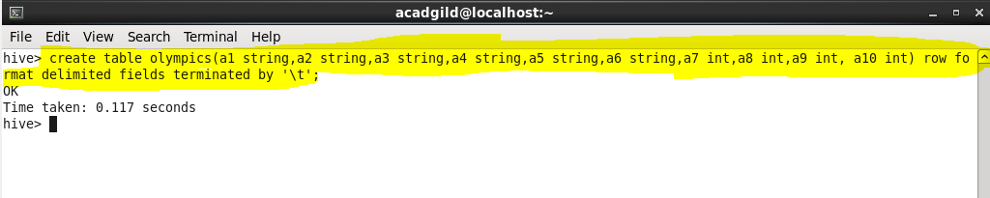

**LOADING A FILE IN THE TABLE**

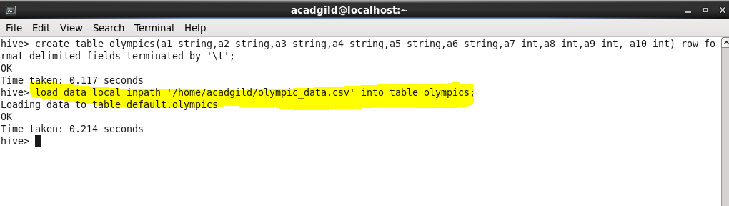

**INPUT DATA**

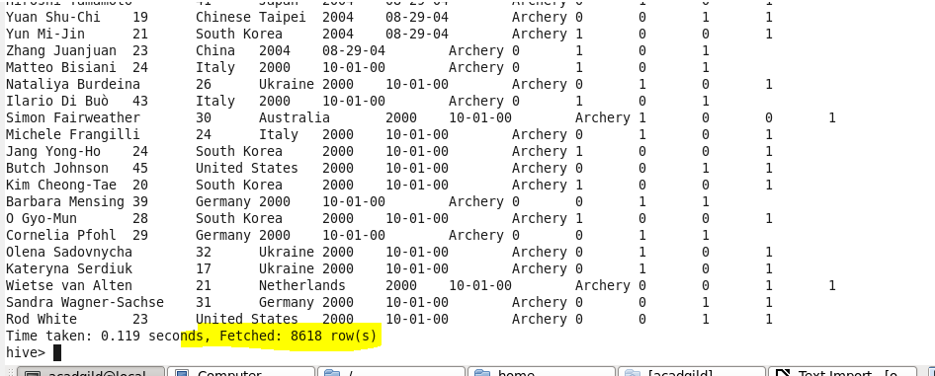

**Q.1. Write a Hive program to find the number of medals won by each country in swimming.**

**COMMAND**

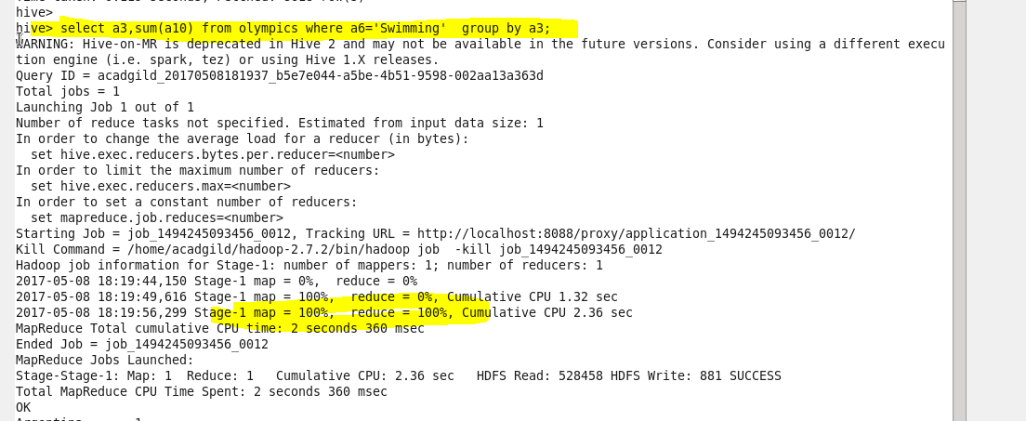

**OUTPUT**

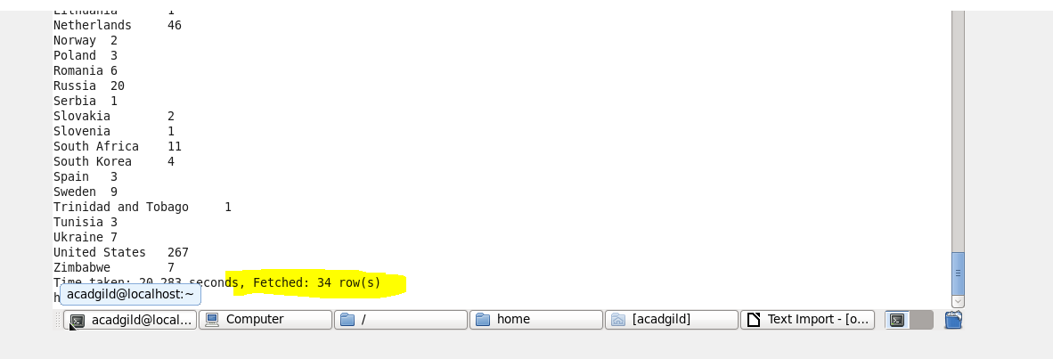

**Q.2. Write a Hive program to find the number of medals that India won year wise.**

**OUTPUT**

