**Create table travel data**

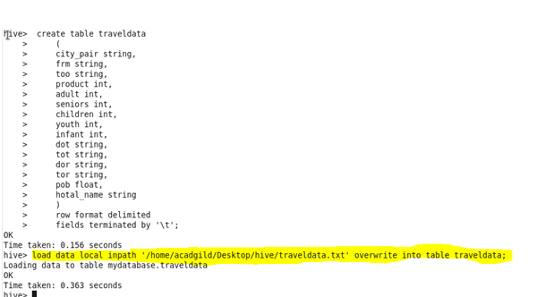

**Q.1. Write a hive query to find the top 20 destination people travel the most: Based on the given data.**

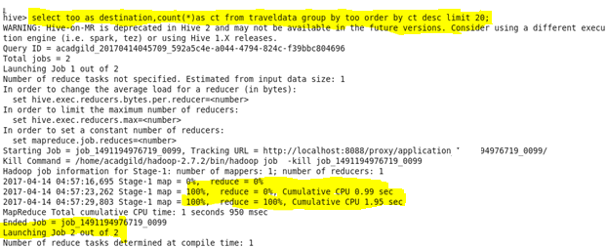

**Output**

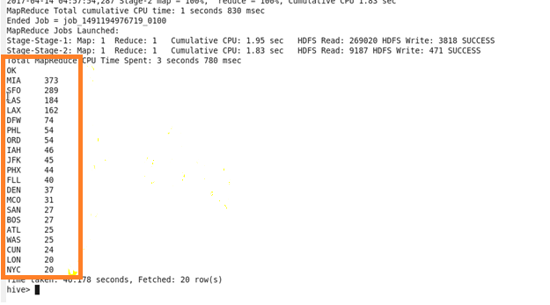

**Q.2. Write a hive query to find the top 20 locations from where people travel the most.**

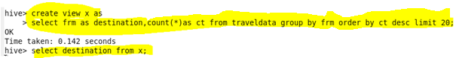

**Output**

