**Q. Implement view in hive by following the steps in the below blog**

**Input file 1**

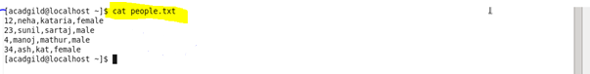

**Input file 2**

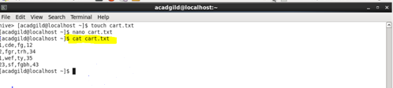

**Create table and load data**

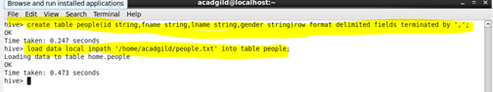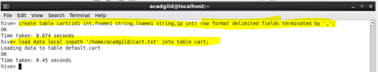

**Create view**

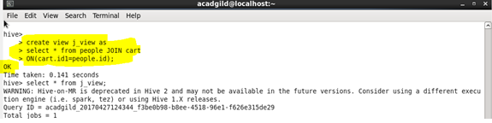

**Output**

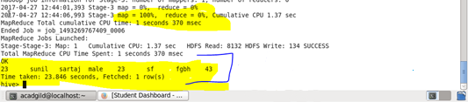

**Query**

