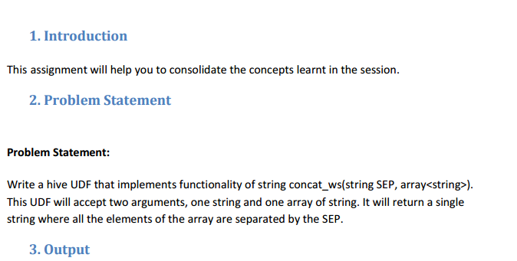

**Here is the java code to return all elements of the array separated by separator**

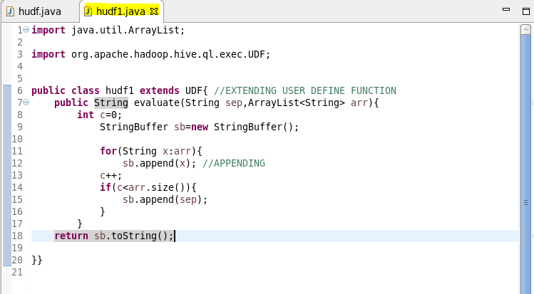

**Here, adding the jar file**

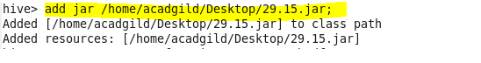

**Creating a table so as to perform operations using user define function and inserting data into it**

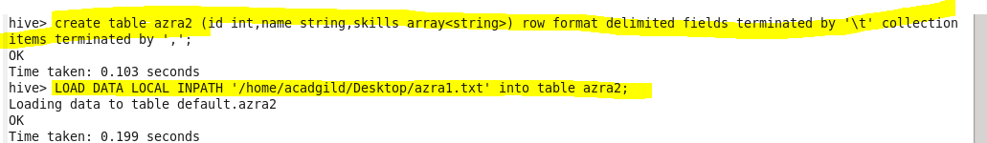

**Creating temporary function ‘conc5’ **

**Performing basic select operation.**

**Describe table we created for the given problem using desc and then using select all we can show the data in our table.**

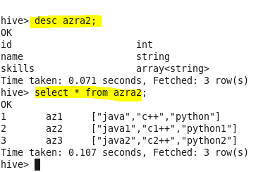

**Retrieving data using temporary function we created**

