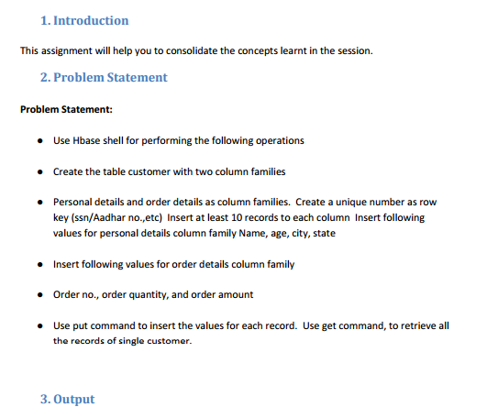

**Creating table customer with two column families > personal details and order details**

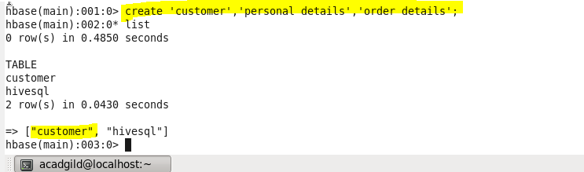

**Using put command**

Inserting values for personal details **column : name**

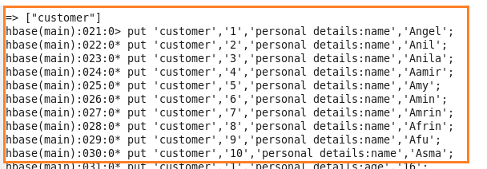

Inserting values for personal details **column : age**

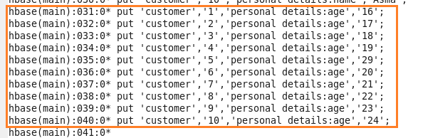

Inserting values for personal details **column :city**

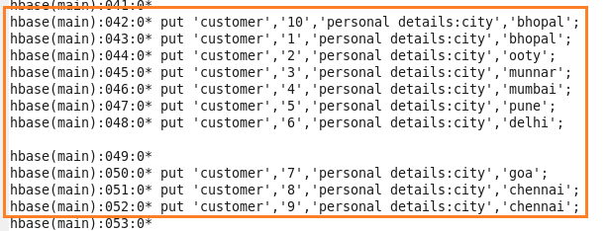

Inserting values for personal details **column : state**

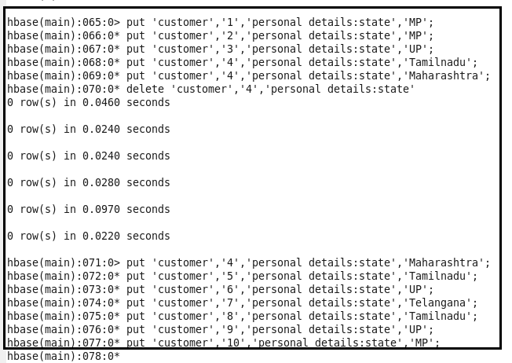

Inserting values for order details **column :order number**

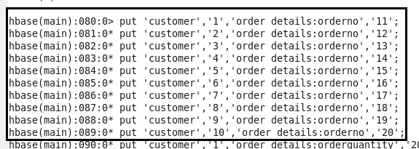

Inserting values for order details **column : order quantity**

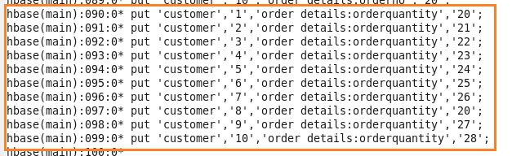

Inserting values for order details **column :order amount**

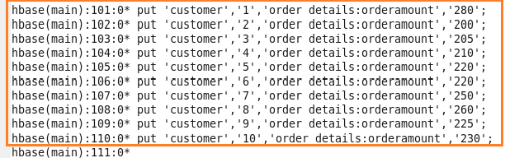

**Retrieving values using get function of table ‘customer’**

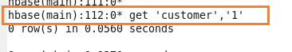

**This will give output for customer table with row key =1;**

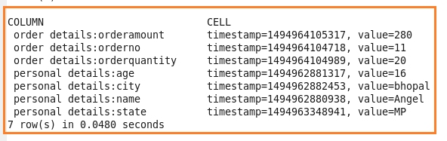

**This will give output for customer table with row key =2;**

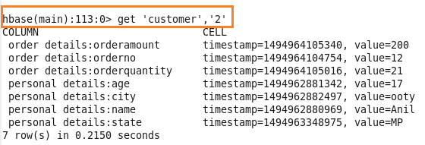

**Similarly for row key =3,4,5,6,7,8,9 and 10**

