Problem Statement1

Write a Java program, to take a HDFS Path as input and display all the files and sub-directories in that HDFS path.

Input:

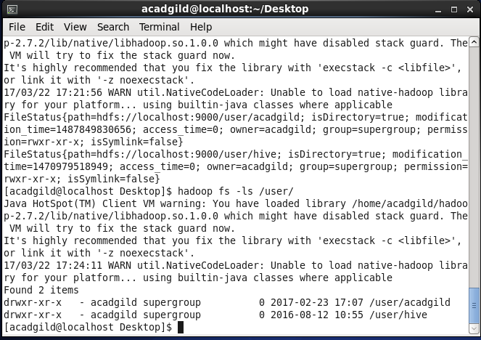

output: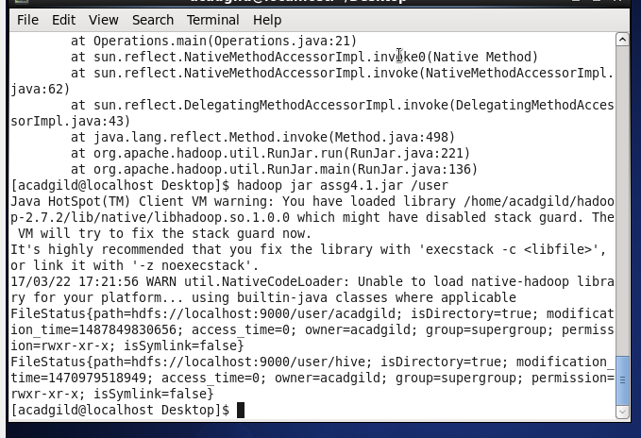program: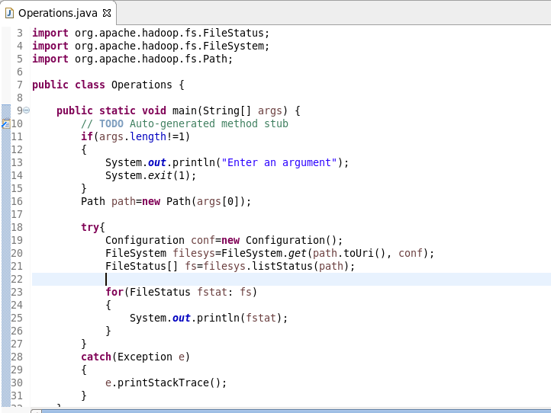

Problem Statement2

Modify the previous program to list all the files and sub-directories in the HDFS path recursively.

Output:

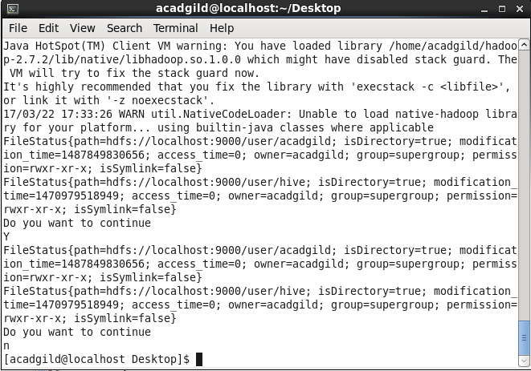

Program:

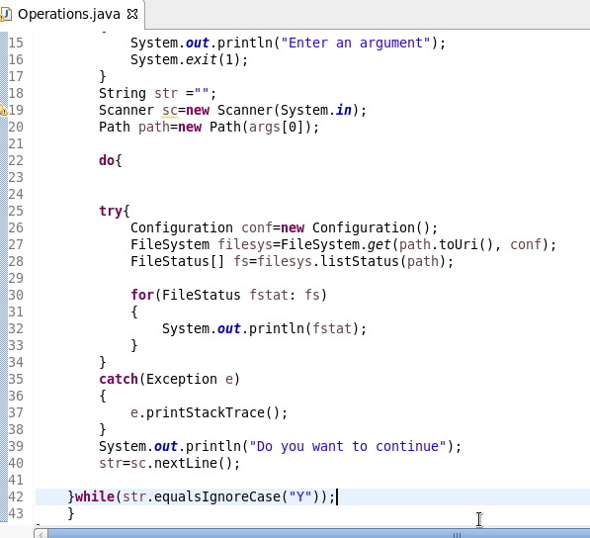

Problem Statement3

Modify the previous program to take multiple HDFS paths (separated by space) and list all the files and sub-directories in those HDFS paths recursively.

Input:

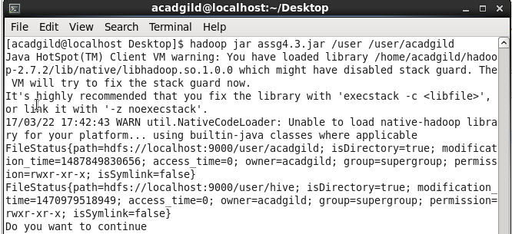

Output:

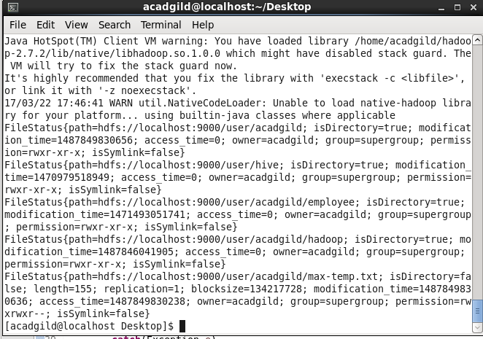

Program:

