Q1.

Mapreduce program to modify Sales of different TV Task 2 to use a custom partitioner with 4 reducers. Make sure that all records whose company name starts with A-F (upper or lower case) should go to 1st reducer, those starting with G-L to 2nd reducer, those starting with M-R to 3rd reducer and others to 4th reducer

Input:

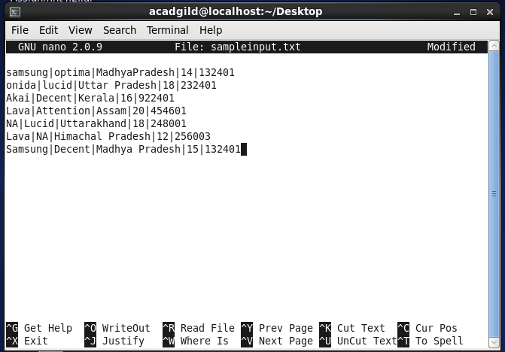

Driver class: 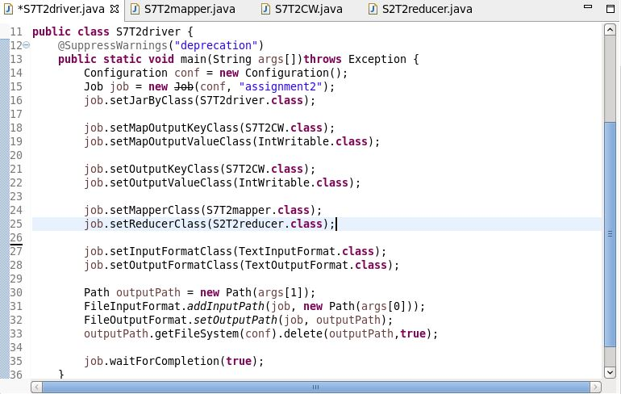

Mapper class:

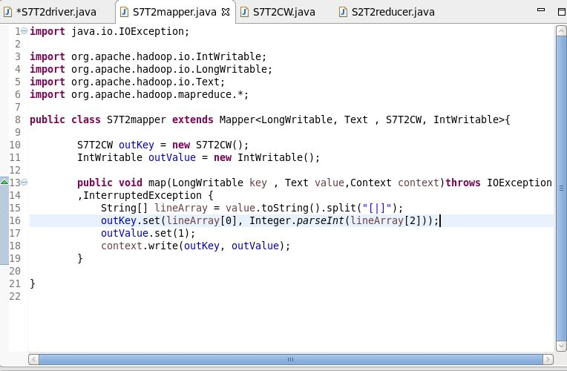

Partitioner class:

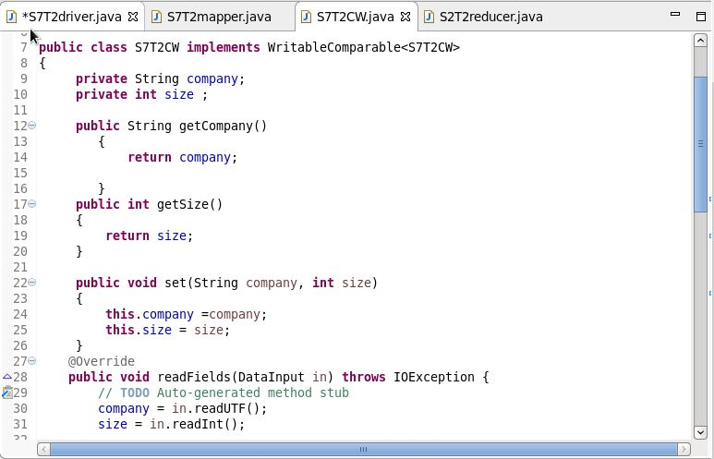

Reducer class:

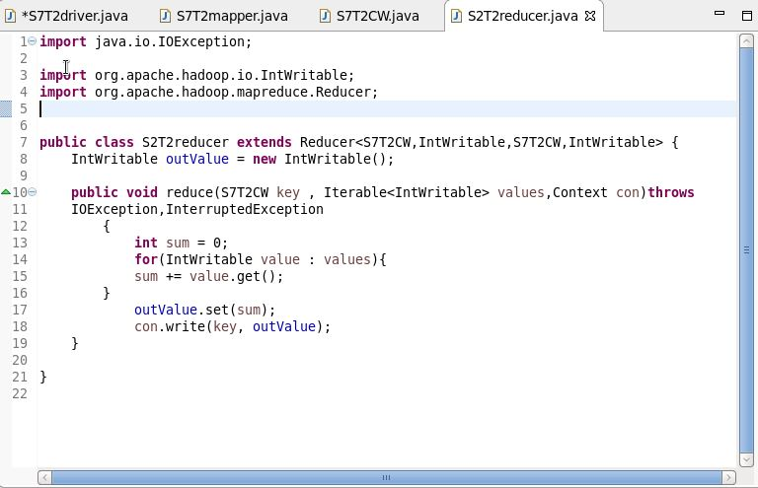

Output:

